Bilateral, Focal Autoimmune Thalamitis
A Clinical Case Suggesting a Potential Role for Viruses in the Development of Human Consciousness
Dr. Ammar Yaseen Mansour

Abstract:
The importance of this clinical-radiological case lies in its being isolated, bilateral, and immune-mediated. The thalami are the sole victims, while the rest of the body is healthy and sound. The infection is viral, but the resulting injury is described as immune-mediated. Then comes the shock from the severity and horror of the clinical picture. After the astonishment, thought ignites, beginning the search into origins and beginnings. From the exclusivity and symmetry of the thalamic involvement, I investigated the function of this thalamus. From the immune mechanism of the injury, I inquired about the existence of a genetic kinship linking the killer and the victim. Finally, I ended up delving into a potential role for viruses in general in updating our genes as humans. So, come with me on this intellectual journey, and do not fault me for the lack of documentation. After the first visit, the patient was lost to follow-up. However, what I have is sufficient for the purpose of this research; it even overflows.

This is a clinical-radiological case I wished to share with you. It concerns a woman in her thirties who was exposed to a confirmed viral infection when she accompanied a relative in the hospital. The sick relative had Guillain-Barré syndrome and spent many days in the hospital. Approximately three weeks later, the patient was admitted to the intensive care unit with symptoms of meningoencephalitis. The patient lost consciousness for more than two weeks. Upon awakening, she exhibited severe deterioration in mental capacities, memory, balance, and voluntary movement as well. She also suffered, and still does, from frequent episodes of muscle spasticity. The symptoms are numerous and varied. If I were to summarize the reality of the situation, I would say the patient has regressed to an early, unconscious childhood state in every detail.
Radiologically: On the magnetic resonance imaging (MRI) scan, which was performed late for reasons I personally do not know, we find two symmetrical lesions in the region of both thalami. The lesions are hypointense on T1-weighted imaging and hyperintense on T2-weighted imaging. Upon contrast administration in T1-weighted imaging, a narrow band of increased signal appeared, encircling the two hypointense lesions. Other than that, the brain appeared normal and remarkably so; see Figure (1).

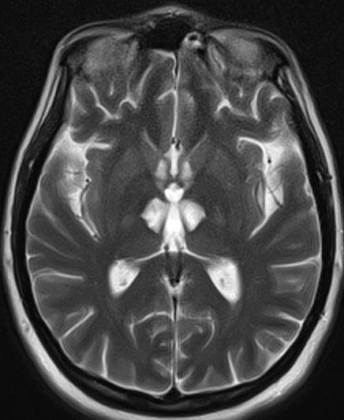  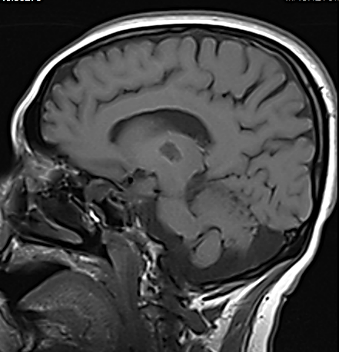 | 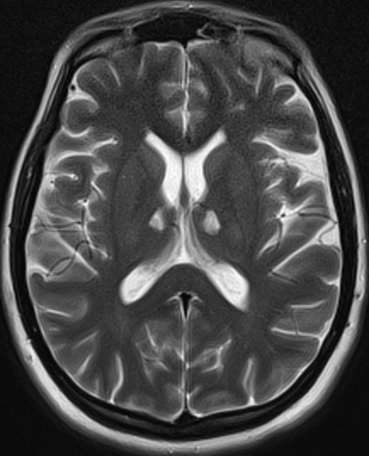  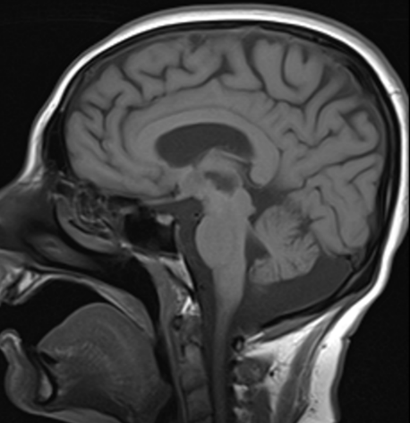
Figure (1): Brain Magnetic Resonance Imaging

MRI images demonstrate bilateral, symmetrical thalamic lesions. The lesions are hypointense on T1-weighted imaging (yellow arrows) and hyperintense on T2-weighted imaging (white arrows). Post-contrast T1-weighted images revealed peripheral contrast enhancement encircling these lesions (yellow arrows). The remainder of the brain parenchyma and anatomical structures appear radiologically normal.
The treating physicians attributed the patient's condition to bilateral thalamic infarction, which I personally do not accept. For how could a bilateral infarction be isolated to the thalamus and spare other structures supplied by the same vascular territory (e.g., from the posterior cerebral arteries)? A bilateral infarction practically means the blockage of an arterial trunk that is the origin of two symmetrical arteries, each responsible for perfusing a side that is precisely opposite to the other... This is not what we find in our case.
The medical literature describes an anomalous artery (Artery of Percheron Type II) that arises from the posterior cerebral artery on one side only and exclusively supplies both thalami. Occlusion of this artery results in infarction of both thalami; however, this infarction is not isolated. It is accompanied by an additional lesion in the midbrain region; see Figure (2).
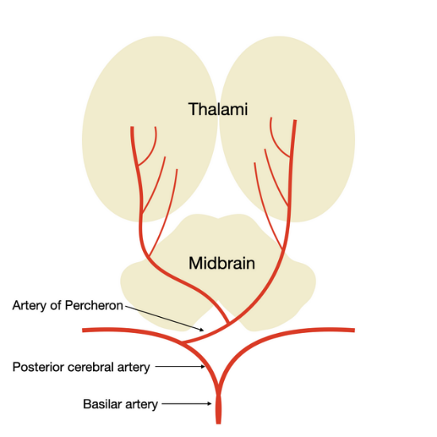
Figure (2): Artery of Percheron - Type II
As shown in the figure above, due to the absence of an alternative blood supply to the thalami, occlusion of this artery can, by itself, cause a bilateral thalamic infarction that is nearly selective. I describe it as nearly selective because it is consistently accompanied by infarction in other areas of the midbrain. This represents one of the rare vascular variants documented in the medical literature.

Therefore, my suspicion leans towards bilateral autoimmune thalamitis. The patient, during her accompaniment of her relative, received her share of the pathogenic virus. The disease did not manifest in our subject patient—a frequent occurrence. However, her immune system detected this foreign invader and formed specific antibodies against it in preparation for a subsequent infection. These antibodies did not find their target virus, but they detected a structurally similar entity and attacked it. The victim was the thalamus, the connection hub between perceptual, sensory, and motor centers in humans. This explains the exclusivity and symmetry of the thalamic injury.
I present this case because my thoughts have led me in a different direction. They led me to another dimension that goes beyond describing a medical condition of a passionate doctor and a suffering patient. They led me to contemplate the role of viruses, like other factors labeled as pathogenic, in the evolution of this human being. I found in it evidence for the existence of genetic commonalities between humans and some viruses. Or let's say it is direct evidence for the role of viruses in the evolution of the human species. For it must be that, at some stage of our evolution, a virus carried an important genetic modification to us, contributing in some way to the rise and development of this human's mental and cognitive faculties. Otherwise, how do we explain this resemblance between the structure of the pathogenic virus and our human thalamus.
Important Note: The diagnosis of Guillain-Barré syndrome in the patient's sister was not confirmed due to limited resources. Furthermore, no one agreed with me on diagnosing the subject patient with bilateral autoimmune thalamitis due to a difference in clinical interpretation... hence this clarification was necessary.
Discussion:
This pathological case is distinguished from other brain injuries in general, and specifically from injuries to the basal nuclei of the brain, by three points:
1. The exclusivity of the thalamic injury: This enables us to understand the function of the thalamus more precisely. The thalamus alone is affected, while other brain elements are healthy and functioning normally. Therefore, every element of the emergent clinical picture will inevitably be attributed to a dysfunction of the thalamus. In this regard, I say: How truly astonishing it is to see a patient with such an injury return to an early childhood state with all its details. This made me believe in the thalamus's role in storing acquired knowledge and experiences, surpassing its assigned role of linking and coordinating between different vital centers in the brain. Here, I will not be definitive about a matter unless I encounter other similar cases in the future.
2. The symmetry of the thalamic injury: This symmetry rules out a vascular factor from the list of pathological causes. A vascular factor does not selectively target a specific organ on one side and its counterpart on the other side of the brain, leaving the adjacent anatomical structures unharmed.
3. The immune-mediated nature of the thalamic injury: This will receive special attention from me in what follows. The appearance of the thalamic injury on both sides in a delayed manner after the initial exposure to the pathogenic virus (three weeks) is strong evidence for the role of specific antibodies to this virus in causing the thalamic damage. This made me seriously search for a potential role of the ancestors of this virus in the anatomical, and subsequently functional, evolution of the thalamus. On the other hand, I explore the role of viruses, as well as viral precursors, bacteria, and other microorganisms, in the evolution of the human species in general.
Specifying the Discussion:
When our body is exposed to a foreign agent, our immune system works to detect this intruder. It studies its external features and determines the most effective ones in building its wall. It then manufactures a specific weapon that protects the body from the current infection and also guards against others that may come later. We call this specific weapon the antibody, and its specific target the antigen.
Sometimes it happens that the antigen is structurally similar to a vital element in the human body. The antibody becomes confused in distinguishing the antigen from that resembling element, and the latter falls victim to the antibody. In other words, the antibody missed its original target and attacked the resident lookalike. Here lies the catastrophe: the immune system attacks a genuine component of the human body. This is technically called an Auto-Immune Disease.
The fundamental question is: How can this structural similarity between that foreign intruder and this resident original exist? Was it impossible for the living organism to create genetic diversity that would protect against such confusion in the structure of its components?
In truth, this resemblance cannot be mere coincidence, nor can it be without a reason of great significance. The structural similarity between the pathogenic virus and the thalamus, as in our case, must hide behind it a genetic similarity between the two elements: the virus and the thalamus. The thalamus, as we know, is a neural nucleus deep within the human brain, and the virus, as we know it in nature, originates from and ends in nature. The problematic question remains: Where did the genetic-structural similarity between these two distantly originated and located elements come from?
In this context, I say:
Viruses have played, and still play, an important role in updating human genes. They are the faithful mail carriers that deliver messages from Mother Nature to her children of the human race. Every emerging variable in nature must have a corresponding new genetic variable that suits it. These genetic updates are carried to humans via various carriers, including viruses. The viral gene reaches the human gene, merges into the human DNA sequence, and becomes an original part of its structure. This foreign gene must manifest itself in some measurable form. Reshaping the tissue structure of the target organ is one form of declaring this new gene.
If we want to apply this to our case under study, I say:
During the long and complex journey of human evolution, ancestors of the pathogenic virus may have somehow contributed to building the thalamus within our brains, or at least contributed to developing one of its many vital functions. The thalamus retained the imprint of this ancient viral influence in its apparent tissue structure.
Of course, things did not remain as they were. Time never leaves anything in its initial state. Humans differed in the size and importance of that viral genetic imprint, and today's viruses also differ genetically from their ancestors. However, it happens that a viral lineage preserves a significant amount of the ancestors' genetic heritage, and it also happens that a human lineage retains a sufficient amount of the genetic imprint of the initial viral infection. All that remains is for the two groups to meet again until the genetic memory is revived, manifesting what was hidden for a long time.
If it is not so, what is the explanation for the isolated thalamic injury... firstly? What is the explanation for the bilateral symmetrical injury... secondly? And what is the underlying reason for the injury appearing in some individuals and not others... finally? And to be specific, how can specific antibodies to a virus target a noble, original element in the human body in some humans and not others? Or how can they select this organ and spare other organs?
In light of this case, and there are many similar ones, should we not reconsider and research all these autoimmune diseases? As I see it, they do not result from a defect that arose in the patient's immune system, causing it to attack natural, genuine organs of the human body. Rather, they are a direct result of viruses that struck, awakening the memory of an ancient, intimate relationship between our ancestors as humans and their ancestors among viruses.
Important Note: This clinical-radiological case supports a hypothesis of mine regarding the role of viruses in updating human genes to suit the changes of time and new developments of place. I have explained this in detail and at length in two separate articles titled:
COVID-19 and Oogonia: Crafting a Genetic Time Bomb Through Barr Body Alterations (DOI)
Eve Preserves Humanity’s Blueprint; Adam Drives Its Evolution (DOI)
………………………………………………………………………………
In other contexts, you can also read the following articles:
 | DOI | The Spinal Reflex, New Hypothesis of Physiology
 | - | The Hyperreflexia, Innovated Pathophysiology
 | DOI | The Spinal Shock: The Pathophysiology
 | - | The Spinal Injury, the Pathophysiology of the Spinal Shock, the Pathophysiology of the Hyperreflexia
 | DOI | Upper Motor Neuron Lesions: The Pathophysiology of the Symptomatology
 | DOI | Hyperreflexia (1): Pathophysiology of Disproportionate Motor Response
 | DOI | Hyperreflexia (2): Pathophysiology of Bilateral-Response Hyperreflexia
 | DOI | Hyperreflexia (3): Pathophysiology of Extended Hyperreflexia
 | DOI | Hyperreflexia (4): Pathophysiology of Multi-Motor-Response Hyperreflexia
- | DOI | The pathophysiology of Triple flexion Reflex
 | DOI | The Clonus, 1st Hypothesis of Pathophysiology
 | DOI | The Clonus, 2nd Hypothesis of Pathophysiology
 | DOI | The Clonus, Two Hypotheses of Pathophysiology
 | DOI | The Nerve Transmission through Neural Fiber: Personal View vs. International View
 | - | The Nerve Transmission through Neural Fiber (1), The Action Pressure Waves
 | - | The Nerve Transmission through Neural Fiber (2), The Action Potentials
 | - | The Nerve Transmission through Neural Fiber (3), The Action Electrical Currents
 | - | The Function of Standard Action Potentials & Currents
 | - | The Three Phases of Nerve transmission
 | DOI | Neural Conduction in the Synapse (Innovated)
 | DOI | Nodes of Ranvier, the Equalizers
 | - | Nodes of Ranvier, the Functions
 | - | Nodes of Ranvier, First Function
 | - | Nodes of Ranvier, Second Function
 | - | Nodes of Ranvier, Third Function
 | - | Node of Ranvier, The Anatomy
 | DOI | Vesicular Dynamics: A Unifying Theory for Wallerian Degeneration and Neural Regeneration
 | - | The Wallerian Degeneration
 | - | The Neural Regeneration
 | DOI | Wallerian Degeneration: Affects Motor Axons while Sparing Sensory Axons
 | DOI | The Sensory Receptors
 | DOI | Electroneurography vs. Neural Reality: Hidden Fallacies in Nerve Conduction Studies
 | DOI | Piriformis Muscle Injection: Personal Approach
 | DOI | In Philosophy of Nerves: Pain First!
 | DOI | In Neurodoctrines: Form is Necessity!
 | DOI | Pronator Teres Syndrome, Struthers-Like Ligament
 | DOI | Ulnar Nerve, Congenital Bilateral Dislocation
 | - | Posterior Interosseous Nerve Syndrome
 | DOI | The Multiple Sclerosis: The Causative Relationship Between  The Galvanic Current & Multiple Sclerosis?
 | DOI | Traumatic Injuries of the Cauda Equina: A Novel Surgical Approach
 | DOI | Carpal Tunnel Syndrome Ends Its Adherence: Complete Median Nerve Transection
 | DOI | Biceps Femoris' Long Head Syndrome (BFLHS)
 | DOI | Barr Body, The Whole Story (Innovated)
 | - | Adam's Rib and Adam's Apple, Two Faces of one Sin
 | - | Adam's Rib, could be the Original Sin?
 | - | Barr Body, the Second Look
 | DOI | Who Decides the Sex of Coming Baby?
 | - | Boy or Girl, Mother Decides!
 | - | Oocytogenesis
 | - | Spermatogenesis
 | - | This Woman Can Only Give Birth to Female Children
 | - | This Woman Can Only Give Birth to Male Children
 | - | This Woman Can Give Birth to Female Children More Than to Male Children
 | - | This Woman Can Give Birth to Male Children More Than to Female Children
 | - | This Woman Can Equally Give Birth to Male Children & to Female Children
 | - | Eve Saved Human Identity; Adam Ensured Human Adaptation
 | DOI | COVID-19: Beyond the Crisis—Is It Targeting Our Genes?
 | DOI | Fibromyalgia
 | - | Mitosis in Animal Cell
 | - | Meiosis
 | DOI | The Creation of the Heavens and the Earth: The Connected Nebular Universe Hypothesis
 | DOI | The Sweeping Celestial Bodies (Al-Jawāri Al-Kunnas)
 | DOI | The Black Hole and the Falling Star Hypothesis
- | DOI | Light is a Wave and the Path is Material: A New Vision of the Nature of Light and its Propagation
 | - | Pneumatic Petrous, Bilateral Temporal Hyperpneumatization
 | DOI | Congenital Bilateral Thenar Hypoplasia
 | DOI | Ulnar Dimelia, Mirror hand Deformity
 | DOI | Brachymetacarpia: Bilateral and Symmetrical Shortening of the Three Ulnar Digits
 | DOI | Thumb Reconstruction Using Microvascular Second Toe to Thumb Transfer
 | DOI | Surgical Restoration of a Smile by Grafting a Segment of the Gracilis Muscle to the Face
 | DOI | Mandible Reconstruction Using Free Fibula Flap
- | DOI | Free Fibula Flap for Bone Lost Complicated with Recalcitrant Osteomyelitis
 | DOI | Presacral Schwannoma
 | DOI | Liver Hemangioma: Urgent Surgery of Giant Liver Hemangioma  Due to Intra-Tumor Bleeding
 | DOI | Free Para Scapular Flap (FPSF) for Skin Reconstruction
 | DOI | Claw Hand Deformity (Brand Operation)
 | DOI | Algodystrophy Syndrome Complicated by Constricting Ring at the Proximal Border of the Edema
 | DOI | Non- Traumatic Non- Embolic Acute Thrombosis of Radial Artery (Buerger’s Disease)
 | DOI | Isolated Axillary Tuberculosis Lymphadenitis
 | DOI | The Iliopsoas Tendonitis... The Snapping Hip
- | DOI | Peri- Menopausal Breast Lesions: Towards a More Decisive Approach
 | To read the original Arabic version of the article, click on:
 | DOI | The New Frankenstein Monster
 | DOI | The Lone Wolf
 | DOI | The Delirium of Night and Day
 | DOI | The Delirium of the Economy
 | DOI | Ovaries in a Secure Corner… Testicles in a Humble Sac:  An Inquiry into the Function of Form
 | DOI | Eve Preserves Humanity’s Blueprint; Adam Drives Its Evolution
 | DOI | The Manufacture of the Unconscious
 | DOI | The Ballad of Eternity
 | DOI | Two Truths Woman Would Never Accept
 | DOI | The 'Iddah (Waiting Period) in Islamic Law: A Comparative Analysis of its Rationale for Divorced Women and Widows
 | DOI | The IVF/ICSI-Conceived Child: A Biologically Suboptimal Outcome
 | DOI | Nature's Relentless Couriers
 | DOI | The Triad of Intelligence... A Traveler's Provisions!
 | DOI | Zero-Value Equations: Modernity’s Hidden Costs and False Promises
 | DOI | The Dialectic of Meaning and Meaninglessness
 | DOI | Societal Schizophrenia: The Delirium of Our Time
 | DOI | The Rational Mind and the Abstract Mind
 | DOI | The Electric Lamp: Between Abstraction and Application - A Journey of a Thousand Years!
 | DOI | Thus spoke Abraham, the Friend: The Eternal... and the Ephemeral
 | DOI | The Crisis of an Intellectual Who Lost His Identity Under Piles of the Read and the Heard
 | DOI | Polygamy and Right-Hand Possession
 | DOI | Quranic Revelations
 | DOI | And the Profession... is a Martyr!
 | DOI | After Death and Before the Final Drive: Either Metamorphosis or Liberation!
 | DOI | The Junction of the Two Seas: An Isthmus Between Two Lives... The Story of Moses Who Lost His Fish
 | DOI | Absurd Wars: The Dualities of Existential Anxiety... Eternal Torment or a Sustained Test?
 | DOI | The Myth, The Aged Truth: Samson the Tale, and Sisyphus the Human
 | DOI | The Black Hole and The Falling Star Hypothesis
 | DOI | Adam's Apple and Adam's Rib: Two Facets of the Human Form
 | DOI | Eve (Hawwā): The Containing Woman.. A Philosophical Study of Name, Nature, and the Feminine Psyche
 | DOI | The Spirit and The Psyche: The First is a Gift from the Creator, The Second is a Craft of the Created
 | DOI | Noah's Ark: A Reprieve from Annihilation, Not from the Ordeal
 | DOI | The Final Deluge: A Great Flood... and No Ark
 | DOI | Unveiling the Veiled: It begins with the Name… and ends with Identity.
 | DOI | Human Society: A Gathering of Necessity or a Gathering of Innate Nature?
 | DOI | The Eternal Dialectic: Thought and Power in the Rise and Fall of Civilizations
 | DOI | She Almost Bore Her Brother: How Genetics Vindicates an Ancient Arabic Saying
 | DOI | The Imam Said: On Solitude and the Cure for a Troubled Time
 | DOI | Vitamin D: Youth For Ever
 | DOI | The Creation of Adam and the Creation of Eve: And from His Rib, Eve Was
 | DOI | Adam's Apple and Adam's Rib: Two Facets of a Single Sin

31/12/2025

