A Clinical Case
Brachymetacarpia
Bilateral and Symmetrical Shortening of the Three Ulnar Digits
Dr. Ammar Yaseen Mansour
At first glance, and before conducting radiographic imaging of the hands, I was hastily led to hypothesize a case of bilateral and symmetrical hyperplasia of the second metacarpal and the first phalanx of the index finger; see Figure (1).

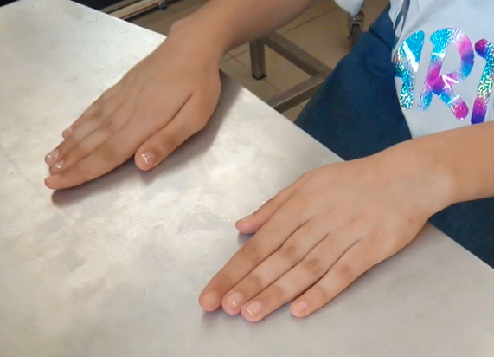
Figure (1): Image of the hands

The index finger may appear longer than the middle finger, which is contrary to logic and the norm. An observer is thus deceived by the apparent presentation, perceiving the condition as index finger hyperplasia. This is precisely what happened to me.

However, the X-ray revealed the truth: bilateral shortening of the three ulnar metacarpals. The index finger and thumb appeared within normal measurements; see Figure (2).

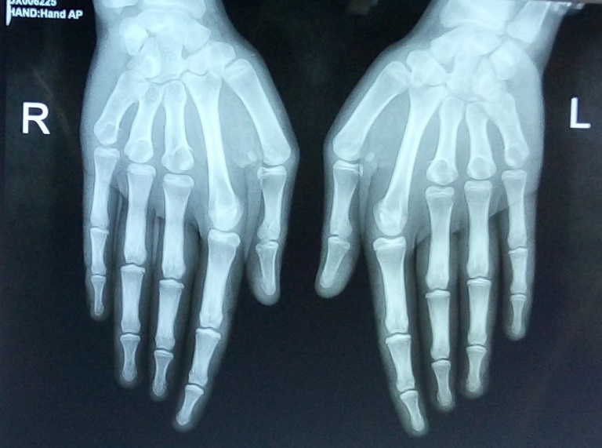
Figure (2): Plain X-Ray of Both Hands, Posterior-Anterior View

Note the shortening of the three ulnar metacarpals in both hands.
The proportional lengths of the bony segments in the affected digits are clearly disrupted, primarily at the expense of the metacarpals. These proportions, however, remain within normal limits for the index finger and thumb on both sides.

Brachymetacarpia occurs due to the premature closure of the growth plate in the affected metacarpal. There are congenital cases, as well as acquired forms resulting from trauma, infection, or surgery. There are no known hereditary factors for brachymetacarpia (thus distinguishing it from brachymetatarsia, which can be part of some hereditary syndromes).
The fourth and then the fifth metacarpals are the most commonly affected by this deformity. Involvement of multiple metacarpals is also possible. The particularity of this case lies in the involvement of three metacarpals, in both hands, and in a completely symmetrical manner. Apart from the shortened metacarpals, the three ulnar digits appeared completely normal in shape and function.
Functionally, there is no issue with finger extension. The problem becomes clearly apparent during flexion and fist formation. The arch of the hand passing through the metacarpal heads between the index and middle fingers is disrupted. Consequently, making a tight fist is impossible, which poses difficulties in performing some daily activities (especially gripping a pen for our patient, who is a student).
Shortened metacarpals are typically lengthened to achieve normal measurements. However, given the specific nature of this case, I proposed to the patient's parents the shortening of the normal second metacarpal. This approach reduces the required surgical procedures from three per hand to a single procedure per hand. It also converts a two-stage bilateral surgery into a single-stage surgery. This is a more tolerable, acceptable, and easier procedure compared to traditional surgery, with a much higher success rate.
The adaptation of the flexor tendons to the new length of the metacarpal is usually good. Due to potential poor functional adaptation of the extensor tendons, I proposed shortening the common extensor tendon of the index finger at the level of the distal third of the forearm, simultaneously with the procedure for shortening the second metacarpal. Performing the surgical procedure on the common extensor tendon at a different level than that for the metacarpal shortening primarily aims to prevent tendon adhesion to the bone.
There are no issues with the adaptation of the neurovascular bundle to the change in length. The adaptation of the intrinsic hand muscles to the new length of the second metacarpal remains speculative. Personally, based on my own experience and that of others, I find no definitive evidence to guarantee either good or poor adaptation in this regard. Therefore, I deem it necessary to allow the intrinsic hand muscles to adapt spontaneously, and then evaluate the results, upon which any subsequent procedure would be based. However, I believe they will likely adapt well.
…………………………………………………………………………………
In other contexts, you can also read the following articles:
 | DOI | The Spinal Reflex, New Hypothesis of Physiology
 | - | The Hyperreflexia, Innovated Pathophysiology
 | DOI | The Spinal Shock
 | - | The Spinal Injury, the Pathophysiology of the Spinal Shock, the Pathophysiology of the Hyperreflexia
 | DOI | Upper Motor Neuron Lesions, the Pathophysiology of the Symptomatology
 | DOI | Hyperreflexia (1): Pathophysiology of Disproportionate Motor Response
 | DOI | Hyperreflexia (2): Pathophysiology of Bilateral-Response Hyperreflexia
 | DOI | Hyperreflexia (3): Pathophysiology of Extended Hyperreflexia
 | DOI | Hyperreflexia (4): Pathophysiology of Multi-Motor-Response Hyperreflexia
- | DOI | The pathophysiology of Triple flexion Reflex
 | DOI | The Clonus, 1st Hypothesis of Pathophysiology
 | DOI | The Clonus, 2nd Hypothesis of Pathophysiology
 | DOI | The Clonus, Two Hypotheses of Pathophysiology
 | DOI | The Nerve Transmission through Neural Fiber, Personal View vs. International View
 | - | The Nerve Transmission through Neural Fiber (1), The Action Pressure Waves
 | - | The Nerve Transmission through Neural Fiber (2), The Action Potentials
 | - | The Nerve Transmission through Neural Fiber (3), The Action Electrical Currents
 | - | The Function of Standard Action Potentials & Currents
 | - | The Three Phases of Nerve transmission
 | DOI | Neural Conduction in the Synapse (Innovated)
 | DOI | Nodes of Ranvier, the Equalizers
 | - | Nodes of Ranvier, the Functions
 | - | Nodes of Ranvier, First Function
 | - | Nodes of Ranvier, Second Function
 | - | Nodes of Ranvier, Third Function
 | - | Node of Ranvier, The Anatomy
 | DOI | Vesicular Dynamics: A Unifying Theory for Wallerian Degeneration and Neural Regeneration
 | - | The Wallerian Degeneration
 | - | The Neural Regeneration
 | DOI | Wallerian Degeneration: Affects Motor Axons while Sparing Sensory Axons
 | DOI | The Sensory Receptors
 | DOI | Electroneurography vs. Neural Reality: Hidden Fallacies in Nerve Conduction Studies
 | DOI | Piriformis Muscle Injection: Personal Approach
 | DOI | In Philosophy of Nerves: Pain First!
 | DOI | In Neurodoctrines: Form is Necessity!
 | DOI | Pronator Teres Syndrome, Struthers-Like Ligament
 | DOI | Ulnar Nerve, Congenital Bilateral Dislocation
 | - | Posterior Interosseous Nerve Syndrome
 | DOI | The Multiple Sclerosis: The Causative Relationship Between  The Galvanic Current & Multiple Sclerosis?
 | - | Cauda Equina Injury, New Surgical Approach
 | DOI | Carpal Tunnel Syndrome Ends Its Adherence: Complete Median Nerve Transection
 | DOI | Biceps Femoris' Long Head Syndrome (BFLHS)
 | DOI | Barr Body, The Whole Story (Innovated)
 | - | Adam's Rib and Adam's Apple, Two Faces of one Sin
 | - | Adam's Rib, could be the Original Sin?
 | - | Barr Body, the Second Look
 | DOI | Who Decides the Sex of Coming Baby?
 | - | Boy or Girl, Mother Decides!
 | - | Oocytogenesis
 | - | Spermatogenesis
 | - | This Woman Can Only Give Birth to Female Children
 | - | This Woman Can Only Give Birth to Male Children
 | - | This Woman Can Give Birth to Female Children More Than to Male Children
 | - | This Woman Can Give Birth to Male Children More Than to Female Children
 | - | This Woman Can Equally Give Birth to Male Children & to Female Children
 | - | Eve Saved Human Identity; Adam Ensured Human Adaptation
 | DOI | COVID-19: Beyond the Crisis—Is It Targeting Our Genes?
 | DOI | Fibromyalgia
 | - | Mitosis in Animal Cell
 | - | Meiosis
 | DOI | The Creation of the Heavens and the Earth: The Connected Nebular Universe Hypothesis
 | DOI | The Sweeping Celestial Bodies (Al-Jawāri Al-Kunnas)
 | DOI | The Black Hole and the Falling Star Hypothesis
- | DOI | Light is a Wave and the Path is Material: A New Vision of the Nature of Light and its Propagation
 | - | Pneumatic Petrous, Bilateral Temporal Hyperpneumatization
 | DOI | Congenital Bilateral Thenar Hypoplasia
 | DOI | Ulnar Dimelia, Mirror hand Deformity
 | DOI | Thumb Reconstruction Using Microvascular Second Toe to Thumb Transfer
 | DOI | Surgical Restoration of a Smile by Grafting a Segment of the Gracilis Muscle to the Face
 | DOI | Mandible Reconstruction Using Free Fibula Flap
- | DOI | Free Fibula Flap for Bone Lost Complicated with Recalcitrant Osteomyelitis
 | DOI | Presacral Schwannoma
 | DOI | Liver Hemangioma: Urgent Surgery of Giant Liver Hemangioma  Due to Intra-Tumor Bleeding
 | DOI | Free Para Scapular Flap (FPSF) for Skin Reconstruction
 | DOI | Claw Hand Deformity (Brand Operation)
 | DOI | Algodystrophy Syndrome Complicated by Constricting Ring at the Proximal Border of the Edema
 | DOI | Non- Traumatic Non- Embolic Acute Thrombosis of Radial Artery (Buerger’s Disease)
 | DOI | Isolated Axillary Tuberculosis Lymphadenitis
 | DOI | The Iliopsoas Tendonitis... The Snapping Hip
- | DOI | Peri- Menopausal Breast Lesions: Towards a More Decisive Approach
 | To read the original Arabic version of the article, click on:
 | DOI | The New Frankenstein Monster
 | DOI | The Lone Wolf
 | DOI | The Delirium of Night and Day
 | DOI | The Delirium of the Economy
 | DOI | Ovaries in a Secure Corner… Testicles in a Humble Sac:  An Inquiry into the Function of Form
 | DOI | Eve Preserves Humanity’s Blueprint; Adam Drives Its Evolution
 | DOI | The Manufacture of the Unconscious
 | DOI | The Ballad of Eternity
 | DOI | Two Truths Woman Would Never Accept
 | DOI | The 'Iddah (Waiting Period) in Islamic Law: A Comparative Analysis of its Rationale for Divorced Women and Widows
 | DOI | The IVF/ICSI-Conceived Child: A Biologically Suboptimal Outcome
 | DOI | Nature's Relentless Couriers
 | DOI | The Triad of Intelligence... A Traveler's Provisions!
 | DOI | Zero-Value Equations: Modernity’s Hidden Costs and False Promises
 | DOI | The Dialectic of Meaning and Meaninglessness
 | DOI | Societal Schizophrenia: The Delirium of Our Time
 | DOI | The Rational Mind and the Abstract Mind
 | DOI | The Electric Lamp: Between Abstraction and Application - A Journey of a Thousand Years!
 | DOI | Thus spoke Abraham, the Friend: The Eternal... and the Ephemeral
 | DOI | The Crisis of an Intellectual Who Lost His Identity Under Piles of the Read and the Heard
 | DOI | Polygamy and Right-Hand Possession
 | DOI | Quranic Revelations
 | DOI | And the Profession... is a Martyr!
 | DOI | After Death and Before the Final Drive: Either Metamorphosis or Liberation!
 | DOI | The Junction of the Two Seas: An Isthmus Between Two Lives... The Story of Moses Who Lost His Fish
 | DOI | Absurd Wars: The Dualities of Existential Anxiety... Eternal Torment or a Sustained Test?
 | DOI | The Myth, The Aged Truth: Samson the Tale, and Sisyphus the Human
 | DOI | The Black Hole and The Falling Star Hypothesis
 | DOI | Adam's Apple and Adam's Rib: Two Facets of the Human Form
 | DOI | Eve (Hawwā): The Containing Woman.. A Philosophical Study of Name, Nature, and the Feminine Psyche
 | DOI | The Spirit and The Psyche: The First is a Gift from the Creator, The Second is a Craft of the Created
 | DOI | Noah's Ark: A Reprieve from Annihilation, Not from the Ordeal
 | DOI | The Final Deluge: A Great Flood... and No Ark
 | DOI | Unveiling the Veiled: It begins with the Name… and ends with Identity.
 | DOI | Human Society: A Gathering of Necessity or a Gathering of Innate Nature?
 | DOI | The Eternal Dialectic: Thought and Power in the Rise and Fall of Civilizations
 | DOI | She Almost Bore Her Brother: How Genetics Vindicates an Ancient Arabic Saying
 | DOI | The Imam Said: On Solitude and the Cure for a Troubled Time
 | DOI | Vitamin D: Youth For Ever
 | DOI | The Creation of Adam and the Creation of Eve: And from His Rib, Eve Was
 | DOI | Adam's Apple and Adam's Rib: Two Facets of a Single Sin

26/11/2025

