AMMAR YASEEN MANSOUR

Cauda Equina Injury
New Surgical Approach

In the management of ignored or old traumatic caudal injuries, one expects dealing with the posterior arch of the lumbar column (i.e. laminectomy, stabilization,), removing the induced protrusion of the inter-vertebral disc, and eliminating any other invasion into the vertebral canal.
All are correct but are not comprehensive. Herein, I present an additional concept to that strategy: " Releasing each root of the Cauda Equina, at the level of the inter-vertebral foramen in particular, could have a tremendous benefit for the patient". Previously, no one has ever thought of exploring the exit-port of the roots while treating the caudal injuries. Fortunately, unusual unique clinical case could make the difference, drawing attention to this troublesome factor.
26-year old male patient came to my clinic with potential traumatic injuries to the 9th and 10th thoracic vertebrae. Spastic palsy was expected, but flaccid palsy was quite present. Why and how it could be? The rest came as follow.

26-year- old male patient was a victim of a gunshot. The projectile smashes the transverse and the spinous process of his 9th and 10th dorsal vertebrae. The patient awoke to complete loss of sensation and active motion from the level of the costal edge down. He lost control on urination – defecation activities. Supra-pubic catheter was in place. While, pampers are still in use for personal hygiene. Sexual activity was the most troubling figure in the clinical picture as well as the saddle anesthesia.
One year passed without any clinical improvement; Figure (1).

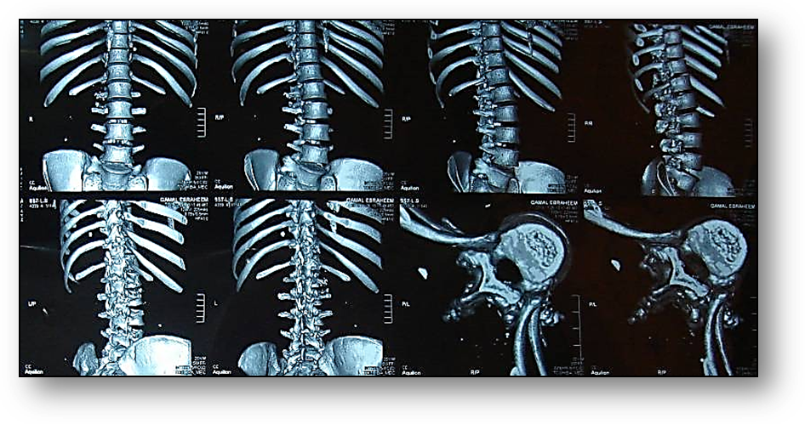
Figure (1)
CT- Scan of Vertebral Column
The projectile smashes the transverse and the spinous process of 9th and 10th dorsal vertebrae of the patient
(The yellow stars). However, the vertebral canal per se is free of any invasion nor direct penetration.

Physical examination showed a clear contradiction between the requirements of potential spine injury and the clinical reality. The absence of active movement with the absence of tendon reflexes (patellar reflex, ankle jerk reflex) as well as skin reflexes (such as cremasteric reflex) made the difference between the expected and the reality. The clinical examination imposes flaccid paraplegia whereas the logic of things suggested spastic paraplegia.

In front of low neuron injury, surgical intervention on Cauda Equina was decided. The target was to release any potential intra-dural sac fibrous adhesions. Adhesions might fix neural roots to each other, or fix each one to the corresponding inter-vertebral foramen.
The begin was by removing the posterior arch (i.e. laminectomy). Dural sac was incised longitudinally for 12 cm. Roots were inspected for any adhesions.
As preoperatively imagined, roots were only fixed at the level of inter-vertebral foramens. Only the quite exposed second and third lumbar roots were liberated from their adhesions. Because of technical reasons, the liberation of the other roots of Cauda Equina was postponed to second time; Figure (2).

Early results are promising. 2-month postoperatively, we find the return of some reflexes such as the cremasteric reflex (L2). The adductors muscles gained power (M3), the quadriceps femoris muscle (M2).

Discussion

Faced with this contradiction between the site of potential spine injury (D9- D10) suggesting spastic paraplegia, and the clinical picture imposing flaccid paraplegia, I assumed the presence of another damage; but at the level of Cauda Equina and/or conus medullaris.
I excluded any penetration injury to Cauda Equina for the absence of any breach of the spinal canal at this level. Thus, the only remaining mechanism to explain the damage was to suppose the presence of constricting adhesions blocking the roots of Cauda Equina.

Fibrosis can occur by one of two mechanisms; either bleeding inside the spinal canal, and is more likely, or as a result of trauma-induced inflammatory changes in cerebrospinal fluid. The induced inflammatory process, absorption of blood effusion, and the liquidation of the cerebrospinal fluid of turbid, randomly make up fibrosis in several places.
The random distribution of the fibrous adhesions may explain this great diversity in the spectrum of clinical symptoms. Fibrosis may be located within the dural sac embracing the roots to each other, or at the outlet of each root; Figure (2).
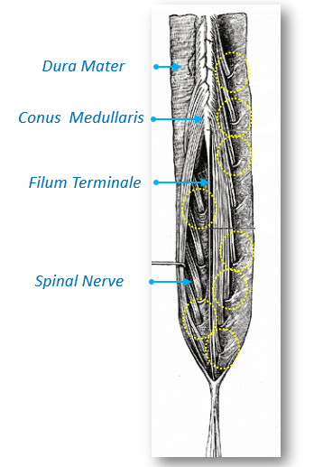
Figure (2)
Cauda Equina, Condemned Sites of Pathology
The Yellow Circles indicate the sites of fibrosis at the outlets of the roots.
The root traverses the inter-vertebral foramen with a narrow sleeve of dura mater.

Each root, with elongation of dura mater, traverse the space between two vertebrae. This passage is the most critical site in the path of the root. Minimal fibrosis or adhesion could block total action of the root; Figure (3).

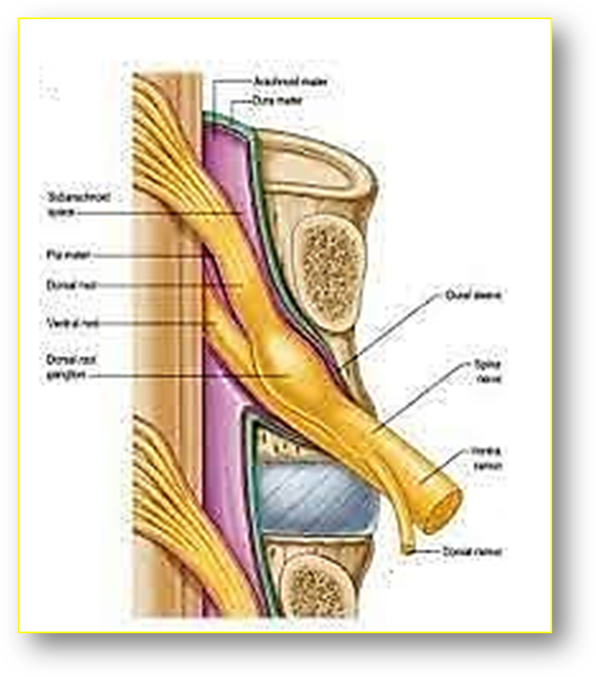 | 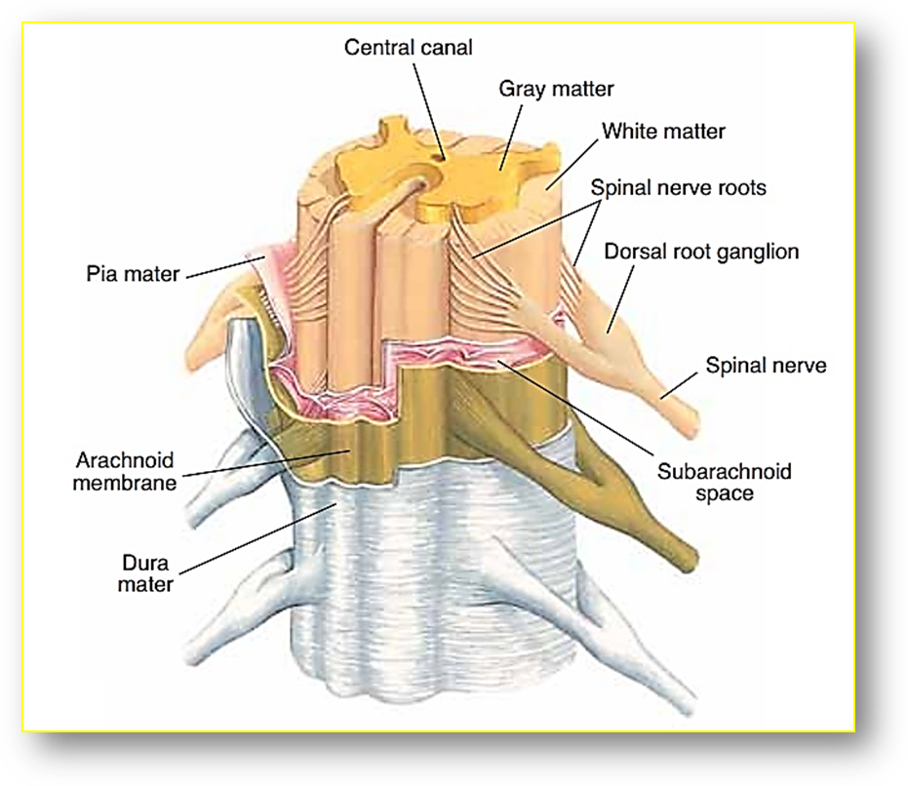
Figur (3- a) | Figure (3- b)
Figure (3)
Cauda Equina,
Meningeal Sleeve is the Risk Factor
Figure (3- a): The Red circle indicates the site of fibrosis concerned in this pathology.
Note the narrow dural sleeve enveloping the root when traversing the corresponding inter-vertebral foramen.
Figure (3- b): Each root leaves the dural sac with an elongation of both the dural mater and arachnoid membrane.
This elongation is the small meningeal sleeve, which in combination with the other sleeve of the second root, forms the bigger meningeal sleeve of the spinal nerve.
Traditionally, in the management of caudal injuries, therapists prefer monitor- strategy, which I do believe of its uselessness. Moreover, the surgical intervention, if done, is to raise the posterior arch of the vertebral column (laminectomy) +/- remove any protruding part of the inter-vertebral disc. Nobody has ever thought of exploring the outlet of roots in caudal injuries.

Indeed, liberating Cauda Equina roots requires extensive exposure of dural sac, at least at the level of the five lumbar and the first sacral vertebrae. After opening the dural sac, each root is followed from the origin to exit-port. Be sure of the continuity of each root (in case of penetrating traumatic injuries at this level), and of its liberty from any adhesion or fibrosis.

Finally, I will not refute the other points of view in this area. But I will strongly recommend surgical intervention in Cauda Equina injuries in the following cases:

- In every traumatic injury to the spine when we find some contradictory elements; such as reported in this case.
- In penetrating injury at this level; directly by the projectile itself or by some of its consequences (i.e. bony or metal sequestration into the vertebral column).
- In old caudal injuries, traditional strategy of treatment (laminectomy+/- removal of protruding inter-vertebral disc) does not suffice. It is recommended to explore the exit-port of Cauda Equina roots.

…………………………………………………………………………………………………...

In another context, one can also read:

 | Neural Conduction, Personal View vs. International View (Innovated)
 | Upper Motor Neuron Lesions, Pathophysiology of Symptomatology
 | Neural Conduction, Action Pressure Waves (Innovated)
 | Neural Conduction, Action Potentials (Innovated)
 | Neural Conduction, Action Electrical Currents (Innovated)
 | The Function of Action Potentials (Innovated)
 | The Three Phases of Neural Conduction (Innovated)
 | Neural Conduction in the Synapse (Innovated)
 | Sensory Receptors
 | Nodes of Ranvier, the Equalizers (Innovated)
 | Nodes of Ranvier, the Functions (Innovated)
 | Nodes of Ranvier, First Function (Innovated)
 | Nodes of Ranvier, Second Function (Innovated)
 | Nodes of Ranvier, Third Function (Innovated)
 | Node of Ranvier The Anatomy
 | The Philosophy of Pain, Pain Comes First! (Innovated)
 | The Philosophy of the Form (Innovated)
 | Spinal Injury, Pathophysiology of Spinal Shock, Pathophysiology of Hyperreflexia
 | Who Decides the Sex of Coming Baby?
 | Spinal Shock (Innovated)
 | The Clonus (Innovated)
 | Hyperactivity Hyperreflexia (Innovated)
 | Hyperreflexia, Extended Sector of Reflex
 | Hyperreflexia, Bilateral Responses
 | Hyperreflexia, Multiple Responses
 | Nerve Conduction Study, Wrong Hypothesis is the Origin of the Misinterpretation (Innovated)
 | Wallerian Degeneration (Innovated)
 | Neural Regeneration (Innovated)
 | Wallerian Degeneration Attacks Motor Axons, While Avoids Sensory Axons
 | Barr Body, the Whole Story (Innovated)
 | Boy or Girl, Mother Decides!
 | Adam's Rib and Adam's Apple, Two Faces of one Sin
 | The Black Hole is a (the) Falling Star?
 | Adam's Rib, could be the Original Sin?
 | Pronator Teres Syndrome, Struthers Like Ligament (Innovated)
 | Function of Standard Action Potentials & Currents
 | Posterior Interosseous Nerve Syndrome
 | Spinal Reflex, New Hypothesis of Physiology
 | Hyperreflexia, Innovated Pathophysiology
 | Clonus, 1st Hypothesis of Pathophysiology
 | Clonus, 2nd Hypothesis of Pathophysiology
 | Clonus, Two Hypotheses of Pathophysiology
 | Hyperreflexia (1), Pathophysiology of Hyperactivity
 | Hyperreflexia (2), Pathophysiology of bilateral Responses
 | Hyperreflexia (3), Pathophysiology of Extended Hyperreflex
 | Hyperreflexia (4), Pathophysiology of Multi-Response Hyperreflex
 | Barr Body, the Second Look
 | Mitosis in Animal Cell
 | Meiosis
 | Universe Creation, Hypothesis of Continuous Cosmic Nebula
 | Circulating Sweepers
 | Pneumatic Petrous, Bilateral Temporal Hyperpneumatization
 | Ulnar Nerve, Congenital Bilateral Dislocation
 | Oocytogenesis
 | Spermatogenesis
 | This Woman Can Only Give Birth to Female Children
 | This Woman Can Only Give Birth to Male Children
 | This Woman Can Give Birth to Female Children More Than to Male Children
 | This Woman Can Give Birth to Male Children More Than to Female Children
 | This Woman Can Equally Give Birth to Male Children & to Female Children
 | Piriformis Muscle Injection_ Personal Approach
 | Eve Saved Human's Identity, Adam Ensured Human's Adaptation
 | Corona Virus (Covid-19): After Humiliation, Is Targeting Our Genes
 | Claw Hand Deformity (Brand Operation)
 | Corona Virus (Covid-19): After Humiliation, Is Targeting Our Genes
 | Barr Body; Mystery of Origin & Ignorance of Function
The Multiple Sclerosis: The Causative Relationship Between
The Galvanic Current & Multiple Sclerosis?
Liver Hemangioma: Urgent Surgery of Giant Liver Hemangioma
Because of Intra-Tumor Bleeding
 | Cauda Equina Injury, New Surgical Approach

19/4/2014

