Free Fibula Flap for Bone Lost Complicated with Recalcitrant Osteomyelitis
Dr. Ammar Yaseen Mansour

A new clinical case is added to previous ones to document the importance of Vascularized Bone Flaps in reconstructing large bone defects, particularly those complicated with Osteomyelitis.
In vascularized bone flaps, the transferred bone segment can be large in size, adhering to the principle of demand. Furthermore, it has its own blood supply independent of the host bone's circulation. Its survival depends on the patency of the arterial anastomosis between the flap's artery and the host artery, not on the nutritional state of the host bone or its environment. These flaps are exceptionally resistant to infection. Moreover, they allow for larger quantities of antibiotics to reach the focus of the bone infection. I will elaborate on this last point.
The venous return from the transplanted bone flap drains mostly into the medullary cavity (bone marrow) of the host bone. This is, incidentally, a significant blood flow. The arterial inflow to the bone flap is substantial due to the importance of its nutrient artery, which has a diameter of 1.5-2 mm, on one hand, and the importance of the perfusion pressure in the host anterior tibial artery (in our case) on the other. The venous blood from the graft flap, saturated with antibiotics, washes the medullary cavity of the host bone as well as its surrounding environment. The significant role this plays in combating infection is evident to all; see Figures (1), (2), (3), (4).
Clinical Case
A 36-year-old male was injured by a gunshot projectile, which caused a fracture and significant bone loss in the bones of the leg: the fibula and the tibia. The loss was significant in the proximal third of the tibia. The fracture was complicated by osteomyelitis, which thwarted all attempts at bone reconstruction using traditional bone grafts.
In such a case, the only remaining management option is the Vascularized Bone Flap. It is known to work even under conditions of severe infection. This case provides the evidence and testimony to the validity of its renowned characteristics.

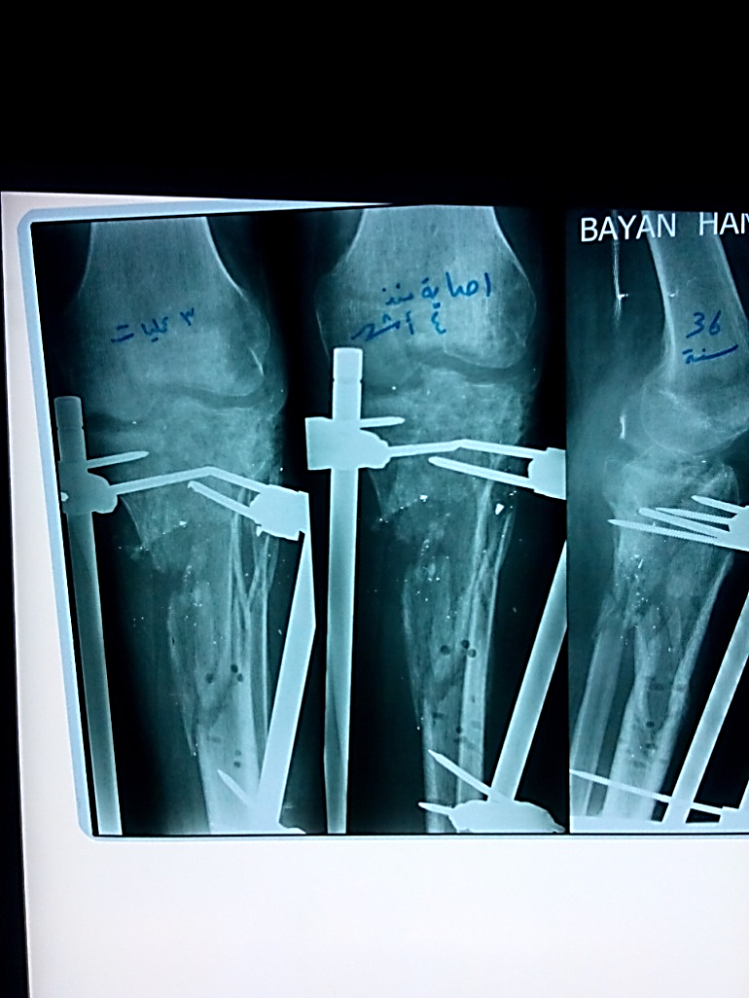
Figure (1): Pre-Operative X-Ray, Left Leg

The patient is a 36-year-old male who sustained a gunshot wound to the left leg.
The projectile caused a fracture in both bones of the leg (the tibia and fibula) in their proximal thirds. The tibia fracture was complicated by osteomyelitis. Multiple attempts at cleaning and debridement were performed. A tibia-to-tibia external fixator was placed to ensure stability.

During the most recent surgical exploration,
the tibia was found to be void of bone material at its proximal epiphysis and metaphysis, with only a narrow bony bridge connecting the two fracture segments.
The decision was made to use a vascularized fibula flap from the right leg to reconstruct the left tibia.
The procedure had two primary goals: first, to address the significant bone loss,
and second, to improve the conditions for combating the bone infection.
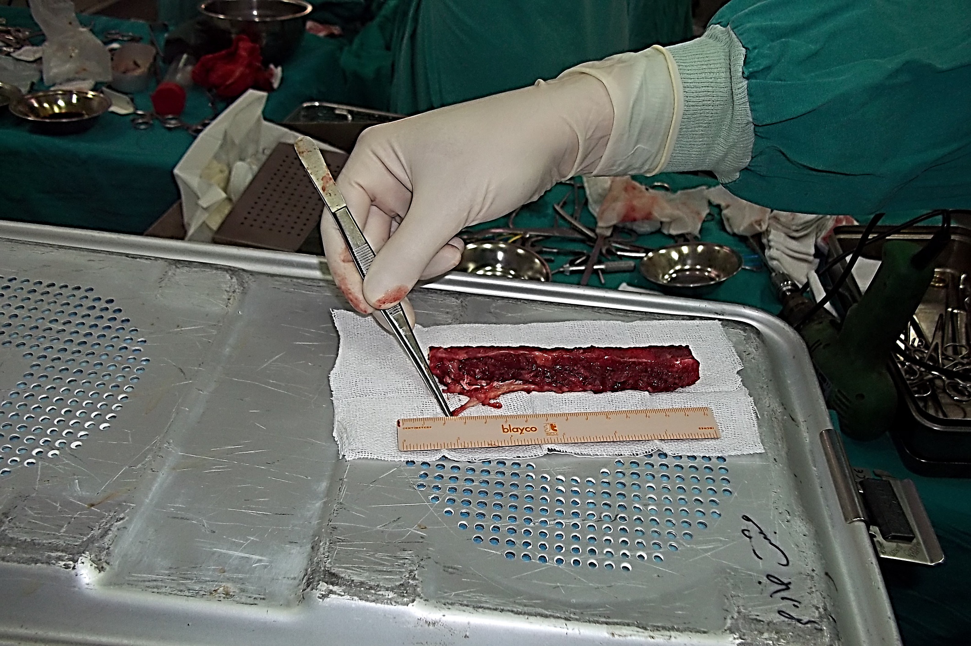
Muscle Cuff
Figure (2): The Vascularized Fibula Flap after Complete Harvesting-
Intraoperative Views
The surgeon's forceps are holding the nutrient artery supplying the bone flap.
The harvested bone segment is 13 cm in length. Meticulous care was taken to preserve a muscle cuff, 1-2 mm thick, along the entire length of the bone segment to protect the periosteal branches. To further enhance the flap's viability, the medullary branch (nutrient artery) originating from the peroneal artery was preserved. This medullary branch enters the fibula bone approximately at its midpoint, with a safe margin of 3 cm preserved in both directions along the bone.

Bone Flap
Vascular Pedicle
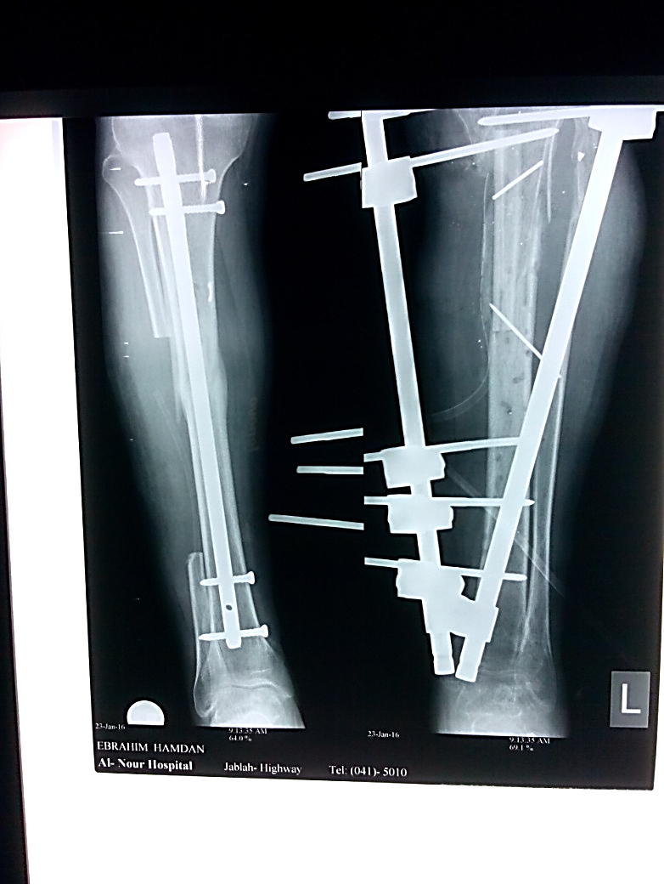
Fibula Flap
Tibia Bone
Figure (3): Post-Operative X-Ray, Left Leg

The vascularized fibula flap is shown in its final position. It is anchored by the host tibia at its proximal end and makes contact with the tibial bone substance at its distal end. The blood supply to the flap was successfully established via a microsurgical end-to-end anastomosis between the graft's fibular artery (peroneal artery) and the host's anterior tibial artery. To provide greater stability, two Kirschner wires were inserted, transfixing both the host tibia and the grafted fibula.

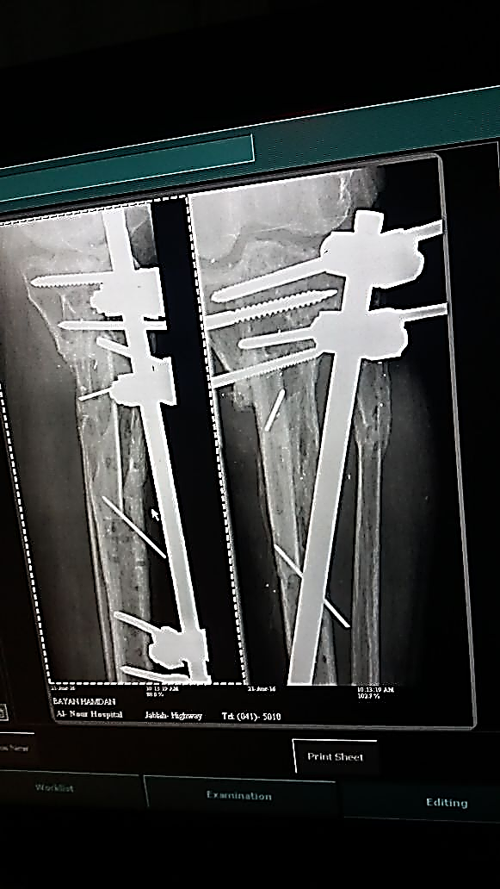
Fibula Flap
Tibia Bone
Figure (4): Post-Operative X-Ray, Left Leg

Summary of Findings:
This X-ray demonstrates a successful long-term outcome.
Key positive indicators include: Bony Union: Solid integration of the graft with the host bone. Periosteal Reaction: Active new bone formation, a sign of excellent graft viability. Graft Hypertrophy: The fibula has thickened in response to mechanical load, a process that will continue until it resembles the native tibia in size and strength.

…………………………………………………………………………………….
In other contexts, you can also read the following articles:
 | DOI | The Spinal Reflex, New Hypothesis of Physiology
 | - | The Hyperreflexia, Innovated Pathophysiology
 | DOI | The Spinal Shock
 | - | The Spinal Injury, the Pathophysiology of the Spinal Shock, the Pathophysiology of the Hyperreflexia
 | DOI | Upper Motor Neuron Lesions, the Pathophysiology of the Symptomatology
 | DOI | Hyperreflexia (1): Pathophysiology of Disproportionate Motor Response
 | DOI | Hyperreflexia (2): Pathophysiology of Bilateral-Response Hyperreflexia
 | DOI | Hyperreflexia (3): Pathophysiology of Extended Hyperreflexia
 | DOI | Hyperreflexia (4): Pathophysiology of Multi-Motor-Response Hyperreflexia
- | DOI | The pathophysiology of Triple flexion Reflex
 | DOI | The Clonus, 1st Hypothesis of Pathophysiology
 | DOI | The Clonus, 2nd Hypothesis of Pathophysiology
 | DOI | The Clonus, Two Hypotheses of Pathophysiology
 | DOI | The Nerve Transmission through Neural Fiber, Personal View vs. International View
 | - | The Nerve Transmission through Neural Fiber (1), The Action Pressure Waves
 | - | The Nerve Transmission through Neural Fiber (2), The Action Potentials
 | - | The Nerve Transmission through Neural Fiber (3), The Action Electrical Currents
 | - | The Function of Standard Action Potentials & Currents
 | - | The Three Phases of Nerve transmission
 | DOI | Neural Conduction in the Synapse (Innovated)
 | DOI | Nodes of Ranvier, the Equalizers
 | - | Nodes of Ranvier, the Functions
 | - | Nodes of Ranvier, First Function
 | - | Nodes of Ranvier, Second Function
 | - | Nodes of Ranvier, Third Function
 | - | Node of Ranvier, The Anatomy
 | DOI | Vesicular Dynamics: A Unifying Theory for Wallerian Degeneration and Neural Regeneration
 | - | The Wallerian Degeneration
 | - | The Neural Regeneration
 | DOI | Wallerian Degeneration: Affects Motor Axons while Sparing Sensory Axons
 | DOI | The Sensory Receptors
 | DOI | Electroneurography vs. Neural Reality: Hidden Fallacies in Nerve Conduction Studies
 | DOI | Piriformis Muscle Injection: Personal Approach
 | DOI | In Philosophy of Nerves: Pain First!
 | DOI | In Neurodoctrines: Form is Necessity!
 | DOI | Pronator Teres Syndrome, Struthers-Like Ligament
 | DOI | Ulnar Nerve, Congenital Bilateral Dislocation
 | - | Posterior Interosseous Nerve Syndrome
 | DOI | The Multiple Sclerosis: The Causative Relationship Between  The Galvanic Current & Multiple Sclerosis?
 | - | Cauda Equina Injury, New Surgical Approach
 | DOI | Carpal Tunnel Syndrome Ends Its Adherence: Complete Median Nerve Transection
 | DOI | Biceps Femoris' Long Head Syndrome (BFLHS)
 | DOI | Barr Body, The Whole Story (Innovated)
 | - | Adam's Rib and Adam's Apple, Two Faces of one Sin
 | - | Adam's Rib, could be the Original Sin?
 | - | Barr Body, the Second Look
 | DOI | Who Decides the Sex of Coming Baby?
 | - | Boy or Girl, Mother Decides!
 | - | Oocytogenesis
 | - | Spermatogenesis
 | - | This Woman Can Only Give Birth to Female Children
 | - | This Woman Can Only Give Birth to Male Children
 | - | This Woman Can Give Birth to Female Children More Than to Male Children
 | - | This Woman Can Give Birth to Male Children More Than to Female Children
 | - | This Woman Can Equally Give Birth to Male Children & to Female Children
 | - | Eve Saved Human Identity; Adam Ensured Human Adaptation
 | DOI | COVID-19: Beyond the Crisis—Is It Targeting Our Genes?
 | DOI | Fibromyalgia
 | - | Mitosis in Animal Cell
 | - | Meiosis
 | - | Universe Creation, Hypothesis of Continuous Cosmic Nebula
 | - | Circulating Sweepers
 | - | The Black Hole is a (the) Falling Star?
 | - | Pneumatic Petrous, Bilateral Temporal Hyperpneumatization
 | DOI | Congenital Bilateral Thenar Hypoplasia
 | DOI | Ulnar Dimelia, Mirror hand Deformity
 | DOI | Thumb Reconstruction Using Microvascular Second Toe to Thumb Transfer
 | DOI | Surgical Restoration of a Smile by Grafting a Segment of the Gracilis Muscle to the Face
 | DOI | Mandible Reconstruction Using Free Fibula Flap
 | DOI | Presacral Schwannoma
 | DOI | Liver Hemangioma: Urgent Surgery of Giant Liver Hemangioma  Due to Intra-Tumor Bleeding
 | DOI | Free Para Scapular Flap (FPSF) for Skin Reconstruction
 | DOI | Claw Hand Deformity (Brand Operation)
 | DOI | Algodystrophy Syndrome Complicated by Constricting Ring at the Proximal Border of the Edema
 | DOI | Non- Traumatic Non- Embolic Acute Thrombosis of Radial Artery (Buerger’s Disease)
 | DOI | Isolated Axillary Tuberculosis Lymphadenitis
 | DOI | The Iliopsoas Tendonitis... The Snapping Hip
- | DOI | Peri- Menopausal Breast Lesions: Towards a More Decisive Approach
 | To read the article in Arabic, click on
 | DOI | The New Frankenstein Monster
 | DOI | The Lone Wolf
 | DOI | The Delirium of Night and Day
 | DOI | The Delirium of the Economy
 | DOI | Ovaries in a Secure Corner… Testicles in a Humble Sac:  An Inquiry into the Function of Form
 | DOI | Eve Preserves Humanity’s Blueprint; Adam Drives Its Evolution
 | DOI | The Manufacture of the Unconscious
 | DOI | The Ballad of Eternity
 | DOI | Two Truths Woman Would Never Accept
 | DOI | The 'Iddah (Waiting Period) in Islamic Law: A Comparative Analysis of its Rationale for Divorced Women and Widows
 | DOI | The IVF/ICSI-Conceived Child: A Biologically Suboptimal Outcome
 | DOI | Nature's Relentless Couriers
 | DOI | The Triad of Intelligence... A Traveler's Provisions!
 | DOI | Zero-Value Equations: Modernity’s Hidden Costs and False Promises
 | DOI | The Dialectic of Meaning and Meaninglessness
 | DOI | Societal Schizophrenia: The Delirium of Our Time
 | DOI | The Rational Mind and the Abstract Mind
 | DOI | The Electric Lamp: Between Abstraction and Application - A Journey of a Thousand Years!
 | DOI | Thus spoke Abraham, the Friend: The Eternal... and the Ephemeral
 | DOI | The Crisis of an Intellectual Who Lost His Identity Under Piles of the Read and the Heard
 | DOI | Polygamy and Right-Hand Possession
 | DOI | Quranic Revelations

23/09/2025

