Dr. Ammar Yaseen Mansour

The Nodes of Ranvier: The Equalizers
A Study on Function and Functional Anatomy

Note: The Arabic version of this article is the authoritative reference. Read it here:
عقدةُ رانفييه ضابطةُ الإيقاعِ.. بحثٌ في الوظيفةِ والتَّشريحِ الوظيفيِّ

Introduction
There is no doubt that neural transmission in myelinated fibers has gained speed and efficiency—firstly due to the myelin sheath, and secondly due to the remarkable structure known as the Node of Ranvier. The myelin sheath’s significance was detailed in a previous article. As for the Node of Ranvier, here is an analysis of its role from a purely personal perspective.
In descriptive anatomy, key structural features of the Node of Ranvier grant it its unique function and exceptional properties:
- The myelin sheath is absent at the Node of Ranvier.
- The neural fiber’s diameter narrows significantly, reaching 30–40% of its value outside the node.
- Its cellular membrane is densely populated with sodium ion (Na⁺) channels.
- Internally, it contains abundant microtubules and microfilaments.
In functional anatomy, I propose three roles for the Node of Ranvier:
- Rhythm regulator: It ensures the proper functioning of Action Pressure Waves by monitoring their trajectory.
- Amplitude modulator: It adjusts their intensity.
- Propagation enhancer: It boosts their speed by organizing molecular components within the transmission medium.
The interplay between form and function defines functional anatomy, and this is where my focus lies. This work attempts to leverage ultraprecise anatomical insights into neural fibers—particularly the Nodes of Ranvier—through the lens of my novel hypothesis on neural transmission (see Figure 1).

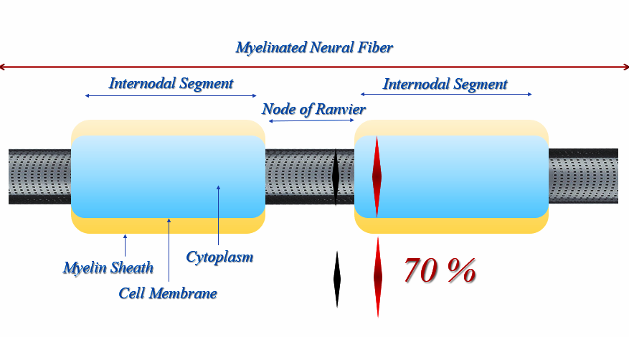
Figure (1)
The Node of Ranvier

For a detailed exploration of the functional anatomy of the Node of Ranvier, watch the video at the following link:
Key Features:
- Unmyelinated Regions: The Nodes of Ranvier are segments of the neural fiber devoid of the myelin sheath.
- Regular Distribution: They are spaced at consistent intervals along the myelinated neural fiber.
- Internodal Segments: The sections between two nodes are fully covered by the myelin sheath.
- Structural Composition:
  - Abundant Sodium Ion (Na⁺) Channels: Represented as "black holes" in the illustration.
  - High Density of Microtubules and Microfilaments: These cytoskeletal elements (not visible in the drawing) are densely packed within the node.
  - Reduced Diameter: The neural fiber’s diameter narrows markedly at the node, reaching 30–40% of its diameter outside the node.
Objective of This Study:
This research seeks to elucidate the functional rationale behind three key characteristics of the Node of Ranvier:
- The abundance of Na⁺ channels,
- The prominence of microtubules and microfilaments,
- The significant reduction in fiber diameter.

Function (1): Regulating the Parameters of Action Pressure Waves
Living organisms have standardized the specifications of action pressure waves within their neural fibers. Each fiber is optimized for specific wave characteristics, defined by three interdependent parameters: wavelength, amplitude, and speed. These parameters are dynamically interactive—controlling one inherently influences the others. To manage this complexity, biological systems prioritize regulating wave amplitude, as it is both the most accessible to modulate and exerts definitive control over the other parameters.
The Nodes of Ranvier act as mandatory checkpoints for action pressure waves. The cross-sectional area of these nodes determines the wave’s amplitude and width, which subsequently dictate its wavelength. For instance, if a wave’s parameters deviate excessively (e.g., due to amplification or distortion) along its pathway, its passage through the next Node of Ranvier will forcibly restore its parameters to standardized levels. Even if errors recur repeatedly, the nodes—strategically spaced along the fiber—ensure rapid, inevitable correction. In this way, the Nodes of Ranvier perpetually monitor and calibrate waves, maintaining them within The Standards (see Figure 2).

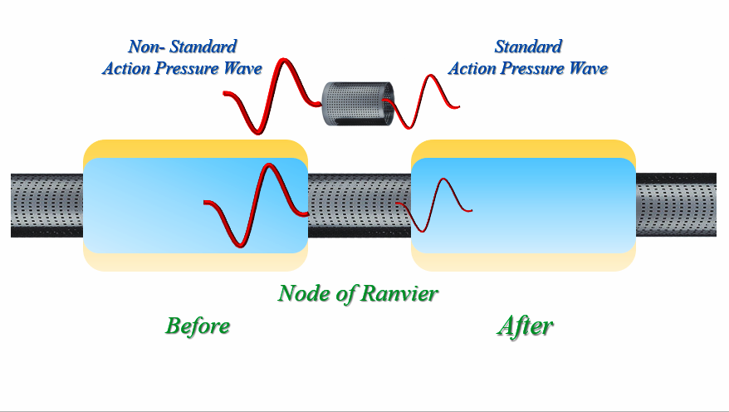
Figure (2)
Function (1): Controlling the Parameters of Action Pressure Waves
To watch a short video explaining how the Node of Ranvier regulates action pressure wave parameters, click on this link:

Scenario:
Suppose an action pressure wave exceeds its permitted parameters—extending its wavelength, overamplifying its energy load, and threatening both the organism’s structural integrity and the target organ’s function.
Biological Safeguards:
Anticipating such disruptions, the organism preemptively engineered the Nodes of Ranvier as rhythm regulators along the neural axon. These nodes act as quality control checkpoints, ensuring waves adhere to standardized speed and energy thresholds.
Mechanism of Correction:
- Deviant Wave Detection: A wave that becomes "rebellious" (e.g., trajectory distortion or excessive amplitude) is forced through the nearest Node of Ranvier.
- Parameter Reset: The node’s structural properties—narrow diameter, sodium channel density, and cytoskeletal organization—restore the wave’s amplitude, wavelength, and speed to safe, functional levels.
- Continuous Monitoring: This corrective process repeats at every node along the axon, culminating at the synaptic terminal.
Visual Comparison:
- Before Correction: A distorted, non-standard Action Pressure Wave in a segment of the axon.
- After Correction: A harmonized standard Action Pressure Wave that aligns with neural transmission requirements and safeguards axonal tissue.
Outcome:
Post-node passage, the action pressure wave regains:
- Functional Harmony: Parameters optimized for efficient signal transmission.
- Tissue Safety: Compliance with structural limits to prevent axonal damage.

Function (2): Regulating the Trajectory of Action Pressure Waves
Like all longitudinal waves, action pressure waves propagate through a tubular section of the transmission medium—not the entire medium, as one might assume. This propagation tube, or wave trajectory, is a functional construct that exists only during the wave’s propagation. Despite its transient nature, it is a measurable, real entity.
Precision in Pathway Design
Biological systems meticulously map the trajectory of action pressure waves within neural fibers:
- Motor Neurons:
  - The trajectory begins at the axon hillock and terminates at the presynaptic knob.
  - The pathway is centrally suspended within the axon and stabilized by anchors—the Nodes of Ranvier.
- Sensory Neurons:
  - The trajectory starts at a sensory receptor and ends at a central synapse.
  - The anchoring role of Nodes of Ranvier remains identical.
Protective Mechanisms
To safeguard axonal components, the organism ensures minimal contact between the wave and neural structures:
- Cell Membrane Avoidance:
  - The cell membrane maintains a safe distance from the wave’s trajectory, except at Nodes of Ranvier, where necessity dictates controlled interaction.
  - A buffer zone of non-active cytoplasm separates the wave’s path from the membrane.
- Role of Non-Active Cytoplasm:
  - While not directly involved in wave propagation, this cytoplasm:
    - Counteracts the negative pressure (trough) of the wave, shielding the membrane from collapsing forces.
    - Absorbs excess compressive energy from the wave’s crest, redirecting residual force to Schwann cells and their product, the myelin sheath (see Figure 3).

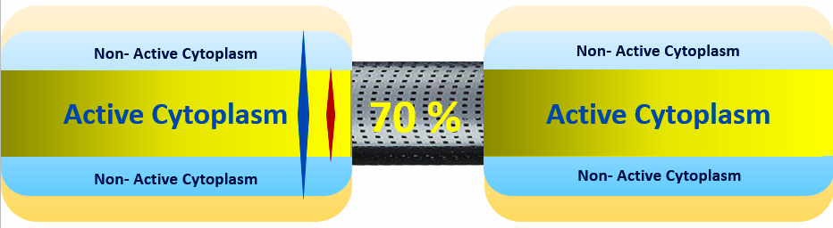
Myelin Sheath
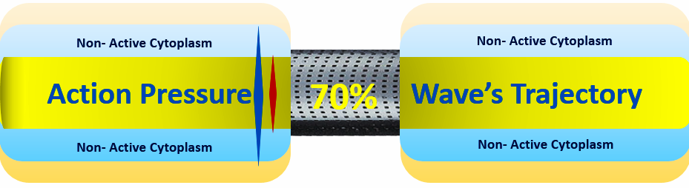
Myelin Sheath
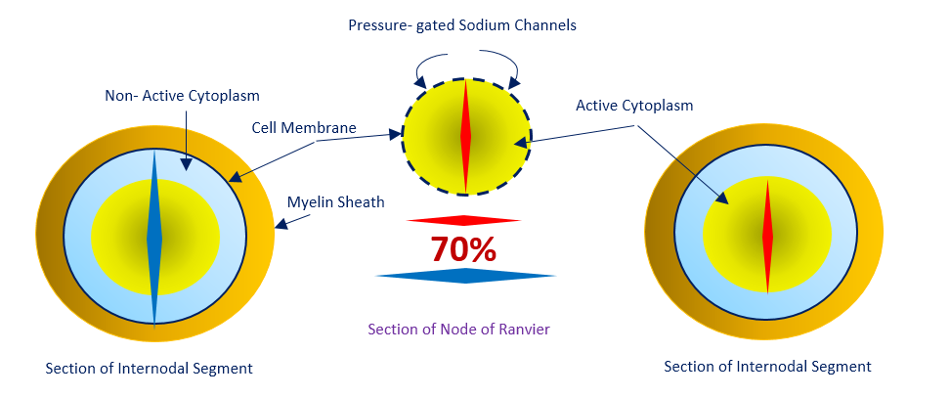
ـ Figure (3)
Functional Anatomy of the Node of Ranvier

Key Structural and Functional Insights:
- Wave Propagation Pathway:
  - Action pressure waves travel through a central tubular tract within the neural fiber’s active cytoplasm.
  - This tract functionally and physically represents the wave’s trajectory.
- Internodal Segment Protection:
  - Between Nodes of Ranvier, the propagation tract is surrounded by a layer of non-active cytoplasm.
  - Role of Non-Active Cytoplasm:
    - Shields the axon’s cell membrane from the collapsing forces of the wave’s trough (negative pressure).
    - Partially absorbs the kinetic energy of the wave’s crest (compressive forces), diverting excess energy to the myelin sheath (produced by Schwann cells).
- Node of Ranvier’s Specialized Structure:
  - Direct Membrane-Wave Interaction:
    - To generate standardized action potentials and ionic currents, the node facilitates direct contact between the wave and the cell membrane.
  - Structural Adaptations:
    - The neural fiber’s diameter narrows by 30–40%, eliminating the non-active cytoplasm buffer.
    - The membrane, densely packed with pressure-gated sodium (Na⁺) channels, moves into direct proximity with the wave.

Mechanistic Summary:
- At Internodal Regions:
  - The myelin sheath absorbs most of the wave’s crest energy, while non-active cytoplasm mitigates trough-induced collapse.
- At Nodes of Ranvier:
  - Structural narrowing and membrane-channel density enable precise electrophysiological activity, ensuring wave parameters align with neural transmission standards.

Hypothetical Scenario: A Rebellious Wave
Suppose an action pressure wave rebels, abandoning its designated trajectory and exploiting the entire internal medium of an internodal segment. It encroaches upon the axonal cell membrane, posing an imminent threat to the organism while dissipating significant energy.
Biological Response:
The organism categorically rejects such aberrations. The Nodes of Ranvier stand guard, intercepting the deviant wave. No aberrant wave can traverse a node without being compelled to:
- Modify Its Behavior: Adjusting its trajectory and energy profile.
- Reassume Compliance: Returning to its prescribed pathway and standardized parameters.
Outcome:
Upon exiting the node—and every subsequent node—the wave emerges calibrated:
- Defined Trajectory: Confined to the central tubular tract.
- Regulated Parameters: Amplitude, wavelength, and speed restored to safe thresholds.
Deterrent Effect:
The wave is acutely aware that identical nodes await it along its entire propagation path (see Figure 4). This inevitability of correction ensures perpetual adherence to biological norms.

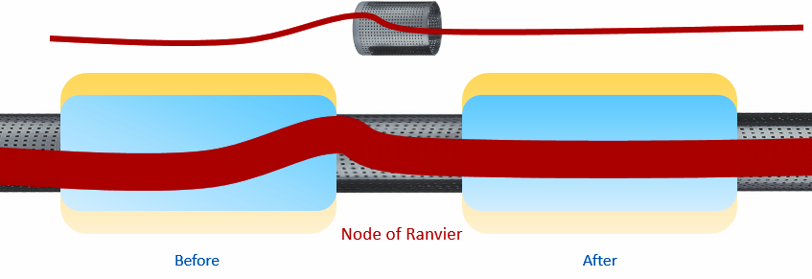
A
Standard Wave's Trajectory
Non- Standard Wave's Trajectory
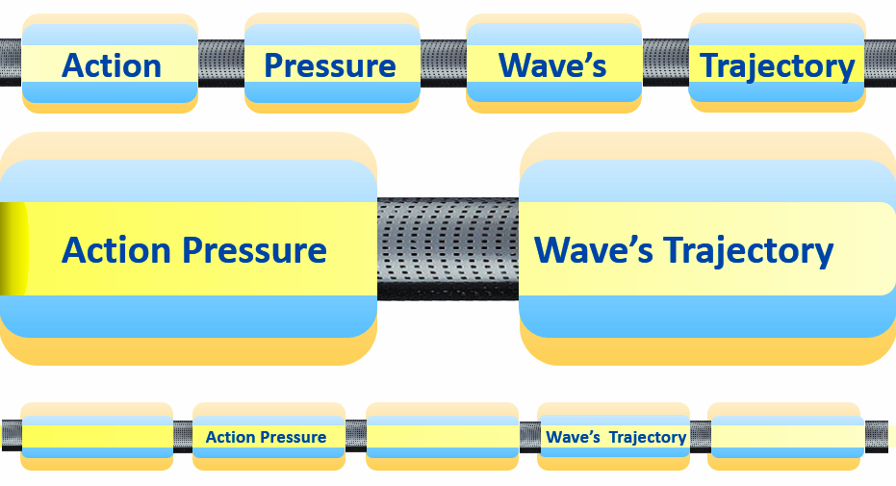
B
Figure (4)
Function (2): Regulating the Trajectory of Action Pressure Waves
To watch a short film detailing how Nodes of Ranvier regulate wave trajectories,
click on this link:

Key Mechanisms:
Figure A:
- Correcting Deviations: If the action pressure wave deviates from its path, the Node of Ranvier forcibly redirects it back to the central axis of the neural fiber.
- Outcome: The wave’s trajectory is recalibrated to its designated pathway.
Figure B:
- Architectural Analogy: Nodes of Ranvier act like bridge pillars, collectively suspending the wave’s trajectory within the neural fiber’s core.
- Structural Role: These nodes function as anchors and stabilizers, creating a nested tubular structure—the wave’s pathway appears as "a tube floating within the center of another tube."

Function (3): Optimizing the Trajectory of Action Pressure Waves
Mechanistic Overview:
- Wave Composition:
  - Action pressure waves are longitudinal waves comprising:
    - Compression (Crest): Positive pressure front.
    - Rarefaction (Trough): Negative pressure tail.
  - These propagate along the axon’s entire length, equivalent to the wave’s trajectory.
- Optimization Challenge:
  - Neural pathways can be extremely long, necessitating mechanisms to streamline wave propagation and minimize energy loss.
- Nodes of Ranvier as Catalysts:
  - At nodes, the wave’s negative pressure tail triggers pressure-gated sodium (Na⁺) channels to open, drawing Na⁺ ions into the cell.
  - These ions impart a positive charge to the trough, contrasting with the axon’s inherently negative intracellular environment (due to plasma proteins and other anions).
- Electrophysiological Cascade:
  - A voltage gradient forms between the positively charged trough and the negatively charged cytoplasm.
  - This generates:
    - Standard Action Potentials: Localized voltage spikes.
    - Standard Electrical Currents: Sequential, unidirectional ionic flows.
- Segmental Pathway Construction:
  - Each action potential and its current optimize a single internodal segment:
    - They reorganize cytoplasmic elements, increasing pathway density and homogeneity.
    - Cumulative segmental refinements create a seamless, high-efficiency trajectory for the wave.
- Functional Outcome:
  - Enhanced Speed: Reduced resistance in the optimized pathway.
  - Energy Conservation: Minimized dissipation through precise ionic regulation.
Key Analogies & Metaphors:
- “Paving the Path”: Action potentials act as molecular pavers, aligning cytoplasmic components to create a smooth “road” for the wave.
To watch a film explaining how standard action potentials and their currents enhance wave trajectory efficiency, click on this link:
- “Self-Erasure”: Each action potential ceases once the next begins, ensuring sequential, non-overlapping optimization.
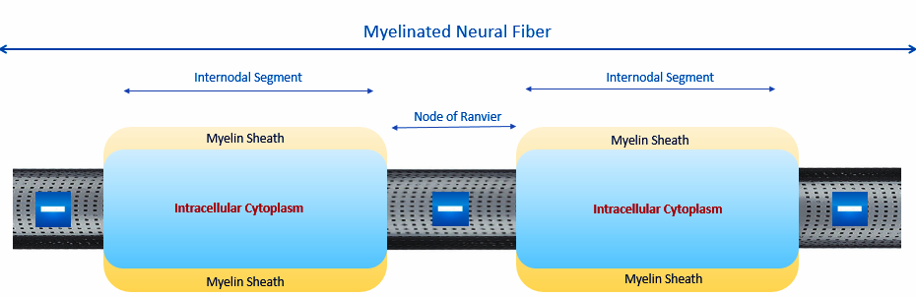
The Action Pressure Wave
Crest
Na⁺

⁼
Standard Action Potential
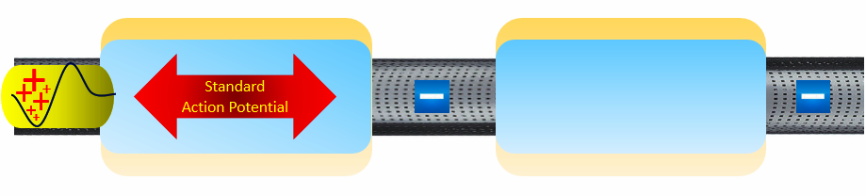
Previous Standard Action
Potential in the Fading Phase
Trough
The New
Standard Action Potential

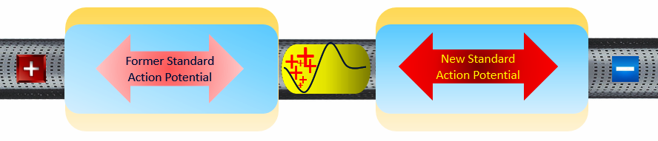
Previous Decreasing-Value Positive Polarity
Inherent Negative Polarity

) Proteins)
New Positive Polarity

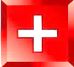
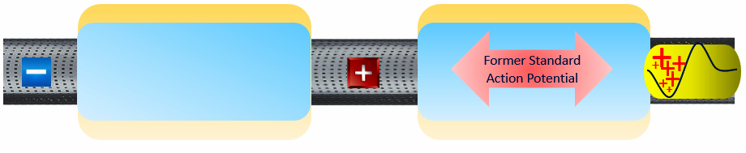
Previous Decreasing-Value
Positive Polarity
Return to Negative Polarity

) Proteins)
New Positive Polarity
Figure (5)
Function (3): Regeneration of the Standard Action Potential & the Standard Electrical Current
To watch a short film explaining how the Node of Ranvier generates the standard action potential, click on this link:

Mechanism of Action Potential Generation
- Triggering Sodium Influx:
  - When an action pressure wave reaches the Node of Ranvier, the negative pressure of the wave’s trough (rarefaction phase) opens pressure-gated sodium (Na⁺) channels.
  - This allows an influx of Na⁺ ions into the intracellular space of the node.
- Polarity Shift:
  - The accumulation of Na⁺ ions charges the node’s intracellular environment with positive polarity.
  - This contrasts with the axon’s inherent negative polarity, maintained by negatively charged plasma proteins and other anions.
- Electrochemical Gradient Formation:
  - The opposition of positive polarity (from Na⁺ influx) and negative polarity (baseline intracellular charge) creates a voltage gradient.
  - This gradient drives the generation of the standard action potential and its associated standard electrical current.

Key Outcomes:
- Standard Action Potential: A localized, transient depolarization event critical for signal propagation.
- Standard Electrical Current: A unidirectional ionic flow that reinforces wave efficiency and speed.

Functional Anatomy of the Node of Ranvier
Key Structural and Functional Adaptations
- Myelin Sheath Absence:
  - The axon sheds its myelin sheath at the Node of Ranvier (1), enabling direct interaction between the action pressure wave and the cell membrane. Actually, the absence of myelin at Nodes of Ranvier facilitates:
  - Direct extracellular interaction: The wave’s trough (negative pressure) directly mobilizes extracellular Na⁺ ions, unimpeded by myelin.
  - Membrane dynamics: The high-pressure front transiently displaces the membrane outward, while elastic recoil restores its position—a cycle critical for wave reinforcement.
- Sodium Channel Density:
  - The node is densely packed with pressure-gated sodium (Na⁺) channels (2), critical for ion exchange.
- Axonal Narrowing:
  - The neural fiber’s diameter narrows by 30–40% at the node (3). The constricted diameter of the nerve fiber at Nodes of Ranvier serves four critical functions in this mechanoelectrical conduction model:
a) Enforced Central Pathway:
  - The narrowed diameter creates a mandatory narrow conduit at the nerve fiber’s core.
  - Forces the Action Pressure Wave to propagate centrally, minimizing lateral deviations.
  - Any trajectory drift is corrected by subsequent nodes, ensuring wave fidelity.
b) Wave Parameter Modulation:
  - The diameter constriction imposes height restrictions on the Action Pressure Wave:
    - A wave exceeding the nodal height threshold must reduce its amplitude to traverse the node.
    - Amplitude reduction alters the wave’s wavelength, energy, and velocity, standardizing these parameters to physiological norms.
c) Direct Mechanoelectrical Interface:
  - The reduced diameter eliminates peripheral non-active cytoplasm, ensuring direct contact between the Action Pressure Wave and the nodal membrane.
  - This allows the wave’s trough (negative pressure) to exert unmediated effects on:
    - Pressure-gated Na⁺ channel gates (opening them).
    - Extracellular Na⁺ ions (drawing them into the axoplasm).
d) Membrane Elastic Rebound & Pressure Reinforcement:
  - The high-pressure front of the wave transiently expands the nodal membrane outward.
  - The membrane’s elastic recoil (supported by microtubules/microfilaments) generates two synergistic effects:
    - Pressure amplification: Recoil force intensifies intracellular pressure, boosting wave propagation.
    - Structural stabilization: Prevents permanent membrane deformation despite repeated mechanical stress.

- Cytoskeletal Reinforcement:
  - A dense network of microtubules and microfilaments (4) lines the inner membrane, serving dual roles:
    - Protection: Shields the membrane from mechanical stress caused by wave compression (crest) and rarefaction (trough).
    - Permeability: Facilitates free ion exchange with the extracellular environment.
Why Not Use Myelin at Nodes?
Q: Why doesn’t the organism deploy Schwann cells and their myelin sheath to protect the node’s membrane?
A:
- The myelin sheath, while robust, is impermeable—blocking Na⁺ channels essential for generating action potentials.
- Myelin effectively absorbs compressive forces (wave crests) but fails to counteract the destructive suction forces of the trough.
Mechanism of Pressure-Gated Na⁺ Channels (Figure 6)
- Gate Structure:
  - Centralized inner gates are anchored near the channel’s wave-facing side.
- Operation:
  - Crest Passage: High-pressure wave fronts (crests) bend the gates inward, closing the channels.
  - Trough Passage: The trailing negative pressure (trough) pulls the gates open, siphoning Na⁺ ions into the cell.
- Outcome:
  - Sequential Na⁺ influx regenerates standard action potentials and electrical currents, perpetuating signal propagation.

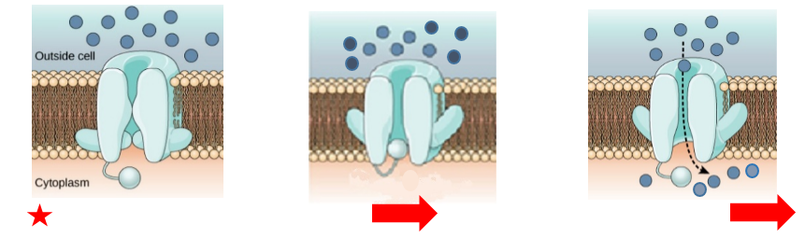
C
B
A

Figure (6)
Pressure-Gated Sodium (Na⁺) Channels

Part (A): Structural Anatomy
- Gate Composition: A polypeptide complex protrudes into the axon’s cytoplasmic lumen, anchored to the channel wall closest to the neuron’s soma (denoted by a red star in motor neurons).
- Ionic Distribution: Sodium ions (Na⁺, blue circles) are densely concentrated in the extracellular space.
- Resting State: At rest, baseline pressure (resting pressure) keeps the gates closed, preventing ion leakage.

Part (B): Channel Closure During Wave Crest
- Crest Passage: As the high-pressure crest (red arrow) of the action pressure wave reaches the channel:
  - The elevated pressure forces the gate to bend toward the channel wall.
  - Result: The channel closes, blocking Na⁺ influx.

Part (C): Channel Opening During Wave Trough
- Trough Passage: Following the crest, the negative pressure of the wave’s trough (rarefaction phase) exerts suction:
  - The gate is pulled inward, opening the channel.
  - Na⁺ ions flow into the cytoplasm (black dotted arrow), generating a localized positive polarity critical for action potential initiation.

Functional Significance
- Dynamic Regulation: Pressure-gated channels respond to mechanical forces (crest/trough) rather than voltage, enabling rapid, localized ion flux.
- Wave-Phase Coordination: Ensures Na⁺ influx occurs only during the trough, synchronizing electrical activity with mechanical wave propagation.

The Node of Ranvier, the Equalizer
To further explore the three functions of Nodes of Ranvier, watch this video:
Key Insights
- Speed and Precision of Neural Transmission:
  - Action pressure waves propagate rapidly through the axon, with neural transmission occurring countless times.
  - Even minor deviations in a wave’s parameters (amplitude, wavelength, speed) or trajectory could lead to catastrophic consequences for the organism, threatening both functional outcomes and anatomical integrity.
- Biological Safeguards:
  - The organism employs rigorous quality control mechanisms, delegating responsibility to the Nodes of Ranvier to regulate wave parameters and trajectory.
  - The optimal pathway for wave propagation is envisioned as a suspended tubular tract within the axon’s cytoplasm, anchored centrally by the Nodes of Ranvier.
- Role as Accelerators:
  - Each Node of Ranvier optimizes its segment of the pathway by:
    - Aligning cytoplasmic elements to streamline wave propagation.
    - "Paving the road" for the action pressure wave, minimizing energy loss.
  - This efficiency is achieved through standard action potentials and their electrical currents, which enhance speed and precision.

Critical Note
To learn more about my hypothesis on neural transmission, read my article:
"Neural Conduction in Neural Fibers: Personal vs. International Perspectives"
……………………………………………………………………………………………….
In other contexts, you can also read the following articles:
The Spinal Reflex, New Hypothesis of Physiology
The Hyperreflexia, Innovated Pathophysiology
The Spinal Shock
The Spinal Injury, the Pathophysiology of the Spinal Shock, the Pathophysiology of the Hyperreflexia
Upper Motor Neuron Lesions, the Pathophysiology of the Symptomatology
The Hyperreflexia (1), the Pathophysiology of Hyperactivity
The Hyperreflexia (2), the Pathophysiology of Bilateral Responses
The Hyperreflexia (3), the Pathophysiology of Extended Hyperreflex
The Hyperreflexia (4), the Pathophysiology of Multi-Response Hyperreflex
The Clonus, 1st Hypothesis of Pathophysiology
The Clonus, 2nd Hypothesis of Pathophysiology
The Clonus, Two Hypotheses of Pathophysiology
The Nerve Transmission through Neural Fiber, Personal View vs. International View
The Nerve Transmission through Neural Fiber (1), The Action Pressure Waves
The Nerve Transmission through Neural Fiber (2), The Action Potentials
The Nerve Transmission through Neural Fiber (3), The Action Electrical Currents
The Function of Standard Action Potentials & Currents
The Three Phases of Nerve transmission
Neural Conduction in the Synapse (Innovated)
Nodes of Ranvier, the Equalizers
Nodes of Ranvier, the Functions
Nodes of Ranvier, First Function
Nodes of Ranvier, Second Function
Nodes of Ranvier, Third Function
Node of Ranvier, The Anatomy
The Wallerian Degeneration
The Neural Regeneration
The Wallerian Degeneration Attacks Motor Axons, While Avoids Sensory Axons
The Sensory Receptors
Nerve Conduction Study, Wrong Hypothesis is the Origin of the Misinterpretation (Innovated)
Piriformis Muscle Injection_ Personal Approach
The Philosophy of Pain, Pain Comes First! (Innovated)
The Philosophy of the Form (Innovated)
Pronator Teres Syndrome, Struthers-Like Ligament (Innovated)
Ulnar Nerve, Congenital Bilateral Dislocation
Posterior Interosseous Nerve Syndrome
The Multiple Sclerosis: The Causative Relationship Between
The Galvanic Current & Multiple Sclerosis?
Cauda Equina Injury, New Surgical Approach
Carpal Tunnel Syndrome Complicated by Complete Rupture of Median Nerve
Biceps Femoris' Long Head Syndrome (BFLHS)
Barr Body, The Whole Story (Innovated)
Adam's Rib and Adam's Apple, Two Faces of one Sin
Adam's Rib, could be the Original Sin?
Barr Body, the Second Look
Who Decides the Sex of Coming Baby?
Boy or Girl, Mother Decides!
Oocytogenesis
Spermatogenesis
This Woman Can Only Give Birth to Female Children
This Woman Can Only Give Birth to Male Children
This Woman Can Give Birth to Female Children More Than to Male Children
This Woman Can Give Birth to Male Children More Than to Female Children
This Woman Can Equally Give Birth to Male Children & to Female Children
Eve Saved Human Identity; Adam Ensured Human Adaptation
Coronavirus (Covid-19): After Humiliation, Is Targeting Our Genes
Coronavirus (Covid-19): After Humiliation, Is Targeting Our Genes
The Black Hole is a (the) Falling Star?
Mitosis in Animal Cell
Meiosis
Universe Creation, Hypothesis of Continuous Cosmic Nebula
Circulating Sweepers
Pneumatic Petrous, Bilateral Temporal Hyperpneumatization
Congenital Bilateral Thenar Hypoplasia
Ulnar Dimelia, Mirror hand Deformity
Surgical Restoration of a Smile by Grafting a Segment of the Gracilis Muscle to the Face
Mandible Reconstruction Using Free Fibula Flap
Presacral Schwannoma
Liver Hemangioma: Urgent Surgery of Giant Liver Hemangioma
Due to Intra-Tumor Bleeding
Free Para Scapular Flap (FPSF) for Skin Reconstruction
Claw Hand Deformity (Brand Operation)
Algodystrophy Syndrome Complicated by Constricting Ring at the Proximal Border of the Edema
Non- Traumatic Non- Embolic Acute Thrombosis of Radial Artery
(Buerger’s Disease)
Isolated Axillary Tuberculosis Lymphadenitis
The Iliopsoas Tendonitis... The Snapping Hip
To read the article in Arabic, click on
The New Frankenstein Monster
The Lone Wolf
The Delirium of Night and Day
The Delirium of the Economy
Ovaries in a Secure Corner… Testicles in a Humble Sac:
An Inquiry into the Function of Form
Eve Preserves Humanity’s Blueprint; Adam Drives Its Evolution

07/08/2018

