Dr. Ammar Yaseen Mansour
The Extended Hyperreflexia
The Pathophysiology of Extended Hyperreflexia
To watch a short video explaining in detail the pathological mechanism of the extended spinal hyperreflexia, click on this link:

Under normal conditions, where the brain is dominant over all sensory afferent input as well as all motor efferent output, each spinal reflex maintains its own specific and independent circuit, separate from others. Stimulating the receptive field of a specific spinal reflex triggers a motor response unique to that reflex. It is a single, non-repetitive response, specific to the reflex being studied, with controlled intensity and force, and on the same side where the stimulation occurred.
In contrast, in upper motor neuron (UMN) injuries, the brain becomes functionally absent, and things spiral out of the control of its regulatory influences. At this point, the interneurons become active to fill the functional void. They activate old, dormant neural pathways from early childhood, and/or work on forming new neural pathways that did not exist before.
On one hand, they connect sensory neurons and motor neurons within the same side of their residing spinal cord segment (e.g., segment X). On the other hand, they extend their connections further, incorporating an additional set of active interneurons and sensory neurons from the neighboring spinal segments (segment X+1 and/or segment X-1). The result is the addition of an increased number of sensory neurons along with their associated sensory receptors into the circuit of the exaggerated spinal reflex specific to spinal segment X (according to our previous example).
Consequently, the resulting circuit of the spinal hyperreflexia expands its sector of work. It recruits and employs an additional number of sensory receptors to serve its reflex. Consequently, stimulating just one of these receptors—whether the original or a newly recruited one—is sufficient to trigger the entire circuit of the exaggerated spinal reflex. This is precisely the meaning of the concept of the "extended reflex arc" of the hyperactive reflex (Extended Hyperreflexia); see the figure below.
For example, in healthy individuals, tapping the patellar tendon triggers the knee jerk reflex. However, in a state of hyperreflexia, tapping the muscle body itself or even irritating the skin overlying it may also trigger the reflexive muscle contraction.
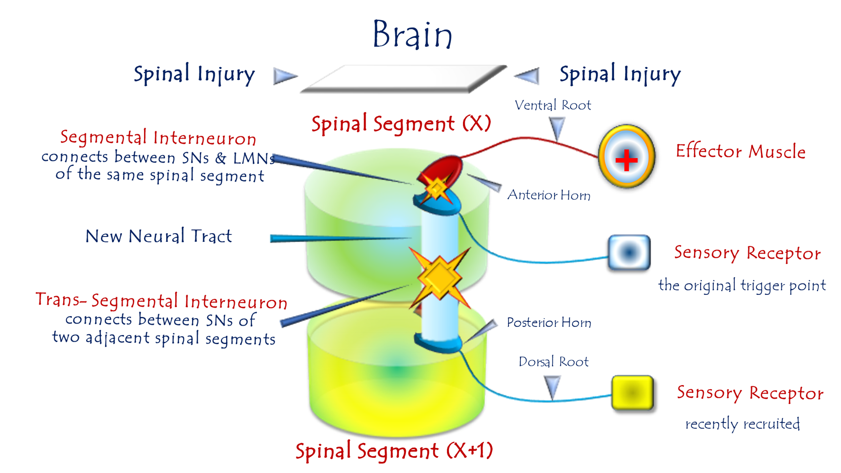
The Pathophysiology of Extended Hyperreflexia
To watch a short video explaining in detail the Pathophysiology of the Extended Hyperreflexia, click on this link:
In upper motor neuron (UMN) lesion,
the lower motor neuron may form connections with sensory neurons across more than one segmental level, specifically within its own segment and the adjacent ones.
Sensory stimuli originating from one or more of the newly allied sensory neuron receptive fields can now trigger the spinal hyperreflexia.
……………………………………………………………………………………….
In other contexts, you can also read the following articles:
 | DOI | The Spinal Reflex, New Hypothesis of Physiology
 | - | The Hyperreflexia, Innovated Pathophysiology
 | DOI | The Spinal Shock
 | - | The Spinal Injury, the Pathophysiology of the Spinal Shock, the Pathophysiology of the Hyperreflexia
 | DOI | Upper Motor Neuron Lesions, the Pathophysiology of the Symptomatology
 | - | The Hyperreflexia (1): Pathophysiology of Hyperactivity
 | - | The Hyperreflexia (2): Pathophysiology of Bilateral Responses
 | - | The Hyperreflexia (3): Pathophysiology of Extended Hyperreflex
 | DOI | The Hyperreflexia (4): Pathophysiology of Multi-Motor-Response Hyperreflexia
- | - | The pathophysiology of Triple flexion Reflex
 | - | The Clonus, 1st Hypothesis of Pathophysiology
 | - | The Clonus, 2nd Hypothesis of Pathophysiology
 | DOI | The Clonus, Two Hypotheses of Pathophysiology
 | DOI | The Nerve Transmission through Neural Fiber, Personal View vs. International View
 | - | The Nerve Transmission through Neural Fiber (1), The Action Pressure Waves
 | - | The Nerve Transmission through Neural Fiber (2), The Action Potentials
 | - | The Nerve Transmission through Neural Fiber (3), The Action Electrical Currents
 | - | The Function of Standard Action Potentials & Currents
 | - | The Three Phases of Nerve transmission
 | DOI | Neural Conduction in the Synapse (Innovated)
 | DOI | Nodes of Ranvier, the Equalizers
 | - | Nodes of Ranvier, the Functions
 | - | Nodes of Ranvier, First Function
 | - | Nodes of Ranvier, Second Function
 | - | Nodes of Ranvier, Third Function
 | - | Node of Ranvier, The Anatomy
 | DOI | Vesicular Dynamics: A Unifying Theory for Wallerian Degeneration and Neural Regeneration
 | - | The Wallerian Degeneration
 | - | The Neural Regeneration
 | DOI | Wallerian Degeneration: Affects Motor Axons while Sparing Sensory Axons
 | DOI | The Sensory Receptors
 | DOI | Electroneurography vs. Neural Reality: Hidden Fallacies in Nerve Conduction Studies
 | DOI | Piriformis Muscle Injection: Personal Approach
 | DOI | In Philosophy of Nerves: Pain First!
 | DOI | In Neurodoctrines: Form is Necessity!
 | - | Pronator Teres Syndrome, Struthers-Like Ligament (Innovated)
 | DOI | Ulnar Nerve, Congenital Bilateral Dislocation
 | - | Posterior Interosseous Nerve Syndrome
 | DOI | The Multiple Sclerosis: The Causative Relationship Between  The Galvanic Current & Multiple Sclerosis?
 | - | Cauda Equina Injury, New Surgical Approach
 | DOI | Carpal Tunnel Syndrome Ends Its Adherence: Complete Median Nerve Transection
 | DOI | Biceps Femoris' Long Head Syndrome (BFLHS)
 | DOI | Barr Body, The Whole Story (Innovated)
 | - | Adam's Rib and Adam's Apple, Two Faces of one Sin
 | - | Adam's Rib, could be the Original Sin?
 | - | Barr Body, the Second Look
 | DOI | Who Decides the Sex of Coming Baby?
 | - | Boy or Girl, Mother Decides!
 | - | Oocytogenesis
 | - | Spermatogenesis
 | - | This Woman Can Only Give Birth to Female Children
 | - | This Woman Can Only Give Birth to Male Children
 | - | This Woman Can Give Birth to Female Children More Than to Male Children
 | - | This Woman Can Give Birth to Male Children More Than to Female Children
 | - | This Woman Can Equally Give Birth to Male Children & to Female Children
 | - | Eve Saved Human Identity; Adam Ensured Human Adaptation
 | DOI | COVID-19: Beyond the Crisis—Is It Targeting Our Genes?
 | DOI | Fibromyalgia
 | - | Mitosis in Animal Cell
 | - | Meiosis
 | - | Universe Creation, Hypothesis of Continuous Cosmic Nebula
 | - | Circulating Sweepers
 | - | The Black Hole is a (the) Falling Star?
 | - | Pneumatic Petrous, Bilateral Temporal Hyperpneumatization
 | DOI | Congenital Bilateral Thenar Hypoplasia
 | DOI | Ulnar Dimelia, Mirror hand Deformity
 | DOI | Thumb Reconstruction Using Microvascular Second Toe to Thumb Transfer
 | DOI | Surgical Restoration of a Smile by Grafting a Segment of the Gracilis Muscle to the Face
 | DOI | Mandible Reconstruction Using Free Fibula Flap
 | DOI | Presacral Schwannoma
 | DOI | Liver Hemangioma: Urgent Surgery of Giant Liver Hemangioma  Due to Intra-Tumor Bleeding
 | DOI | Free Para Scapular Flap (FPSF) for Skin Reconstruction
 | DOI | Claw Hand Deformity (Brand Operation)
 | DOI | Algodystrophy Syndrome Complicated by Constricting Ring at the Proximal Border of the Edema
 | DOI | Non- Traumatic Non- Embolic Acute Thrombosis of Radial Artery (Buerger’s Disease)
 | DOI | Isolated Axillary Tuberculosis Lymphadenitis
 | DOI | The Iliopsoas Tendonitis... The Snapping Hip
 | To read the article in Arabic, click on
 | DOI | The New Frankenstein Monster
 | DOI | The Lone Wolf
 | DOI | The Delirium of Night and Day
 | DOI | The Delirium of the Economy
 | DOI | Ovaries in a Secure Corner… Testicles in a Humble Sac:  An Inquiry into the Function of Form
 | DOI | Eve Preserves Humanity’s Blueprint; Adam Drives Its Evolution
 | DOI | The Manufacture of the Unconscious
 | DOI | The Ballad of Eternity
 | DOI | Two Truths Woman Would Never Accept
 | DOI | The 'Iddah (Waiting Period) in Islamic Law: A Comparative Analysis of its Rationale for Divorced Women and Widows
 | DOI | The IVF/ICSI-Conceived Child: A Biologically Suboptimal Outcome

23/08/2025

