Dr. Ammar Yaseen Mansour
The Multi-Motor-Response Hyperreflexia
The Pathophysiology of Multi-Motor-Response Hyperreflexia
To watch a short video explaining in detail the pathological mechanism of the multi-motor-response of spinal hyperreflexia, click on this link:

Under normal conditions, where the brain is dominant over all sensory afferent and all motor efferent pathways, each spinal reflex retains its own specific and independent circuit, separate from others. Stimulating the receptive field of a specific spinal reflex triggers a motor response unique to that reflex. It is a single, non-repetitive response, specific to the reflex being studied, with controlled intensity and force, and on the same side where the stimulation occurred.
In contrast, in Upper Motor Neuron injuries, the brain becomes functionally absent, and matters escape the effects of control and regulation. At this point, the Interneurons become active to fill the functional void. They activate old, abandoned neural pathways from early childhood and/or work to form new neural pathways that did not previously exist.
Sometimes, this networking can be extensive in its scope. It brings together the distant and the near, the functionally synergistic and antagonistic, into a single aberrant functional unit: the pathological lower motor neuron pool. Here, a single stimulus to one of these newly interconnected circuits is enough to activate all of them at once. The final result is multiple reaction responses from a single stimulus; and this is precisely the meaning of the concept of the Multi-Motor-Response Hyperreflex; see Figure (1).
Tapping the right patellar tendon elicits extension of the right knee; this is the case under normal conditions. However, in a state of pathological hyperreflexia, it may also elicit flexion movement in the right hip joint.
Through the same mechanism, many pathological reflexes and signs pathognomonic of upper motor neuron lesions can be explained, such as the Hoffman Sign, the Babinski Sign, and Muscle Spasm. All of them are the product of aberrant, emergent, multi-faceted lower circuits, such as those in spinal cord lesions.
For example, the Hoffman sign and the Babinski sign are pathological products of the activation of an old partnership between neural circuits that were originally functionally synergistic in their primitive origin (Agonistic Neural Circuits). As for muscle spasm, it may be the result of a recent, ill-fated partnership between circuits that are inherently antagonistic (Antagonistic Neural Circuits).
Regarding the latter, I state: a partnership between functionally antagonistic circuits is always a detrimental partnership at the motor level, and to a much greater extent than a partnership between functionally synergistic circuits. Furthermore, a partnership between antagonists may be responsible for a wider spectrum of clinical symptoms and signs of Spastic Paralysis. What particularly concerns me in this regard is Muscle Rigidity and Muscle Weakness.

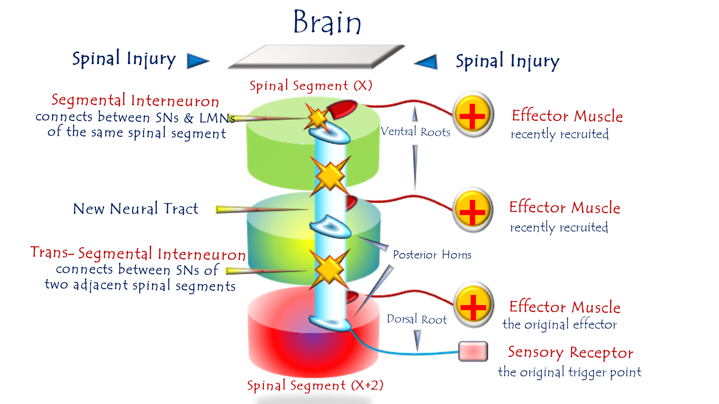
Figure (1):
The Pathophysiology of Multi-Motor-Response Hyperreflexia
To watch a short video explaining in detail the pathological mechanism of the multi-motor-response of spinal hyperreflexia, click on this link:
During the formation of the hyperreflexic spinal circuit,
the interneurons may form connections with a group of lower motor neurons across several adjacent spinal segments. Thus, the neural circuits of the emerging hyperreflex in spinal segment (X+II), for example, merge with the circuits of the two reflexes emerging in segments (X+I) and (X) into a single, aberrant functional unit. At this point, a single sensory afferent input can trigger a multi-motor response simultaneously.

………………………………………………………………………………………………..
In other contexts, you can also read the following articles:
 | DOI | The Spinal Reflex, New Hypothesis of Physiology
 | - | The Hyperreflexia, Innovated Pathophysiology
 | DOI | The Spinal Shock
 | - | The Spinal Injury, the Pathophysiology of the Spinal Shock, the Pathophysiology of the Hyperreflexia
 | DOI | Upper Motor Neuron Lesions, the Pathophysiology of the Symptomatology
 | - | The Hyperreflexia (1), the Pathophysiology of Hyperactivity
 | - | The Hyperreflexia (2), the Pathophysiology of Bilateral Responses
 | - | The Hyperreflexia (3), the Pathophysiology of Extended Hyperreflex
 | - | The Hyperreflexia (4), the Pathophysiology of Multi-Response Hyperreflex
- | - | The pathophysiology of Triple flexion Reflex
 | - | The Clonus, 1st Hypothesis of Pathophysiology
 | - | The Clonus, 2nd Hypothesis of Pathophysiology
 | DOI | The Clonus, Two Hypotheses of Pathophysiology
 | DOI | The Nerve Transmission through Neural Fiber, Personal View vs. International View
 | - | The Nerve Transmission through Neural Fiber (1), The Action Pressure Waves
 | - | The Nerve Transmission through Neural Fiber (2), The Action Potentials
 | - | The Nerve Transmission through Neural Fiber (3), The Action Electrical Currents
 | - | The Function of Standard Action Potentials & Currents
 | - | The Three Phases of Nerve transmission
 | DOI | Neural Conduction in the Synapse (Innovated)
 | DOI | Nodes of Ranvier, the Equalizers
 | - | Nodes of Ranvier, the Functions
 | - | Nodes of Ranvier, First Function
 | - | Nodes of Ranvier, Second Function
 | - | Nodes of Ranvier, Third Function
 | - | Node of Ranvier, The Anatomy
 | DOI | Vesicular Dynamics: A Unifying Theory for Wallerian Degeneration and Neural Regeneration
 | - | The Wallerian Degeneration
 | - | The Neural Regeneration
 | DOI | Wallerian Degeneration: Affects Motor Axons while Sparing Sensory Axons
 | DOI | The Sensory Receptors
 | DOI | Electroneurography vs. Neural Reality: Hidden Fallacies in Nerve Conduction Studies
 | DOI | Piriformis Muscle Injection: Personal Approach
 | DOI | In Philosophy of Nerves: Pain First!
 | DOI | In Neurodoctrines: Form is Necessity!
 | - | Pronator Teres Syndrome, Struthers-Like Ligament (Innovated)
 | DOI | Ulnar Nerve, Congenital Bilateral Dislocation
 | - | Posterior Interosseous Nerve Syndrome
 | DOI | The Multiple Sclerosis: The Causative Relationship Between  The Galvanic Current & Multiple Sclerosis?
 | - | Cauda Equina Injury, New Surgical Approach
 | DOI | Carpal Tunnel Syndrome Ends Its Adherence: Complete Median Nerve Transection
 | DOI | Biceps Femoris' Long Head Syndrome (BFLHS)
 | DOI | Barr Body, The Whole Story (Innovated)
 | - | Adam's Rib and Adam's Apple, Two Faces of one Sin
 | - | Adam's Rib, could be the Original Sin?
 | - | Barr Body, the Second Look
 | DOI | Who Decides the Sex of Coming Baby?
 | - | Boy or Girl, Mother Decides!
 | - | Oocytogenesis
 | - | Spermatogenesis
 | - | This Woman Can Only Give Birth to Female Children
 | - | This Woman Can Only Give Birth to Male Children
 | - | This Woman Can Give Birth to Female Children More Than to Male Children
 | - | This Woman Can Give Birth to Male Children More Than to Female Children
 | - | This Woman Can Equally Give Birth to Male Children & to Female Children
 | - | Eve Saved Human Identity; Adam Ensured Human Adaptation
 | DOI | COVID-19: Beyond the Crisis—Is It Targeting Our Genes?
 | DOI | Fibromyalgia
 | - | Mitosis in Animal Cell
 | - | Meiosis
 | - | Universe Creation, Hypothesis of Continuous Cosmic Nebula
 | - | Circulating Sweepers
 | - | The Black Hole is a (the) Falling Star?
 | - | Pneumatic Petrous, Bilateral Temporal Hyperpneumatization
 | DOI | Congenital Bilateral Thenar Hypoplasia
 | DOI | Ulnar Dimelia, Mirror hand Deformity
 | DOI | Thumb Reconstruction Using Microvascular Second Toe to Thumb Transfer
 | DOI | Surgical Restoration of a Smile by Grafting a Segment of the Gracilis Muscle to the Face
 | DOI | Mandible Reconstruction Using Free Fibula Flap
 | DOI | Presacral Schwannoma
 | DOI | Liver Hemangioma: Urgent Surgery of Giant Liver Hemangioma  Due to Intra-Tumor Bleeding
 | DOI | Free Para Scapular Flap (FPSF) for Skin Reconstruction
 | DOI | Claw Hand Deformity (Brand Operation)
 | DOI | Algodystrophy Syndrome Complicated by Constricting Ring at the Proximal Border of the Edema
 | DOI | Non- Traumatic Non- Embolic Acute Thrombosis of Radial Artery (Buerger’s Disease)
 | DOI | Isolated Axillary Tuberculosis Lymphadenitis
 | DOI | The Iliopsoas Tendonitis... The Snapping Hip
 | To read the article in Arabic, click on
 | DOI | The New Frankenstein Monster
 | DOI | The Lone Wolf
 | DOI | The Delirium of Night and Day
 | DOI | The Delirium of the Economy
 | DOI | Ovaries in a Secure Corner… Testicles in a Humble Sac:  An Inquiry into the Function of Form
 | DOI | Eve Preserves Humanity’s Blueprint; Adam Drives Its Evolution
 | DOI | The Manufacture of the Unconscious
 | DOI | The Ballad of Eternity
 | DOI | Two Truths Woman Would Never Accept
 | DOI | The 'Iddah (Waiting Period) in Islamic Law: A Comparative Analysis of its Rationale for Divorced Women and Widows
 | DOI | The IVF/ICSI-Conceived Child: A Biologically Suboptimal Outcome

21/08/2025

