Ammar Yaseen Mansour
Sensory Receptors:
A Novel Mechanism for Sustained Tactile Perception
How Pulse Pressure Overcomes Receptor Adaptation to Maintain Continuous Perception
The initial detection of contact with the skin is well-understood: mechanoreceptors (e.g., Pacinian corpuscles) transduce mechanical energy into neural signals. However, the persistent awareness of sustained contact—such as the continuous feel of an object held in the hand—has remained a physiological enigma.
Superficial Sensory Receptors (SSRs)
SSRs are distributed across all contact surfaces between an organism and its environment, serving as communication bridges linking the internal and external environments.
Sensory receptors (SRs) associated with a single sensory neuron (SN) share identical structural and functional properties. Furthermore, SSRs performing the same role exhibit consistent architecture regardless of their location.
Each dendritic neural fiber innervates a single SR, forming the receptor’s core (central neurite). Every SSR is sensitive to a specific energy spectrum of stimuli. Regardless of the stimulus type, the SSR transduces this energy into a pressure Wave Unit. These Wave Units aggregate at the dendritic root to form an Action Pressure Wave (Figure 1), which carries the afferent signal to the central nervous system.
In subsequent sections, I will elaborate on the operational mechanism of SSRs, using Pacinian corpuscles as a model. This choice is twofold:
- Pacinian corpuscles exemplify the general functional principles shared by all SSRs.
- Their mechanotransductive properties vividly illustrate the proposed mode of action.
The Wave Units
In sensory neurons (SNs), Action Pressure Waves are generated peripherally at the dendritic root. These waves propagate centrally toward the axon terminal branches and consist of aggregated components termed Wave Units. Each Wave Unit originates in the central neurite of a sensory receptor (SR). At the dendritic root, Wave Units from multiple SRs within a single SN converge to form an Action Pressure Wave (Figure 1).

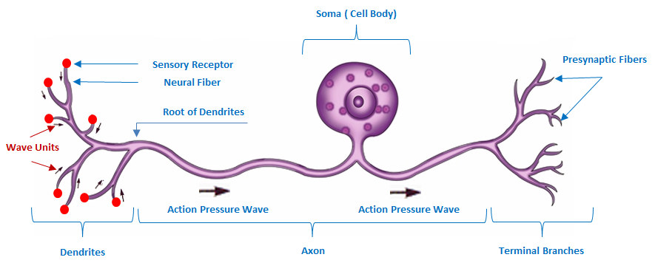
Figure 1: Generation and Propagation of Wave Units
Wave Units are generated within the nerve fiber. At the dendritic root, multiple Wave Units from activated sensory receptors converge to form a single
Action Pressure Wave. This wave propagates along the axon toward its terminal branches, facilitating signal transmission to downstream neural circuits.

A mechanical stimulus (e.g., contact) activates an SR only once, irrespective of the stimulus duration. In response, the SR emits a single Wave Unit. This mechanism explains why a pinprick elicits immediate pain (a "flash" signal), while sustained contact (e.g., a stationary pin) does not produce ongoing pain—a critical protective feature of nociceptors (pain receptors).
However, continuous detection of prolonged contact is physiologically essential. Without it, organisms might fail to perceive retained objects (e.g., a held item slipping from the hand). To resolve this, the nervous system employs pulse pressure (Figure 4), which cyclically reactivates receptors, enabling persistent monitoring of static stimuli.

The All-or-None Law
Unlike motor neurons, sensory neurons (SNs) do not strictly adhere to the all-or-none principle (Figure 2). This deviation is critical to their function: somatosensory receptors (SSRs) must detect even minimal contact with external stimuli. If SNs followed the all-or-none law, subthreshold stimuli (e.g., light touch) would fail to elicit action potentials, rendering many subtle contact events imperceptible.
As demonstrated in Figure 2, sensory neurons encode stimulus intensity through graded receptor activation rather than binary firing. For example, weak stimuli activate only a subset of receptors (Figure 2-A), generating proportional signals (e.g., 5/8 of a full Action Pressure Wave). This mechanism allows the nervous system to distinguish between faint and strong stimuli, ensuring sensitivity to even the slightest environmental changes.

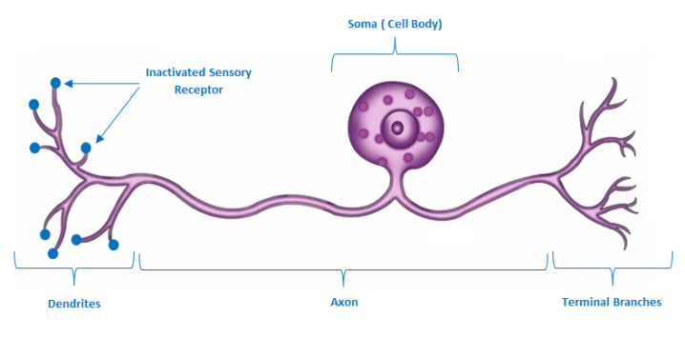
Figure 2: Sensory Receptor Activation States
(A) Inactive Sensory Receptors
- Each sensory receptor (blue circles) surrounds a dendritic neural fiber.
- At rest, no receptors are activated by external stimuli.

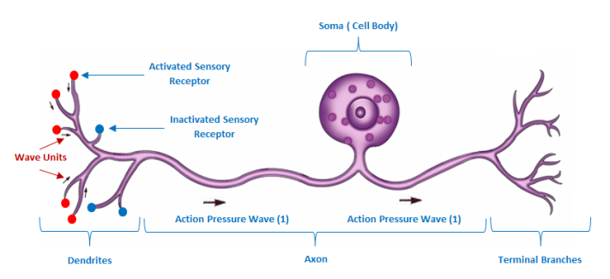
(B) Partial Activation (Subthreshold Stimulus)
- A weak stimulus activates 5 out of 8 receptors (red circles) on a single sensory neuron.
- Activated receptors generate pressure wave units, which converge to form a single Action Pressure Wave at the dendritic root.
- The remaining 3 receptors (blue circles) remain inactive.
- The sensory processing center interprets the stimulus intensity as proportional to the activated receptor ratio (5/8 of a full Action Pressure Wave’s magnitude).

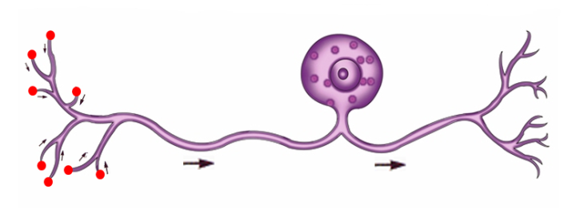
Neuron 1
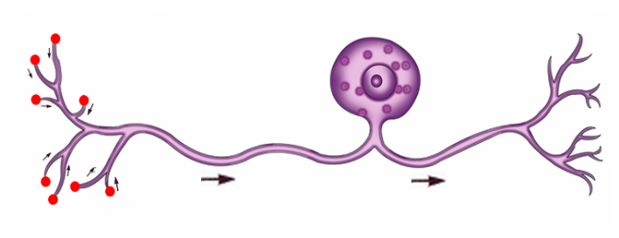
Neuron 2
Neuron 3
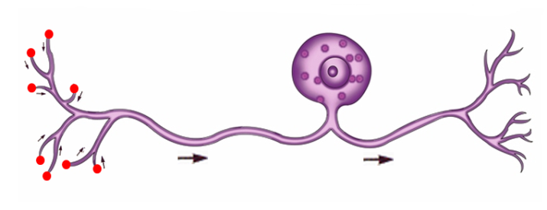
Neuron4
Neuron 5
(C) Full Activation (Suprathreshold Stimulus)
- A strong stimulus activates all receptors across a group of 5 sensory neurons (40 receptors total; 8 per neuron).
- Each neuron generates a full Action Pressure Wave from its 8 activated receptors.
- The sensory processing center integrates these signals, interpreting the stimulus intensity as the sum of all 5 Action Pressure Waves.

Pressure Receptors (Pacinian Corpuscles)
Like other somatosensory receptors (SSRs), Pacinian corpuscles detect mechanical stimuli (e.g., pressure) upon initial contact. They encode the precise magnitude of the applied pressure (Pm mmHg) instantaneously. However, these receptors rapidly adapt, ceasing to respond to sustained stimuli within moments (Figure 4).
This adaptation occurs because Pacinian corpuscles are activated by changes in pressure (i.e., the pressure differential created by the stimulus). When the stimulus remains static, this differential dissipates (reaching zero), causing the receptor
to stop signaling. To maintain detection during prolonged contact, pulse pressure provides a cyclical, intrinsic pressure differential. This pulsatile mechanism reactivates the receptors repeatedly, enabling ongoing monitoring of the stimulus.
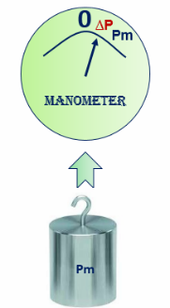 | 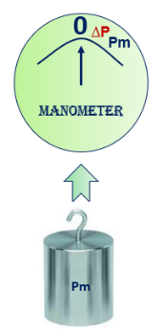 | 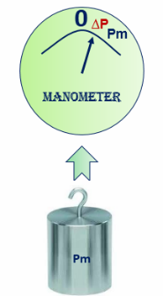 | 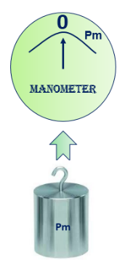 | 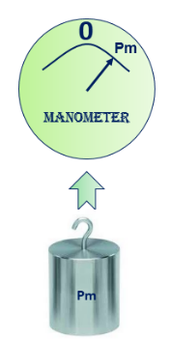 | 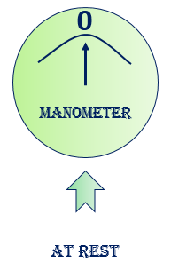
5 | 4 | 3 | 2 | 1 | 0
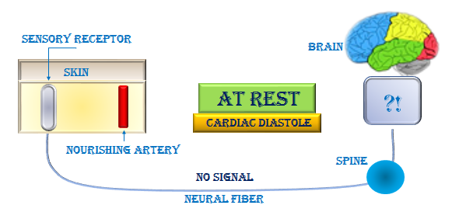
0
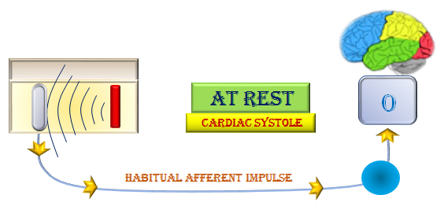
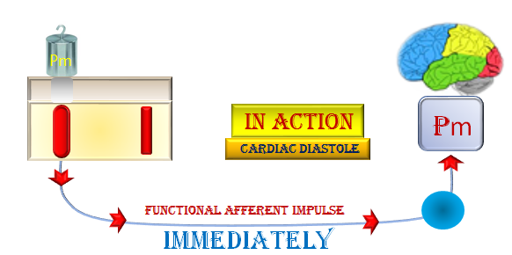
1
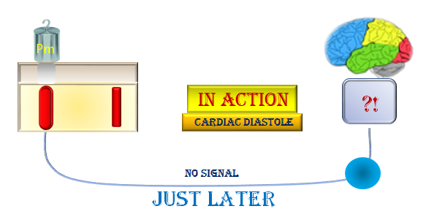
2
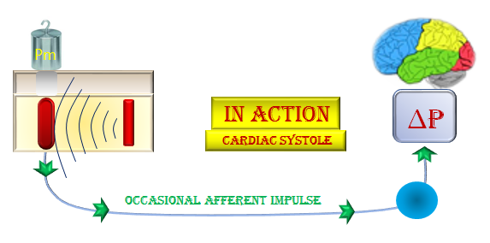
3
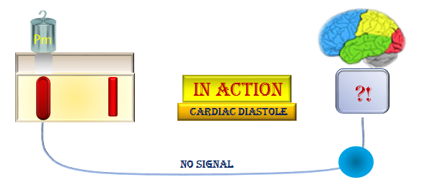
4
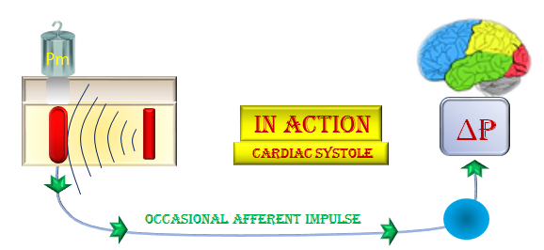
5
Figure 4:
Mechanism of Sensory Receptor Signaling During Rest and Object Contact
(0) At Rest (No Contact): During diastole, peripheral signals cease ("silent phase"). The brain perceives this absence of input as anomalous and activates pulse pressure to scan the tissue. In systole, sensory receptors detect the pulse pressure wave and transmit Habitual Afferent Impulses to the brain. With no external stimulus, the brain registers a null outcome (0), resolving its "anxiety."
(1) Initial Contact (Object Detected): Upon contact, the sensory receptor immediately detects the object’s pressure (Pm mmHg) and transmits a Stimulus-Specific Afferent Impulse. The brain interprets this accurately, estimating the object’s pressure as ≈ Pm mmHg.
(2) Sustained Contact (Signal Loss): Shortly after, the receptor loses the pressure differential (due to adaptation) and stops signaling. The brain rejects this peripheral silence as implausible.
(3) Sustained Contact (Pulse Pressure Compensation): Subsequently, the receptor utilizes pulse pressure as a surrogate differential value, transmitting Stimulus-Evoked Afferent Impulses (Occasional Afferent Impulses). The brain now estimates the object’s pressure based on pulse pressure magnitude (≈ ΔP).
(4) Sustained Contact (Diastolic Silence): During diastole, pulse pressure subsides, and the receptor re-enters a silent phase. No afferent signals are sent.
(5) Sustained Contact (Cyclic Reactivation): In the next systolic phase, pulse pressure restores the differential value, reactivating the receptor-brain signaling loop.

Thus, only the initial pressure reading reflects the true magnitude of the external stimulus. Subsequent signals are mediated by pulse pressure, resulting in estimations based on its amplitude (≈ ΔP) rather than the object’s actual pressure (Figure 4).

For more clarity, watch the linked video:

Discussion
Pulse pressure serves as the primary driver for sensory receptors to detect even subtle changes in their environment. It generates a sustained pressure differential, essential for the continuous functioning of all sensory receptors.
This pressure differential arises from the pulsations of local arteries and arterioles. While distinct from the pressure changes induced by external stimuli themselves, this mechanism operates with remarkable efficiency. Consequently, even as a stimulus interacts with the organism, Pacinian corpuscles persist in detecting its presence, albeit through a distinct modality.
Both at rest and during stimulation, sensory receptors (e.g., Pacinian corpuscles) consistently respond to pulse pressure. They transmit afferent impulses to the brain, which then interprets these signals appropriately.
At rest (in the absence of external contact), afferent impulses generated by pulse pressure exhibit a baseline pattern. These are termed Habitual Afferent Impulses. The brain recognizes this baseline activity and interprets it as the absence of contact (Figure 4-0).
During stimulation, however, once an object makes contact, the afferent impulses shift to an altered pattern. These are termed Stimulus-Evoked Afferent Impulses. Through this mechanism, the brain continuously detects the object’s presence on the surface (Figure 4).
…………………………………………………………………………………………
In other contexts, you can also read the following articles:

The Spinal Reflex, New Hypothesis of Physiology
The Hyperreflexia, Innovated Pathophysiology
The Spinal Shock
The Spinal Injury, the Pathophysiology of the Spinal Shock, the Pathophysiology of the Hyperreflexia
Upper Motor Neuron Lesions, the Pathophysiology of the Symptomatology
The Hyperreflexia (1), the Pathophysiology of Hyperactivity
The Hyperreflexia (2), the Pathophysiology of Bilateral Responses
The Hyperreflexia (3), the Pathophysiology of Extended Hyperreflex
The Hyperreflexia (4), the Pathophysiology of Multi-Response Hyperreflex
The Clonus, 1st Hypothesis of Pathophysiology
The Clonus, 2nd Hypothesis of Pathophysiology
The Clonus, Two Hypotheses of Pathophysiology
The Nerve Transmission through Neural Fiber, Personal View vs. International View
The Nerve Transmission through Neural Fiber (1), The Action Pressure Waves
The Nerve Transmission through Neural Fiber (2), The Action Potentials
The Nerve Transmission through Neural Fiber (3), The Action Electrical Currents
The Function of Standard Action Potentials & Currents
The Three Phases of Nerve transmission
Neural Conduction in the Synapse (Innovated)
Nodes of Ranvier, the Equalizers
Nodes of Ranvier, the Functions
Nodes of Ranvier, First Function
Nodes of Ranvier, Second Function
Nodes of Ranvier, Third Function
Node of Ranvier, The Anatomy
The Wallerian Degeneration
The Neural Regeneration
The Wallerian Degeneration Attacks Motor Axons, While Avoids Sensory Axons
The Sensory Receptors
Nerve Conduction Study, Wrong Hypothesis is the Origin of the Misinterpretation (Innovated)
Piriformis Muscle Injection_ Personal Approach
The Philosophy of Pain, Pain Comes First! (Innovated)
The Philosophy of the Form (Innovated)
Pronator Teres Syndrome, Struthers-Like Ligament (Innovated)
Ulnar Nerve, Congenital Bilateral Dislocation
Posterior Interosseous Nerve Syndrome
The Multiple Sclerosis: The Causative Relationship Between
The Galvanic Current & Multiple Sclerosis?
Cauda Equina Injury, New Surgical Approach
Carpal Tunnel Syndrome Complicated by Complete Rupture of Median Nerve
Biceps Femoris' Long Head Syndrome (BFLHS)
Barr Body, The Whole Story (Innovated)
Adam's Rib and Adam's Apple, Two Faces of one Sin
Adam's Rib, could be the Original Sin?
Barr Body, the Second Look
Who Decides the Sex of Coming Baby?
Boy or Girl, Mother Decides!
Oocytogenesis
Spermatogenesis
This Woman Can Only Give Birth to Female Children
This Woman Can Only Give Birth to Male Children
This Woman Can Give Birth to Female Children More Than to Male Children
This Woman Can Give Birth to Male Children More Than to Female Children
This Woman Can Equally Give Birth to Male Children & to Female Children
Eve Saved Human Identity; Adam Ensured Human Adaptation
Coronavirus (Covid-19): After Humiliation, Is Targeting Our Genes
Coronavirus (Covid-19): After Humiliation, Is Targeting Our Genes
The Black Hole is a (the) Falling Star?
Mitosis in Animal Cell
Meiosis
Universe Creation, Hypothesis of Continuous Cosmic Nebula
Circulating Sweepers
Pneumatic Petrous, Bilateral Temporal Hyperpneumatization
Congenital Bilateral Thenar Hypoplasia
Ulnar Dimelia, Mirror hand Deformity
Surgical Restoration of a Smile by Grafting a Segment of the Gracilis Muscle to the Face
Mandible Reconstruction Using Free Fibula Flap
Presacral Schwannoma
Liver Hemangioma: Urgent Surgery of Giant Liver Hemangioma
Due to Intra-Tumor Bleeding
Free Para Scapular Flap (FPSF) for Skin Reconstruction
Claw Hand Deformity (Brand Operation)
Algodystrophy Syndrome Complicated by Constricting Ring at the Proximal Border of the Edema
Non- Traumatic Non- Embolic Acute Thrombosis of Radial Artery
(Buerger’s Disease)
Isolated Axillary Tuberculosis Lymphadenitis
The Iliopsoas Tendonitis... The Snapping Hip
To read the article in Arabic, click on
The New Frankenstein Monster
The Lone Wolf
The Delirium of Night and Day
The Delirium of the Economy
Ovaries in a Secure Corner… Testicles in a Humble Sac:
An Inquiry into the Function of Form
Eve Preserves Humanity’s Blueprint; Adam Drives Its Evolution

^{15/8/2018}

