AMMAR YASEEN MANSOUR
Retro-peritoneal
Malignant Fibrous Histiocytoma
Malignant fibrous histiocytoma (MFH) is the most common sarcomas. It originates from the bones as from the other soft tissues. Some believe it to be the end phase
of many different sarcomas. While some others confirm its authentic identity from
the beginning. The males are more vulnerable than females with a privilege to the ages between 50-70 years. Clinically, MFHs are silent per se. So, any relating symptoms or signs come essentially from the neighbors' suffering from the mass effect of the tumor. MFHs prefer the lower limb as an origin. The upper limb and retroperitoneum locations are not banal. Their retroperitoneal forms might reach an extremely huge size before being evident. Here- after, I present a case of a huge retroperitoneal MFH in a female patient of 55 years.
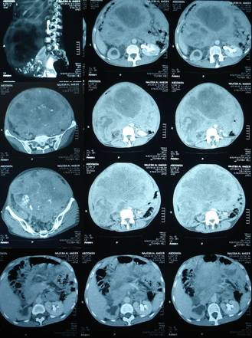

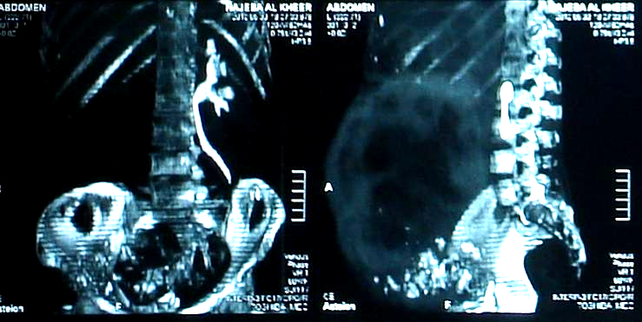
Figure (1)
CT scan of the abdomen with contrast infusion- Selected slices
I have selected different slices for better imagination of the tumor's size and location. Upper- right slice (sagittal), shows the gigantism of the tumor; occupying the space from the little pelvis caudally to the liver superiorly.
It measures 35X15 cm. The rest slices (axial), reveal the inhomogeneity of the tumor texture.
The tumor extends from the vertebral column posteriorly to the abdomen wall anteriorly.
Some spots of calcifications and mucoidal degenerations stand beside each other throughout the tumor.
The left kidney is still functional, whereas the right kidney is totally silent.

Figure (2)
Sagital view (left)- Coronal view (right)
The left slice (sagittal+ contrast infusion), the tumor extends from the floor of the true pelvis inferiorly to the costal margin superiorly. It concentrates the contrast material in its periphery, while its center fails doing so.
We find calcifications spots particularly in the lower pole of the tumor.
The right slice (coronary+ contrast infusion) reveals complete silence of the right kidney.
The left kidney works very well.
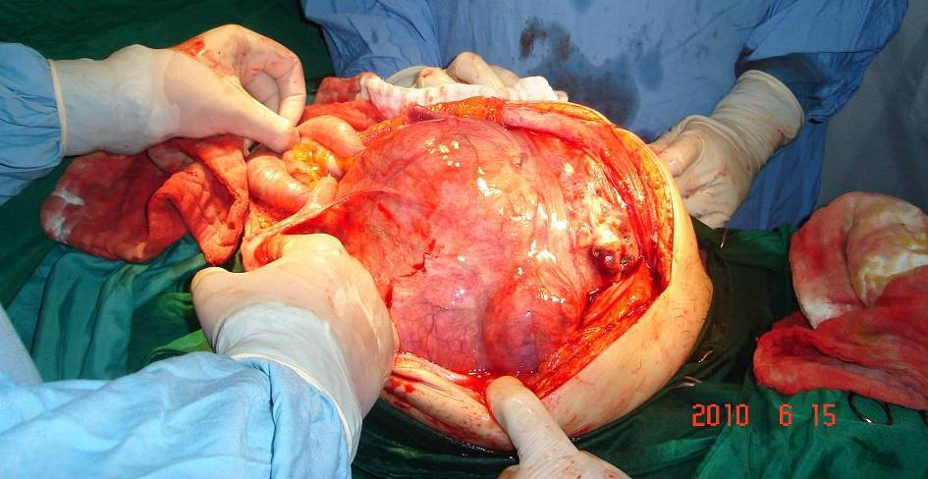

Figure (3)
Per-operation View
Via midline incision, the tumor appeared as a gigantesque ball with a cone-like extension into the lesser pelvis. The small intestines were crowded to the left superior corner of the abdominal cavity.

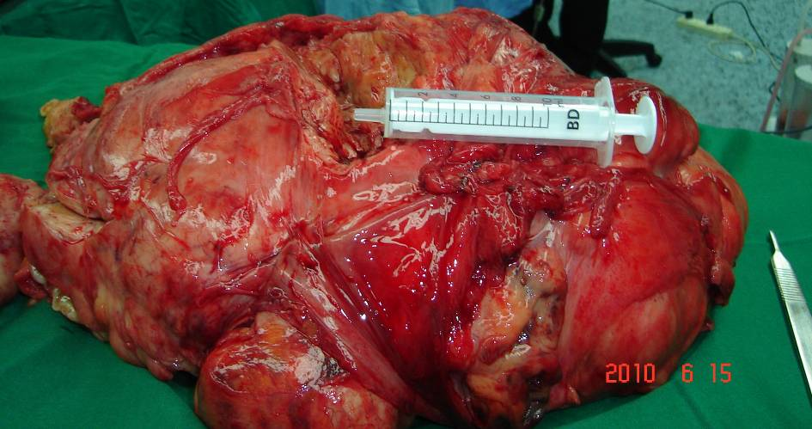

Figure (4)
Per-operation View- Resected Tumor
Sub-total resection of the tumor.
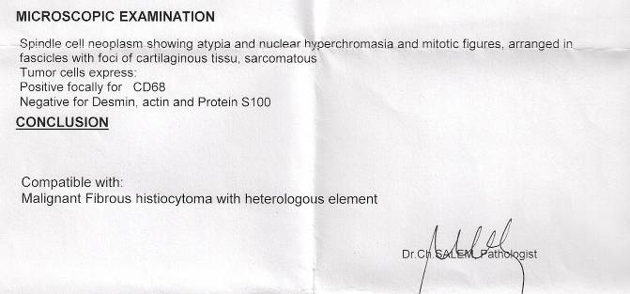

Figure (5)
Malignant Fibrous Histiocytoma
......................................................................................................................................................................
In another context, one could read:
- | Neural Conduction, Personal View vs. International View (Innovated)
 | Neural Conduction, Action Pressure Waves (Innovated)
 | Neural Conduction, Action Potentials (Innovated)
 | Neural Conduction, Action Electrical Currents (Innovated)
 | The Function of Action Potentials (Innovated)
 | The Three Phases of Neural Conduction
 | Neural Conduction in the Synapse (Innovated)
 | Sensory Receptors
- | Nodes of Ranvier, the Equalizers (Innovated)
 | Nodes of Ranvier, the Functions (Innovated)
 | Nodes of Ranvier, Function N1 (Innovated)
 | Nodes of Ranvier, Function N2 (Innovated)
 | Nodes of Ranvier, Function N3 (Innovated)
- | The Philosophy of Pain, Pain Comes First! (Innovated)
- | The Philosophy of Form (Innovated)
- | Spinal Injury, pathology of Spinal Shock, Pathology of Hyperreflexia
 | Spinal Shock (Innovated)
 | The Clonus (Innovated)
 | Hyperactivity Hyperreflexia (Innovated)
 | Hyperreflexia, Extended Sector of Reflex
 | Hyperreflexia, Bilateral Responses
 | Hyperreflexia, Multiple Responses
- | Nerve Conduction Study, Wrong Hypothesis is the Origin of Misinterpretation (Innovated)
 | Wallerian Degeneration (Innovated)
 | Neural Regeneration (Innovated)
- | Wallerian Degeneration Attacks Motor Axons, While Avoids Sensory Axons
 | Barr Body, the Whole Story (Innovated)
 | Boy or Girl, Mother Decides!
 | Adam's Rib and Adam's Apple, Two Faces of one Sin
 | The Black Hole is a (the) Falling Star?
 | Adam's Rib, could be the Original Sin?
 | Pronator Teres Syndrome, Struthers _ like Ligament (Innovated)

15/7/2010

