AMMAR YASEEN MANSOUR
The Multiple Sclerosis
The Causative Relationship Between
The Galvanic Current & Multiple Sclerosis?
Clinically, Multiples Sclerosis is known for its rages, silence, and the inevitability of weakness eventually. Pathologically, Multiples Sclerosis is characterized by demyelinating lesions in the white matter of central nervous system. Of great importance are those linked tightly to the cortex (Juxtacortical lesions), perpendicular to the ventricles (Dawson fingers), Infratentorial, and particularly the spinal lesions. Women are more subject to the disease than men; 2 to 1. The preferred age group is 20-40. There is no obvious cause behind the disease. However, immunity is accused of producing and activating antibodies against Myelin covering the neural axons. The provocative factor of this aberrancy is still a controversial issue. In this paper I shall introduce a clinical case of a woman who is thought to have Multiples Sclerosis. Throughout this case, I am trying to raise the question of the responsibility of Galvanic current.

The tragedy of this 30-year-old female patient began just after one single session of a galvanic current application in the left occipital region. Since then, the terrible feeling of fatigue and incapability has installed. The blurred vision in the left eye and the right hemi-paresis were at the top of her sufferings.

The patient familial history has not shown any direct or indirect vulnerability. The only positive finding was a recurrent frontal headache which she used to have for many years, in a rhythm of 3 to 4 episodes per an. The pain increases once the patient bends down her face looking down. There were no other neural symptoms in association with the headache. For this headache the session of galvanic current therapy has been recommended as a means of treatment to kill the pain.

Galvanic current has been applied to the left occipital region. The indication of such procedure, as well as the intensity and the duration of the used current are still unknown. Anyhow, a period of three hours of total satisfaction has been achieved. But shortly afterwards the patient's situation has deteriorated. The patient felt thoroughly drowsy and slept for 5 minutes as far as she remembered. The patient woke up, suffering from unfamiliar symptoms; paresis in her upper right limb, vision blurredness in the left eye, absence of the sense of taste in her tongue, and dramatic deterioration in her mood. The first brain MRI at the third day has revealed one frontal white matter lesion (WML), which was hyper-intense at the Flair time,
Figure (1).
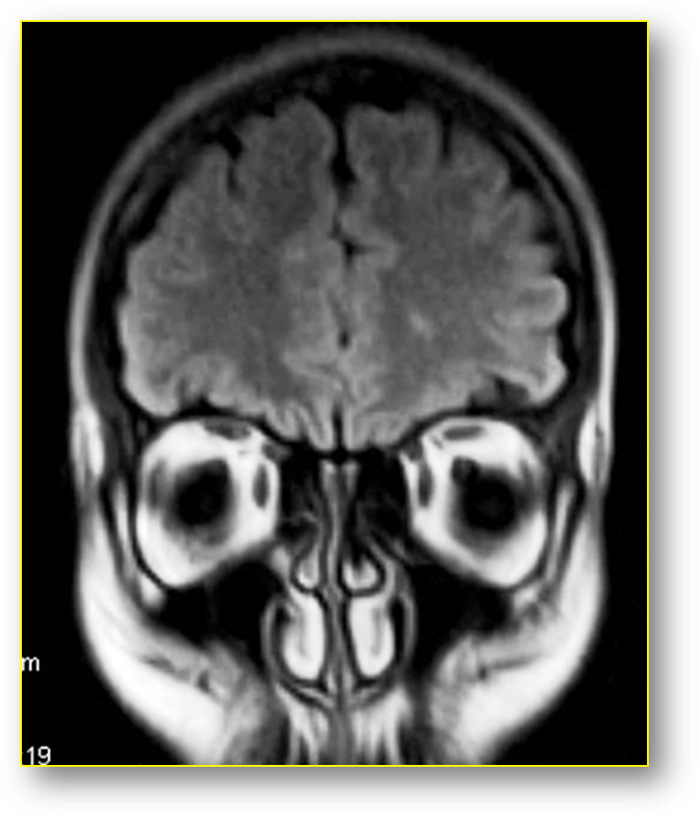
Fig. (1) Brain MRI
Coronary section at the Flair time
3 days after the painkilling session,
A hyper-intense white matter lesion in the left frontal lobe (the same as pointed at in Fig. 2)

Nine days later, the patient seemed worried and apprehensive. However, she was well oriented in terms of time and place, and she has been mentally doing very well. The physical examination revealed right hemi paresis and right supranuclear facial paresis. The upper limb was more affected than the lower limb and the facial nerve. Despite of their importance, the tests of balance and movement coordination in the right part of the body, have been neglected due to the muscular weakness in this part of the body. The eye movement test seemed normal. Despite the negative result of the previous MRI, the new MRI in the 10th day was charged of new pathological findings.
The new radiological findings have greatly supported the clinical tendency towards having Multiples Sclerosis. The patient has been given a high dose of prednisolone, for 5 days, providing that the medication will be gradually withdrawn. Right after the treatment, the patient felt much better.

The new brain MRI (without injection) revealed white matter lesions (WMLs); hypo-intense in T1, hyper-intense in T2 and in the Flair time. Some of these WMLs were Juxtacortical, while the others were deep and perpendicular to the ventricles (Dawson fingers). In addition to that, there are other locations of the WMLs but they were less specific than the previous ones, Fig. (2), (3).
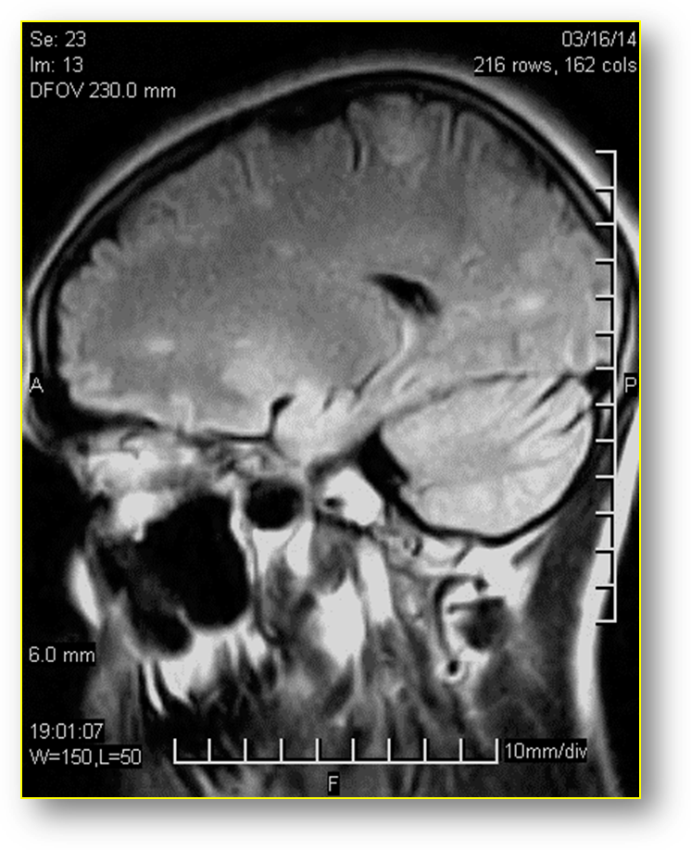
Fig (2) Brain MRI
Sagittal section in Flair time
10 days after the painkilling session,
It revealed many hyper-intense white matter lesions.
Some of them are Juxtacortical, whereas the others are deep in the white matter.

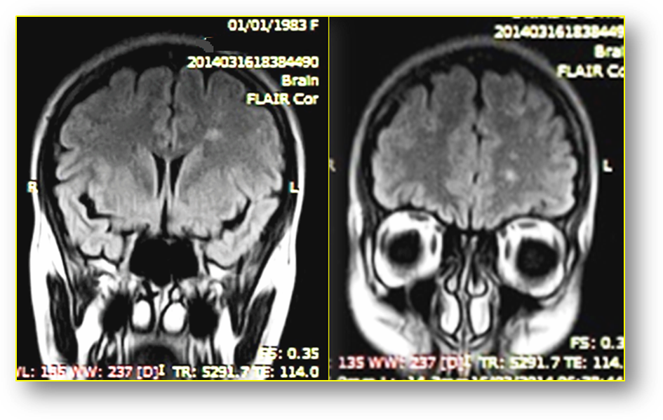
Fig (3) Brain MRI,
Coronary sections in the flair time
10th days after the painkilling session,
there are many hyper-intense WMLs in the flair time.
Some of WMLs are juxtacortical, others are of long axe and perpendicular to ventricles (Dawson fingers).

Case Discussion
The symptoms and clinical signs can indicate a brain damage. The blurredness in the left eye vision can be due to left optical neuritis. The right hemi-paresis and the supranuclear facial palsy in the same side can precisely determine the area of the brain damage, namely, the left side of the brain. I shall not rush into drawing conclusions about the diagnose of the disease, yet, I will only describe it as a brain disease.

On the 10th brain MRI, 8 white matter lesions are counted on the left hemi-sphere. They are hypo-intense on T1, and hyper-intense in T2 and in the Flair time, Fig (2) & (3). These lesions qualification goes with demyelinating lesions.

Multiple sclerosis disease is suggested due to the location of some WMLs. One WML is of long axe and is perpendicular to the ventricle (Dawson finger), and few of them are very close to the cortex (Juxtacortical lesions), Fig (2) & (3). Having these available elements uncovered by the MRI gives more weight to Multiple Sclerosis, despite the absence of the most important indicator of which, i.e. Corpus Callosum, Infratentorial lesions and Spinal lesions. All the above-mentioned elements refer to Multiple Sclerosis.

It is very crucial to refer to the fact that having one only WML on the third day MRI, fig (1) and several WMLs on the 10th day MRI, fig (2) & (3), do confirm the newness of this disease. An MRI indicator is added to the clinical story to underpin the starting time of having Multiple Sclerosis is the same time of being exposed to the Galvanic current.

In fact, the vascular contraction which might be provoked by the galvanic current application has initially been thought to be the cause of the new symptoms due to several reasons. The first reason is the negative personal and familial history of the patient. The second reason is the non-specific patient's complain that preceded and was behind the application of galvanic current. I have the tendency to refer all patient's complain to frontal sinusitis. The third reason is having neurological symptoms three hours after the application of the galvanic current. The fourth reason is the spread of the white matter lesions in one side of the brain which is the same side on which the galvanic current has been applied. However, the vascular theory has been refuted due to the MRI features of the brain lesions on one hand, and its spread on the white matter of brain without the cortex on the other hand.

Therefore, someone might consider that the essential patient's complain is not more than the initial symptom of the disease (M.S). Consequently, the application of the Galvanic current, as a treatment procedure, has basically been a provoker and an accelerator of the attack of the disease not the reason. Another claim might consider the hard luck to be behind the concordance of the beginning of the disease and the application of the Galvanic current. I shall no longer support or oppose any of the arguments, I'd rather display my own logic, leaving this case among those are interested and have the potential means of scientific research to examine the hypotheses of the causative relationship between the Galvanic Current and Multiple Sclerosis.
……………………………………………………………………………
In another context, one can also read:
 | Neural Conduction, Personal View vs. International View (Innovated)
 | Upper Motor Neuron Lesions, Pathophysiology of Symptomatology
 | Neural Conduction, Action Pressure Waves (Innovated)
 | Neural Conduction, Action Potentials (Innovated)
 | Neural Conduction, Action Electrical Currents (Innovated)
 | The Function of Action Potentials (Innovated)
 | The Three Phases of Neural Conduction (Innovated)
 | Neural Conduction in the Synapse (Innovated)
 | Sensory Receptors
 | Nodes of Ranvier, the Equalizers (Innovated)
 | Nodes of Ranvier, the Functions (Innovated)
 | Nodes of Ranvier, First Function (Innovated)
 | Nodes of Ranvier, Second Function (Innovated)
 | Nodes of Ranvier, Third Function (Innovated)
 | Node of Ranvier The Anatomy
 | The Philosophy of Pain, Pain Comes First! (Innovated)
 | The Philosophy of the Form (Innovated)
 | Spinal Injury, Pathophysiology of Spinal Shock, Pathophysiology of Hyperreflexia
 | Who Decides the Sex of Coming Baby?
 | Spinal Shock (Innovated)
 | The Clonus (Innovated)
 | Hyperactivity Hyperreflexia (Innovated)
 | Hyperreflexia, Extended Sector of Reflex
 | Hyperreflexia, Bilateral Responses
 | Hyperreflexia, Multiple Responses
 | Nerve Conduction Study, Wrong Hypothesis is the Origin of the Misinterpretation (Innovated)
 | Wallerian Degeneration (Innovated)
 | Neural Regeneration (Innovated)
 | Wallerian Degeneration Attacks Motor Axons, While Avoids Sensory Axons
 | Barr Body, the Whole Story (Innovated)
 | Boy or Girl, Mother Decides!
 | Adam's Rib and Adam's Apple, Two Faces of one Sin
 | The Black Hole is a (the) Falling Star?
 | Adam's Rib, could be the Original Sin?
 | Pronator Teres Syndrome, Struthers Like Ligament (Innovated)
 | Function of Standard Action Potentials & Currents
 | Posterior Interosseous Nerve Syndrome
 | Spinal Reflex, New Hypothesis of Physiology
 | Hyperreflexia, Innovated Pathophysiology
 | Clonus, 1st Hypothesis of Pathophysiology
 | Clonus, 2nd Hypothesis of Pathophysiology
 | Clonus, Two Hypotheses of Pathophysiology
 | Hyperreflexia (1), Pathophysiology of Hyperactivity
 | Hyperreflexia (2), Pathophysiology of bilateral Responses
 | Hyperreflexia (3), Pathophysiology of Extended Hyperreflex
 | Hyperreflexia (4), Pathophysiology of Multi-Response Hyperreflex
 | Barr Body, the Second Look
 | Mitosis in Animal Cell
 | Meiosis
 | Universe Creation, Hypothesis of Continuous Cosmic Nebula
 | Circulating Sweepers
 | Pneumatic Petrous, Bilateral Temporal Hyperpneumatization
 | Ulnar Nerve, Congenital Bilateral Dislocation
 | Oocytogenesis
 | Spermatogenesis
 | This Woman Can Only Give Birth to Female Children
 | This Woman Can Only Give Birth to Male Children
 | This Woman Can Give Birth to Female Children More Than to Male Children
 | This Woman Can Give Birth to Male Children More Than to Female Children
 | This Woman Can Equally Give Birth to Male Children & to Female Children
 | Piriformis Muscle Injection_ Personal Approach
 | Eve Saved Human's Identity, Adam Ensured Human's Adaptation
 | Corona Virus (Covid-19): After Humiliation, Is Targeting Our Genes
 | Claw Hand Deformity (Brand Operation)
 | Corona Virus (Covid-19): After Humiliation, Is Targeting Our Genes
 | Barr Body; Mystery of Origin & Ignorance of Function

12/04/2014

