AMMAR YASEEN MANSOUR

The Spinal Reflex
The New Hypothesis of Physiology

For more details concerning the New Physiology of the Spinal Reflex,
see the linked video:

I do believe
the spinal reflex to be the function of the upper neuron (i.e., the brain).
In such a way, the stimulus will provoke an afferent impulse that arrives to the brain via the sensory ascending tracts.
Thereafter, it is up to the brain to process the afferent data and then
to make the adapted reaction(s) vis-à-vis the stimulus.
Then, the efferent impulse takes the descending motor tracts in order to reach the lower motor neurons and then the effector organ(s)
(target organ) sequentially; figure (1).

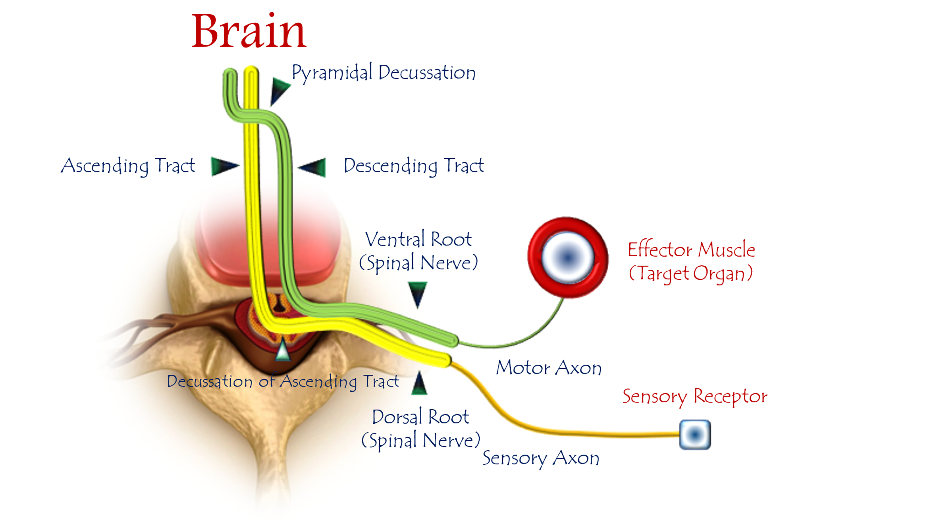
Figure (1)
The New Physiology of Spinal Reflex
(The Upper Motor Neuron Circuit)
For more details concerning the New Physiology of the Spinal Reflex,
see the linked video:

I do believe the spinal reflex runs in this manner:
The afferent sensory impulses end in the sensory neuron.
The ascending neural tracts conduct the afferent impulses toward the brain.
The Brain treats the afferent data, and then arrives to a certain conclusion.
The upper motor neuron (UMN) receives this conclusion, and in turn decides the appropriate motor reflex.
The efferent motor order descends to the lower motor neurons (LMN).
Finally, the LMN executes the motor order.

……………………………………………………………………………………………………
One can also read:

Neural Conduction, Personal View vs. International View (Innovated)
Upper Motor Neuron Lesions, Pathophysiology of Symptomatology
Neural Conduction, Action Pressure Waves (Innovated)
Neural Conduction, Action Potentials (Innovated)
Neural Conduction, Action Electrical Currents (Innovated)
The Function of Action Potentials (Innovated)
The Three Phases of Neural Conduction (Innovated)
Neural Conduction in the Synapse (Innovated)
Sensory Receptors
Nodes of Ranvier, the Equalizers (Innovated)
Nodes of Ranvier, the Functions (Innovated)
Nodes of Ranvier, First Function (Innovated)
Nodes of Ranvier, Second Function (Innovated)
Nodes of Ranvier, Third Function (Innovated)
Node of Ranvier The Anatomy
The Philosophy of Pain, Pain Comes First! (Innovated)
The Philosophy of the Form (Innovated)
Spinal Injury, Pathophysiology of Spinal Shock, Pathophysiology of Hyperreflexia
Who Decides the Sex of Coming Baby?
Spinal Shock (Innovated)
The Clonus (Innovated)
Hyperactivity Hyperreflexia (Innovated)
Hyperreflexia, Extended Sector of Reflex
Hyperreflexia, Bilateral Responses
Hyperreflexia, Multiple Responses
Nerve Conduction Study, Wrong Hypothesis is the Origin of the Misinterpretation (Innovated)
Wallerian Degeneration (Innovated)
Neural Regeneration (Innovated)
Wallerian Degeneration Attacks Motor Axons, While Avoids Sensory Axons
Barr Body, the Whole Story (Innovated)
Boy or Girl, Mother Decides!
Adam's Rib and Adam's Apple, Two Faces of one Sin
The Black Hole is a (the) Falling Star?
Adam's Rib, could be the Original Sin?
Pronator Teres Syndrome, Struthers Like Ligament (Innovated)
Function of Standard Action Potentials & Currents
Posterior Interosseous Nerve Syndrome
Spinal Reflex, New Hypothesis of Physiology
Hyperreflexia, Innovated Pathophysiology
Clonus, 1st Hypothesis of Pathophysiology
Clonus, 2nd Hypothesis of Pathophysiology
Clonus, Two Hypotheses of Pathophysiology
Hyperreflexia (1), Pathophysiology of Hyperactivity
Hyperreflexia (2), Pathophysiology of bilateral Responses
Hyperreflexia (3), Pathophysiology of Extended Hyperreflex
Hyperreflexia (4), Pathophysiology of Multi-Response Hyperreflex
Barr Body, the Second Look
Mitosis in Animal Cell
Meiosis
Universe Creation, Hypothesis of Continuous Cosmic Nebula
Circulating Sweepers
Pneumatic Petrous, Bilateral Temporal Hyperpneumatization
Ulnar Nerve, Congenital Bilateral Dislocation
Oocytogenesis
Spermatogenesis
This Woman Can Only Give Birth to Female Children
This Woman Can Only Give Birth to Male Children
This Woman Can Give Birth to Female Children More Than to Male Children
This Woman Can Give Birth to Male Children More Than to Female Children
This Woman Can Equally Give Birth to Male Children & to Female Children
Piriformis Muscle Injection_ Personal Approach
Eve Saved Human's Identity, Adam Ensured Human's Adaptation
Corona Virus (Covid-19): After Humiliation, Is Targeting Our Genes
Claw Hand Deformity (Brand Operation)
Corona Virus (Covid-19): After Humiliation, Is Targeting Our Genes
Barr Body; Mystery of Origin & Ignorance of Function
The Multiple Sclerosis: The Causative Relationship Between
The Galvanic Current & Multiple Sclerosis?
Liver Hemangioma: Urgent Surgery of Giant Liver Hemangioma
Because of Intra-Tumor Bleeding
Cauda Equina Injury, New Surgical Approach

Ulnar Dimelia, Mirror hand Deformity
Carpal Tunnel Syndrome Complicated by Complete Rupture of Median Nerve
Presacral Schwannoma
Congenital Bilateral Thenar Hypoplasia
Biceps Femoris' Long Head Syndrome (BFLHS)
Algodystrophy Syndrome Complicated by Constricting Ring at the Proximal Border of the Edema
Mandible Reconstruction Using Free Fibula Flap
Non- Traumatic Non- Embolic Acute Thrombosis of Radial Artery
(Buerger’s Disease)
Isolated Axillary Tuberculosis Lymphadenitis
Free Para Scapular Flap (FPSF) for Skin Reconstruction
Three Steps of Neural Conduction

1/6/2020

