AMMAR YASEEN MANSOUR
Ulnar Dimelia
"Mirror Hand Deformity"
Ulnar Dimelia, commonly called the Mirror Hand Deformity, is an extremely rare congenital anomaly of the upper limb. It is characterized by the duplication of the ulna, absent radius, and seven to eight well-formed digits. There is no thumb. All the elements of the radial axis; i.e. the 1st metacarpal, the trapezium, trapezoid, and the scaphoid, all are absent.
Here after, a case of a 5-year-old male child with no thumb, eight triphalangeal digits symmetrically positioned around the central axis. On x-ray, there are two ulnae; Figures (1), (2), (3), (4), (5).

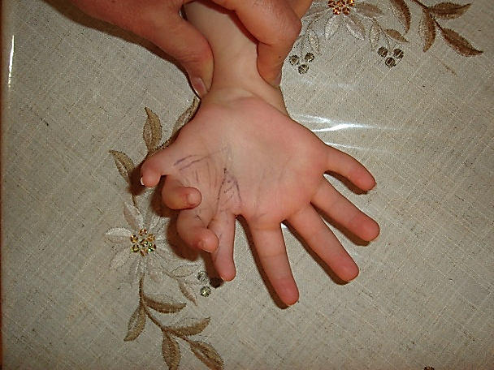
Figure (1)
Right Ulnar Dimelia
- Palmar view -
To the left, the four essential digits. To the right, the four extra digits.
The eight triphalangeal digits are symmetrically positioned regarding the central axis.

For more details, see the linked video:

Figure (2)
Right Ulnar Dimelia
- Dorsal view-
To the right, the four original digits. To the left, the four duplicated digits.
There is no thumb. One could easily notice the increased width of the wrist.

Figure (3)
Right Ulnar Dimelia
- Fist Formation -
While flexing the digits, their tops seek the central axis but the extra ( radial) index fails flexing.
Failure of active flexion excluded the extra index from the list of choice of the future thumb.
(My thumb is trying to fix the patient's wrist in order to support his weak wrist extensors.)

Figure (4)
Right Ulnar Dimelia
The extra hand (mirror hand) in the front.
In spite of the complete active flexion of the wrist (tenodesis effect),
the four extra (radial) metacarpo- phalangeal joints are still in the flexion position.
Whereas, the four ulnar digits (in the back of the photo) take a more extension position. That is explained by the absence, or the hypoplasia, of the extra Extensor Digitorum Communis muscle of the mirror (extra) digits.
The Extensor Digitorum Communis muscle of the ulnar fingers is in full activity.

For more details, see the linked video:

Figure (5)
Right Ulnar Dimelia
X- Ray Study
X-ray of the right forearm and the right hand
The ulna is duplicated, they face each other. The radius is absent.
Similarly, we cannot find the thumb nor its supporting bony structures; i.e. the 1st metacarpal, the trapezium, the trapezoid, and the scaphoid.
One could count eight metacarpals with eight triphalangeal digits.

Discussion
Ulnar Dimelia is an extremely rare congenital anomaly of the upper limb. There are no more than one hundred cases in the medical literature. It is characterized by the duplication of ulna. The radius is absent. In fact, all the radial structures; i.e. the 1st metacarpal, the trapezium, the trapezoid, and the scaphoid, are completely absent.
In contrast, one finds seven to eight triphalangeal fingers.
Al- Qattan and Al Thunayan et el classified the ulnar dimelia deformity in five categories: 1) Two ulnae and no radius. 2) Two ulnae and one radius. 3) One ulna and one radius. 4) Syndromal mirror hand. 5) Multiple hand.
A 5-year-old male child was brought to my clinic. He had a right hand with eight well-formed fingers. The thumb was completely absent. The right wrist was larger than the left one. The flexion of the wrist and the fingers was total with the exception of the extra (radial) index whose flexion was incomplete. Similarly, we could recognize some weakness in the extensor of the four radial (extra) fingers and of the wrist extensors. The right elbow was unable to flex nor rotate.
On X-ray, there were two ulnae and no radius. In fact, the total bony structures of the radial axis; i.e. the radius, the scaphoid, the trapezium, trapezoid, the 1st metacarpal, the thumb, were absent. There were eight metacarpals, and eight fingers with three phalanges for each.
The management of ulnar dimelia has two targets;
- Ablation of the extra (radial) fingers except one needed for the next step;
- Pollicization of the remained extra finger by the concept of Buck- Gramcko.
Physical examination revealed bad flexion of the extra index and good flexion of the rest extra fingers; including the middle finger. So, the extra index was excluded from the list of choice of the new thumb. While the extra middle finger was prepared for the pollicization.
.......................................................................................................................................
In another context, one can also read:
Neural Conduction, Personal View vs. International View (Innovated)
Upper Motor Neuron Lesions, Pathophysiology of Symptomatology
Neural Conduction, Action Pressure Waves (Innovated)
Neural Conduction, Action Potentials (Innovated)
Neural Conduction, Action Electrical Currents (Innovated)
The Function of Action Potentials (Innovated)
The Three Phases of Neural Conduction (Innovated)
Neural Conduction in the Synapse (Innovated)
Sensory Receptors
Nodes of Ranvier, the Equalizers (Innovated)
Nodes of Ranvier, the Functions (Innovated)
Nodes of Ranvier, First Function (Innovated)
Nodes of Ranvier, Second Function (Innovated)
Nodes of Ranvier, Third Function (Innovated)
Node of Ranvier The Anatomy
The Philosophy of Pain, Pain Comes First! (Innovated)
The Philosophy of the Form (Innovated)
Spinal Injury, Pathophysiology of Spinal Shock, Pathophysiology of Hyperreflexia
Who Decides the Sex of Coming Baby?
Spinal Shock (Innovated)
The Clonus (Innovated)
Hyperactivity Hyperreflexia (Innovated)
Hyperreflexia, Extended Sector of Reflex
Hyperreflexia, Bilateral Responses
Hyperreflexia, Multiple Responses
Nerve Conduction Study, Wrong Hypothesis is the Origin of the Misinterpretation (Innovated)
Wallerian Degeneration (Innovated)
Neural Regeneration (Innovated)
Wallerian Degeneration Attacks Motor Axons, While Avoids Sensory Axons
Barr Body, the Whole Story (Innovated)
Boy or Girl, Mother Decides!
Adam's Rib and Adam's Apple, Two Faces of one Sin
The Black Hole is a (the) Falling Star?
Adam's Rib, could be the Original Sin?
Pronator Teres Syndrome, Struthers Like Ligament (Innovated)
Function of Standard Action Potentials & Currents
Posterior Interosseous Nerve Syndrome
Spinal Reflex, New Hypothesis of Physiology
Hyperreflexia, Innovated Pathophysiology
Clonus, 1st Hypothesis of Pathophysiology
Clonus, 2nd Hypothesis of Pathophysiology
Clonus, Two Hypotheses of Pathophysiology
Hyperreflexia (1), Pathophysiology of Hyperactivity
Hyperreflexia (2), Pathophysiology of bilateral Responses
Hyperreflexia (3), Pathophysiology of Extended Hyperreflex
Hyperreflexia (4), Pathophysiology of Multi-Response Hyperreflex
Barr Body, the Second Look
Mitosis in Animal Cell
Meiosis
Universe Creation, Hypothesis of Continuous Cosmic Nebula
Circulating Sweepers
Pneumatic Petrous, Bilateral Temporal Hyperpneumatization
Ulnar Nerve, Congenital Bilateral Dislocation
Oocytogenesis
Spermatogenesis
This Woman Can Only Give Birth to Female Children
This Woman Can Only Give Birth to Male Children
This Woman Can Give Birth to Female Children More Than to Male Children
This Woman Can Give Birth to Male Children More Than to Female Children
This Woman Can Equally Give Birth to Male Children & to Female Children
Piriformis Muscle Injection_ Personal Approach
Eve Saved Human's Identity, Adam Ensured Human's Adaptation
Corona Virus (Covid-19): After Humiliation, Is Targeting Our Genes
Claw Hand Deformity (Brand Operation)
Corona Virus (Covid-19): After Humiliation, Is Targeting Our Genes
Barr Body; Mystery of Origin & Ignorance of Function
The Multiple Sclerosis: The Causative Relationship Between
The Galvanic Current & Multiple Sclerosis?
Liver Hemangioma: Urgent Surgery of Giant Liver Hemangioma
Because of Intra-Tumor Bleeding
Cauda Equina Injury, New Surgical Approach

Ulnar Dimelia

20/7/2015
Updated 1/12/2021

