Dr. Ammar Yaseen Mansour
Upper Motor Neuron Lesions
The Pathophysiology of Symptomatology

N.B.
The Arabic version of this article is the reference,
read it via one of the following links:

أذيَّاتُ العصبونِ المُحرِكِ العلويِّ
بحثٌ في فيزيولوجيا الأعراضِ والعلاماتِ السَّريريَّةِ
The Upper Motor Neuron Injuries
The Pathophysiology of Symptomatology

Accurate knowledge of the physiological mechanisms of the living organism in its natural state is indispensable for understanding its aberrant behavior during pathological events. Spinal reflexes will form the foundation of all our subsequent approaches. How could they not? For they alone persist following upper motor neuron lesions.
In upper motor neuron lesions, voluntary movement is abolished in the body segment disconnected from its higher commands. Over time, a peculiar pattern of uncoordinated movements emerges. Conventionally termed involuntary movements, I instead designate them as Reflexive Movements.
In truth, these "involuntary movements" are merely motor manifestations of distorted spinal reflexes that have deviated from regulatory balance, escaping the framework of conscious awareness. Here, the conscious, expert brain has withdrawn, surrendering command to untrained subordinate elements. These elements were accustomed to transmitting sensory input and executing motor output—while perception, processing, and decision-making remained functions entirely foreign to their operational systems and training, until the moment of injury.
In this open article, I will present a purely personal perspective on the regulatory schema of normal spinal reflexes, followed by their pathological counterparts. I describe it as an "open article" because updates will be continuously integrated as new insights are gained into the pathological mechanisms of specific spinal hyperreflexes.

1. The Spinal Reflex: The Traditional Physiology
To watch a brief video explaining the classic physiology of the Spinal Reflex,
click this link:
Conventionally, each spinal reflex is said to possess:
- An afferent sensory pathway
- An efferent motor pathway
Typically, the first pathway terminates where the second begins—within the same spinal segment. Occasionally, both pathways interface across adjacent spinal segments (rostral or caudal).
- Sensory Afferent Pathway:
Converges at sensory neurons within the spinal ganglion of the posterior root (dorsal root) of the spinal nerve.
- Motor Efferent Pathway:
Originates from motor neurons in the anterior horn of the spinal cord.
So far, I agree with traditional physiology regarding the occurrence of the spinal reflex. Beyond this, my perspectives diverge irrevocably.
The Traditional Model Asserts:
Interposed between sensory neurons (SN) and lower motor neurons are intermediate neurons (interneurons). These interneurons relay the afferent impulse directly from sensory to motor neurons, thereby completing a functional circuit:
- The Lower Motor Neuron (LMN) Circuit
- Equivalently, the Spinal Reflex Circuit
Thus, according to this model (see Figure 1), the spinal reflex comprises:
- The sensory neuron (SN)
- The lower motor neuron (LMN) (within the same or adjacent segment)
- Interneurons bridging them...or so they claim.

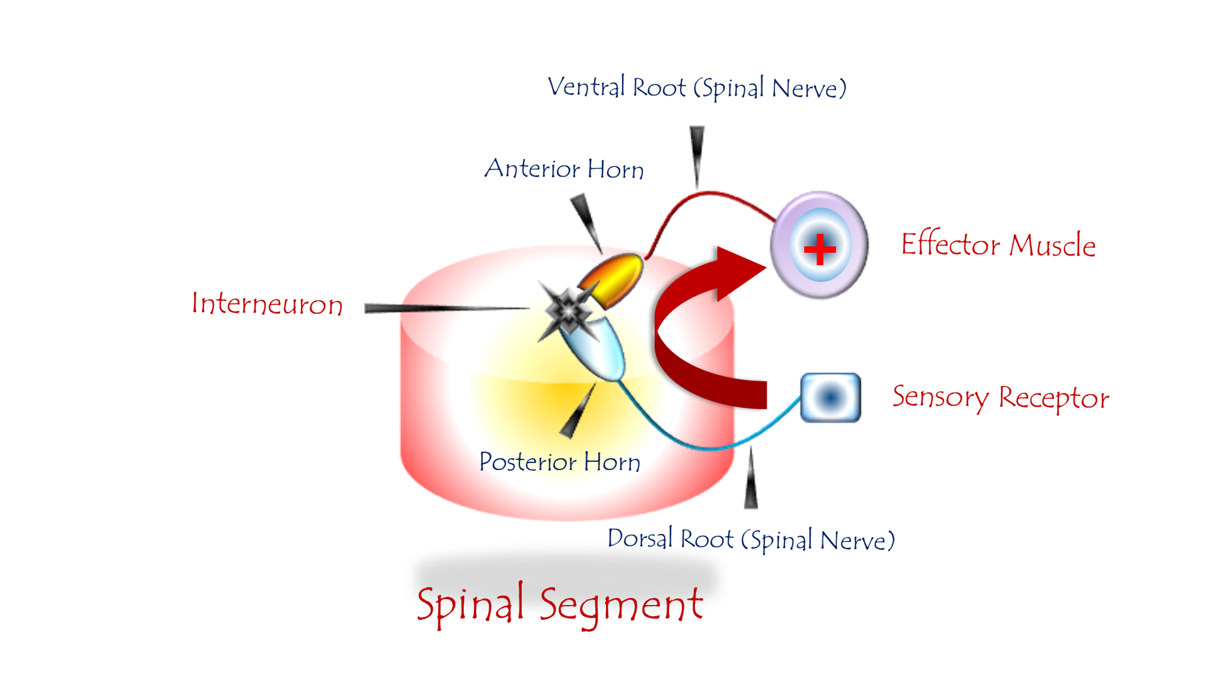
Figure 1: The Spinal Reflex (Traditional Conception)
To watch a brief video explaining the classic physiology of the spinal reflex, click this link:
The spinal reflex circuit comprises three elements:
- Sensory Neuron (SN)
- Interneuron (Intermediate Neuron)
- Lower Motor Neuron (LMN)
Neuroanatomical Localization:
Component | Location
Sensory Neuron (SN) | Spinal ganglion of the dorsal root
Interneuron | Posterior horn of the spinal cord
Lower Motor Neuron (LMN) | Anterior horn of the spinal cord
All neural elements reside within one or two adjacent spinal segments.

Physiological Sequence (Traditional View):
- Sensory input arrives at the sensory neuron (SN).
- Excitation is relayed via an interneuron to the lower motor neuron (LMN).
- The sensory input carries a binding motor command that mandates execution.
- LMNs promptly issue motor orders to effector targets.

Role of the Upper Motor Neuron (UMN):
The UMN remains detached from the decision site. It merely:
- Monitors reflex activity
- Evaluates reflex performance...without direct engagement in the reflex execution.

2. The Spinal Reflex: A Novel Physiological Perspective
(The Upper Motor Neuron Circuit)
"The spinal reflex is not a segmental automation but a brain-orchestrated symphony."
To watch a brief video explaining the modern physiology of the Spinal Reflex,
click this link:
It is a fresh perspective on the physiology of the spinal reflex, one that will undoubtedly clash with diehard proponents of the old, traditional view. Nevertheless, I intended it to be new, modern, and consistent with my convictions, making it easier to explain what has long resisted comprehension. By this latter point, I specifically mean the pathophysiology of hyperreflexia, clonus, and many other phenomena.
In normal circumstances, the brain acts as the supreme controller over all sensory afferent input, as well as all motor efferent output. All data is at its complete disposal, subject to its study and analysis. Subsequently, it holds the decision-making authority for the appropriate reaction or reactions. In this lies the new and unprecedented claim I assert.
Thanks to the brain, each spinal reflex retains its own independent circuit, separate from others. It is a complete circuit in all aspects. First, there are the trigger points – specialized sensory receptors endowed with an innate functional specificity from the initial development. These have an afferent pathway: a specialized afferent sensory neural fiber (axon), with unique characteristics for each receptor type. They connect to a sensory neuron, residing in the ganglion of the posterior root of the spinal nerve. From there, an ascending tract originates, carrying the afferent neural signals to specialized centers within the brain.
From there (the brain), following deliberation and processing, the efferent motor signal descends via the descending motor tracts to the lower motor neuron in the anterior horn of the spinal cord.
This lower motor neuron, in turn, transmits the motor command to the execution apparatus via an efferent motor axon (neural fiber). The target organ receives the motor command and responds according to its predetermined functional programming established at inception.
This is my personal conception of the Spinal Reflex Circuit. It fundamentally contradicts the currently prevailing model in one essential element of its circuitry: the Brain.
The Brain is absent from what they have claimed, and continue to claim, constitutes the Spinal Reflex Circuit. Yet, the Brain is the very foundation of the reflex according to my claim. As I see it, the Brain is what bestows upon the Spinal Reflex its value of existence and its essence of being.
The Brain forms the central nexus of the Spinal Reflex and sits at the apex of its hierarchy. Thanks to the Brain, the Spinal Reflex acquires its: purpose, logic, direction, uniqueness (singularity), and finally, its coherence with the actual nature and reality of the absolute triggering Stimulus.
Consequently, stimulating the receptor field of a specific spinal reflex elicits a motor response unique to that reflex. It is a singular, unrepeatable response – qualitatively specific to the reflex under study, precisely regulated in intensity and force, and directed exclusively toward the site of stimulation. All of this is achieved by virtue of the brain's wisdom and accumulated experience in confronting urgent emergencies.
As for the elements of the lower circuit, they maintain strict passivity and neutrality in every respect. They merely transmit the cerebral command, ensure its optimal execution, and deliver it to the execution apparatus – nothing more. (See Figure 2).
Here, despite the multiplicity of synaptic relays I propose, I harbor no doubt regarding either transmission speed or processing immediacy. The intelligence I speak of in this context is that of the organism—not human cognition. The distinction between the two is profound. Neural conduction along axons and across synapses operates at velocities far exceeding what we were taught for decades, and through mechanisms altogether different from those traditionally described.

N.B.
For further validation, readers may consult my articles:
'Neural Transmission: Between Deficient Heritage and Present Innovation'
and
'Neural Transmission Across Synapses'

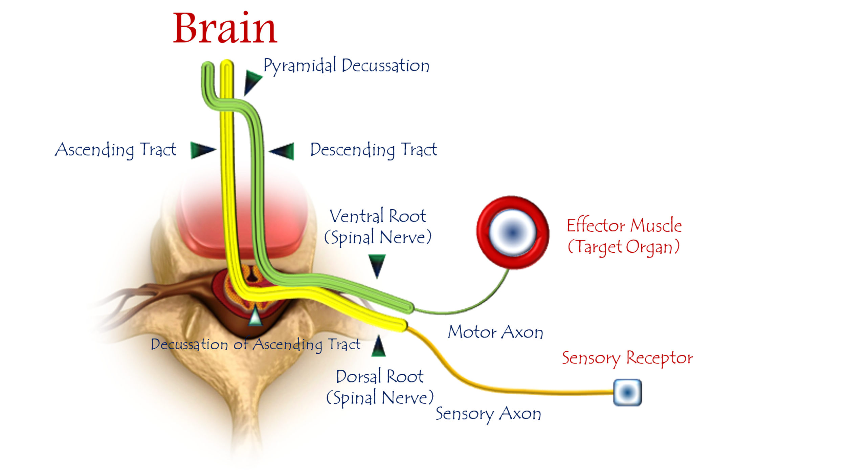
Figure 2: The Innovated Physiology of the Spinal Reflex
(The Upper Motor Neuron Circuit)
For details, see linked video:

Core Tenets of the Innovated Model
My theory redefines spinal reflexes as brain-supervised processes, rejecting the classical segmental view. The sequence is:
- Afferent Sensory Impulses
  - Terminate at sensory neurons (spinal ganglia).
- Ascending Neural Tracts
  - Relay impulses to specialized brain centers.
- Brain Processing
  - Analyzes data, formulates context-specific motor decisions.
- Upper Motor Neuron (UMN) Command
  - Receives conclusions and issues precise motor orders.
- Descending Motor Pathways
  - Deliver efferent commands via corticospinal tracts.
- Lower Motor Neuron (LMN) Execution
  - Executes orders at target organs (muscles/glands).

"The brain is the conductor—without it, reflexes lack purpose, direction,
and precision."

Key Innovations vs. Traditional Model
Aspect | Traditional Model | Innovated Model
Reflex Initiation | Spinal interneurons | Sensory receptors → Brain
Decision Authority | Segmental spinal circuits | Cortical/UMN integration
Role of UMN | Absent/Passive | Central commander
Response Specificity | Stereotyped | Contextually tailored
Speed Justification | "Rapid" spinal loops | Faster neural transmission claimed

Pathophysiological Implications
- UMN Lesions → Pathological "Reflexive Movements":
Loss of brain oversight unleashes unmodulated spinal outputs (e.g., spasticity, clonus).
- Hyperreflexia ≠ "True Reflexes":
These are distorted spinal reactions, not preserved evolutionary reflexes.

Theoretical Foundations
- Brain as Reflex Architect:
  - Assigns purpose, logic, and spatial specificity.
- Passive Spinal Elements:
  - LMNs/interneurons merely relay commands—"completely neutral and passive".
- Neural Speed Defense:
  - Synaptic transmission is faster than traditionally taught.

Conclusion: Paradigm Shift
This model positions the brain as the non-negotiable center of spinal reflexes:
- Reflexes gain functional meaning only through cortical integration.
- UMN lesions expose primitive spinal patterns—not "released" reflexes.
- Validates top-down neuromodulation for spasticity management.

"The spinal reflex is not a segmental automation but a brain-orchestrated symphony."

3. Spinal Hyperreflexia: Pathophysiology
(The Lower Motor Neuron Circuit)
"This circuit isn't just damaged—it's rebelliously autonomous."
To watch a brief video explaining the pathophysiology of the Spinal Hyperreflexia,
click this link:

The Lower Motor Neuron (LMN) Circuit is a Pathological Circuit that forms secondarily to the interruption of neural transmission between the Upper Motor Neuron (UMN) and the Lower Motor Neuron (LMN).
The LMN, by means of a group of interneurons, succeeds in securing neural transmission flow by networking with sensory neurons at its own spinal level as well as at adjacent levels. The LMN interprets sensory stimuli (originating from sensory neurons) as motor commands requiring execution. For the LMN, neural transmission flow is genderless (i.e., it cannot distinguish signal sources). All neural transmissions carry both the energy of action and the authority of command (instructional validity); see Figure (3)."
It is a Vicious Circuit. Once established, it reinforces its own structural elements and carves deep pathways, rendering it virtually impossible for the organism to dismantle its connections thereafter.
Suppose the organism eventually succeeds in restoring the neural transmission bridges between the Upper Motor Neuron (UMN) and the Lower Motor Neuron (LMN). At that point, the descending transmission current from the higher centers will collide with an impervious functional fortress formed by the interconnected elements of the LMN circuit.
The fledgling lower circuit is vigorous and robust, while the upper circuit remains frail, laboriously carving its descending path through the debris of compressive forces and subsequent reparative processes. In truth, the Lower Motor Neuron circuit is an agent of harm that burdens the prognosis in Upper Motor Neuron lesions.
This is the circuit of the ill-fated hyperreflexic spinal reflex – the defining hallmark of all Upper Motor Neuron (UMN) Lesions. Once this circuit is established, sensory afferent input bypasses higher centers, transferring directly from its peripheral sources (the Sensory Receptors / Trigger Points of the spinal reflex) to the Lower Motor Neuron (LMN), which becomes the new motor commandant.
The Brain, meanwhile, is displaced – absent from the arena of perception and action. Actions below the level of injury escape regulation and control, resulting in movements that are:
- Involuntary,
- Crude,
- Discoordinated,
- Unmodulated in intensity,
- And devoid of purpose.
These are the quintessential acquired characteristics of the hyperreflexic spinal reflex (See Figure 3).

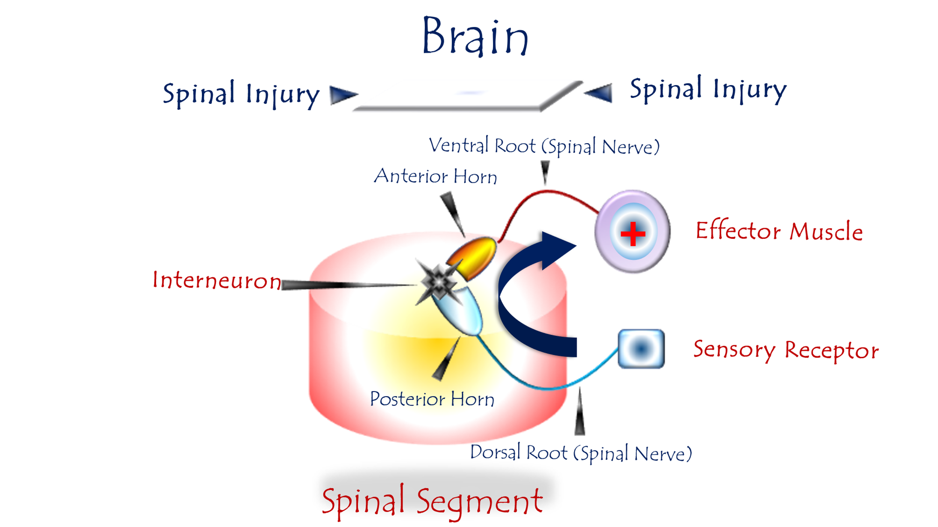
Figure 3: Pathophysiology of Spinal Hyperreflexia
(The Lower Motor Neuron Circuit)
For video explanation, click:

Core Mechanism: Pathological Rewiring Post-UMN Lesion
Trigger: Disconnection between upper motor neurons (brain) and lower motor neurons (spinal cord).
Response: Spinal elements form an aberrant self-sustaining circuit through:
- Novel Neural Bridges
  - LMNs, sensory neurons, and interneurons forge new synaptic connections (same/adjacent segments).
- Sensory-Motor Hijacking
  - Sensory neurons dump raw, unprocessed input directly onto LMNs.
- Signal Misinterpretation
  - LMNs treat all sensory signals as "mandatory motor commands.
"The LMN circuit becomes a dictator—issuing orders without context or restraint."

Pathological Characteristics
Feature | Consequence
Unfiltered Input | Sensory impulses bypass brain modulation → Sensory bombardment
Non-Selective Execution | LMNs execute all signals → Non-graded, explosive movements
Functional Incompetence | Responses mismatch stimulus intensity/purpose → Maladaptive outputs
Circuit Entrenchment | Becomes a "functional fortress" resisting cortical reintegration
Clinical Manifestations:
- Spasticity, clonus, Babinski sign
- Coarse involuntary movements
- Loss of fine motor control

Why This Circuit Dooms Recovery
- Blocks Cortical Reconnection
  - Even if UMN pathways heal, the entrenched LMN circuit intercepts descending commands.
- Self-Reinforcing Vicious Cycle
  - Synaptic strengthening makes disruption progressively harder.
- Worsens Prognosis
  - Primary reason for treatment-resistant spasticity in chronic UMN lesions.

"This circuit isn't just damaged—it's rebelliously autonomous."

Contrast: Normal vs. Pathological LMN
Function | Healthy LMN | Pathological LMN Circuit
Input Processing | Receives filtered brain orders | Interprets raw sensory noise
Output Control | Precision movements | Explosive, uncoordinated actions
Hierarchy | Subordinate to brain | Self-governing "dictatorship"
Adaptability | Context-appropriate responses | Stereotyped, non-adaptive reactions

Therapeutic Implications
Intervention Goals:
- Prevent Circuit Formation
  - Early neuromodulation.
- Disrupt Existing Circuit
  - Intrathecal baclofen: Suppresses synaptic hyperactivity.
  - Botulinum toxin: Chemically denervates overactive LMNs.
- Cortical Bypass Strategies
  - Brain-computer interfaces to reroute motor commands.

Prognostic Reality:
- Once solidified, the circuit becomes a permanent pathological entity.
- Explains why chronic spasticity rarely fully resolves.

Conclusion: The Autonomy of Dysfunction
This model reframes hyperreflexia as:
"A self-organized neural insurgency—where spinal elements seize control, executing chaos without purpose or permission."
This circuit embodies the tragic paradox of neuroplasticity: The same adaptability that enables recovery also forges chains of permanent dysfunction.

3.1 Pathophysiology of Overactive Spinal Hyperreflexia
"The LMN becomes a puppet to sensory tyranny—every whisper becomes a shout."
(Feather touch → Hammer-like reflex)
To watch a brief video explaining the pathophysiology of the Overactive Spinal Hyperreflexia, click this link:
Under normal conditions – where the brain maintains supreme control over all sensory afferent input and motor efferent output – each spinal reflex retains its own dedicated, self-contained circuit.
Stimulating a specific spinal reflex’s receptor field elicits a motor response that is:
unique to that reflex, singular and unrepeatable, qualitatively specific, precisely modulated in intensity/force, spatially targeted to the site of stimulation.
Conversely, in Upper Motor Neuron (UMN) injuries, the brain becomes functionally absent, and regulatory control collapses. In this void, interneurons activate to fill the functional deficit. They reactivate ancient, abandoned neural pathways dating back to early infancy. And/or forge entirely new neural circuits with no prior anatomical existence.
These interneurons aberrantly link sensory neurons with motor neurons residing in the anterior horn of the same spinal segment and ipsilateral side. Consequently, novel neural circuits emerge – functionally aberrant entities that constitute the Hyperreflexia Circuit.
When this emergent circuit is stimulated, neural signals propagate directly: from Sensory Receptor →Sensory Neuron → Interneuron→ Lower Motor Neuron (LMN) →Target Muscle (Effector).
Here – due to the functional absence of the brain – afferent signals undergo zero processing or modulation. Instead, they dump their full energetic load directly onto the LMN.
Consequently, the LMN's output becomes: violent, abrupt, biologically incoherent, disproportionate to stimulus intensity. This constitutes the precise essence of Overactive Hyperreflexia – a response stripped of biological purpose, governed solely by pathological signal amplification (See Figure 4).

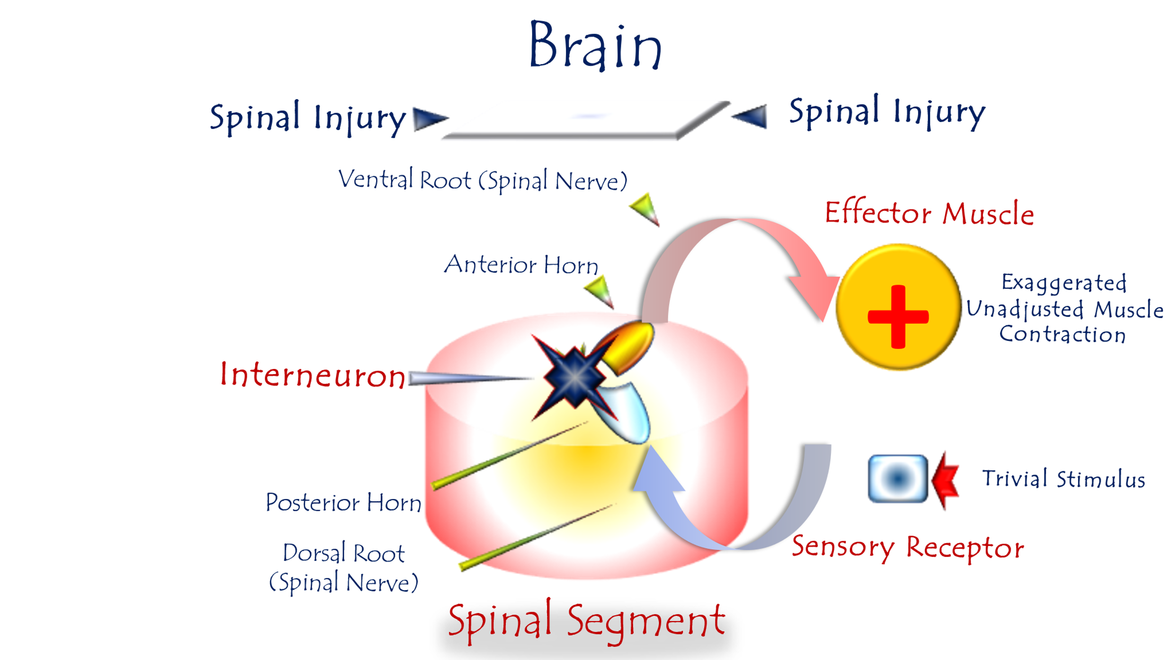

Figure 4: Pathophysiology of Overactive Spinal Hyperreflexia
For video explanation, click here

Core Mechanism: Pathological LMN-SN Coupling
Trigger: Loss of UMN control → LMN develops "energy hunger"
Response:
- Aberrant Synapse Formation
  - LMN directly connects with sensory neurons (SN) in the same or adjacent spinal segment.
- Sensory Signal Hijacking
  - SN dumps raw, unprocessed sensory data onto LMN (throwing its full load into LMN's lap).
- Emergency Motor Interpretation
  - LMN misinterprets all sensory input as high-priority motor commands.
"The LMN becomes a puppet of sensory chaos—every whisper becomes a scream for action."
Functional Consequences
Normal UMN Function | Pathological LMN Response
Sensory Refinement | Raw sensory bombardment (no filtering)
Motor Dose Calibration | Explosive, non-graded output
Contextual Adaptation | Stereotyped violence to mild stimuli
Clinical Hallmarks:
- Disproportionate Reflexes: e.g., Light touch triggers limb jerk
- Clonus: Self-sustaining oscillations (foot tapping → sustained ankle beating)
- Loss of Spatial Specificity: Reflex spreads beyond stimulus site

Why "Overactivity" Emerges
- Functional absence of brain oversight
- Unmodulated "sensory dumping" onto LMNs
- Lost Inhibitory Gates
  - Absent UMN suppression (e.g., corticospinal GABAergic control)
- Signal Amplification
  - Interneurons boost sensory gain by 200-400% (compensatory hyperactivity)
Therapeutic Implications
Intervention Targets:
Goal | Approach
Block Aberrant Synapses | Botulinum toxin (SN-LMN junction)
Dampen Sensory Noise | GABA agonists (baclofen), vibration therapy
Restore Inhibition | rTMS to stimulate residual UMN pathways
Prognostic Reality:
- Once entrenched, the circuit becomes autonomous (self-nourishing energy loop).
- Explains why chronic hyperreflexia resists treatment.

Conclusion: Neurology of Dysregulation
This model reveals overactive hyperreflexia as:
"A perfect storm of neural desperation—starved of brain governance, the LMN forges reckless alliances, turning sensory whispers into motor thunder."
This explains three clinical paradoxes:
- Why mild stimuli trigger violence (lost sensory refinement)
- Why reflexes lack gradation (absent motor dosing)
- Why recovery plateaus (entrenched pathological autonomy)

3.2 Pathophysiology of Bilateral-Response Spinal Hyperreflexia
"One sensory whisper becomes a bilateral motor shout."
To watch a brief video explaining the pathophysiology of the Bilateral-Response Spinal Hyperreflexia, click this link:

Under normal conditions – where the brain maintains supreme control over all sensory afferent input and motor efferent output – each spinal reflex retains its own dedicated, self-contained circuit.
Stimulating a specific spinal reflex’s receptor field elicits a motor response that is:
unique to that reflex, singular and unrepeatable, qualitatively specific, precisely modulated in intensity/force, spatially targeted to the site of stimulation.
Conversely, in Upper Motor Neuron (UMN) Injuries, the brain becomes functionally absent, and regulatory control collapses. In this void, interneurons activate to fill the functional deficit. They reactivate ancient neural pathways abandoned since early infancy, and/or forge entirely new neural circuits that never existed before. These interneurons interlink with sensory neurons and motor neurons – both ipsilaterally and contralaterally – within the same spinal segment.
Consequently, the hyperreflexia circuit on one side merges with its contralateral counterpart into a single, monolithic aberrant functional circuit: the Bilateral-Response Hyperreflexia Circuit. Stimulating the reflex circuit on either side now triggers a motor response in both limbs simultaneously – this defines the core concept of Bilateral Response. (See Figure 5).
Critically, interneurons serve as the central orchestrators. They become the conductive bridge between both poles of the pathological spinal reflex – connecting sensory neurons with lower motor neurons bilaterally.

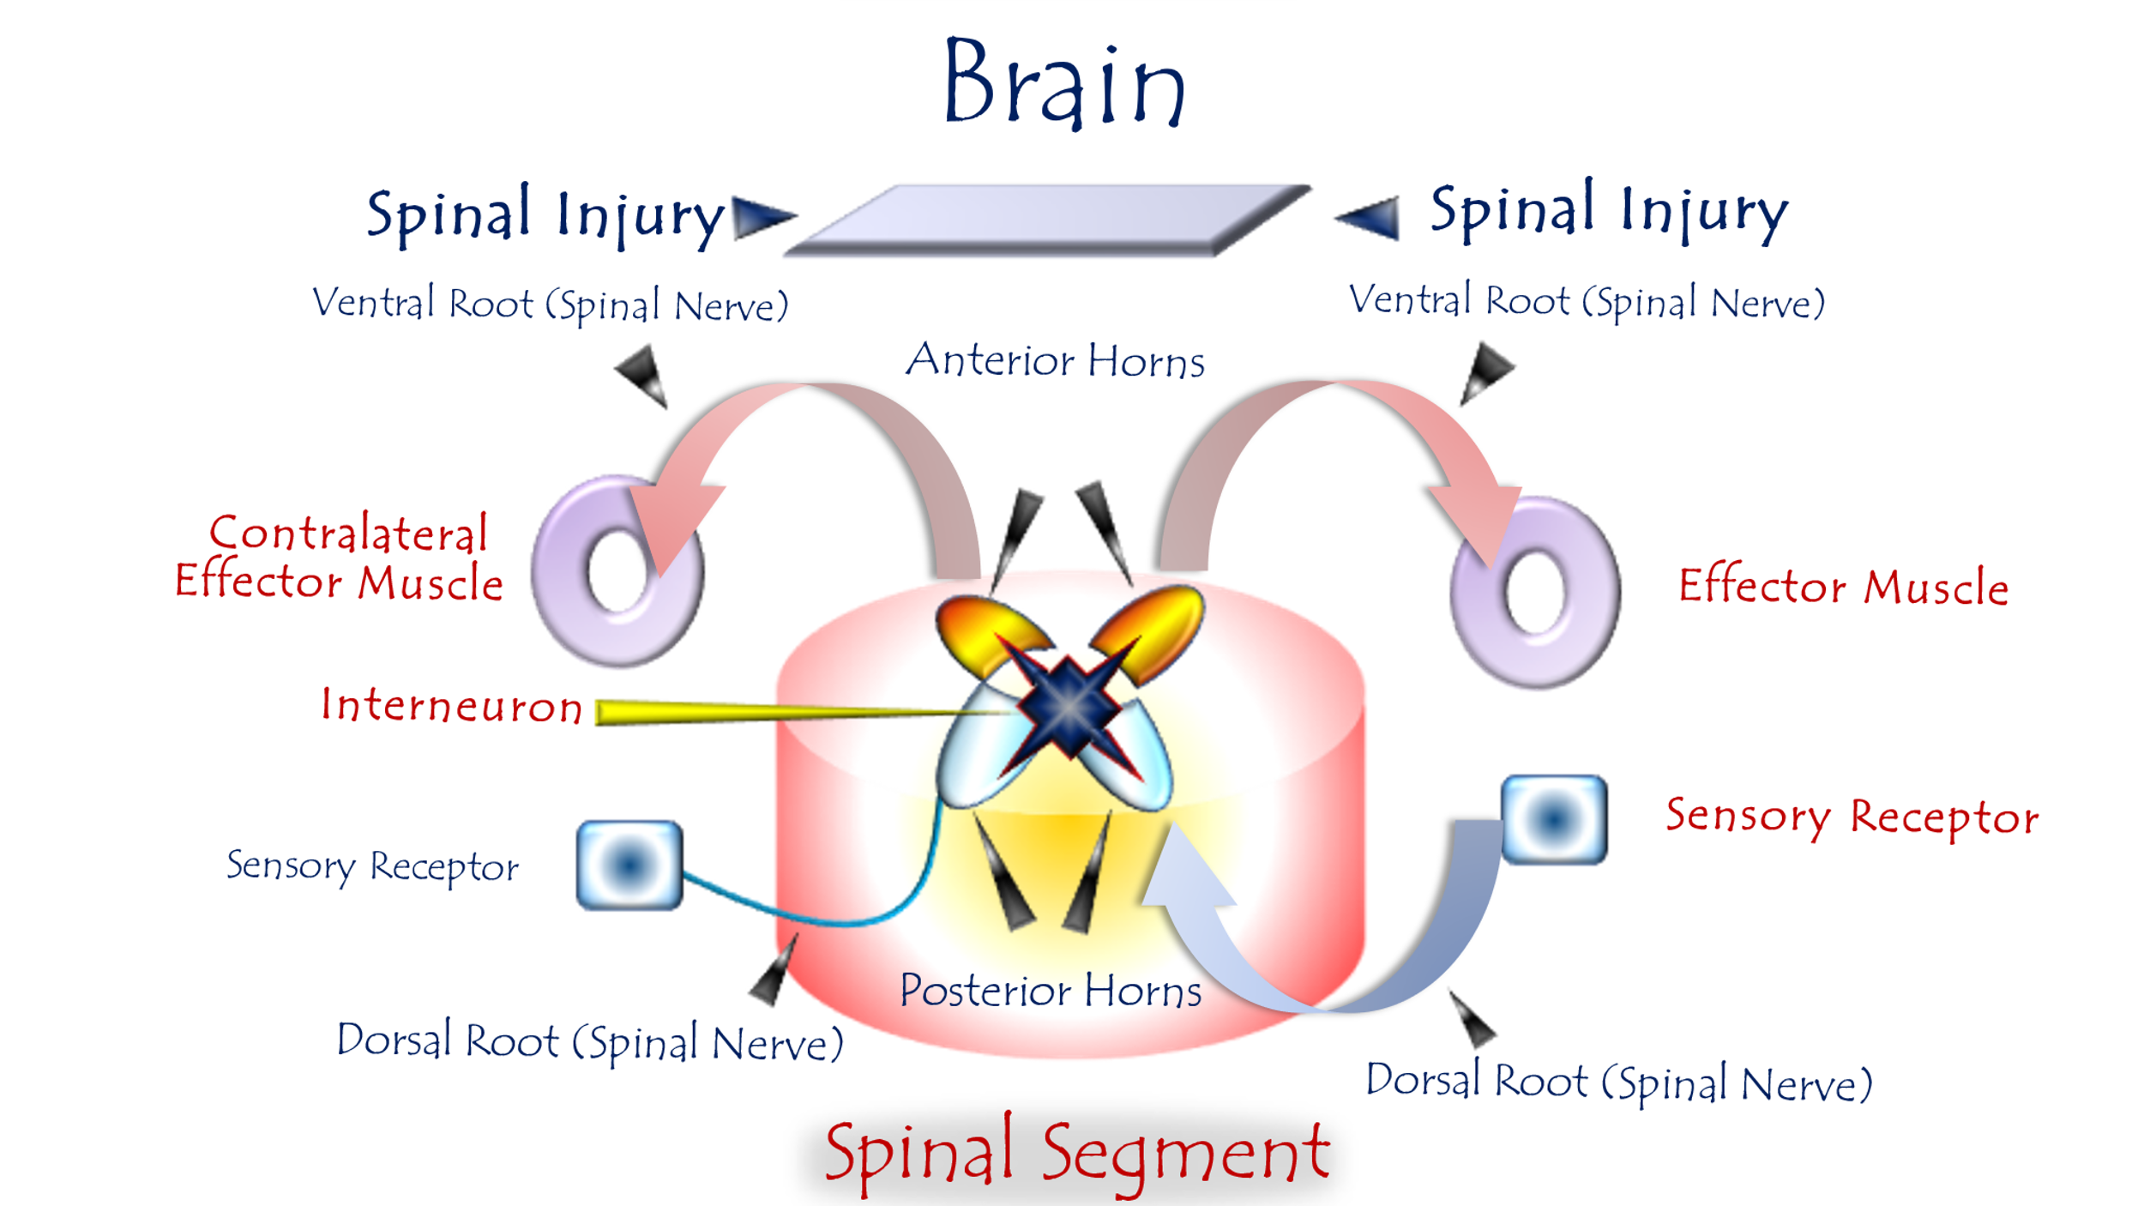

Figure 5: Pathophysiology of Bilateral-Response Spinal Hyperreflexia
For video explanation, click here

Core Mechanism: Pathological Cross-Wiring
Trigger: Loss of UMN control → Spinal neural autonomy
Response: Aberrant sensory-motor bridging across spinal segments:

Key Pathological Features
Normal Physiology | UMN Lesion Pathology
Unilateral stimulus → Unilateral response | Unilateral stimulus → Bilateral motor output
Strict somatotopic containment | Cross-segmental/cross-lateral signal spillover
Cortical gating of neural overflow | Unchecked interneuronal crosstalk
Clinical Hallmarks:
- Patellar tap (one knee) → Bilateral knee extension
- Plantar stimulation → Bilateral Babinski responses
- Loss of reflex lateralization
Role of Interneurons: The Chaos Architects
- Cross-Midline Signal Bridges
  - Forge abnormal connections
- Signal Amplifiers
  - Boost sensory gain 200-400% via glutamatergic hyperactivity
- Synchronizers
  - Phase-lock LMN firing across hemispheres (→ mirror movements)

"One sensory whisper becomes a bilateral motor shout."
Why Recovery Fails
- Self-Reinforcing Circuit
  - Reciprocal excitation: Contralateral LMN activation → Re-excites interneurons
- Glial Scarring
  - Astrocytic barriers block cortical reintegration
- Neuroplasticity Trap
  - Maladaptive synapses strengthen with time (the pathological circuit digs its own trenches)
Therapeutic Strategies
Goal | Approach | Limitations
Disrupt Cross-Talk | Intrathecal baclofen/GABA agonists | Systemic side effects
Desensitize Pathways | Contralateral vibration therapy | Temporary relief
Neural Resegmentation | Dorsal root entry zone (DREZ) lesioning | Irreversible damage
Prognostic Insight:
Bilateral responses indicate advanced circuit entrenchment → Predicts poor rehabilitation outcomes.
Conclusion: The Neurology of Spilled Signals
This model reveals bilateral hyperreflexia as:
"A neural insurrection against somatotopy—where sensory impulses breach spinal cord borders, hijacking motor outputs on both sides."
This explains:
- Why focal stimuli trigger global responses (lost spatial containment)
- Why "mirroring" worsens over time (self-reinforcing circuit)
- Why bilateral hyperreflexia = poor prognostic sign (irreversible maladaptive plasticity)

3.3 Pathophysiology of Extended Spinal Hyperreflexia
"The LMN becomes a desperate monarch—welcoming sensory envoys from any spinal province."
To watch a brief video explaining the pathophysiology of the Extended Spinal Hyperreflexia, click this link:
Under normal conditions – where the brain maintains supreme control over all sensory afferent input and motor efferent output – each spinal reflex retains its own dedicated, self-contained circuit.
Stimulating a specific spinal reflex’s receptor field elicits a motor response that is:
unique to that reflex, singular and unrepeatable, qualitatively specific, precisely modulated in intensity/force, spatially targeted to the site of stimulation.
Conversely, in Upper Motor Neuron (UMN) Injuries, the brain becomes functionally absent, and regulatory control collapses. In this void, interneurons activate to fill the functional deficit. They reactivate ancient neural pathways abandoned since early infancy, and/or forge entirely new neural circuits that never existed before.
These interneurons establish connections between sensory neurons and motor neurons within their native spinal segment (e.g., Segment X) on the ipsilateral side. Simultaneously, they extend their synaptic reach to incorporate additional cohorts of interneurons and active sensory neurons from adjacent spinal segments (Segment X+1 and/or X-1). Consequently, an expanded contingent of sensory neurons – along with their associated sensory receptors – become recruited into the hyperreflexic circuit originally localized to spinal segment X. (Figure 6).
For example, in healthy individuals, striking the patellar tendon elicits the specific knee jerk reflex (quadriceps contraction). Conversely, in hyperreflexic states: Percussing the muscle belly itself, or even scratching the overlying skin
may trigger pathological reflexogenic muscle contraction.
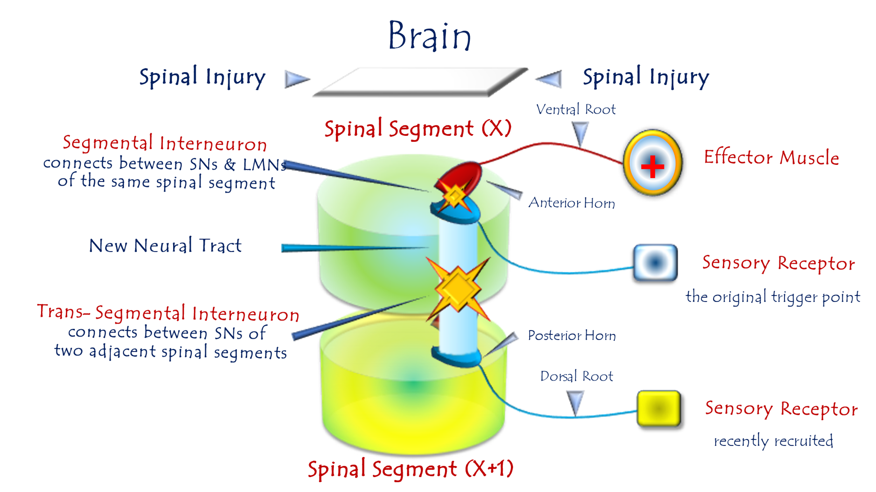
Figure 6: Pathophysiology of Extended Spinal Hyperreflexia
For video explanation, click here
Core Mechanism: Multi-Segmental Hijacking
Pathogenesis: Post-UMN lesion → LMNs forge aberrant alliances with sensory neurons across multiple spinal segments:
Key Pathological Features
Normal Reflex | Extended Hyperreflexia
Stimulus confined to specific receptor field | Stimuli anywhere in expanded sector trigger response
Segmental precision (e.g., L4-only) | Multi-segmental spillover (L3-L5)
Requires high-specificity triggers | Low-threshold/non-specific activation
Clinical Example:
- Normal: Knee jerk requires patellar tendon strike (L2-L4)
- Pathological:
  - Skin scratch over thigh → Quadriceps contraction
  - Calf muscle percussion → Quadriceps contraction
  - Foot pressure → Quadriceps contraction
Neurophysiological Basis
- Denervation Hypersensitivity
  - LMNs develop "synaptic hunger," accepting inputs from ANY sensory neuron
- Interneuron Complicity
  - Mediate connections between LMNs and distant sensory pools
- Signal Amplification
  - Stimuli gain 200-400% potency via glutamatergic overdrive
"The LMN becomes a desperate monarch—welcoming sensory envoys from any spinal province."
Why Extension Worsens Prognosis
- Treatment Resistance
  - Blocking one sensory input fails (redundant pathways)
- Self-Reinforcing Loop
- Functional Disability
  - Simple touch triggers disabling spasms
Therapeutic Strategies
Goal | Approach | Efficacy
Contain Expansion | Segmental dorsal root ganglion (DRG) blocks | Moderate (temporary)
Dampen Hyperexcitability | Intrathecal ziconotide (Ca²⁺ channel blocker) | High (risk heavy)
Restore Inhibition | Repetitive transcranial magnetic stimulation (rTMS) | Limited in chronic cases
Critical Insight:
Extended sectors indicate irreversible maladaptive plasticity → Focus shifts from cure to symptom management.
Conclusion: Neurology of Territorial Invasion
This model defines extended hyperreflexia as:
"A sensory insurgency without borders—where LMNs surrender to any stimulus, turning the spinal cord into an anarchic reflex free-for-all."
This explains three clinical imperatives:
- Avoid sensory provocation in UMN lesion patients
- Prioritize early intervention before segmental spread
- Accept functional trade-offs in chronic cases (e.g., partial denervation)

3.4 Pathophysiology of Multi-Motor-Response Spinal Hyperreflexia
A neural coup d'état – where interneurons dissolve segmental borders, conscripting motor circuits into a chaotic hive-mind."
To watch a brief video explaining the pathophysiology of the Multi-Motor Spinal Hyperreflexia, click this link:
Under normal conditions – where the brain maintains supreme control over all sensory afferent input and motor efferent output – each spinal reflex retains its own dedicated, self-contained circuit.
Stimulating a specific spinal reflex’s receptor field elicits a motor response that is:
unique to that reflex, singular and unrepeatable, qualitatively specific, precisely modulated in intensity/force, spatially targeted to the site of stimulation.
Conversely, in Upper Motor Neuron (UMN) Injuries, the brain becomes functionally absent, and regulatory control collapses. In this void, interneurons activate to fill the functional deficit. They reactivate ancient neural pathways abandoned since early infancy, and/or forge entirely new neural circuits that never existed before.
Occasionally, this aberrant networking achieves extraordinary scope – incorporating distant and proximate segments, functionally synergistic and antagonistic muscle groups, into a single pathological functional unit: the maladaptive Lower Motor Neuron Circuit.
Here, stimulating any single component of these newly interconnected circuits simultaneously activates the entire network. The resultant motor output manifests as discoordinated, biological orphaned movements– actions devoid of purpose or functional coherence.
Striking the right patellar tendon elicits right knee extension – this constitutes the normal response. In pathological hyperreflexic states, the same stimulus may additionally trigger right hip flexion.
Through this same mechanism, we can explain numerous pathological reflexes and signs hallmarking Upper Motor Neuron (UMN) lesions – including Hoffman's Sign, Babinski's Sign, and Muscle Spasms. All stem from emergent, multi-segmented aberrant lower circuits.
Thus, Hoffman's Sign and Babinski's Sign represent pathological reawakenings of ancient phylogenetic alliances – partnerships between functionally synergistic neural circuits preserved from our earliest developmental blueprint.
Conversely, muscle spasms often emerge from newly forged, pathologically illicit partnerships between intrinsically antagonistic neural circuits.
In this latter case (antagonistic circuits), I assert: Functional partnerships between antagonistic circuits are biologically condemnable at the motor level – and far more deleterious than synergistic circuit alliances.
Moreover, antagonistic partnerships may underlie a broader spectrum of clinical manifestations in spastic paralysis, chief among them: Muscle Rigidity, Muscle Weakness, Neuromuscular Fatigue. (Figure 7).

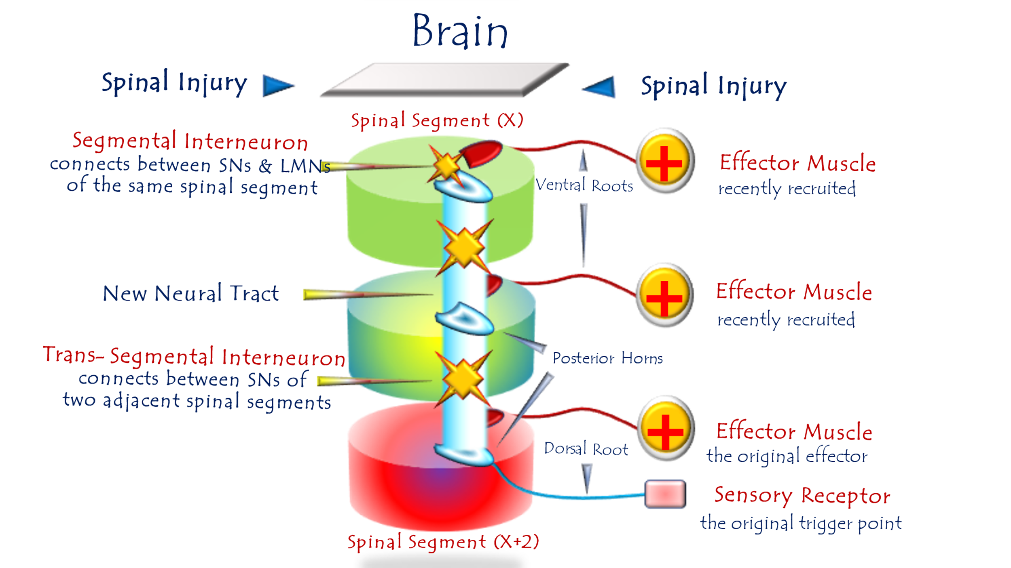
Figure 7: Pathophysiology of Multi-Motor-Response Spinal Hyperreflexia
For video explanation, click here:
Core Mechanism: Pathological Circuit Fusion
Process: Post-UMN lesion → Interneurons bridge hyperreflex circuits across adjacent spinal segments (X, X+I, X+II), creating a unified aberrant network.
Key Pathological Features
Normal Physiology | Multimotor Hyperreflexia
1 stimulus → 1 motor response | 1 stimulus → Multiple motor responses
Segmental isolation | Cross-segmental circuit fusion
Functionally specific | Discordant, non-purposeful outputs
Clinical Examples:
- Patellar tap (L4) → Knee extension + Hip flexion
- Plantar stimulus → Babinski sign + Toe fanning
Neurophysiological Basis
- Interneuron Hyperactivity
- Loss of Inhibitory Control
  - Absent cortical GABAergic suppression → Unchecked signal spread
- Maladaptive Synaptic Potentiation
  - "Silent synapses" in adjacent segments activated → Circuit integration
"Interneurons become anarchist unifiers—melting spinal segments into a single pathological entity."
Why Multimotor Responses Worsen Disability
- Energy Waste
  - Co-contracting muscles cancel useful movement → Net weakness
- Functional Chaos
  - Walking attempt → Leg extension + hip flexion + foot inversion (→ fall risk)
- Metabolic Exhaustion
  - Futile contractions deplete ATP → Early fatigue
Therapeutic Challenges & Strategies
Challenge | Intervention | Limitations
Circuit Redundancy | Dorsal root ganglion (DRG) radiofrequency ablation | Temporary relief
Glutamatergic Storm | Intrathecal riluzole (glutamate inhibitor) | CNS side effects
Irreversible Fusion | Functional electrical stimulation (FES) | Retrains circuits, not curative
Prognostic Reality:
Multimotor responses signal end-stage maladaptive plasticity → Focus shifts to palliative symptom control.
Clinical Correlation:
Pathological Reflex | Mechanism
Babinski Sign | Fusion of plantar + toe extension circuits
Hoffman Sign | Fusion of finger flexion + wrist flexion circuits
Muscle Spasm | Agonist-antagonist co-activation (e.g., biceps/triceps)
Rigidity | "Condemned partnership" of antagonistic circuits
"Rigidity is the price of forced neural alliances – enemies shackled together, waging constant war."

Conclusion: Neurology of Forced Unity
This model defines multimotor hyperreflexia as:
"A neural coup d'état – where interneurons dissolve segmental borders, conscripting motor circuits into a chaotic hive-mind."
This explains three clinical imperatives:
- Early intervention prevents circuit fusion
- Antagonistic co-activation is the chief driver of disability
- Rigidity ≠ spasticity – requires targeted therapy

3.5 Pathophysiology of the Triple Flexion Reflex
"The reflex becomes an empty ritual—performed without purpose, abandoned without resolution"
Functional Abolishment:
In UMN lesions, due to loss of conscious supraspinal command, reflexes forfeit their fundamental biological purpose. They degrade into incoherent movements devoid of meaning and utility.
The Withdrawal Reflex
A protective reflex comprising two integrated components:
- Involuntary Reflex Arc (Non-conscious loop)
- Voluntary Conscious Response (Cortically modulated escape strategy)
Physiology of the Protective Withdrawal Reflex
Pathway Activation:
Involuntarily, a painful stimulus to the great toe triggers the reflex arc. This initiates:
- Dorsiflexion of the ankle
- Flexion of the knee
- Flexion of the hip
Sustained Response Mechanism:
Higher centers:
- Perceive the noxious nature of the stimulus
- Recognize ongoing danger while contact persists
Consequently, supraspinal command centers issue sustained motor commands to maintain limb withdrawal – this constitutes the volitional, rational component of the reflex for continuous protection.
Key Neurophysiological Principles
Component | Mechanism | Clinical Significance
Involuntary Reflex Arc | Dorsiflexion-Knee-Hip Flexion | Initial escape from harm
Voluntary Conscious Response | Cortical assessment of threat duration | Prevents re-injury during sustained danger
Temporal Integration | Reflex duration = Stimulus duration | Adaptive biological preservation
Pathological Transformation in UMN Lesions
- Stimulus Degradation:
Non-painful foot stimuli can trigger the reflex (Loss of nociceptive specificity → receptor field expansion)
- Temporal Disintegration:
The triple flexion lasts mere seconds – indifferent to stimulus persistence
(Absent cortical threat assessment → spinal signal storm without purpose)
Rationale for Renaming:
The altered characteristics and complete loss of defensive function compelled experts to designate a new term for this pathological state. The designation 'Triple Flex Reflex' most accurately captures its mechanistic reality – distinguishing it from the physiologically integrated Withdrawal Reflex.
Normal Reflex | Pathological Reflex
Withdrawal Reflex | Triple Flex Reflex
• Biologically purposeful | • Functionally orphaned
• Stimulus-specific (nociceptive) | • Stimulus-indiscriminate
• Duration = Threat duration | • Fixed-duration storm (3-5 sec)
• Integrated cortical-spinal loop | • Isolated spinal arc
The Ontological Degradation of Sensory Input in Triple Flexion Reflex
Noxious and non-noxious stimuli alike generate an Action Pressure Wave – a deaf wave stripped of all meaning save the authority of command. Only higher centers imbue such waves with purpose, context, and conscious perception.
In the triple flexion reflex, every potential meaning of the incoming impulse is extinguished. No longer does it carry perceptible sensory significance as ordained since life's dawn. Instead, it degenerates into a mere pressure wave propagating through neural conduits – hollow of meaning yet potent in command.
Mechanistic Consequence:
Thus, the action pressure wave plunges directly from receptive fields to effector muscles. Its energy rapidly depletes like a dying ripple, rendering the pathological reflex:
- Transient
- Stimulus-duration independent
- Biologically decoupled from its raison d'être
Actually, in UMN lesions, sensory input degenerates from perceived experience to mechanical wave – executing neurologically orphaned movements that parody protective reflexes while voiding their biological essence. (Figure 8).

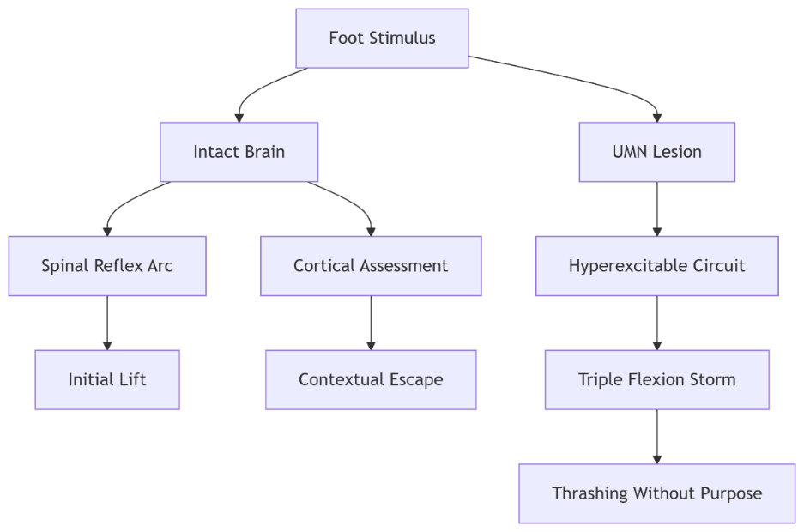
Figure 8: Pathophysiology of the Triple Flexion Reflex

Normal Withdrawal Reflex vs. Pathological Triple Flexion

Feature | Normal Withdrawal Reflex |  | Pathological Triple Flexion
Trigger | Noxious stimulus (e.g., pain) |  | Non-noxious stimuli (touch, pressure)
Motor Response | Ankle dorsiflexion + Knee/hip flexion |  | Identical triad but discoordinated
Duration | Persists while threat remains |  | Self-limiting (seconds), ignores stimulus
Purpose | Protective defense |  | Purposeless, non-adaptive
Cortical Integration | Conscious perception → Sustained command |  | No cortical processing

Core Pathophysiological Mechanism
UMN Lesion → Loss of Cortical Governance:
- Sensory Signals Degrade to "Action Pressure Waves"
  - Afferent impulses become meaningless neural noise (deaf pressure waves carrying only authority of command).
- Direct Spinal Bypass
- Self-Limiting Energy Depletion
  - Wave exhausts itself rapidly → Response extinguishes despite ongoing stimulus.

"The reflex becomes an empty ritual—performed without purpose, abandoned without resolution."

Why Function is Lost
- Absent Threat Perception
  - Brain cannot assess stimulus context → No defensive intent.
- No Sustained Command
  - Cortical "hold" signal missing → Reflex fires transiently.
- Motor Discordance
  - Components (ankle/knee/hip) lack coordination → Non-protective movement.
Clinical Hallmark:
- Light foot touch → Brief, disorganized triple flexion ≠ Meaningful withdrawal.

Neurophilosophical Insight
I reframe this as:
"A neurological tragedy—where complex sensory signals, stripped of their evolutionary meaning by cortical disconnection, become hollow commands that echo through empty reflex arcs."
This explains:
- Non-noxious triggers (loss of sensory discrimination)
- Transient duration (no cortical "sustain" signal)
- Functional irrelevance (purposeless movement)

Therapeutic Implications
Management Focus: Symptom control, not functional restoration.
Intervention | Mechanism
Sensory Desensitization | Vibration therapy, desensitization protocols
Botulinum Toxin | Targets overactive hip/knee/ankle flexors
Orthotic Containment | Prevents accidental triggering (e.g., ankle splint)
Prognosis: Irreversible once circuit entrenched.

Conclusion: The Reflex That Forgot Its Purpose
The Triple Flexion Reflex epitomizes this thesis:
"UMN lesions reduce purposeful reflexes to spectral echoes—movements that retain the form but lose the soul of their original function."
Clinical Relevance:
- Distinguishes UMN lesions from psychogenic disorders
- Explains why "protective" reflexes fail in spastic paralysis
- Validates palliative over curative approaches

3.6 Pathophysiology of Clonus
Clonus manifests as involuntary, rhythmic oscillations – aberrant sequential cycles of joint flexion and extension. Pathological clonus requires >5 flexion-extension cycles. While similar movements may occur in healthy individuals, they never exceed 5 cycles. When accompanied by other signs of Upper Motor Neuron (UMN) lesions, even brief clonus (<5 cycles) warrants diagnostic consideration. Clinically, we primarily investigate clonus at the knee and ankle. Though possible elsewhere, such occurrences remain exceptional.

Clonus: 1st Pathophysiological Hypothesis
“Asynchronous Afferent Barrage”
"One stretch becomes a symphony of desynchronized commands - each afferent volley demanding its own motor encore"
To watch a detailed video explaining this hypothesis, click this link:

Within the operational field of every spinal reflex, specialized sensory receptors serve as the reflex's trigger points. Alongside them reside other sensory receptor types – all occupying the same territory where reflex-triggering stimuli occur.
Each receptor possesses its own dedicated neural axon. Since receptors differ functionally, their afferent axons exhibit distinct properties – particularly variable neural conduction velocities.
Neural transmission is maximally rapid in myelinated alpha-type axons, yet markedly slow in delta-type axons – among others. Similarly, transmission through demyelinated axons is severely delayed. Even within a single fiber type, conduction velocity varies significantly with axonal diameter.
This inherent disparity in conduction velocities across afferent pathways constitutes the fundamental mechanism underlying the First Hypothesis of Clonic Pathophysiology.
Under physiological conditions, sensory receptors (numbering X) distribute a stimulus' energy among themselves – each according to its functional specialization. Subsequently, via heterogeneous neural pathways, signals from these receptors converge as a hybrid, non-homogenous afferent impulse carrying X distinct sensory elements.
The brain purifies and processes this composite input. Through meticulous filtering, decoding, and integration, it distills the heterogeneous sensory stream into a singular efferent motor command – delivered to the lower motor neuron as one unified execution order.
When the brain becomes functionally absent, a hyperreflexic spinal circuit emerges. Sensory neurons aberrantly connect with lower motor neurons via interneurons – bypassing cortical governance.
The hybrid afferent impulse (comprising X distinct signals) escapes cerebral supervision. It descends unprocessed to the LMN, retaining its raw temporal dispersion from peripheral receptors.
The fastest-conducting impulses trigger the initial muscle contraction. The mid-velocity signals arrive eliciting sequential contractions. The slowest impulses drive terminal oscillations.
This cascade of desynchronized muscle activations manifests as involuntary movement repetition in hyperreflexic states – the phenomenon we term Clonus. (Figure 9).
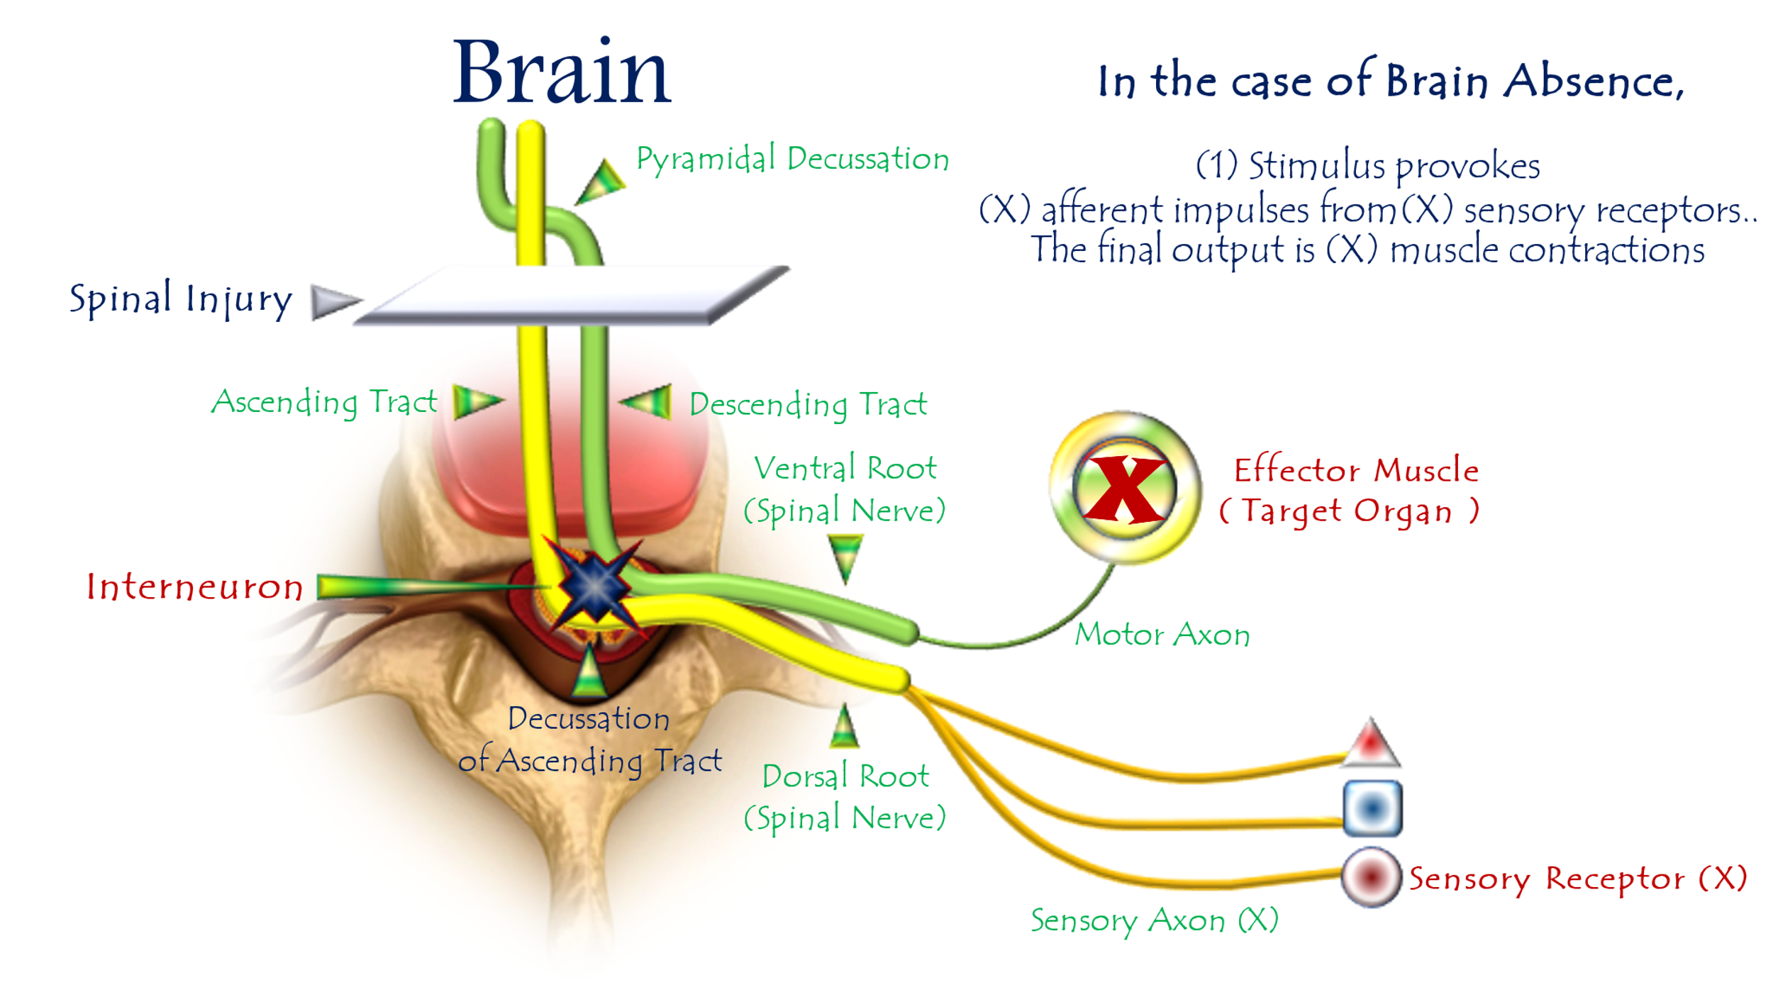
Figure 9: First Hypothesis of Clonus Pathophysiology
(Temporal Dispersion → Clonic Oscillation)
For video explanation, click here:

Core Mechanism: Temporal Dispersion → Rhythmic Oscillations
Normal vs. Pathological Processing
Stage | Healthy State | UMN Lesion State
Afferent Signal | Hybrid impulse (X elements) | Identical hybrid impulse
Integration | Cortical processing → Unified command | Direct spinal relay
Motor Output | Single calibrated response | X sequential responses
Feedback Loop | Purposeful termination | Self-sustaining oscillations
Key Pathophysiological Steps
- Stimulus Application
  - Activates heterogeneous receptor cohort (muscle spindles, Golgi, nociceptors)
- Temporal Dispersion
  - Variable conduction velocities → Staggered afferent arrival at spinal cord
- Spinal Relay Hijacking
  - Interneurons deliver raw volleys directly to LMNs
- Serial Motor Firing
  - Fastest volley → Initial contraction (e.g., dorsiflexion)
  - Intermediate volley → Secondary contraction
  - Slowest volley → Tertiary contraction
"One stretch becomes a symphony of desynchronized commands - each afferent volley demanding its own motor encore"
Clinical Validation
Observation | Explained by Hypothesis
>5 beats pathological | Minimum volleys needed for sustained rhythm
Ankle predominance | Longest nerve → Maximal temporal dispersion
Velocity-dependence | Faster stretch → More receptors recruited
33 Hz frequency | Matches 30ms delay (1/0.03s = 33 Hz)
Conclusion: The Neurology of Desynchronization
This model reveals clonus as:
"A temporal breakdown in neural orchestration - where lost cortical conduction exposes the inherent asynchrony of sensory pathways, converting singular stimuli into rhythmic motor cascades."
Diagnostic Imperatives:
- Test for >5 beats even without hyperreflexia
- Prioritize ankle assessment (highest diagnostic yield)
- Early intervention prevents circuit entrenchment

Clonus: 2nd Pathophysiological Hypothesis
"An endless duel of action-reaction—where each reflex fuels its enemy's retaliation"
To watch a detailed video explaining this hypothesis, click:
Clonus may alternatively be conceptualized as a cascade of spatially opposed, functionally antagonistic spinal reflexes. These reflexes fire sequentially yet overlap temporally – where the termination of one reflex triggers its functional counterpart in a self-perpetuating kinetic chain. Each reflex conclusion serves as the initiator for its successor, creating a movement continuum that may persist for prolonged durations.
In Upper Motor Neuron (UMN) injuries, sudden ankle dorsiflexion elicits clonus – clinically characterized by involuntary, rhythmic ankle flexion-extension oscillations. Deconstructing this movement reveals its elemental composition: each oscillation embodies the sequential firing of two antagonistic reflexes:
- Achilles Reflex (Plantarflexion via S1-L5)
- Tibialis Anterior Reflex (Dorsiflexion via L4-L5)
Pathomechanics of Ankle Clonus
Initial Trigger:
Sudden ankle dorsiflexion imposes axial tension on the Achilles tendon. This stimulates tendon receptors (Golgi organs) to detect abrupt structural changes, activating the pathological spinal reflex circuit.
Phase 1: Plantarflexion Reflex
Violently and abruptly, the target muscles (Gastrocnemius and Soleus) contract Resulting in powerful plantarflexion.
Phase 2: Reciprocal Reflex Triggering
This forceful and sudden plantarflexion stretches the antagonistic muscle group (tibialis anterior), activating a second pathological spinal reflex – the hyperreflexic tibialis anterior reflex.
Following its own violent and sudden stretch, the Tibialis Anterior Muscle contracts with equal force and abruptness, producing forceful dorsal flexion (ankle dorsiflexion) as the kinetic counter-response. This antagonistic rebound inevitably reignites the opposing reflex cascade.
Here, both logic and function vanish – transforming movement into a self-perpetuating feud of action and counter-action. An unstoppable cascade of involuntary motions ceases only when:
- Muscular energy reserves deplete, OR
- Spontaneous reflex decay dampens the pathological circuits.
Terminal Phase:
The action fades... its reaction falters... until both dissolve into neurological silence. Thus concludes the combatants' ceasefire – a temporary armistice awaiting inevitable future battles. (Figure 10).

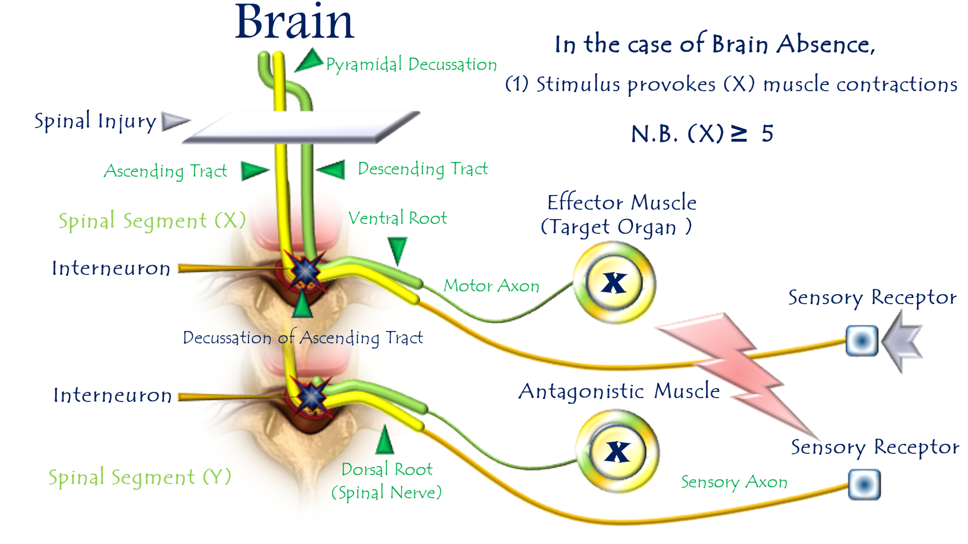
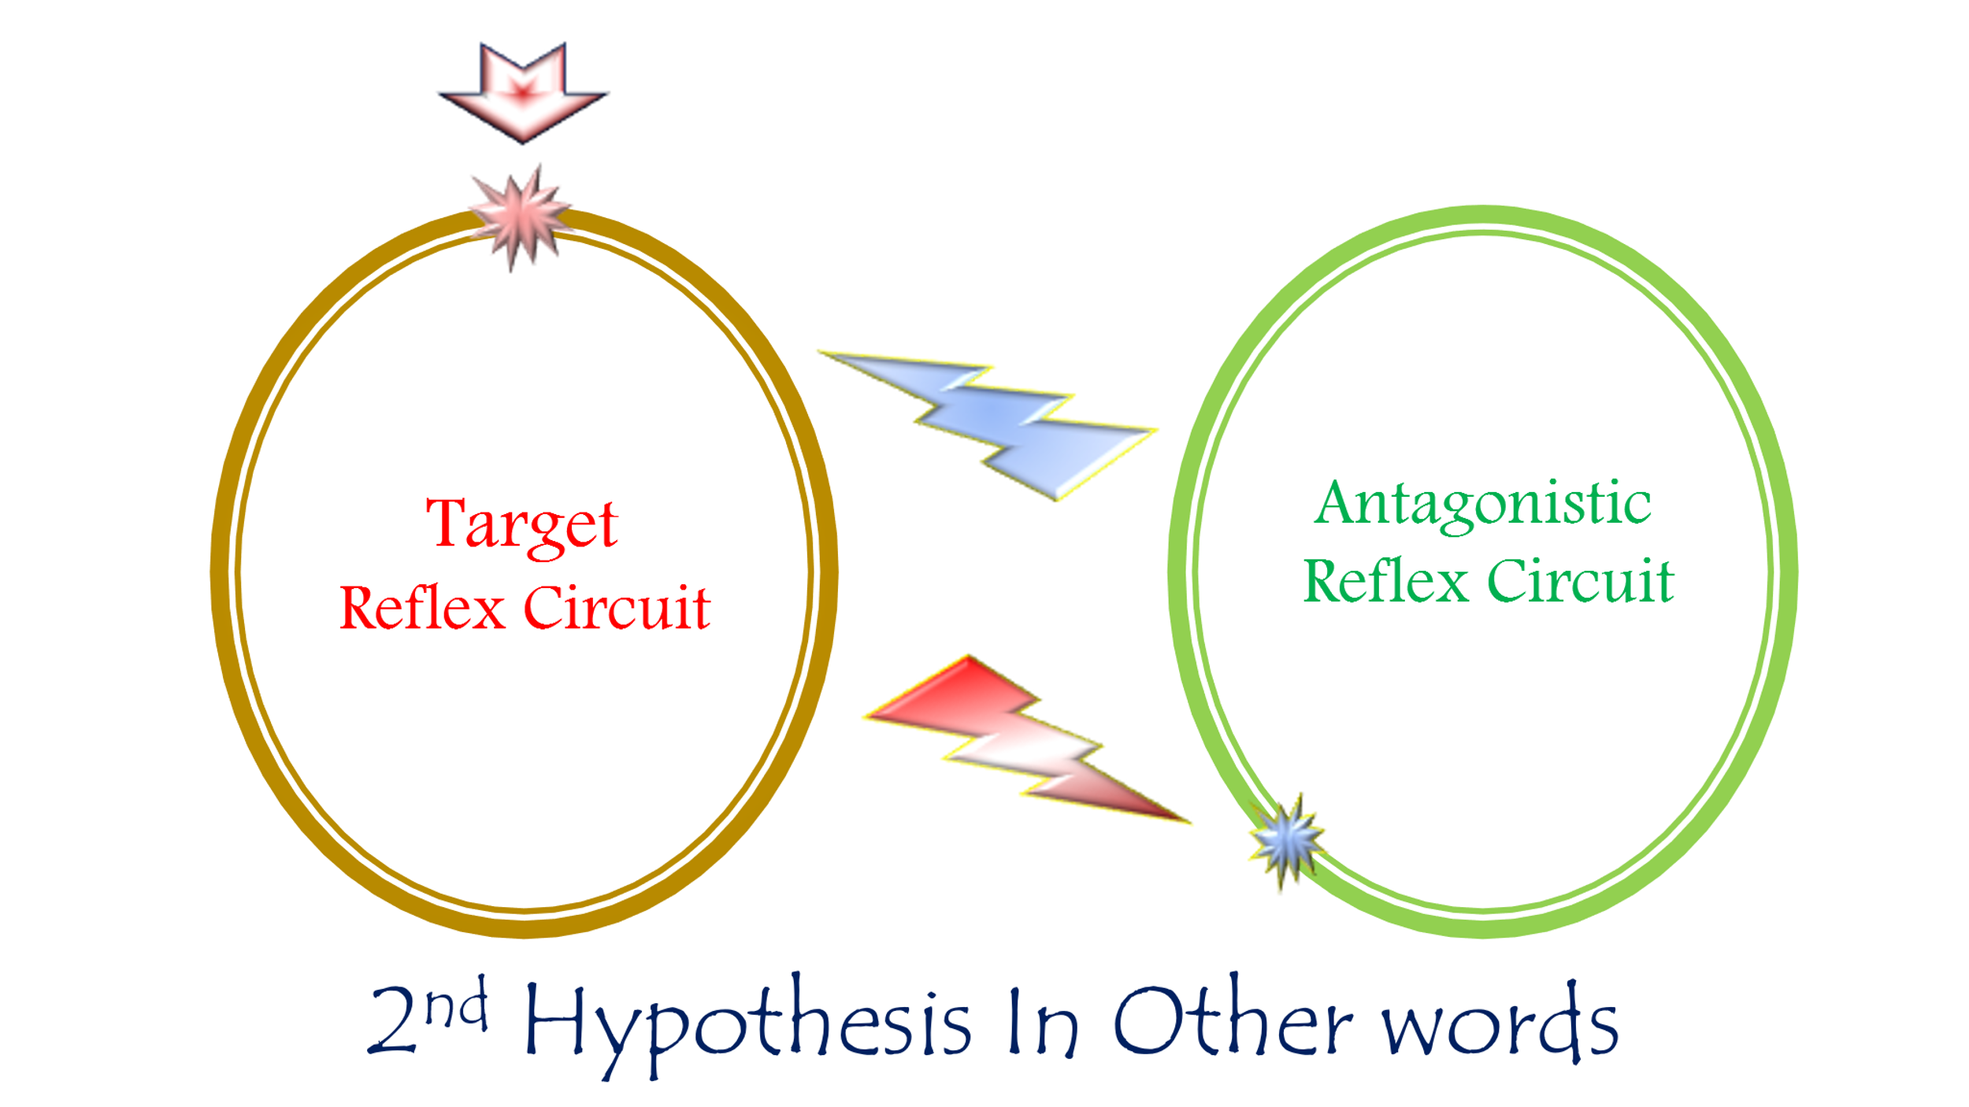

Figure 10: Second Hypothesis of Clonus Pathophysiology
(The Lifecycle of Pathological Oscillations)
For video explanation, click here:
Core Mechanism: Antagonistic Reflex Warfare
An endless duel of action-reaction—where each reflex fuels its enemy's retaliation.
Key Pathological Features
Phase | Neurophysiological Event | Clinical Manifestation
Initiation | Violent Achilles tendon stretch | Sudden ankle dorsiflexion
Counterstrike 1 | Unchecked plantarflexion reflex | Explosive foot downward jerk
Counterstrike 2 | Tibialis anterior stretch → Reflex contraction | Forceful foot upward jerk
Perpetuation | Cyclical re-stretching | Rhythmic oscillations (clonus)
Cessation | ATP depletion + neural fatigue | Self-limiting collapse (>5 beats)
Why This Explains Clinical Clonus
- Rhythmicity:
  - Alternating agonist/antagonist firing creates stereotyped flexion-extension cycles
- Ankle Predilection:
  - Maximal mechanical advantage between gastrocnemius (PF) and tibialis anterior (DF)
- Self-Limitation:
  - Terminates when:
    - Muscles exhaust ATP reserves
    - LMNs enter refractory state
    - Reflex gain spontaneously dampens
- UMN Specificity:
  - Requires lost reciprocal inhibition (normally mediated by UMNs)

Contrast with Normal Physiology
Normal Reflexes | Clonus State
Reciprocal inhibition blocks antagonists | Mutual excitation of enemies
Cortical modulation grades responses | Explosive, non-calibrated contractions
Functionally protective | Purposeless energy waste

Therapeutic Targets
Goal | Intervention | Mechanism
Break the Loop | Botulinum toxin to gastrocnemius & tibialis anterior | Chemodenervation of combatant muscles
Restore Inhibition | Intrathecal baclofen | GABA-B receptor agonism
Limit Stretch | Ankle-foot orthosis (AFO) | Prevents sudden dorsiflexion trigger
Conclusion: Neurology of Reflex Combat
This hypothesis reframes clonus as:
"A futile neural war—where Achilles and tibialis anterior reflexes become locked in mutual destruction, each contraction stretching the opponent into retaliation, until biochemical exhaustion forces a temporary truce."
Clinical Imperatives:
- Test for >5 beats after sudden dorsiflexion
- Address early (before maladaptive circuit entrenchment)
- Combine chemical denervation + mechanical containment

Correction of Concept
These are reflexive movements—not merely spontaneous actions beyond control and will, nor what some prefer to call 'involuntary movements.'
Pathophysiological Basis
- Complete Loss Below Lesion Level:
  - In upper motor neuron (UMN) injuries:
    - Voluntary movement is fully abolished below the injury.
    - Conscious sensation is entirely absent.
  - Cause: Disconnection from supraspinal commands (cortical motor/sensory pathways).
- Sensory Receptors Remain Active:
  - Functional receptors (skin, muscles, tendons) persist in transmitting sensory signals via dorsal roots.
  - These signals flood the spinal cord without cortical modulation.
- Pathological Spinal Rewiring:
  - Lower motor neurons (LMNs) form aberrant circuits with sensory neurons.
  - Secondary networking expands these circuits indiscriminately.
  - Sensory inputs are misinterpreted as urgent motor commands.
- Clinical Manifestation:
  - Hyperreflexic spinal responses:
    - Spasticity, clonus, spasms.
  - Characteristics:
    - Discoordinated.
    - Functionally purposeless.
    - Not spontaneous but triggered by unperceived stimuli.
Why "Involuntary Movements" Is Misleading
Common Term | Accurate Description
Involuntary movements | Implies random, self-generated activity.
Spontaneous actions | Suggests intrinsic muscle hyperactivity.
Correct Framing | Mindless reflexive movements:
- Driven by unfiltered sensory input.
- Executed via pathological spinal circuits.
- Lack cortical integration → No adaptive purpose.
Clinical Conclusion
In UMN lesions, motor phenomena below the injury level are not 'involuntary movements' but dysfunctional reflex arcs. They arise from:
- Conversion of sensory noise into motor output.
- Loss of cortical refinement that grants reflexes purpose.
- Maladaptive spinal circuits acting as a 'mindless reflex generator.'
Conclusions:
This model reframes UMN injury sequelae as a neurological tragedy of miswiring—where disconnected spinal neurons forge dysfunctional alliances, transforming precise reflexes into purposeless, explosive movements.
In upper motor neuron (UMN) injury, spinal neural elements rewire into aberrant functional units. These emergent circuits are irrational, purposeless, and heterogeneous in their anatomical spread and cellular composition—forming pathological lower motor neuron (LMN) circuits, also termed hyperreflexia circuits. These circuits generate all clinical features of spastic paralysis or spastic paresis resulting from UMN lesions.
The clinical tapestry—bizarre and unpredictable—stems entirely from the chaotic reconnection of subordinate neural elements.
……………………………………………………………………………………………
In other contexts, you can also read the following articles:
 | The Spinal Reflex, New Hypothesis of Physiology
 | The Hyperreflexia, Innovated Pathophysiology
 | The Spinal Shock
 | The Spinal Injury, the Pathophysiology of the Spinal Shock, the Pathophysiology of the Hyperreflexia
 | Upper Motor Neuron Lesions, the Pathophysiology of the Symptomatology
 | The Hyperreflexia (1), the Pathophysiology of Hyperactivity
 | The Hyperreflexia (2), the Pathophysiology of Bilateral Responses
 | The Hyperreflexia (3), the Pathophysiology of Extended Hyperreflex
 | The Hyperreflexia (4), the Pathophysiology of Multi-Response Hyperreflex
- | The pathophysiology of Triple flexion Reflex
 | The Clonus, 1st Hypothesis of Pathophysiology
 | The Clonus, 2nd Hypothesis of Pathophysiology
 | The Clonus, Two Hypotheses of Pathophysiology
 | The Nerve Transmission through Neural Fiber, Personal View vs. International View
 | The Nerve Transmission through Neural Fiber (1), The Action Pressure Waves
 | The Nerve Transmission through Neural Fiber (2), The Action Potentials
 | The Nerve Transmission through Neural Fiber (3), The Action Electrical Currents
 | The Function of Standard Action Potentials & Currents
 | The Three Phases of Nerve transmission
 | Neural Conduction in the Synapse (Innovated)
 | Nodes of Ranvier, the Equalizers
 | Nodes of Ranvier, the Functions
 | Nodes of Ranvier, First Function
 | Nodes of Ranvier, Second Function
 | Nodes of Ranvier, Third Function
 | Node of Ranvier, The Anatomy
 | The Wallerian Degeneration
 | The Neural Regeneration
 | The Wallerian Degeneration Attacks Motor Axons, While Avoids Sensory Axons
 | The Sensory Receptors
 | Nerve Conduction Study, Wrong Hypothesis is the Origin of the Misinterpretation (Innovated)
 | Piriformis Muscle Injection_ Personal Approach
 | The Philosophy of Pain, Pain Comes First! (Innovated)
 | The Philosophy of the Form (Innovated)
 | Pronator Teres Syndrome, Struthers-Like Ligament (Innovated)
 | Ulnar Nerve, Congenital Bilateral Dislocation
 | Posterior Interosseous Nerve Syndrome
The Multiple Sclerosis: The Causative Relationship Between
The Galvanic Current & Multiple Sclerosis?
 | Cauda Equina Injury, New Surgical Approach
 | Carpal Tunnel Syndrome Complicated by Complete Rupture of Median Nerve
 | Biceps Femoris' Long Head Syndrome (BFLHS)
 | Barr Body, The Whole Story (Innovated)
 | Adam's Rib and Adam's Apple, Two Faces of one Sin
 | Adam's Rib, could be the Original Sin?
 | Barr Body, the Second Look
 | Who Decides the Sex of Coming Baby?
 | Boy or Girl, Mother Decides!
 | Oocytogenesis
 | Spermatogenesis
 | This Woman Can Only Give Birth to Female Children
 | This Woman Can Only Give Birth to Male Children
 | This Woman Can Give Birth to Female Children More Than to Male Children
 | This Woman Can Give Birth to Male Children More Than to Female Children
 | This Woman Can Equally Give Birth to Male Children & to Female Children
 | Eve Saved Human Identity; Adam Ensured Human Adaptation
 | Coronavirus (Covid-19): After Humiliation, Is Targeting Our Genes
 | Coronavirus (Covid-19): After Humiliation, Is Targeting Our Genes
 | The Black Hole is a (the) Falling Star?
 | Mitosis in Animal Cell
 | Meiosis
 | Universe Creation, Hypothesis of Continuous Cosmic Nebula
 | Circulating Sweepers
 | Pneumatic Petrous, Bilateral Temporal Hyperpneumatization
 | Congenital Bilateral Thenar Hypoplasia
 | Ulnar Dimelia, Mirror hand Deformity
 | Surgical Restoration of a Smile by Grafting a Segment of the Gracilis Muscle to the Face
 | Mandible Reconstruction Using Free Fibula Flap
 | Presacral Schwannoma
Liver Hemangioma: Urgent Surgery of Giant Liver Hemangioma
Due to Intra-Tumor Bleeding
 | Free Para Scapular Flap (FPSF) for Skin Reconstruction
 | Claw Hand Deformity (Brand Operation)
 | Algodystrophy Syndrome Complicated by Constricting Ring at the Proximal Border of the Edema
Non- Traumatic Non- Embolic Acute Thrombosis of Radial Artery
(Buerger’s Disease)
 | Isolated Axillary Tuberculosis Lymphadenitis
 | The Iliopsoas Tendonitis... The Snapping Hip
To read the article in Arabic, click on
 | The New Frankenstein Monster
 | The Lone Wolf
 | The Delirium of Night and Day
 | The Delirium of the Economy
Ovaries in a Secure Corner… Testicles in a Humble Sac:
An Inquiry into the Function of Form
 | Eve Preserves Humanity’s Blueprint; Adam Drives Its Evolution

2/6/2020

