Dr. Ammar Yaseen Mansour
Vesicular Dynamics: A Unifying Theory for Wallerian Degeneration and Neural Regeneration
N.B.
The Arabic version of this article is the reference,
read it via one of the following links:

التَّنكُّسُ الفاليريُّ والتَّجدُّدُ العصبيُّ: رؤيةٌ جديدةٌ في آليَّاتِ الحدوث
Wallerian Degeneration & Neural Regeneration: A Novel Perspective
Before presenting my findings on traumatic peripheral nerve injuries, I had thoroughly studied the established principles in the field. However, a growing disparity emerged between these doctrines and my clinical observations. When repeated results contradicted prevailing laws, doubt was inevitable, prompting a rigorous search for a new explanation.
Herein, I present a series of personal insights based on direct evidence. I will begin by detailing the process of Wallerian Degeneration, then proceed to Neural Regeneration following injury rectification. My aim is not to debate existing literature point by point, but to present a clearer, evidence-based model that challenges the current scientific consensus.
1. Wallerian Degeneration
Contrary to prevailing scientific views, I contend that Wallerian Degeneration fundamentally depends on two sequential events:
  - Primary Mechanism: Depletion of vesicles within the distal segment of the severed axon (the segment distal to the injury site).
  - Secondary Requirement: Subsequent depletion of neurotransmitter within the synaptic cleft.
Wallerian Degeneration is only complete when both conditions are met.
Neurotransmitter Pathway (Normal State):
  - Neurotransmitters are synthesized in the neuronal soma.
  - They are packaged into vesicles and transported anterogradely to the presynaptic terminal.
  - Vesicles fuse with the presynaptic membrane, releasing neurotransmitters into the synaptic cleft to enable electrochemical transmission.
Post-Injury Dynamics:
Following neural injury:
  - Vesicles undergoing anterograde transport from the soma halt and accumulate proximal to the injury site.
  - Vesicles already present distal to the injury continue their anterograde transport towards the synapse.
  - These distal vesicles successfully undergo exocytosis, releasing their neurotransmitter cargo into the synaptic cleft.
Mechanism of Degeneration:
Consequently:
  - Vesicles within the distal segment are progressively depleted following neurotransmitter release.
  - Neurotransmitter within the synaptic cleft is rapidly depleted through normal activity without replenishment.
  - Only upon the depletion of both distal vesicles and synaptic cleft neurotransmitter is Wallerian Degeneration complete.
Diagnostic Implication:
Crucially, it is at this specific stage—characterized by vesicle and neurotransmitter depletion—and not before, that the neural injury becomes detectable via electromyography (EMG) of the affected nerve (see Figure 1).

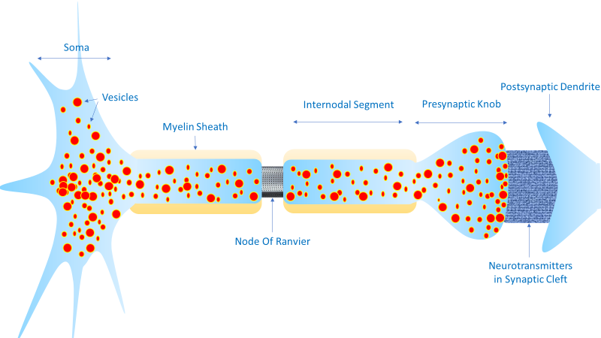
A
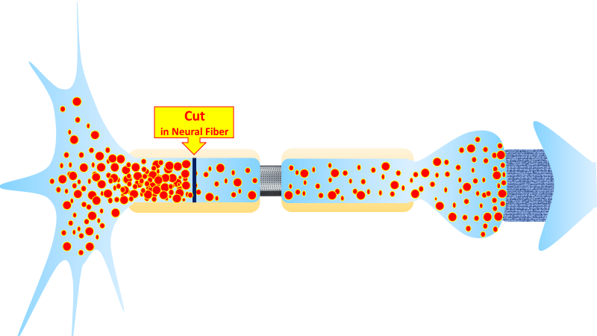
B
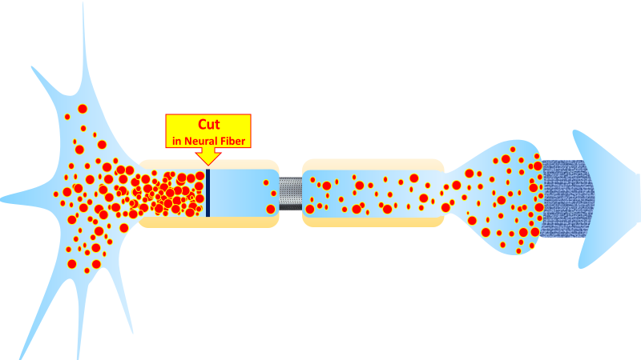
C
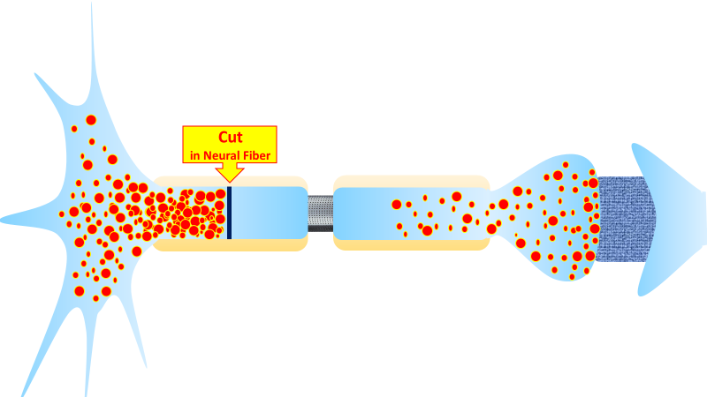
D
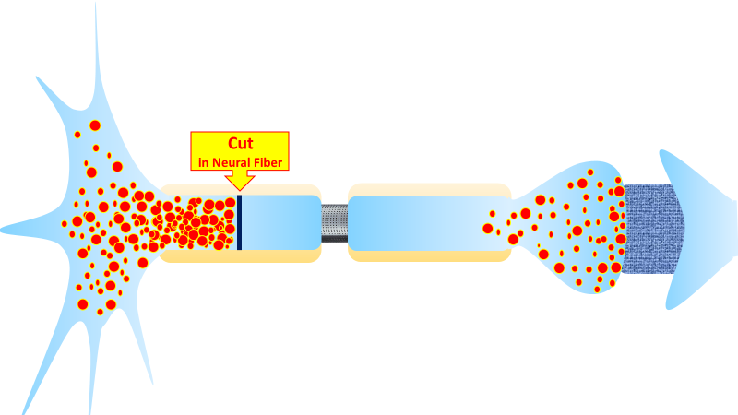
E
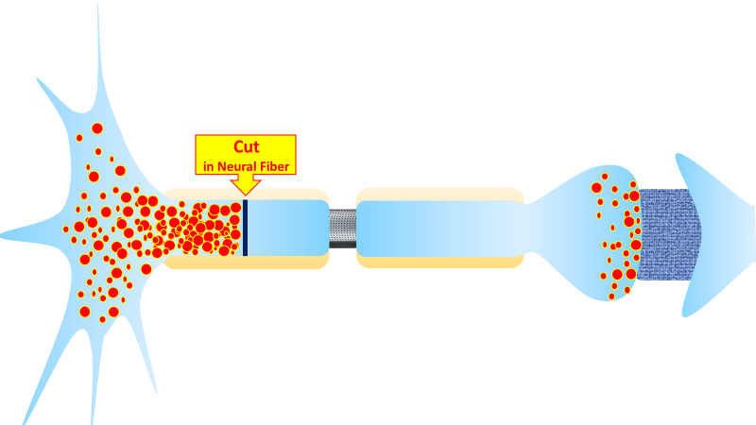
F
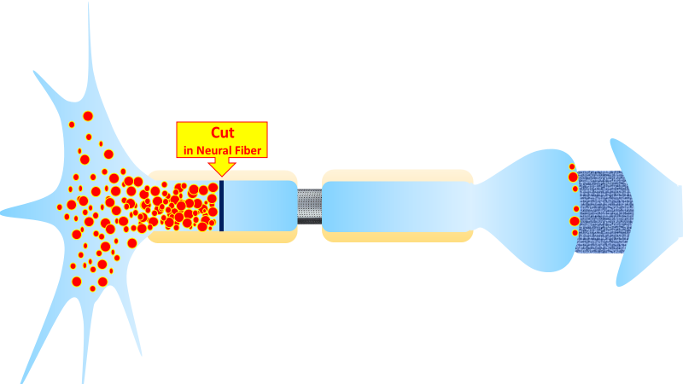
G
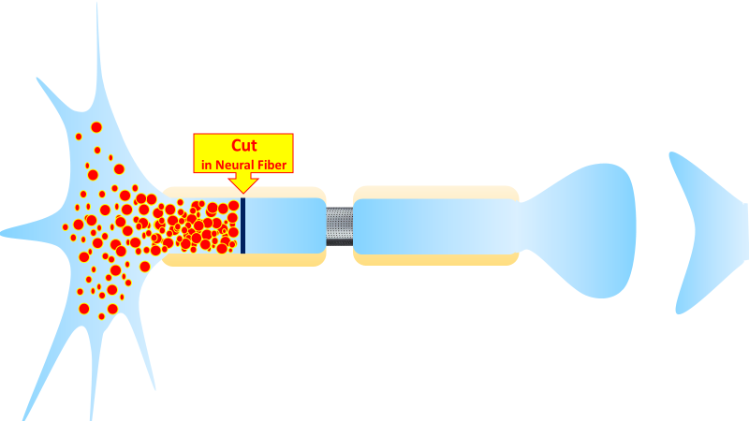
H
Figure (1): Wallerian Degeneration
To watch a short film detailing Wallerian Degeneration, click this link:
Core Principles
- Spatial Scope: Affects only the distal axon segment beyond the site of neural injury.
- Progression Mechanism: Advances gradually from the injury site toward the synaptic terminal, following anterograde vesicle kinetics.
- Completion Criteria: Degeneration is complete only when:
  - The distal segment is fully depleted of vesicles
  - The synaptic cleft is cleared of neurotransmitter
(Typical duration: 2–3 weeks post-injury in humans)
Stage-by-Stage Breakdown
Figure (A): Normal Neural Transmission
- Vesicles undergo anterograde transport (1–3 mm/day) from soma to synapse.
- Vesicles release neurotransmitter into the synaptic cleft upon arrival.
- Neurotransmitter enables electrochemical conduction across the cleft.
- This cycle persists during neural activity and rest.
Figure (B): Acute Phase (Immediately Post-Injury)
- Following axotomy:
  - Vesicles accumulate proximal to the injury site (due to ongoing somatic synthesis).
  - Distal vesicles continue migration, fully inject their burden of neurotransmitter into the synaptic cleft.
- Key trigger: Initial vesicle depletion in the distal segment marks the onset of Wallerian Degeneration.
Figures (C to G): Progressive Degeneration
- Vesicles gradually exit the distal segment via degradation.
- Critical observation: Neurotransmitter persists longest in the synaptic cleft.
- Clinical correlation:
  - EMG studies show normal conductivity until neurotransmitter is fully cleared from the cleft.
  - This occurs even with complete nerve transection.
Figure (H): Degeneration Completion
- Absence of biomarkers:
  - No vesicles in distal segment
  - No neurotransmitter in synaptic cleft
- Definitive functional confirmation:
  - Loss of EMG response upon proximal nerve stimulation.
  - Wallerian Degeneration is now functionally complete.

2. Neural Regeneration
Immediately following the repair of the neural injury, the vesicles accumulated proximal to the injury site initiate their innate anterograde transport toward the synaptic cleft. Neural regeneration commences precisely with the resumption of this vesicular transport.
Key Characteristics:
- Temporally Extended Process:
Neural regeneration is intrinsically slow and temporally extended.
Its pace is dictated by the inherently slow rate of vesicular transport within the axon.
- Completion Criteria:
The process is only complete when vesicles:
a) Successfully reach their destination at the presynaptic terminal, and
b) Undergo exocytosis, releasing their neurotransmitter cargo into the synaptic cleft.
(See Figure 2)
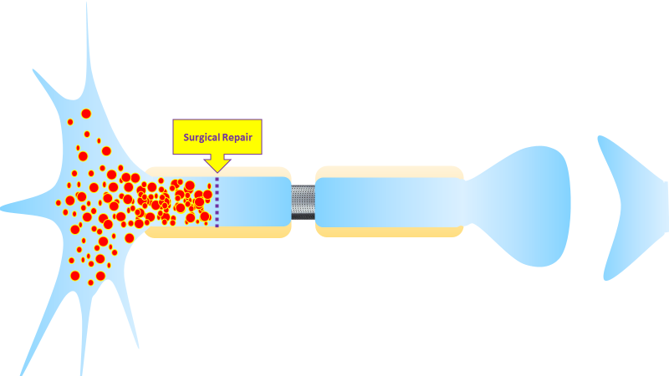
A
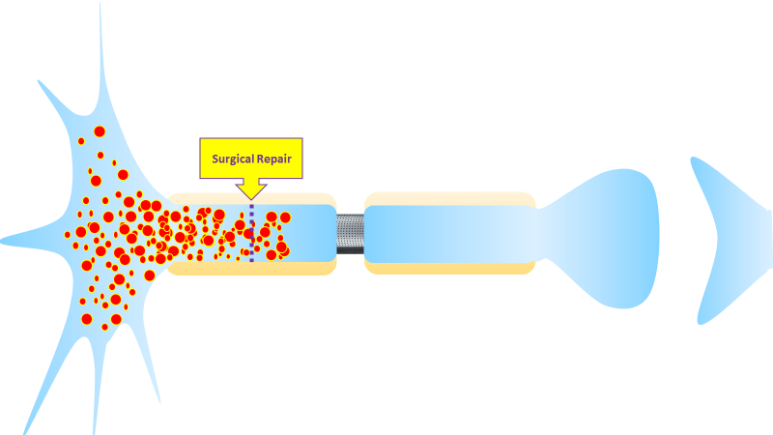
B
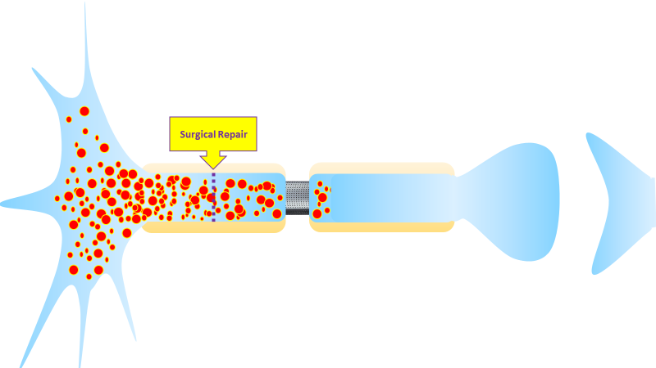
C
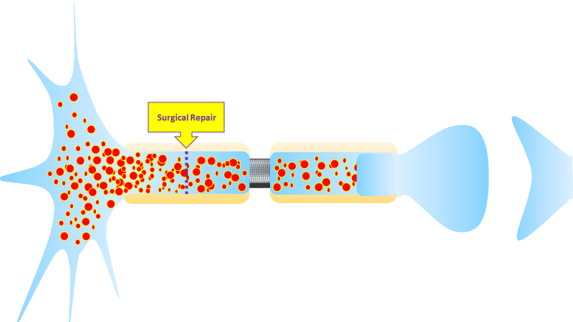
D
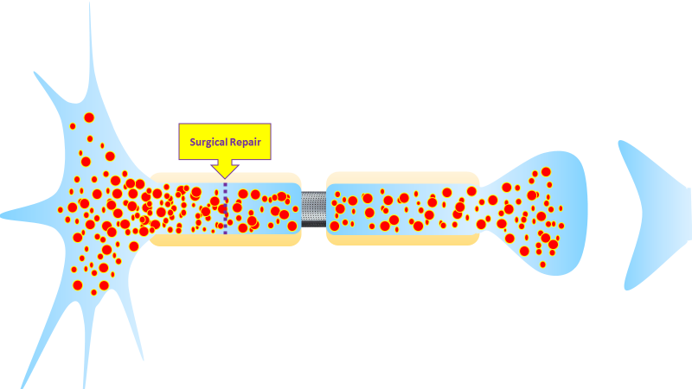
E
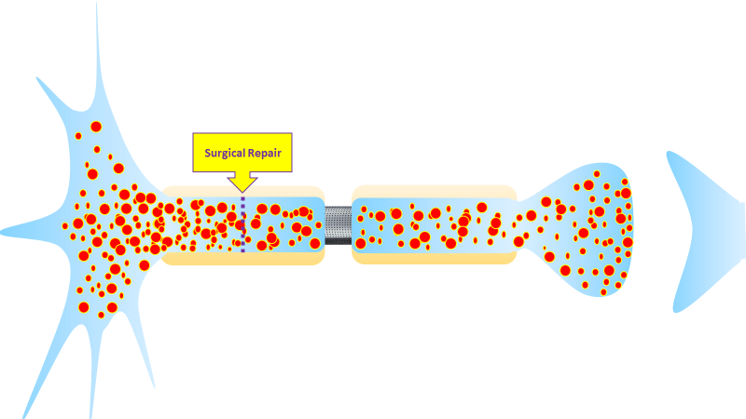
F
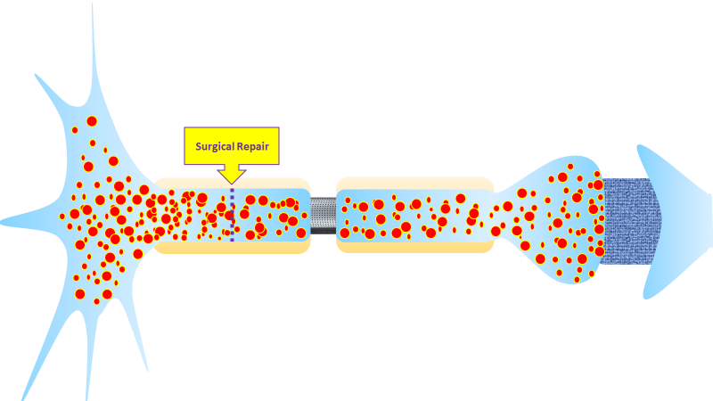
G
H
Figure (2): The Neural Regeneration
To watch a short film detailing Neural Regeneration, click this link:
Core Thesis
I propose that neural regeneration is exclusively determined by two sequential events:
- Replenishment of vesicles in the presynaptic terminal.
- Neurotransmitter release into the synaptic cleft.
Thus, the rate of neural regeneration equals the rate of anterograde vesicle transport to the synapse.
Stage-by-Stage Breakdown
Figure (A): Regeneration Initiation
- Following surgical repair and stabilization of the axonal pathway:
  - Vesicles escape confinement at the suture line.
  - Anterograde migration from the injury site toward the synapse begins.
- This marks the definitive onset of neural regeneration.
Figures (B to F): Progressive Anterograde Transport
- Vesicles advance steadily (1–3 mm/day) along the axon.
- Regeneration progresses strictly synchronously with vesicle migration—a slow, metabolically intensive process.
- Clinical correlation: Explains delayed motor recovery post-repair (weeks to months).
Figure (G): Functional Completion
- Upon reaching the synaptic terminal:
  - Vesicles release neurotransmitter into the cleft.
  - Neurotransmitter restores electrochemical conduction across the synapse.
- Definitive milestones:
  - Resumption of neural transmission
  - EMG-detectable motor unit potentials
  - Onset of clinical functional recovery
Figure (H): Restored Basal State
- In regenerated/healthy nerves:
  - Synaptic cleft maintains tonic neurotransmitter presence (even at rest).
  - Ensures immediate readiness for signal transmission.

3. The Visionary Conclusion
In summary, I assert the following:
A neural injury divides the nerve fiber into two distinct segments:
- A proximal segment (central to the injury site)
- A distal segment (peripheral to the injury site)
In the Distal Segment (Wallerian Degeneration):
- Vesicles distal to the injury site at the moment of trauma are progressively depleted as they complete their anterograde transport to the synapse.
- This anterograde transport is intrinsically slow and time-consuming.
- Depletion concludes only when the last vesicle originally present distal to the injury releases its neurotransmitter.
- Following vesicle depletion, neurotransmitter within the synaptic cleft is subsequently depleted through normal activity without replenishment.
- Therefore, Wallerian Degeneration fundamentally results from the anterograde transport and ultimate depletion of vesicles that were distal to the injury at the time of trauma.
In the Proximal Segment (Neural Regeneration):
- Vesicles—newly synthesized and continuously supplied from the soma—accumulate proximal to the injury site.
- This accumulation represents the preparatory phase of Neural Regeneration.
- Upon repair of the injury and removal of the obstruction:
  - Vesicles resume anterograde transport along the restored axonal pathway.
  - They advance with deliberate, steadfast progression toward the synapse.
  - Upon reaching the presynaptic terminal, they undergo exocytosis, releasing neurotransmitters into the synaptic cleft.
- Only upon vesicle arrival and neurotransmitter release does the nerve fiber regain its conductive function, marking the completion of Neural Regeneration.
The Unifying Principle:
Vesicles—and vesicles alone—define both phenomena:
- Depletion of vesicles from the distal segment marks the onset of degeneration.
- Replenishment of vesicles into the distal segment (via resumed transport) marks the onset of regeneration.
- Completion is defined by synaptic cleft neurotransmitter status:
  - Degeneration: Complete upon neurotransmitter depletion.
  - Regeneration: Complete upon neurotransmitter restoration.
………………………………………………………………………………………………..
In other contexts, you can also read the following articles:
 | DOI | The Spinal Reflex, New Hypothesis of Physiology
 | - | The Hyperreflexia, Innovated Pathophysiology
 | DOI | The Spinal Shock
 | - | The Spinal Injury, the Pathophysiology of the Spinal Shock, the Pathophysiology of the Hyperreflexia
 | DOI | Upper Motor Neuron Lesions, the Pathophysiology of the Symptomatology
 | - | The Hyperreflexia (1), the Pathophysiology of Hyperactivity
 | - | The Hyperreflexia (2), the Pathophysiology of Bilateral Responses
 | - | The Hyperreflexia (3), the Pathophysiology of Extended Hyperreflex
 | - | The Hyperreflexia (4), the Pathophysiology of Multi-Response Hyperreflex
- | - | The pathophysiology of Triple flexion Reflex
 | - | The Clonus, 1st Hypothesis of Pathophysiology
 | - | The Clonus, 2nd Hypothesis of Pathophysiology
 | DOI | The Clonus, Two Hypotheses of Pathophysiology
 | DOI | The Nerve Transmission through Neural Fiber, Personal View vs. International View
 | - | The Nerve Transmission through Neural Fiber (1), The Action Pressure Waves
 | - | The Nerve Transmission through Neural Fiber (2), The Action Potentials
 | - | The Nerve Transmission through Neural Fiber (3), The Action Electrical Currents
 | - | The Function of Standard Action Potentials & Currents
 | - | The Three Phases of Nerve transmission
 | DOI | Neural Conduction in the Synapse (Innovated)
 | DOI | Nodes of Ranvier, the Equalizers
 | - | Nodes of Ranvier, the Functions
 | - | Nodes of Ranvier, First Function
 | - | Nodes of Ranvier, Second Function
 | - | Nodes of Ranvier, Third Function
 | - | Node of Ranvier, The Anatomy
 | - | The Wallerian Degeneration
 | - | The Neural Regeneration
 | DOI | Wallerian Degeneration: Affects Motor Axons while Sparing Sensory Axons
 | DOI | The Sensory Receptors
 | DOI | Electroneurography vs. Neural Reality: Hidden Fallacies in Nerve Conduction Studies
 | DOI | Piriformis Muscle Injection: Personal Approach
 | DOI | In Philosophy of Nerves: Pain First!
 | DOI | In Neurodoctrines: Form is Necessity!
 | - | Pronator Teres Syndrome, Struthers-Like Ligament (Innovated)
 | DOI | Ulnar Nerve, Congenital Bilateral Dislocation
 | - | Posterior Interosseous Nerve Syndrome
 | DOI | The Multiple Sclerosis: The Causative Relationship Between  The Galvanic Current & Multiple Sclerosis?
 | - | Cauda Equina Injury, New Surgical Approach
 | DOI | Carpal Tunnel Syndrome Ends Its Adherence: Complete Median Nerve Transection
 | DOI | Biceps Femoris' Long Head Syndrome (BFLHS)
 | DOI | Barr Body, The Whole Story (Innovated)
 | - | Adam's Rib and Adam's Apple, Two Faces of one Sin
 | - | Adam's Rib, could be the Original Sin?
 | - | Barr Body, the Second Look
 | DOI | Who Decides the Sex of Coming Baby?
 | - | Boy or Girl, Mother Decides!
 | - | Oocytogenesis
 | - | Spermatogenesis
 | - | This Woman Can Only Give Birth to Female Children
 | - | This Woman Can Only Give Birth to Male Children
 | - | This Woman Can Give Birth to Female Children More Than to Male Children
 | - | This Woman Can Give Birth to Male Children More Than to Female Children
 | - | This Woman Can Equally Give Birth to Male Children & to Female Children
 | - | Eve Saved Human Identity; Adam Ensured Human Adaptation
 | DOI | COVID-19: Beyond the Crisis—Is It Targeting Our Genes?
 | DOI | Fibromyalgia
 | - | Mitosis in Animal Cell
 | - | Meiosis
 | - | Universe Creation, Hypothesis of Continuous Cosmic Nebula
 | - | Circulating Sweepers
 | - | The Black Hole is a (the) Falling Star?
 | - | Pneumatic Petrous, Bilateral Temporal Hyperpneumatization
 | DOI | Congenital Bilateral Thenar Hypoplasia
 | DOI | Ulnar Dimelia, Mirror hand Deformity
 | DOI | Thumb Reconstruction Using Microvascular Second Toe to Thumb Transfer
 | DOI | Surgical Restoration of a Smile by Grafting a Segment of the Gracilis Muscle to the Face
 | DOI | Mandible Reconstruction Using Free Fibula Flap
 | DOI | Presacral Schwannoma
 | DOI | Liver Hemangioma: Urgent Surgery of Giant Liver Hemangioma  Due to Intra-Tumor Bleeding
 | DOI | Free Para Scapular Flap (FPSF) for Skin Reconstruction
 | DOI | Claw Hand Deformity (Brand Operation)
 | DOI | Algodystrophy Syndrome Complicated by Constricting Ring at the Proximal Border of the Edema
 | DOI | Non- Traumatic Non- Embolic Acute Thrombosis of Radial Artery (Buerger’s Disease)
 | DOI | Isolated Axillary Tuberculosis Lymphadenitis
 | DOI | The Iliopsoas Tendonitis... The Snapping Hip
 | To read the article in Arabic, click on
 | DOI | The New Frankenstein Monster
 | DOI | The Lone Wolf
 | DOI | The Delirium of Night and Day
 | DOI | The Delirium of the Economy
 | DOI | Ovaries in a Secure Corner… Testicles in a Humble Sac:  An Inquiry into the Function of Form
 | DOI | Eve Preserves Humanity’s Blueprint; Adam Drives Its Evolution
 | DOI | The Manufacture of the Unconscious
 | DOI | The Ballad of Eternity
 | DOI | Two Truths Woman Would Never Accept
 | DOI | The 'Iddah (Waiting Period) in Islamic Law: A Comparative Analysis of its Rationale for Divorced Women and Widows
 | DOI | The IVF/ICSI-Conceived Child: A Biologically Suboptimal Outcome

18/08/2025

