AMMAR YASEEN MANSOUR
Non- Traumatic Non- Embolic
Acute Thrombosis of Radial Artery
(Buerger’s Disease)
Apart from the traumatic thrombosis of the radial artery which nowadays are very common, one can hardly find in the medical literature a paper concerning the non-traumatic non-embolic thrombosis of the artery. Hereafter, you might read one of the rarest uprising of the radial artery. Herein will be no evidence of a trauma nor a hard-manual work that could be the origin of the concerned pathology. A long- lasting exposure to the cold in a heavy smoker is the only incriminated factor that was quite evident in this case.
A 44- year old male patient presented to the clinic with a painful left forearm. The pain was acute, severe, and was dated just to the precedent white night. Neither fever nor general fatigue could be reported. The patient loudly accused the cold for his sufferance.
On the physical examination of the left forearm, it looked a little bit edematous, rigid, and particularly tender on the middle third. Tinel's sign was positive over the course of median nerve. The radial pulse was absent. No impact of the pathology on the fingers and wrist's movements. Just the flexion of fingers against resistance was painful.
Echo-Doppler confirmed the absence of blood flow in the two distal thirds of the left radial artery. In contrast, the flow of blood in the palmar arterial arcades was normal. Multi-slices CTscan was totally consistent with, Figure (1).
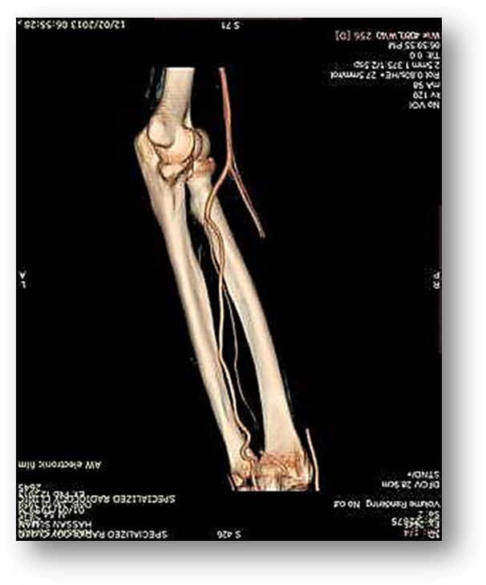
Brachial Artery
Ulnar Artery
Radial Artery
Thrombosed Segment
Figure (1)
Multi- Slices CT scan of the left forearm
Radial Artery is occluded for 14 cm of its length; just 5 cm after its origin from the brachial artery.
The distal part of the artery is free revealing the patency and efficacy
of the arterial arcades between it and the ulnar artery.

Surgical resection of the thrombosed segment of the artery was my decision in order to reach the following targets:
- A surgical specimen for the pathological study and to make the definitive diagnosis.
- Sympathectomy in order to free off the distal distributions of the radial artery from the persistent sympathetic stimulations induced by the primary and/or the secondary arterial inflammation.
- Fasciectomy to open the anterior compartment of the left forearm in order to protect the median nerve that seemed bothered by the elevated internal pressure.
The surgical time run out with no specific difficulties and the surgical findings were as expected pre-operatively; Figure (2). Two per-operative findings I have to declare. Firstly, all the small branches of the thrombosed artery, the perforating branch included, were also thrombosed. Secondly, the presence of some foci of bleeding alongside the thrombosed segment. 14- cm segment of the radial artery is resected without arterial reconstruction. The capillary refilling time in fingers was less than 6 seconds which made any effort to reconstruct the resected artery superfluous.

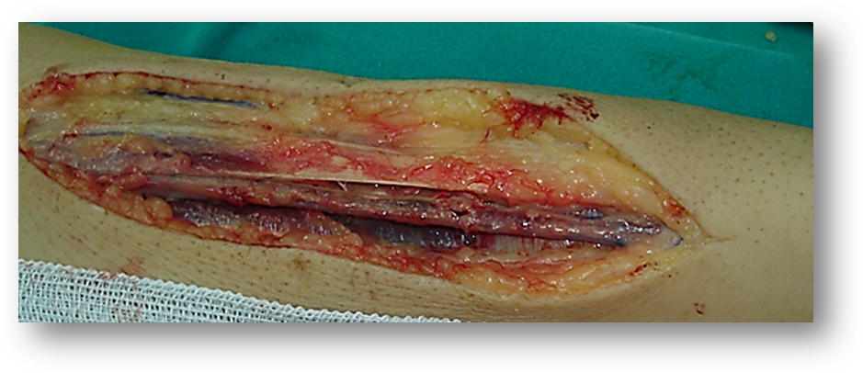
14 cm- Thrombosed Segment of Radial Artery

Figure (2)
Per- Operative Findings
14-cm segment of the radial artery was completely thrombosed.
The distal segment of the artery was clear of thrombus.
All the small branches, the perforating one included, were thrombosed.
Finally, I have to reveal the presence of some bleeding foci distributed alongside the thrombosed segment.
The pathological study of the resected arterial specimen showed no evidence of fibrinoid necrosis, giant cells, eosinophilic infiltrate, granuloma, or atheroma. The conclusion was aretritis and periarteritis, non specific with large luminal thrombosis. The pathological changes are consistent with Buerger’s disease; Figure (3).

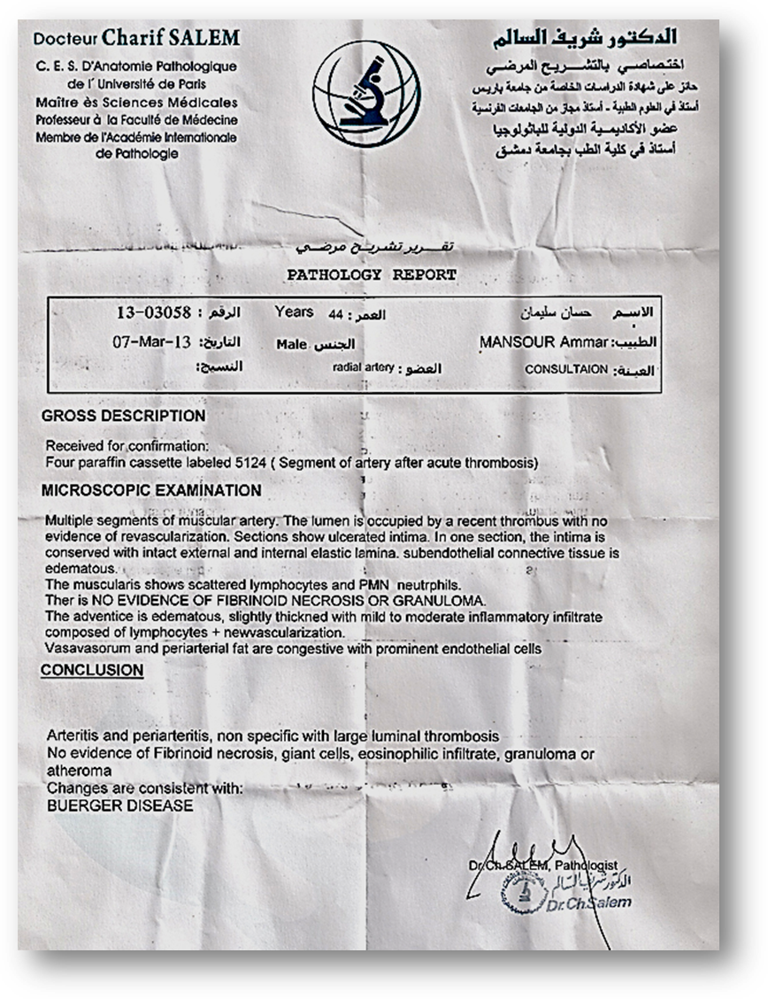
Figure (3)
The Pathology Report
The pathological study of the resected arterial specimen showed no evidence of fibrinoid necrosis, giant cells, eosinophilic infiltrate, granuloma, nor atheroma. The conclusion was arteritis and periarteritis, non-specific with large luminal thrombosis. The pathological changes are consistent with Buerger’s disease

Discussion
Buerger’s disease is a rare disease of the arteries and veins. It affects the median and small arteries in the upper and lower extremities. Buerger’s disease usually attacks the hands and feet at first, and may eventually affect larger areas of the arms and legs. Tobacco smoking has the essential role in the pathology.

The initial symptoms of Buerger’s Disease often include claudication in the feet and/or hands, or pain in theses areas at rest. Other signs and symptoms of this disease may include numbness and/or tingling in the limbs and Raynaud’s phenomenon. Skin ulceration and gangrene of the digits are common in Buerger’s disease.
Angiogram of the affected limb is essential to make the diagnosis of Buerger’s disease. In the proper clinical setting, certain angiographic findings are diagnostic of Buerger’s disease. These findings include a “corkscrew” appearance of arteries that result from vascular damage, particularly the arteries in the region of wrists and ankles. Angiograms may also show occlusions and stenoses in multiple areas of both the arms and legs.
A part of this pathology, our patient is quite healthy. He has never complained from claudication in his legs and/or hands, pain at rest in these areas, nor from Raynaud’s phenomenon. Neither personal history of skin ulcerations nor a history of gangrene of digits has been reported. Exceptionally, Buerger’s disease affected the radial artery while the smallest arteries in the hand of the same extremity are normal. A CT scan multislice of the affected arm doesn’t show the “corkscrew” appearance, essential radiological sign of chronic vascular occlusion. No other radiological findings are present in the CT scan multislices. These all remarks make the difference in our case.
…………………………………………………………….......
In another context, one can also read:
 | Neural Conduction, Personal View vs. International View (Innovated)
 | Upper Motor Neuron Lesions, Pathophysiology of Symptomatology
 | Neural Conduction, Action Pressure Waves (Innovated)
 | Neural Conduction, Action Potentials (Innovated)
 | Neural Conduction, Action Electrical Currents (Innovated)
 | The Function of Action Potentials (Innovated)
 | The Three Phases of Neural Conduction (Innovated)
 | Neural Conduction in the Synapse (Innovated)
 | Sensory Receptors
 | Nodes of Ranvier, the Equalizers (Innovated)
 | Nodes of Ranvier, the Functions (Innovated)
 | Nodes of Ranvier, First Function (Innovated)
 | Nodes of Ranvier, Second Function (Innovated)
 | Nodes of Ranvier, Third Function (Innovated)
 | Node of Ranvier The Anatomy
 | The Philosophy of Pain, Pain Comes First! (Innovated)
 | The Philosophy of the Form (Innovated)
 | Spinal Injury, Pathophysiology of Spinal Shock, Pathophysiology of Hyperreflexia
 | Who Decides the Sex of Coming Baby?
 | Spinal Shock (Innovated)
 | The Clonus (Innovated)
 | Hyperactivity Hyperreflexia (Innovated)
 | Hyperreflexia, Extended Sector of Reflex
 | Hyperreflexia, Bilateral Responses
 | Hyperreflexia, Multiple Responses
 | Nerve Conduction Study, Wrong Hypothesis is the Origin of the Misinterpretation (Innovated)
 | Wallerian Degeneration (Innovated)
 | Neural Regeneration (Innovated)
 | Wallerian Degeneration Attacks Motor Axons, While Avoids Sensory Axons
 | Barr Body, the Whole Story (Innovated)
 | Boy or Girl, Mother Decides!
 | Adam's Rib and Adam's Apple, Two Faces of one Sin
 | The Black Hole is a (the) Falling Star?
 | Adam's Rib, could be the Original Sin?
 | Pronator Teres Syndrome, Struthers Like Ligament (Innovated)
 | Function of Standard Action Potentials & Currents
 | Posterior Interosseous Nerve Syndrome
 | Spinal Reflex, New Hypothesis of Physiology
 | Hyperreflexia, Innovated Pathophysiology
 | Clonus, 1st Hypothesis of Pathophysiology
 | Clonus, 2nd Hypothesis of Pathophysiology
 | Clonus, Two Hypotheses of Pathophysiology
 | Hyperreflexia (1), Pathophysiology of Hyperactivity
 | Hyperreflexia (2), Pathophysiology of bilateral Responses
 | Hyperreflexia (3), Pathophysiology of Extended Hyperreflex
 | Hyperreflexia (4), Pathophysiology of Multi-Response Hyperreflex
 | Barr Body, the Second Look
 | Mitosis in Animal Cell
 | Meiosis
 | Universe Creation, Hypothesis of Continuous Cosmic Nebula
 | Circulating Sweepers
 | Pneumatic Petrous, Bilateral Temporal Hyperpneumatization
 | Ulnar Nerve, Congenital Bilateral Dislocation
 | Oocytogenesis
 | Spermatogenesis
 | This Woman Can Only Give Birth to Female Children
 | This Woman Can Only Give Birth to Male Children
 | This Woman Can Give Birth to Female Children More Than to Male Children
 | This Woman Can Give Birth to Male Children More Than to Female Children
 | This Woman Can Equally Give Birth to Male Children & to Female Children
 | Piriformis Muscle Injection_ Personal Approach
 | Eve Saved Human's Identity, Adam Ensured Human's Adaptation
 | Corona Virus (Covid-19): After Humiliation, Is Targeting Our Genes
 | Claw Hand Deformity (Brand Operation)
 | Corona Virus (Covid-19): After Humiliation, Is Targeting Our Genes
 | Barr Body; Mystery of Origin & Ignorance of Function
The Multiple Sclerosis: The Causative Relationship Between
The Galvanic Current & Multiple Sclerosis?
Liver Hemangioma: Urgent Surgery of Giant Liver Hemangioma
Because of Intra-Tumor Bleeding
 | Cauda Equina Injury, New Surgical Approach
 | Ulnar Dimelia, Mirror hand Deformity
 | Carpal Tunnel Syndrome Complicated by Complete Rupture of Median Nerve
 | Presacral Schwannoma
 | Congenital Bilateral Thenar Hypoplasia
 | Biceps Femoris' Long Head Syndrome (BFLHS)
 | Algodystrophy Syndrome Complicated by Constricting Ring at the Proximal Border of the Edema
 | Mandible Reconstruction Using Free Fibula Flap

18/2/2013
Updated 29/12/2021

