AMMAR YASEEN MANSOUR
Carpal Tunnel Syndrome
Complicated by Complete Rupture of Median Nerve
Carpal tunnel syndrome is a quite known syndrome. It has been deeply studied in regard to its etiology, symptomatology, and prognosis. Severe prolonged pressure on the median nerve can completely stop its function, clinically and electrically (EMG). Nevertheless, the diameter of the nerve can extremely be reduced at the high-pressure zone. Thereby, the nerve presents the famous sand-hour deformation. Hereafter will be a presentation of an unusual carpal tunnel syndrome complicated by complete rupture of the median nerve. To my knowledge, this should be the first reported case in the medical literature.
A male patient, of 24-year-old, presented to the clinic with a complain of complete paralysis of his right thumb, and complete loss of sensitivity in thumb, index, and middle fingers of the same hand. The thumb was strongly fixed to the palm. Active and passive motions in the trapezio- metacarpal and 1st metacarpo- phalangeal joints of thumb were quite absent.
A proximately 1- year old cutaneous ulcer, reluctant to medical care, was seen in thenar region. Another cutaneous ulcer of same age was also found in the distal third of the forearm. Because of lack of sensitivity a thermal burn has been recently induced in the bulb of right index; Figure (1- a).
On radiology, rather than the rizarthrose, there was marked sclerosis of the right trapezium bone, flexed 1st metacarpo- phalangeal joint, and reduced first- second metacarpal angle; Figure (1-b).
EMG of the right median nerve confirmed the complete paralysis of the nerve distal to the carpal tunnel.
Surgical Findings
Unexpectedly, there was a complete rupture of the median nerve. The gap, of 1.5-2 cm, between the cut endings of the nerve was bridged by the median artery and its branches. The cut endings of the nerve were quite smooth without any evidence of neurofibroma formation. The surrounding structures were contact, sliding throughout a healthy environment; Figure (2).

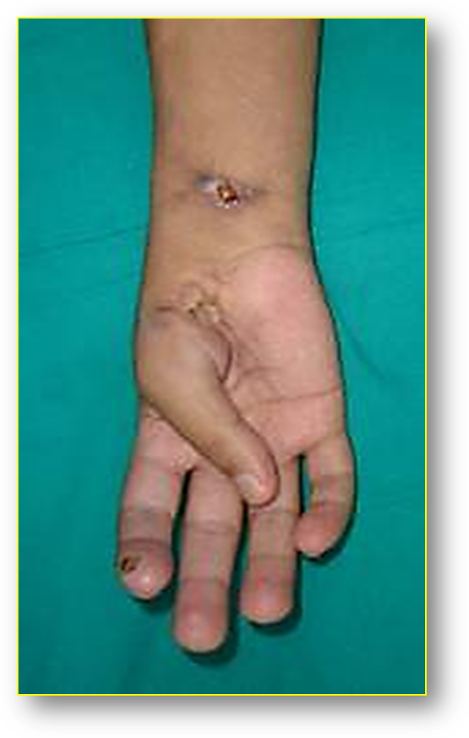 | 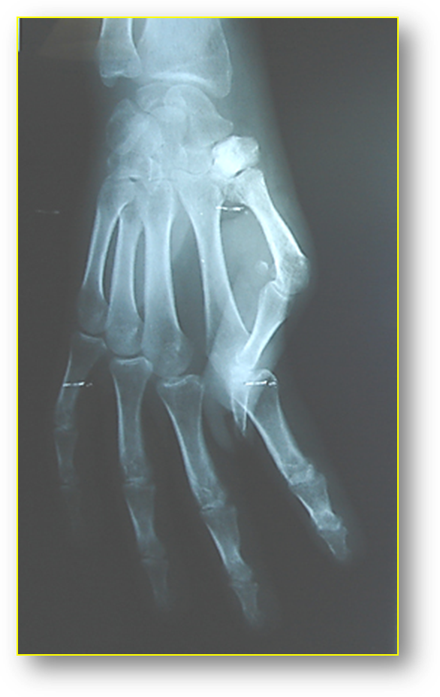
Figure (1-a)  Pre- Operative View | Figure (1-b)  Pre- Operative X- Ray
Figure (1)
Pre- Operative Data of Right hand
Figure (1- a): The thumb of the right hand was fixed in the position of extreme adduction.
Two ulcers were present, one in the thenar eminence whereas the other was in the forearm. Small recently induced burn in the bulb of the index finger.
Figure (1- b): Pre- operative X-ray shows necrosed trapezium, flexed 1st metacarpo- phalangeal joint,
and reduced first- second metacarpal angle.

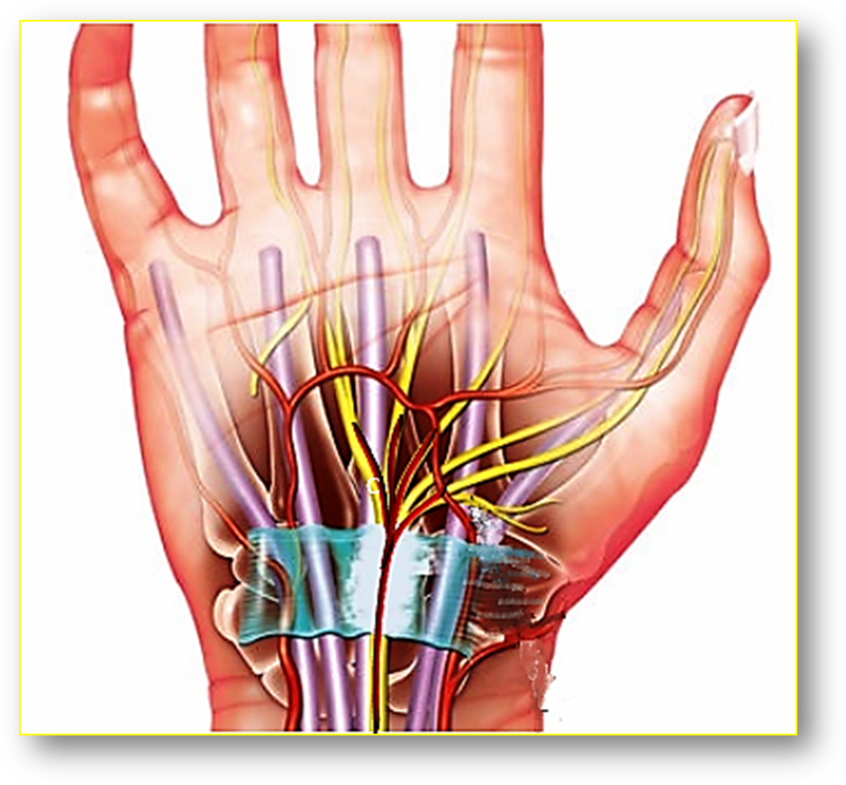
Nutrient Artery of Median Nerve

Transverse Carpal Ligament
(Flexor Retinaculum)

Figure (2)
Drawing of Surgical Findings
There was a complete rupture of the median nerve.
Notice the contact median artery and its branches bridging the gap between the cut endings of the nerve.

The thenar cutaneous ulcer has been found too deep eroding the most bloc of the thenar muscles; M. pollicis abductor brevis, M. opponens pollicis, M. pollicis flexor brevis. At its fond, was the contact tendon of the long flexor muscle of thumb.
The first, second, and the third digital nerves have been anastomosed to the proximal end of the nerve. The thenar branch of the median nerve has been left without repair because of the disruption of the muscle- target; the thenar muscles. The thenar ulcer has been debirided. A full- thickness skin graft was necessary to cover the resulting skin defect. Whereas the forearm ulcer has been easily managed by local solutions.
Discussion
It was surprising to find the median nerve in such condition because of an overwhelming pressure exercised upon it. I have calculated a number of reasons for what I presumed to be a rare, maybe unique, complication of the carpal tunnel syndrome:
- The median nerve was the only victim of such etiology. It is obvious that any presumed cutting force wouldn't respect the neighboring structures; tendons, arteries, particularly the median artery.
- There was no local evidence of a penetrating criminal force. Neither the skin, nor the inside local tissues gave any index of such invasion. In contrast, they have been of normal appearance and elasticity.
- There was no neurofibroma in the proximal end of the ruptured nerve. This should be a strong evidence of the nature of the criminal force, that played on the nerve nutrition and nerve regeneration.
- The extremely adducted thumb for more than one year could explain the cause of the hyper pressure exercised over the median nerve. The trapezium bone sclerosis maybe the other index of such etiology.
……………………………………………………………………
In another context, one can also read:
 | Neural Conduction, Personal View vs. International View (Innovated)
 | Upper Motor Neuron Lesions, Pathophysiology of Symptomatology
 | Neural Conduction, Action Pressure Waves (Innovated)
 | Neural Conduction, Action Potentials (Innovated)
 | Neural Conduction, Action Electrical Currents (Innovated)
 | The Function of Action Potentials (Innovated)
 | The Three Phases of Neural Conduction (Innovated)
 | Neural Conduction in the Synapse (Innovated)
 | Sensory Receptors
 | Nodes of Ranvier, the Equalizers (Innovated)
 | Nodes of Ranvier, the Functions (Innovated)
 | Nodes of Ranvier, First Function (Innovated)
 | Nodes of Ranvier, Second Function (Innovated)
 | Nodes of Ranvier, Third Function (Innovated)
 | Node of Ranvier The Anatomy
 | The Philosophy of Pain, Pain Comes First! (Innovated)
 | The Philosophy of the Form (Innovated)
 | Spinal Injury, Pathophysiology of Spinal Shock, Pathophysiology of Hyperreflexia
 | Who Decides the Sex of Coming Baby?
 | Spinal Shock (Innovated)
 | The Clonus (Innovated)
 | Hyperactivity Hyperreflexia (Innovated)
 | Hyperreflexia, Extended Sector of Reflex
 | Hyperreflexia, Bilateral Responses
 | Hyperreflexia, Multiple Responses
 | Nerve Conduction Study, Wrong Hypothesis is the Origin of the Misinterpretation (Innovated)
 | Wallerian Degeneration (Innovated)
 | Neural Regeneration (Innovated)
 | Wallerian Degeneration Attacks Motor Axons, While Avoids Sensory Axons
 | Barr Body, the Whole Story (Innovated)
 | Boy or Girl, Mother Decides!
 | Adam's Rib and Adam's Apple, Two Faces of one Sin
 | The Black Hole is a (the) Falling Star?
 | Adam's Rib, could be the Original Sin?
 | Pronator Teres Syndrome, Struthers Like Ligament (Innovated)
 | Function of Standard Action Potentials & Currents
 | Posterior Interosseous Nerve Syndrome
 | Spinal Reflex, New Hypothesis of Physiology
 | Hyperreflexia, Innovated Pathophysiology
 | Clonus, 1st Hypothesis of Pathophysiology
 | Clonus, 2nd Hypothesis of Pathophysiology
 | Clonus, Two Hypotheses of Pathophysiology
 | Hyperreflexia (1), Pathophysiology of Hyperactivity
 | Hyperreflexia (2), Pathophysiology of bilateral Responses
 | Hyperreflexia (3), Pathophysiology of Extended Hyperreflex
 | Hyperreflexia (4), Pathophysiology of Multi-Response Hyperreflex
 | Barr Body, the Second Look
 | Mitosis in Animal Cell
 | Meiosis
 | Universe Creation, Hypothesis of Continuous Cosmic Nebula
 | Circulating Sweepers
 | Pneumatic Petrous, Bilateral Temporal Hyperpneumatization
 | Ulnar Nerve, Congenital Bilateral Dislocation
 | Oocytogenesis
 | Spermatogenesis
 | This Woman Can Only Give Birth to Female Children
 | This Woman Can Only Give Birth to Male Children
 | This Woman Can Give Birth to Female Children More Than to Male Children
 | This Woman Can Give Birth to Male Children More Than to Female Children
 | This Woman Can Equally Give Birth to Male Children & to Female Children
 | Piriformis Muscle Injection_ Personal Approach
 | Eve Saved Human's Identity, Adam Ensured Human's Adaptation
 | Corona Virus (Covid-19): After Humiliation, Is Targeting Our Genes
 | Claw Hand Deformity (Brand Operation)
 | Corona Virus (Covid-19): After Humiliation, Is Targeting Our Genes
 | Barr Body; Mystery of Origin & Ignorance of Function
The Multiple Sclerosis: The Causative Relationship Between
The Galvanic Current & Multiple Sclerosis?
Liver Hemangioma: Urgent Surgery of Giant Liver Hemangioma
Because of Intra-Tumor Bleeding
 | Cauda Equina Injury, New Surgical Approach
 | Ulnar Dimelia, Mirror hand Deformity
 | Carpal Tunnel Syndrome Complicated by Complete Rupture of Median Nerve

3/12/2012
Updated 3/12/2021

