AMMAR YASEEN MANSOUR
Presacral Schwannoma
Schwannomas are rare neoplasms arising off Schwann cells. Most of them are benign. Acoustic schwannoma is the most famous tumor of the family. Retroperitoneal schwannomas form 1-5% of all retroperitoneal primary tumors. Pelvic schwannomas consist 1% of all schwannomas. Thus, they are coming too far after the head, the neck, and the upper extremities ones. Nevertheless, there are only 21 cases of presacral schwannoma reported in the english medical literature.
Case report
A 40-year-old male patient presented with a history of both Crohn's disease and left ureteral calculi. Crohn's disease dates to 2 years ago. Whereas, the left ureteral calculi were first put in evidence 2 months ago. It was during the ultra sound screening when a pelvic mass was seen occupying the presacral space.
The ultra sound study was undetermined about the nature of the mass. In contrast, CT scan with contrast infusion showed a round well- demarcated mass, measuring 8 cm, occupying the presacral space, deviated a little bit to the right of the midline, pushing forward the other pelvic organs (rectum, bladder). The mass was inhomogeneous in taking the contrast. Figures (1) & (2).
The decision was made to totally remove the tumor via anterior midline approach. Supported by the clear contour of the mass, the integrity of the sacrum, the absence of any neural signs and symptoms, I did not expect any difficulty in operating on.
Smoothly run out the time of the operation. Two hours and the mass has been removed by enucleation, and been outside on a lateral table. Blood loss was less than 100 ml. The patient has discharged the second postoperative day; Figure (3).
Contrary to all preoperative differential diagnosis, the pathologic analysis of the resected specimen was" benign schwannoma"; Figure (4).

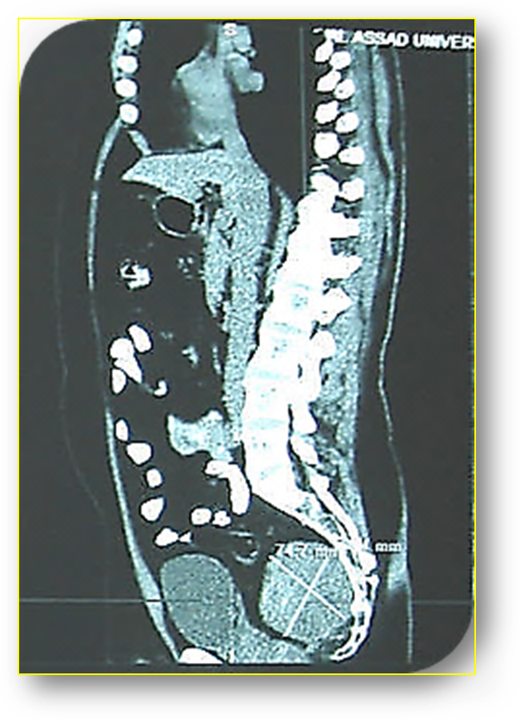
Presacral Schwannoma
Urinary Bladder
Figure (1)
CT- Scan with Contrast Infusion
Sagittal Section
Round well demarcated mass in the presacral space, measuring 8 cm, and pushing forward the bladder.

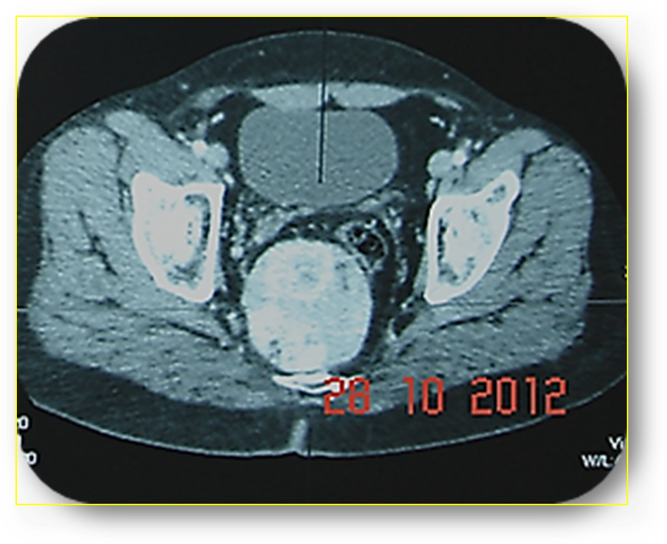
Presacral Schwannoma
Urinary Bladder
Rectum
Sacrum
Midline
Figure (2)
CT- Scan with Contrast Infusion
Axial Section
The mass is inhomogeneous in taking the contrast. Note how the mass is deviated from the midline of the sacrum to the right. The rectum is pushed away to the left- anterior side.

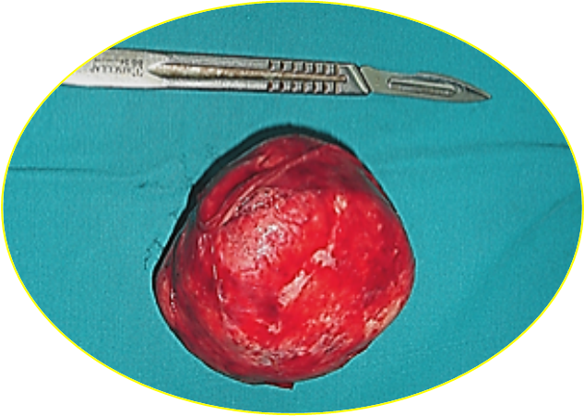 | 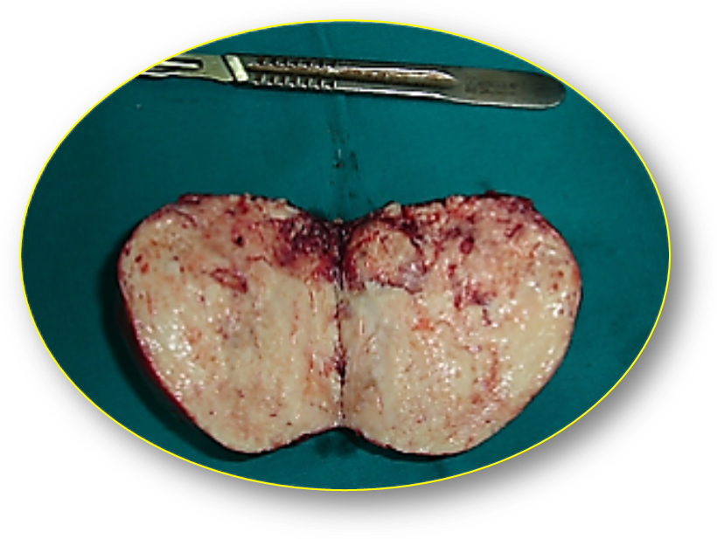
Figure (3- a)  Per- Operative View | Figure (3- b)  Per- Operative View
Figure (3)
The Resected Mass, Macroscopic View
Per- Operative Views
Figure (3- a): The tumor has spherical shape with two polar elongations. It has elastic rather than hard nature.
Figure (3- b): Cut surface of the resected mass shows degenerated cystic structures and hemorrhagic foci.

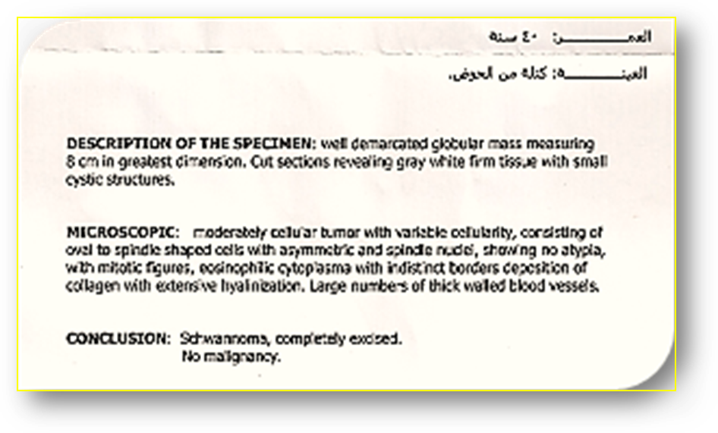
Figure (4)
Pathology Report
Benign schwannoma totally excised.
There also were cystic changes revealing the old age of the tumor.

Discussion:
Schwannomas are rare benign neoplasms arising from the nerve sheath. Some cases of malignant transformation have been reported. In fact, these were a transformation from plexiform neurofibromatosis rather than a malignant degeneration of previously exist benign schwannomas.
Schwannomas mostly occur in the head, neck, and the upper extremities. Acoustic schwannoma is the most popular member of the family. Retroperitoneal schwannomas are very rare; no more than 133 reported case in the english medical literature, Takatera et al*. Retroperitoneal schwannomas consist 1-5% of all primary retroperitoneal tumors. Nevertheless, just 21 reported cases, mostly in women, of presacral schwannomas are described in the medical literature.
Pelvic retroperitoneal schwannomas are classified as sacral, dumb-bell, and presacral schwannoma. Sacral schwannomas are completely confined to the sacrum. Dumb-bell schwannomas have two components; one intra-sacral whereas the other extra- sacral. Presacral schwannomas are very rare tumor entirely located in the presacral space.
Presacral schwannoma gets very large size before being detectable. In spite of its origin from the nerve sheath, it seldom causes functional disorders. The slow growth of the tumor gives the neighboring nerves the opportunity to compensate the functional loss caused by the tumor impaction on the mother nerve.
There are no specific symptoms. The most presenting symptoms are those related to the rectum, bladder, nerves, compressed by the tumor mass. Most often, the tumor is discovered incidentally with rectal examination or while doing radio investigations to the pelvis for another reason.
CT, MRI, are the radio of choice. MRI has the privilege of better showing the texture, internal cystic degenerations, location, size, and the relationship of the tumor with the soft neighborhoods. CT scan superimposes in delineating the bone- tumor relationship. The presence of calcifications and cystic degenerations within the tumor are synonym to old age. Finally, the tumor location outside the midline is considered good radio sign to differentiate it from chordoma which quite respect the midline of the sacrum.
Since benign schwannomas are encapsulated tumor, total excision of the tumor is the treatment. However, piecemeal excision of the tumor is another surgical choice whenever total excision of the tumor is technically difficult, and harbors great risk of bleeding or nervous compromise. Such cases are expected each time the tumor invades the sacrum. There is no adjuvant therapy even with partial excision. Reoccurrence rate is 11% in total excision, over 50% in partial excision.
…………………………………………………………………………………………………
* lin CM, Kao CC, Lin TC, Cha TL, Wu ST. Giant presacral schwannoma mimicking malignancy in a man. Acta Chir Belg 2010;110:387-389.

In another context, one can also read:
 | Neural Conduction, Personal View vs. International View (Innovated)
 | Upper Motor Neuron Lesions, Pathophysiology of Symptomatology
 | Neural Conduction, Action Pressure Waves (Innovated)
 | Neural Conduction, Action Potentials (Innovated)
 | Neural Conduction, Action Electrical Currents (Innovated)
 | The Function of Action Potentials (Innovated)
 | The Three Phases of Neural Conduction (Innovated)
 | Neural Conduction in the Synapse (Innovated)
 | Sensory Receptors
 | Nodes of Ranvier, the Equalizers (Innovated)
 | Nodes of Ranvier, the Functions (Innovated)
 | Nodes of Ranvier, First Function (Innovated)
 | Nodes of Ranvier, Second Function (Innovated)
 | Nodes of Ranvier, Third Function (Innovated)
 | Node of Ranvier The Anatomy
 | The Philosophy of Pain, Pain Comes First! (Innovated)
 | The Philosophy of the Form (Innovated)
 | Spinal Injury, Pathophysiology of Spinal Shock, Pathophysiology of Hyperreflexia
 | Who Decides the Sex of Coming Baby?
 | Spinal Shock (Innovated)
 | The Clonus (Innovated)
 | Hyperactivity Hyperreflexia (Innovated)
 | Hyperreflexia, Extended Sector of Reflex
 | Hyperreflexia, Bilateral Responses
 | Hyperreflexia, Multiple Responses
 | Nerve Conduction Study, Wrong Hypothesis is the Origin of the Misinterpretation (Innovated)
 | Wallerian Degeneration (Innovated)
 | Neural Regeneration (Innovated)
 | Wallerian Degeneration Attacks Motor Axons, While Avoids Sensory Axons
 | Barr Body, the Whole Story (Innovated)
 | Boy or Girl, Mother Decides!
 | Adam's Rib and Adam's Apple, Two Faces of one Sin
 | The Black Hole is a (the) Falling Star?
 | Adam's Rib, could be the Original Sin?
 | Pronator Teres Syndrome, Struthers Like Ligament (Innovated)
 | Function of Standard Action Potentials & Currents
 | Posterior Interosseous Nerve Syndrome
 | Spinal Reflex, New Hypothesis of Physiology
 | Hyperreflexia, Innovated Pathophysiology
 | Clonus, 1st Hypothesis of Pathophysiology
 | Clonus, 2nd Hypothesis of Pathophysiology
 | Clonus, Two Hypotheses of Pathophysiology
 | Hyperreflexia (1), Pathophysiology of Hyperactivity
 | Hyperreflexia (2), Pathophysiology of bilateral Responses
 | Hyperreflexia (3), Pathophysiology of Extended Hyperreflex
 | Hyperreflexia (4), Pathophysiology of Multi-Response Hyperreflex
 | Barr Body, the Second Look
 | Mitosis in Animal Cell
 | Meiosis
 | Universe Creation, Hypothesis of Continuous Cosmic Nebula
 | Circulating Sweepers
 | Pneumatic Petrous, Bilateral Temporal Hyperpneumatization
 | Ulnar Nerve, Congenital Bilateral Dislocation
 | Oocytogenesis
 | Spermatogenesis
 | This Woman Can Only Give Birth to Female Children
 | This Woman Can Only Give Birth to Male Children
 | This Woman Can Give Birth to Female Children More Than to Male Children
 | This Woman Can Give Birth to Male Children More Than to Female Children
 | This Woman Can Equally Give Birth to Male Children & to Female Children
 | Piriformis Muscle Injection_ Personal Approach
 | Eve Saved Human's Identity, Adam Ensured Human's Adaptation
 | Corona Virus (Covid-19): After Humiliation, Is Targeting Our Genes
 | Claw Hand Deformity (Brand Operation)
 | Corona Virus (Covid-19): After Humiliation, Is Targeting Our Genes
 | Barr Body; Mystery of Origin & Ignorance of Function
The Multiple Sclerosis: The Causative Relationship Between
The Galvanic Current & Multiple Sclerosis?
Liver Hemangioma: Urgent Surgery of Giant Liver Hemangioma
Because of Intra-Tumor Bleeding
 | Cauda Equina Injury, New Surgical Approach
 | Ulnar Dimelia, Mirror hand Deformity
 | Carpal Tunnel Syndrome Complicated by Complete Rupture of Median Nerve
 | Presacral Schwannoma

5/11/2012
Updated 9/12/2021

