Dr. Ammar Yaseen Mansour
The Creation of Adam and the Creation of Eve
And from His Rib, Eve Was

To read the original Arabic version of this article, click here: (DOI)
خَلقُ آدمَ وخَلقُ حوَّاءَ: ومنْ ضِلعِهِ كانتْ حوَّاءُ
Today's topic is complex and arduous. It is a discourse on the very first genesis of humanity. It concerns the origin of the human male and the origin of the human female. This article examines the creation of Adam and Eve, with particular focus on the creation of Eve from Adam's rib. This discourse specifically concerns the first man, Adam, and the first woman, Eve. It therefore does not at all concern the creation of the men and women who came after them, as the secondary creation process has its own entirely different laws. This is an important detail that required clarification.
Now, returning to the creation of Adam and Eve, the divine declaration is clear and explicit in this regard. Adam and Eve were created from a single soul. And from Adam's soul, Eve came into being and existence. I will explore with you the scientific possibility of such a creation. I will discuss the far-reaching implications and the scientific significance of such a divine declaration. Given the precise and difficult nature of this topic for non-specialists, I will use illustrations and animations to elucidate what is challenging for the mind to grasp. Upon these, I build my arguments and logic. I begin directly with the Human Mother Stem Cell.
The primordial human cell, the Mother Stem Cell, contained the basic genetic blueprint for modern humans. Within its repositories, it held the precursor of the sex chromosome for both genders. I hypothesize that this primordial pair was the XX chromosomal pair. Driven by its innate instinct for survival, the Mother Stem Cell sought to reproduce and increase its number. The monumental event was the product of this desire. It adhered to the conditions and laws governing the process of asexual reproduction, Mitosis. Yet, a terrible error marred the progression of its life.
It duplicated its genetic store, as it must. And it intended, as is its right, to divide it equally between its two daughter cells. However, an error in division occurred, and the two structures ended up with different shares. Due to a division error, one cell retained an extra segment from its twin's X chromosome and forcibly annexed it to its own X chromosome. The latter swelled with its gain, while the former became truncated in its loss. The truncated chromosome became the male sexual chromosome Y, the associate of masculinity. The swollen chromosome became the female sexual chromosome, the precursor of the Barr Body and the counterpart of femininity; see the figures below.

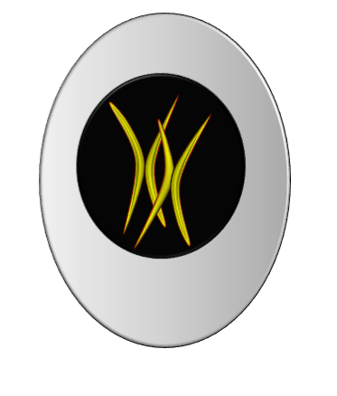

The Human Mother Stem Cell

It contained the fundamental genes for modern humans. The most important of all, undoubtedly, was the XX chromosomal pair. It is the precursor of the two sexual chromosomal pairs for both genders, male and female. To reach its full potential, it was in a state of neutrality, having not yet adopted a sexual orientation; that is, it was an asexual chromosomal pair.

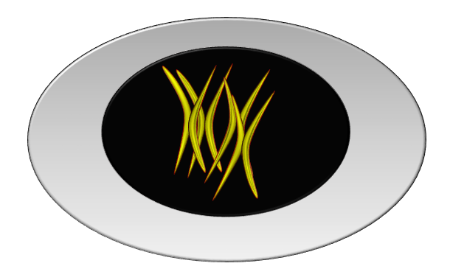
(1): The Human Mother Stem Cell in Asexual Reproduction
(Mitosis - Early Prophase)

The Human Mother Stem Cell entered the phase of asexual reproduction (Mitosis). It began by duplicating its store of genes in preparation for an equitable division between its two daughter cells.

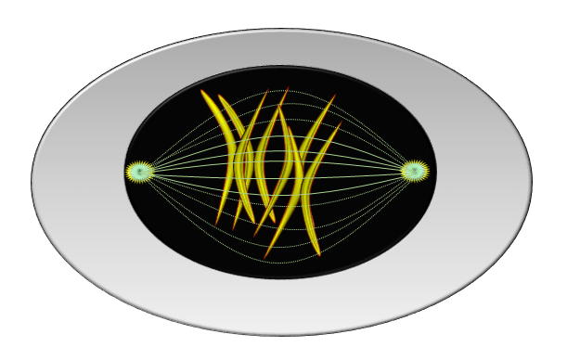
(2): The Human Mother Stem Cell in Asexual Reproduction
(Mitosis - Late Prophase)

The mitotic spindle formed, and the two centrosomes of the division spindle formed. The spindle microtubules attached to the genes in preparation for separating the twins from each other in two opposite directions.
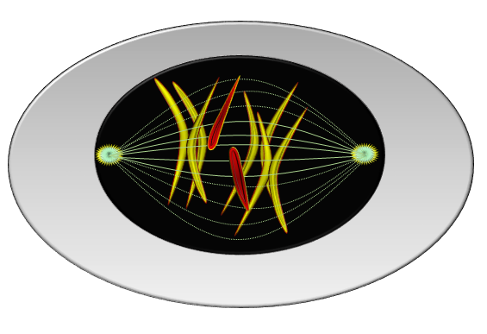
(3): The Human Mother Stem Cell in Asexual Reproduction
(Mitosis - Anaphase)

Here, the sin of cellular division occurred. A "rib" was torn from the X chromosome of one of the daughter cells and attached to the X chromosome of its twin. This is the fundamental sin of our existence as humans in the form we are in. A sin for which humanity continues to pay the price of its instigation to this day.

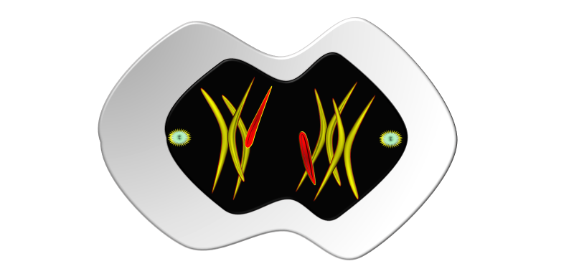

(4): The Human Mother Stem Cell in Asexual Reproduction
(Mitosis - Telophase)

The Human Mother Stem Cell continued its division. Here, the usurped rib gradually merges with the X chromosome of the dominant daughter cell.

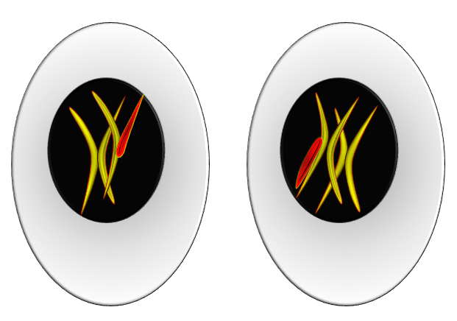
(5): The Human Mother Stem Cell in Asexual Reproduction
(Mitosis - Cytokinesis)

The Human Mother Stem Cell completed its asexual reproduction. It ultimately resulted in two non-identical daughter cells. Rather, they are complete opposites in every way, except in their origin. All of this, in essence and detail, stems from a rib excised from the X chromosome of the losing daughter cell, which the winning daughter cell annexed as a precious gain.

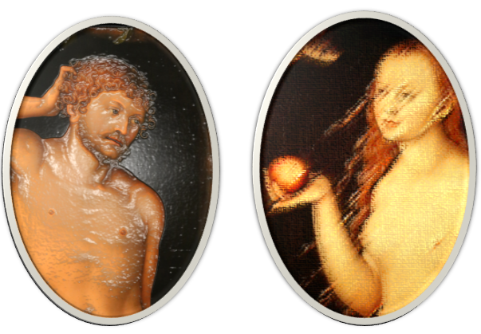
(6): The Human Mother Stem Cell in Asexual Reproduction
(Image Phase)

The daughter cell that usurped the rib differentiated into the first female being: Eve. The daughter cell that lost its rib assumed the role of the first man of creation: Adam.

You have undoubtedly sensed the nature of this "rib," lost between two cells, one losing and one gaining, which acted to distinguish their sexes. It is the rib of Adam, the basis for the manifestation of gender. The daughter cell that lost this rib yielded the first man, Adam. While the daughter cell that gained it differentiated and yielded the first woman, Eve.
Thus, from a sin in cellular division came our father Adam, and from it also came our mother Eve. The essence of the sin was a rib plucked from the origin of Adam and joined to the origin of Eve. It is the fundamental sin of our existence as humans. A sin that has long angered the heavens and vexed the earth... and still does.
Here are my arguments, and here is the sequence of my logic. It is, without doubt, the revelation of a mind that has journeyed afar. It is, undoubtedly, the harbinger of an intellect that has rebelled. I intended it as a search into uncharted territories that insisted on resistance. I intended it as sentiments of the heart that denied everything except liberation. It is a discovery that paved the way for many other discoveries. From the secrets of the creation of the human male and female from a single soul, to the secret of Eve's creation from Adam's rib, to the implications of the Barr Body as a witness to creation, to what has long perplexed scientists in their long-standing conjectures and suppositions about the sex of the fetus—all of these are now within the grasp of mind and thought.
These are scientific proofs and a research trajectory I place in your hands. Whether you accept them or discard them, the honor of the leap lies in the pursuit of excellence, whether the leaper attains the truth or falls as a martyr at its doorstep... it makes no difference!
………………………………………………………………………………………
In other contexts, you can also read the following articles:
 | DOI | The Spinal Reflex, New Hypothesis of Physiology
 | - | The Hyperreflexia, Innovated Pathophysiology
 | DOI | The Spinal Shock
 | - | The Spinal Injury, the Pathophysiology of the Spinal Shock, the Pathophysiology of the Hyperreflexia
 | DOI | Upper Motor Neuron Lesions, the Pathophysiology of the Symptomatology
 | DOI | Hyperreflexia (1): Pathophysiology of Disproportionate Motor Response
 | DOI | Hyperreflexia (2): Pathophysiology of Bilateral-Response Hyperreflexia
 | DOI | Hyperreflexia (3): Pathophysiology of Extended Hyperreflexia
 | DOI | Hyperreflexia (4): Pathophysiology of Multi-Motor-Response Hyperreflexia
- | DOI | The pathophysiology of Triple flexion Reflex
 | DOI | The Clonus, 1st Hypothesis of Pathophysiology
 | DOI | The Clonus, 2nd Hypothesis of Pathophysiology
 | DOI | The Clonus, Two Hypotheses of Pathophysiology
 | DOI | The Nerve Transmission through Neural Fiber, Personal View vs. International View
 | - | The Nerve Transmission through Neural Fiber (1), The Action Pressure Waves
 | - | The Nerve Transmission through Neural Fiber (2), The Action Potentials
 | - | The Nerve Transmission through Neural Fiber (3), The Action Electrical Currents
 | - | The Function of Standard Action Potentials & Currents
 | - | The Three Phases of Nerve transmission
 | DOI | Neural Conduction in the Synapse (Innovated)
 | DOI | Nodes of Ranvier, the Equalizers
 | - | Nodes of Ranvier, the Functions
 | - | Nodes of Ranvier, First Function
 | - | Nodes of Ranvier, Second Function
 | - | Nodes of Ranvier, Third Function
 | - | Node of Ranvier, The Anatomy
 | DOI | Vesicular Dynamics: A Unifying Theory for Wallerian Degeneration and Neural Regeneration
 | - | The Wallerian Degeneration
 | - | The Neural Regeneration
 | DOI | Wallerian Degeneration: Affects Motor Axons while Sparing Sensory Axons
 | DOI | The Sensory Receptors
 | DOI | Electroneurography vs. Neural Reality: Hidden Fallacies in Nerve Conduction Studies
 | DOI | Piriformis Muscle Injection: Personal Approach
 | DOI | In Philosophy of Nerves: Pain First!
 | DOI | In Neurodoctrines: Form is Necessity!
 | DOI | Pronator Teres Syndrome, Struthers-Like Ligament
 | DOI | Ulnar Nerve, Congenital Bilateral Dislocation
 | - | Posterior Interosseous Nerve Syndrome
 | DOI | The Multiple Sclerosis: The Causative Relationship Between  The Galvanic Current & Multiple Sclerosis?
 | - | Cauda Equina Injury, New Surgical Approach
 | DOI | Carpal Tunnel Syndrome Ends Its Adherence: Complete Median Nerve Transection
 | DOI | Biceps Femoris' Long Head Syndrome (BFLHS)
 | DOI | Barr Body, The Whole Story (Innovated)
 | - | Adam's Rib and Adam's Apple, Two Faces of one Sin
 | - | Adam's Rib, could be the Original Sin?
 | - | Barr Body, the Second Look
 | DOI | Who Decides the Sex of Coming Baby?
 | - | Boy or Girl, Mother Decides!
 | - | Oocytogenesis
 | - | Spermatogenesis
 | - | This Woman Can Only Give Birth to Female Children
 | - | This Woman Can Only Give Birth to Male Children
 | - | This Woman Can Give Birth to Female Children More Than to Male Children
 | - | This Woman Can Give Birth to Male Children More Than to Female Children
 | - | This Woman Can Equally Give Birth to Male Children & to Female Children
 | - | Eve Saved Human Identity; Adam Ensured Human Adaptation
 | DOI | COVID-19: Beyond the Crisis—Is It Targeting Our Genes?
 | DOI | Fibromyalgia
 | - | Mitosis in Animal Cell
 | - | Meiosis
 | DOI | The Creation of the Heavens and the Earth: The Connected Nebular Universe Hypothesis
 | DOI | The Sweeping Celestial Bodies (Al-Jawāri Al-Kunnas)
 | DOI | The Black Hole and the Falling Star Hypothesis
- | DOI | Light is a Wave and the Path is Material: A New Vision of the Nature of Light and its Propagation
 | - | Pneumatic Petrous, Bilateral Temporal Hyperpneumatization
 | DOI | Congenital Bilateral Thenar Hypoplasia
 | DOI | Ulnar Dimelia, Mirror hand Deformity
 | DOI | Thumb Reconstruction Using Microvascular Second Toe to Thumb Transfer
 | DOI | Surgical Restoration of a Smile by Grafting a Segment of the Gracilis Muscle to the Face
 | DOI | Mandible Reconstruction Using Free Fibula Flap
- | DOI | Free Fibula Flap for Bone Lost Complicated with Recalcitrant Osteomyelitis
 | DOI | Presacral Schwannoma
 | DOI | Liver Hemangioma: Urgent Surgery of Giant Liver Hemangioma  Due to Intra-Tumor Bleeding
 | DOI | Free Para Scapular Flap (FPSF) for Skin Reconstruction
 | DOI | Claw Hand Deformity (Brand Operation)
 | DOI | Algodystrophy Syndrome Complicated by Constricting Ring at the Proximal Border of the Edema
 | DOI | Non- Traumatic Non- Embolic Acute Thrombosis of Radial Artery (Buerger’s Disease)
 | DOI | Isolated Axillary Tuberculosis Lymphadenitis
 | DOI | The Iliopsoas Tendonitis... The Snapping Hip
- | DOI | Peri- Menopausal Breast Lesions: Towards a More Decisive Approach
 | To read the original Arabic version of the article, click on:
 | DOI | The New Frankenstein Monster
 | DOI | The Lone Wolf
 | DOI | The Delirium of Night and Day
 | DOI | The Delirium of the Economy
 | DOI | Ovaries in a Secure Corner… Testicles in a Humble Sac:  An Inquiry into the Function of Form
 | DOI | Eve Preserves Humanity’s Blueprint; Adam Drives Its Evolution
 | DOI | The Manufacture of the Unconscious
 | DOI | The Ballad of Eternity
 | DOI | Two Truths Woman Would Never Accept
 | DOI | The 'Iddah (Waiting Period) in Islamic Law: A Comparative Analysis of its Rationale for Divorced Women and Widows
 | DOI | The IVF/ICSI-Conceived Child: A Biologically Suboptimal Outcome
 | DOI | Nature's Relentless Couriers
 | DOI | The Triad of Intelligence... A Traveler's Provisions!
 | DOI | Zero-Value Equations: Modernity’s Hidden Costs and False Promises
 | DOI | The Dialectic of Meaning and Meaninglessness
 | DOI | Societal Schizophrenia: The Delirium of Our Time
 | DOI | The Rational Mind and the Abstract Mind
 | DOI | The Electric Lamp: Between Abstraction and Application - A Journey of a Thousand Years!
 | DOI | Thus spoke Abraham, the Friend: The Eternal... and the Ephemeral
 | DOI | The Crisis of an Intellectual Who Lost His Identity Under Piles of the Read and the Heard
 | DOI | Polygamy and Right-Hand Possession
 | DOI | Quranic Revelations
 | DOI | And the Profession... is a Martyr!
 | DOI | After Death and Before the Final Drive: Either Metamorphosis or Liberation!
 | DOI | The Junction of the Two Seas: An Isthmus Between Two Lives... The Story of Moses Who Lost His Fish
 | DOI | Absurd Wars: The Dualities of Existential Anxiety... Eternal Torment or a Sustained Test?
 | DOI | The Myth, The Aged Truth: Samson the Tale, and Sisyphus the Human
 | DOI | The Black Hole and The Falling Star Hypothesis
 | DOI | Eve (Hawwā): The Containing Woman.. A Philosophical Study of Name, Nature, and the Feminine Psyche
 | DOI | The Spirit and The Psyche: The First is a Gift from the Creator, The Second is a Craft of the Created
 | DOI | Noah's Ark: A Reprieve from Annihilation, Not from the Ordeal
 | DOI | The Final Deluge: A Great Flood... and No Ark
 | DOI | Unveiling the Veiled: It begins with the Name… and ends with Identity.
 | DOI | Human Society: A Gathering of Necessity or a Gathering of Innate Nature?
 | DOI | The Eternal Dialectic: Thought and Power in the Rise and Fall of Civilizations
 | DOI | She Almost Bore Her Brother: How Genetics Vindicates an Ancient Arabic Saying
 | DOI | The Imam Said: On Solitude and the Cure for a Troubled Time
 | DOI | Vitamin D: Youth For Ever

23/11/2025

