The Barr Body Reconsidered: A Novel Hypothesis for the Evolutionary Origin of Human Sex Chromosomes
Dr. Ammar Yaseen Mansour

Abstract:
The Barr body, a condensed chromatin structure derived from an X chromosome in female somatic cells, has been a subject of scientific intrigue since its discovery in 1949. While the prevailing Lyon hypothesis explains it as a product of random X-chromosome inactivation for dosage compensation, this explanation remains entangled with persistent genetic and clinical ambiguities. This paper proposes a novel ontological and functional reinterpretation of the Barr body, challenging the paradigm of inactivation. I posit that the Barr body originates not from a silenced X chromosome, but from the active X chromosome that has incorporated a distinct genomic segment— conceptualized as the "stolen rib"—during a primordial asymmetrical mitotic event. This event is narratively framed as the divergence point giving rise to the first male (XY) and female (XX) cells. My hypothesis redefines the Barr body as a "Royal Witness" to this foundational event, a permanent structural signature of femininity rather than a mere regulatory byproduct. By critically examining the limitations of the Lyon hypothesis—particularly regarding carrier states in X-linked disorders and gametic inheritance patterns—I argue that my model offers a more coherent narrative that reconciles molecular structure with longstanding biological and clinical observations. This perspective invites a fundamental reconsideration of the Barr body’s role from one of suppression to one of unique identity and continuous function.

The Barr Body: A Mystery in Origin and Function
The Barr body, first identified by Murray Barr in 1949, is a hallmark feature of human female somatic cells. Despite being discovered over seven decades ago, it remains one of the most enigmatic structures in cell biology. The origin and functional significance of this condensed X chromosome have long fueled scientific debate, yet none of the proposed hypotheses have achieved unanimous consensus within the academic community.
This study seeks to unravel the complexities surrounding the Barr body by examining its molecular and cellular mechanisms. Through this exploration, unexpected discoveries have emerged, shedding new light on its role in gene regulation. The following sections provide a comprehensive analysis of these findings, offering fresh insights into this enduring biological puzzle.
Where Does the Story Begin?
It began with a single cell and ends with a human being. Between the cell and the human lies a tale as ancient as time itself—a story of creation and wonder. The narrative starts with one cell dividing into two: one male and one female. Between male and female lies a distinct chromosomal pair known as the sex chromosomes: XY in males and XX in females. Yet their origin is one. How, then, does such divergence arise?
The primordial human mother cell contained within its nucleus the blueprint of future humanity. The original sex chromosome must have been XX. This ancestral cell duplicated its genetic material and then divided symmetrically into two daughter cells, each receiving an equal share of its contents—a process modern science terms asexual reproduction, or mitotic division.
Daughter cells are identical to the mother cell. Yet uniformity in genetic content does not account for the diversity of form. What meaning would there be in humans identical in appearance? Difference, then, is inevitable. Herein lies the marvel of creation and the wisdom of the Creator.
Children of Transgression
During the asexual division of the human mother cell, the primordial sex chromosome (XX) duplicated into (XXXX) in preparation for separation into two identical cells. Yet during the anaphase stage of migration, a great transgression occurred—an event that would forever mark the history of humankind.
A treacherous chromosomal pair (XX) severed a segment—a “rib”—from one of the chromosomes in the other pair. The X chromosome that lost this segment became the Y chromosome, transforming the affected pair into XY. The XY pair ended up in the nucleus of one daughter cell. Meanwhile, the usurping pair, having stolen this segment, retained its original XX form but now harbored a new element within the nucleus of the other daughter cell (Figures 1 & 2).

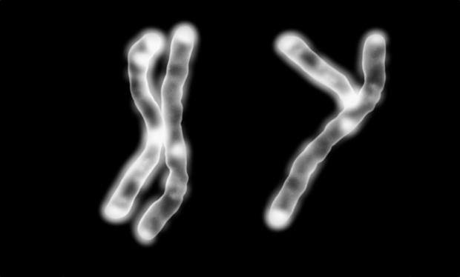 | 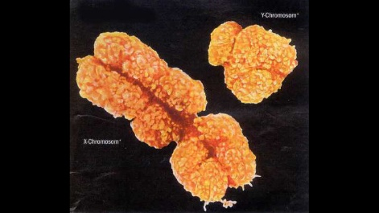
Approximate Depiction of the XY Chromosome Pair | Accurate Depiction of the XY Chromosome Pair
Figure (1)


Figure (2-a)

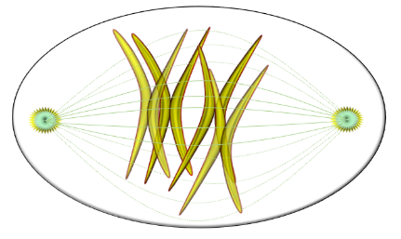
Figure (2-b)

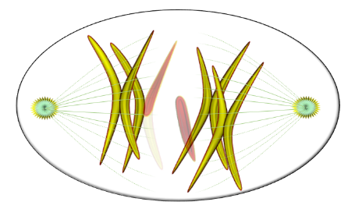
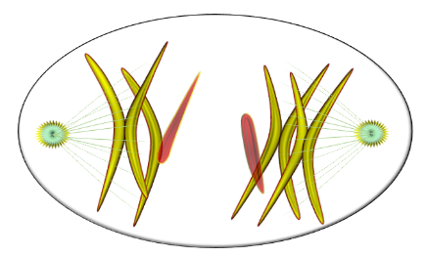
Figure (2-c)

 | 
Figure (2-d)

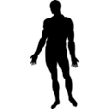 | 
Thr First Man, Adam | The First Woman, Eve
Figure (2): Schematic Illustration of the Asexual Division (The Mitosis)
of the Primordial Mother Cell
Figure (2-a):
The Mother Stem Cell (MSC): Contains 46 chromosomes—44 somatic chromosomes and a primordial pair I term the primordial sex chromosomes (pXX). For simplicity, only the primordial sex chromosomes (pXX) are illustrated.
Figure (2-b):
Mitotic Phase: During asexual reproduction (mitosis), the genetic content of the mother stem cell—represented here by the primordial sex chromosomes—is duplicated in preparation for equal division between the two daughter cells.
Figure (2-c):
Anaphase & Telophase: During chromosomal migration and separation, a segment (rib) from the X chromosome of one daughter cell erroneously joins the X chromosome of the other daughter cell.
Note: The red segment represents the stolen rib annexed to the X chromosome of the usurping cell.
Figure (2-d): Outcome
The X chromosome that lost a segment becomes the Y chromosome—the male sex chromosome. The daughter cell bearing the XY pair becomes the first male cell, destined to form the first man; Adam.
The daughter cell that gained the stolen rib becomes a female cell containing the XX pair. These X chromosomes are genetically asymmetrical: one incorporates the stolen rib, becoming larger than its partner. This modified chromosome is denoted as X*, where the asterisk (*) signifies the annexed rib. This cell is the progenitor of the first woman; Eve.
Note: The red segment marks the stolen rib erroneously fused to the X chromosome.

This new element—the stolen rib—would remain within the nucleus of the treacherous XX cell as an eternal witness to what transpired in the darkness of that distant era. But what purpose does this witness serve within the nucleus of the usurping cell?
The Royal Witness
In a journey as profound as creation itself, the Merciful bestows upon us the abundance of His wisdom, leaving signs at critical junctures—testimonies affirming that the act of creation passed through here. The human body abounds with such witnesses, corroborating all that has been said and making further elaboration unnecessary.
It is true that the stolen rib could have dissolved and vanished within the nucleus of the usurping cell. Yet it is equally plausible that it retained its essence, persisting in some form within that nucleus. I align with the latter view.
The lost rib—or the royal witness—is a fragment that detached from the X chromosome in one daughter cell and migrated into the nucleus of the other. The first daughter cell became XY, while the second retained its original XX form but with a new occupant: the stolen rib. Whether this rib remains independent or merges with another nuclear structure, it must manifest in some measurable form. Guided by this principle, I delve into the depths of the XX cell in search of our lost treasure (Figure 3).
The Mother Stem Cell (MSC)

The Mother Stem Cell  in Mitosis |  | 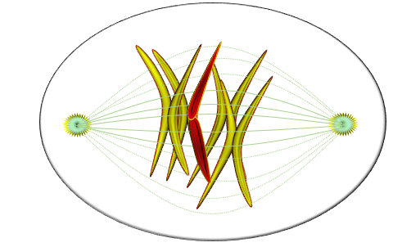
The Mother Stem Cell  in Mitosis |  | 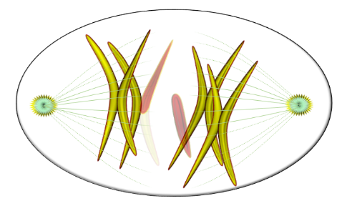
 |  | 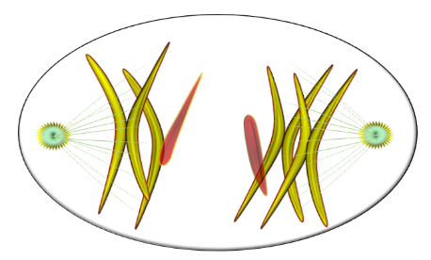
The Looser Daughter Cell
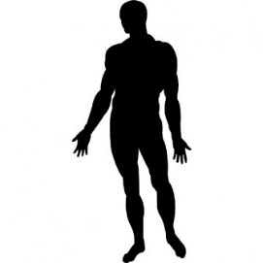

Thr First Man, Adam |  | (a) | (b)
 |  | The Winner Daughter Cell
 |  | 
 |  | The First Woman, Eve
Figure (3): The Barr Body
During the asexual division (the mitosis) of the primordial mother stem cell, a rib (stolen segment) from the X chromosome of one daughter cell (represented by the red segment) attaches to the X chromosome of the other daughter cell.
The first cell becomes a male cell, the origin of the first man, Adam.
The second cell becomes a female cell, the origin of the first woman, Eve.
This newly acquired rib in the nucleus of the recipient cell adopts one of two possible configurations:
Figure (3-a):
The stolen rib (red segment) fully integrates into the X chromosome’s material,
forming a hybrid chromosome with a higher molecular weight than the adjacent X chromosome. Or, it may bind spatially to the X chromosome via microtubules—remnants of the mitotic spindle apparatus.
The combined structure of the X chromosome and the rib forms the Barr Body in the somatic cells of the female.
Figure (3-b):
The stolen rib (red segment) remains a free-floating, autonomous structure within the nucleus of the recipient daughter cell. Over time, this independent entity evolves into the Barr Body in female somatic cells.

N.B. For greater clarity, see the linked video:
Video: https://doi.org/10.5281/zenodo.17741930

The Lyon Hypothesis: Strengths and Weaknesses
No idea endures six decades without a certain force of attraction. The Lyon hypothesis remains a reference in dosage compensation, but beneath its surface lies an accumulation of exceptions that weakens its foundation. Its defenders cite "decisive evidence": a Barr body appears in the normal female, disappears in the Turner female, and appears in the Klinefelter male. Yet these very facts may conceal the seeds of the hypothesis's undoing.
The first flaw is randomness itself. Randomness does not accord with the grandeur of creation; cellular caprice has no place in the logic of life. When reason fails, we must not project our own limitations onto the processes of creation. Randomness is a human trait, not a cellular principle.
The second flaw is the illusion of genetic redundancy. Nature does not deal in surplus. Living organisms may retain vestiges of once-functional organs, but a cell cannot carry a non-functional element the size of an X chromosome. The profound pathology of the Turner female confirms this: the loss of one X would not produce such devastation if that chromosome were truly dispensable.
The third flaw is the presumption of an identical counterpart. Inactivation assumes the two X chromosomes are functionally equivalent. But functionally identical pairs do not justify inactivating one of them. Man possesses two kidneys, two eyes, two ovaries—and no one speaks of functional chaos demanding inactivation. Paired organs exist to share the burden and stand ready in emergencies.
The fourth flaw concerns Klinefelter's paradox. If inactivation were a means of functional correction, it should have rescued the Klinefelter male. It did not. His extra X remains, his infertility persists, and the cell never employs this so-called mechanism against any other genetic malfunction. Inactivation is a selective act without justification.
The fifth flaw is structural. Mitotic condensation resembles no fine architecture comparable to the Barr body. We propose a model—conceptual yet testable—in which the Barr body is not a solid, impermeable mass but a porous architecture, with the X chromosome coiling within it like a serpent in its burrow. Gene escape, reaching 25 percent, is exactly what such porosity permits. A sealed condensation would permit none.
The sixth flaw is the duality of the mechanism: selective in the trophoblast, random elsewhere. Nature does not measure with two measures. If paternal X is silenced in one tissue and randomly silenced in others, then either this is not inactivation, or we must reconsider the very source of the inactivated X.
The seventh flaw is energetic. The cost of silencing a chromosome, then releasing a quarter of its genes, contradicts the principle of cellular economy. Nature favors simple, low-cost solutions. Caenorhabditis elegans moderates both X chromosomes together rather than silencing one—a principle of shared moderation, not wasteful silencing.
The eighth flaw is clinical. The proposition of two active X chromosomes explains X-linked diseases with greater simplicity: a recessive allele renders the female a carrier; a semi-dominant allele manifests only under stress; a dominant allele is mitigated by the healthy chromosome. The Lyon hypothesis, by contrast, invokes gene escape and skewed inactivation to explain every anomaly—a flexibility that reveals its weakness.
Thus, the Barr body stands not as a silenced chromosome but as a fortified one—a witness to the founding genetic event that must surely be revealed. Since 1961, the world has worn Lyon's yellow glasses. Had we once removed them and put on the green glasses of evolution, the cell would have appeared differently: alive, complex, and speaking a language richer than randomness. But only for a time—and the discerning understand the hint.
Conclusion
Lyon attributes Barr body formation to the “genetic overload” of two X chromosomes, necessitating random inactivation of one to regulate gene expression—a perpetual, stochastic process yielding numerous Barr bodies for regulatory purposes.
In my view, inactivating one of the X chromosomes creates the illusion of a flaw in the grand design of creation. This inactivation appears to be a superficial and simplistic evasion of a biological impasse—a notion I categorically reject. I believe both X chromosomes are perpetually active and essential for the optimal development of women, and disabling either would disrupt the delicate balance of form and function.
My hypothesis reframes the Barr body as part of an ancient, singular narrative—a story as old as humanity itself, inherited uniquely by women as a testament to primordial events. The Barr body embodies the qualities of my “lost treasure.” It resides in XX cells but not in XY cells. While Lyon claims it is the inactivated X, I propose it is the active X fused with the “stolen rib” (see Figure 3). Herein lies the debate: Is the Barr body a relic of suppression or a mark of union?
Important Note: In the absence of any comparable structure, the Barr body remains the strongest candidate for the title of the Royal Witness. However, the passage of time and the relentless advance of science may yet reveal a formidable rival to challenge its claim to this noble distinction.
A Novel Perspective
This hypothesis redefines the Barr body as the primary functional X chromosome, while the second X is reinterpreted as a non-sexual 'porter' chromosome—a paradigm shift that resolves key inconsistencies in the Lyon model.
………………………………………………………………………………
Article History: Originally Written & Published: 10/12/2017 Substantively Revised & Updated: 21/12/2025

In other contexts, one can also read the following articles:
- | DOI | Open Letter to Neuroscience Researchers
 | DOI | The Spinal Reflex, New Hypothesis of Physiology
 | - | The Hyperreflexia, Innovated Pathophysiology
 | DOI | The Spinal Shock: The Pathophysiology
 | - | The Spinal Injury, the Pathophysiology of the Spinal Shock, the Pathophysiology of the Hyperreflexia
 | DOI | Upper Motor Neuron Lesions: The Pathophysiology of the Symptomatology
 | DOI | Hyperreflexia (1): Pathophysiology of Disproportionate Motor Response
 | DOI | Hyperreflexia (2): Pathophysiology of Bilateral-Response Hyperreflexia
 | DOI | Hyperreflexia (3): Pathophysiology of Extended Hyperreflexia
 | DOI | Hyperreflexia (4): Pathophysiology of Multi-Motor-Response Hyperreflexia
- | DOI | The pathophysiology of Triple flexion Reflex
 | DOI | The Clonus, 1st Hypothesis of Pathophysiology
 | DOI | The Clonus, 2nd Hypothesis of Pathophysiology
 | DOI | The Clonus, Two Hypotheses of Pathophysiology
- | DOI | The Unified Mechanical Model of Neurotransmission: A Theoretical Framework and Experimental Blueprint for Validation
 | DOI | The Nerve Transmission through Neural Fiber: Personal View vs. International View
 | - | The Nerve Transmission through Neural Fiber (1), The Action Pressure Waves
 | - | The Nerve Transmission through Neural Fiber (2), The Action Potentials
 | - | The Nerve Transmission through Neural Fiber (3), The Action Electrical Currents
 | - | The Function of Standard Action Potentials & Currents
 | - | The Three Phases of Nerve transmission
 | DOI | Neural Conduction in the Synapse (Innovated)
 | DOI | Nodes of Ranvier, the Equalizers
 | - | Nodes of Ranvier, the Functions
 | - | Nodes of Ranvier, First Function
 | - | Nodes of Ranvier, Second Function
 | - | Nodes of Ranvier, Third Function
 | - | Node of Ranvier, The Anatomy
 | DOI | Vesicular Dynamics: A Unifying Theory for Wallerian Degeneration and Neural Regeneration
 | - | The Wallerian Degeneration
 | - | The Neural Regeneration
 | DOI | Wallerian Degeneration: Affects Motor Axons while Sparing Sensory Axons
 | DOI | The Sensory Receptors
 | DOI | Electroneurography vs. Neural Reality: Hidden Fallacies in Nerve Conduction Studies
 | DOI | Piriformis Muscle Injection: Personal Approach
 | DOI | In Philosophy of Nerves: Pain First!
 | DOI | In Neurodoctrines: Form is Necessity!
 | DOI | Pronator Teres Syndrome, Struthers-Like Ligament
 | DOI | Ulnar Nerve, Congenital Bilateral Dislocation
 | - | Posterior Interosseous Nerve Syndrome
 | DOI | The Multiple Sclerosis: The Causative Relationship Between  The Galvanic Current & Multiple Sclerosis?
 | DOI | Traumatic Injuries of the Cauda Equina: A Novel Surgical Approach
 | DOI | Carpal Tunnel Syndrome Ends Its Adherence: Complete Median Nerve Transection
 | DOI | Biceps Femoris' Long Head Syndrome (BFLHS)
- | DOI | Open Letter to Cytology and Genecology Researchers
 | DOI | The Founding Excision Hypothesis: A Testable Physical Prediction of Bimodal X Chromosome Mass in Human Oocytes and the True Nature of the Barr Body (Executive Summary)
- | DOI | The Story of Human Genesis: From Ancestral Predecessor to Human Successor — Bridging Theological Metaphor and Scientific Exposition
 | DOI | Barr Body, The Whole Story (Innovated)
- | DOI | A Critical Review of the Lyon Hypothesis
 | - | Adam's Rib and Adam's Apple, Two Faces of one Sin
 | - | Adam's Rib, could be the Original Sin?
 | - | Barr Body, the Second Look
 | DOI | Who Decides the Sex of Coming Baby?
 | - | Boy or Girl, Mother Decides!
 | - | Oocytogenesis
 | - | Spermatogenesis
 | - | This Woman Can Only Give Birth to Female Children
 | - | This Woman Can Only Give Birth to Male Children
 | - | This Woman Can Give Birth to Female Children More Than to Male Children
 | - | This Woman Can Give Birth to Male Children More Than to Female Children
 | - | This Woman Can Equally Give Birth to Male Children & to Female Children
 | DOI | Eve Saved Human Identity; Adam Ensured Human Adaptation
 | DOI | COVID-19: Beyond the Crisis—Is It Targeting Our Genes?
 | DOI | Fibromyalgia
 | - | Mitosis in Animal Cell
 | - | Meiosis
 | DOI | The Creation of the Heavens and the Earth: The Connected Nebular Universe Hypothesis
 | DOI | The Sweeping Celestial Bodies (Al-Jawāri Al-Kunnas)
 | DOI | The Black Hole and the Falling Star Hypothesis
- | DOI | Light is a Wave and the Path is Material: A New Vision of the Nature of Light and its Propagation
 | - | Pneumatic Petrous, Bilateral Temporal Hyperpneumatization
 | DOI | Congenital Bilateral Thenar Hypoplasia
 | DOI | Ulnar Dimelia, Mirror hand Deformity
 | DOI | Brachymetacarpia: Bilateral and Symmetrical Shortening of the Three Ulnar Digits
 | DOI | Thumb Reconstruction Using Microvascular Second Toe to Thumb Transfer
 | DOI | Surgical Restoration of a Smile by Grafting a Segment of the Gracilis Muscle to the Face
 | DOI | Mandible Reconstruction Using Free Fibula Flap
- | DOI | Free Fibula Flap for Bone Lost Complicated with Recalcitrant Osteomyelitis
 | DOI | Presacral Schwannoma
 | DOI | Liver Hemangioma: Urgent Surgery of Giant Liver Hemangioma  Due to Intra-Tumor Bleeding
 | DOI | Free Para Scapular Flap (FPSF) for Skin Reconstruction
 | DOI | Claw Hand Deformity (Brand Operation)
 | DOI | Algodystrophy Syndrome Complicated by Constricting Ring at the Proximal Border of the Edema
 | DOI | Non- Traumatic Non- Embolic Acute Thrombosis of Radial Artery (Buerger’s Disease)
 | DOI | Isolated Axillary Tuberculosis Lymphadenitis
 | DOI | The Iliopsoas Tendonitis... The Snapping Hip
- | DOI | Bilateral, Focal Autoimmune Thalamitis
- | DOI | Peri- Menopausal Breast Lesions: Towards a More Decisive Approach
To read the original Arabic version of the article, click on:
 | DOI | The New Frankenstein Monster
 | DOI | The Lone Wolf
 | DOI | The Delirium of Night and Day
 | DOI | The Delirium of the Economy
 | DOI | Ovaries in a Secure Corner… Testicles in a Humble Sac:  An Inquiry into the Function of Form
 | DOI | Eve Preserves Humanity’s Blueprint; Adam Drives Its Evolution
 | DOI | The Manufacture of the Unconscious
 | DOI | The Ballad of Eternity
 | DOI | Two Truths Woman Would Never Accept
 | DOI | The 'Iddah (Waiting Period) in Islamic Law: A Comparative Analysis of its Rationale for Divorced Women and Widows
 | DOI | The IVF/ICSI-Conceived Child: A Biologically Suboptimal Outcome
 | DOI | Nature's Relentless Couriers
 | DOI | The Triad of Intelligence... A Traveler's Provisions!
 | DOI | Zero-Value Equations: Modernity’s Hidden Costs and False Promises
 | DOI | The Dialectic of Meaning and Meaninglessness
 | DOI | Societal Schizophrenia: The Delirium of Our Time
 | DOI | The Rational Mind and the Abstract Mind
 | DOI | The Electric Lamp: Between Abstraction and Application - A Journey of a Thousand Years!
 | DOI | Thus spoke Abraham, the Friend: The Eternal... and the Ephemeral
 | DOI | The Crisis of an Intellectual Who Lost His Identity Under Piles of the Read and the Heard
 | DOI | Polygamy and Right-Hand Possession
 | DOI | Quranic Revelations
 | DOI | And the Profession... is a Martyr!
 | DOI | After Death and Before the Final Drive: Either Metamorphosis or Liberation!
 | DOI | The Junction of the Two Seas: An Isthmus Between Two Lives... The Story of Moses Who Lost His Fish
 | DOI | Absurd Wars: The Dualities of Existential Anxiety... Eternal Torment or a Sustained Test?
 | DOI | The Myth, The Aged Truth: Samson the Tale, and Sisyphus the Human
 | DOI | The Black Hole and The Falling Star Hypothesis
 | DOI | Adam's Apple and Adam's Rib: Two Facets of the Human Form
 | DOI | Eve (Hawwā): The Containing Woman.. A Philosophical Study of Name, Nature, and the Feminine Psyche
 | DOI | The Spirit and The Psyche: The First is a Gift from the Creator, The Second is a Craft of the Created
 | DOI | Noah's Ark: A Reprieve from Annihilation, Not from the Ordeal
 | DOI | The Final Deluge: A Great Flood... and No Ark
 | DOI | Unveiling the Veiled: It begins with the Name… and ends with Identity.
 | DOI | Human Society: A Gathering of Necessity or a Gathering of Innate Nature?
 | DOI | The Eternal Dialectic: Thought and Power in the Rise and Fall of Civilizations
 | DOI | She Almost Bore Her Brother: How Genetics Vindicates an Ancient Arabic Saying
 | DOI | The Imam Said: On Solitude and the Cure for a Troubled Time
 | DOI | Vitamin D: Youth For Ever
 | DOI | The Creation of Adam and the Creation of Eve: And from His Rib, Eve Was
 | DOI | Adam's Apple and Adam's Rib: Two Facets of a Single Sin
 | DOI | The Barr Body Reconsidered: A Novel Hypothesis for the Evolutionary Origin of Human Sex Chromosomes
 | DOI | In the Philosophy of the Atom: Who Gave the Electron its Negative Charge?
 | DOI | The Story of Human Genesis: From Ancestral Predecessor to Human Successor — Bridging Theological Metaphor and Scientific Exposition
 | DOI | Research Proposal: Re-evaluating the Structural Mass of the Human X Chromosome ​Demystifying Algorithmic Filtering in Genomic Assemblies and Characterizing the Sovereign Function of the Barr Body
 | DOI | The Founding Excision Hypothesis: A Testable Physical Prediction of Bimodal X Chromosome Mass in Human Oocytes and the True Nature of the Barr Body (Executive Summary)
 | DOI | The Unified Mechanical Model of Neurotransmission: A Theoretical Framework and Experimental Blueprint for Validation
 | DOI | A Critical Review of the Lyon Hypothesis

21/12/2025

