Dr. Ammar Yaseen Mansour
Clonus: 2nd Pathophysiological Hypothesis
"An endless duel of action-reaction—where each reflex fuels its enemy's retaliation"

To watch a detailed video explaining this hypothesis, click:
Clonus manifests as involuntary, rhythmic oscillations – aberrant sequential cycles of joint flexion and extension. Pathological clonus requires >5 flexion-extension cycles. While similar movements may occur in healthy individuals, they never exceed 5 cycles. When accompanied by other signs of Upper Motor Neuron (UMN) lesions, even brief clonus (<5 cycles) warrants diagnostic consideration. Clinically, we primarily investigate clonus at the knee and ankle. Though possible elsewhere, such occurrences remain exceptional.
Clonus may alternatively be conceptualized as a cascade of spatially opposed, functionally antagonistic spinal reflexes. These reflexes fire sequentially yet overlap temporally – where the termination of one reflex triggers its functional counterpart in a self-perpetuating kinetic chain. Each reflex conclusion serves as the initiator for its successor, creating a movement continuum that may persist for prolonged durations.
In Upper Motor Neuron (UMN) injuries, sudden ankle dorsiflexion elicits clonus – clinically characterized by involuntary, rhythmic ankle flexion-extension oscillations. Deconstructing this movement reveals its elemental composition: each oscillation embodies the sequential firing of two antagonistic reflexes:
- Achilles Reflex (Plantarflexion via S1-L5)
- Tibialis Anterior Reflex (Dorsiflexion via L4-L5)
Pathomechanics of Ankle Clonus
Initial Trigger:
Sudden ankle dorsiflexion imposes axial tension on the Achilles tendon. This stimulates tendon receptors (Golgi organs) to detect abrupt structural changes, activating the pathological spinal reflex circuit.
Phase 1: Plantarflexion Reflex
Violently and abruptly, the target muscles (Gastrocnemius and Soleus) contract Resulting in powerful plantarflexion.
Phase 2: Reciprocal Reflex Triggering
This forceful and sudden plantarflexion stretches the antagonistic muscle group (tibialis anterior), activating a second pathological spinal reflex – the hyperreflexic tibialis anterior reflex.
Following its own violent and sudden stretch, the Tibialis Anterior Muscle contracts with equal force and abruptness, producing forceful dorsal flexion (ankle dorsiflexion) as the kinetic counter-response. This antagonistic rebound inevitably reignites the opposing reflex cascade.
Here, both logic and function vanish – transforming movement into a self-perpetuating feud of action and counter-action. An unstoppable cascade of involuntary motions ceases only when:
- Muscular energy reserves deplete, OR
- Spontaneous reflex decay dampens the pathological circuits.
Terminal Phase:
The action fades... its reaction falters... until both dissolve into neurological silence. Thus concludes the combatants' ceasefire – a temporary armistice awaiting inevitable future battles. (See Figure Below).

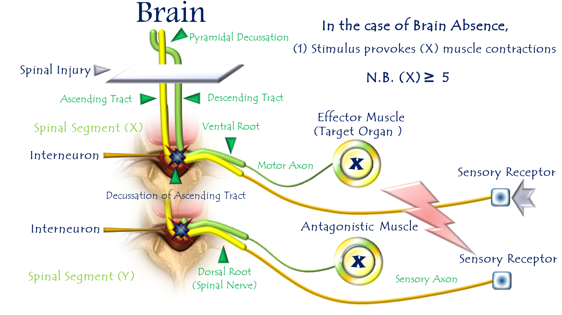
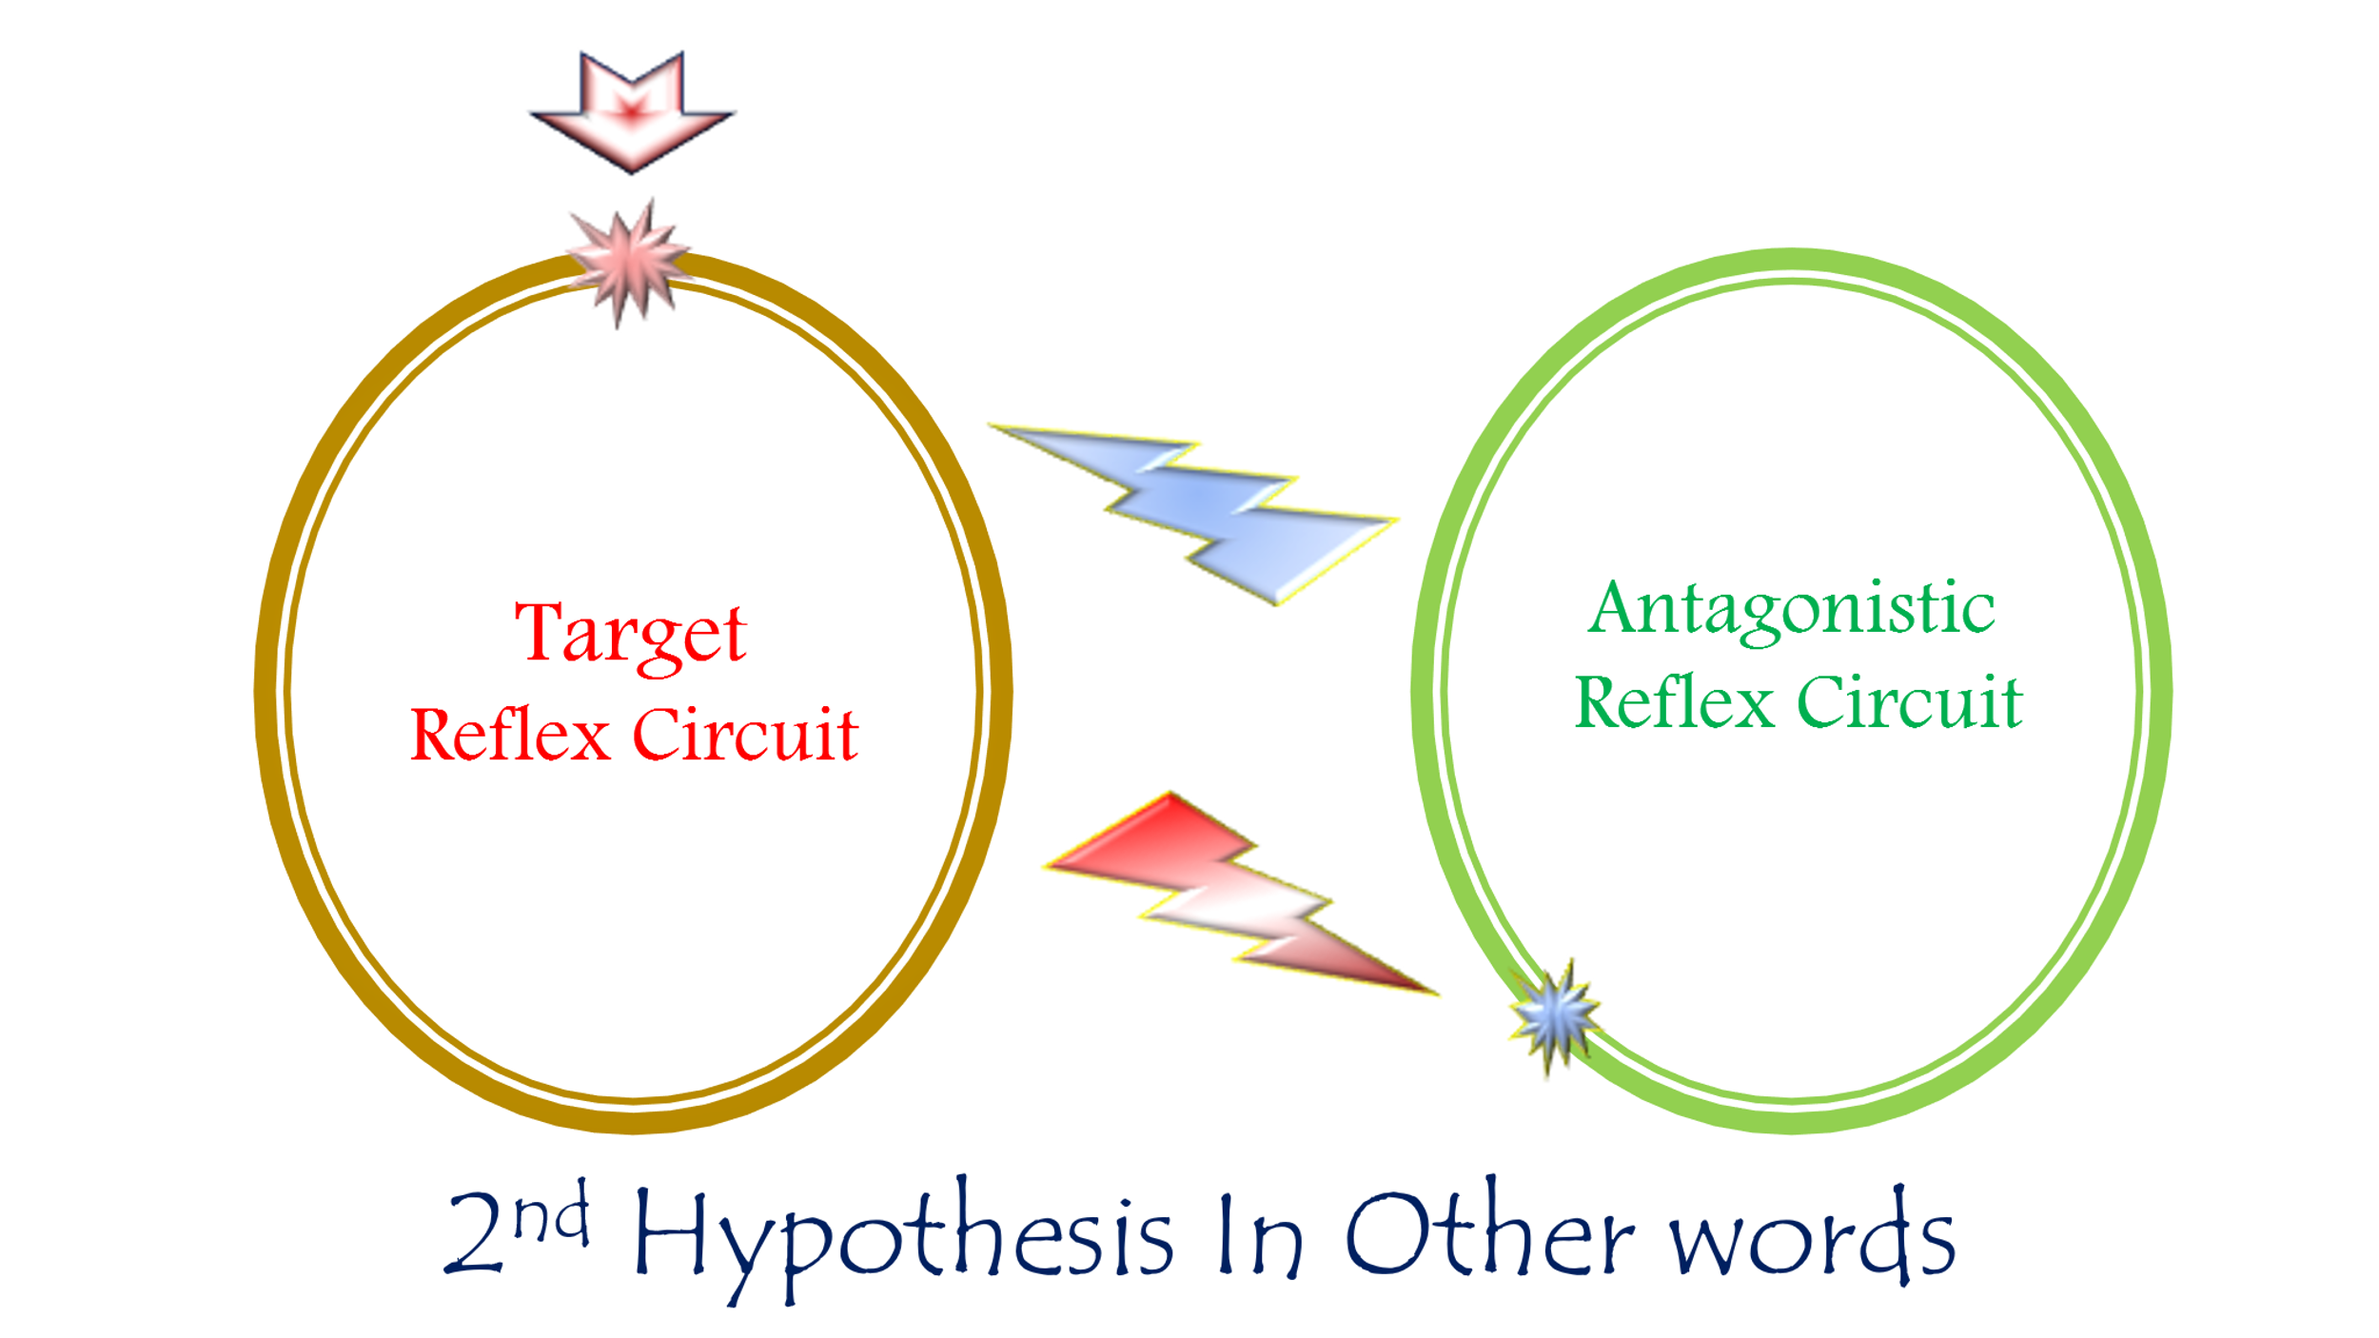

Second Hypothesis of Clonus Pathophysiology
(The Lifecycle of Pathological Oscillations)
For video explanation, click here:
Core Mechanism: Antagonistic Reflex Warfare
An endless duel of action-reaction—where each reflex fuels its enemy's retaliation.
Key Pathological Features
Phase | Neurophysiological Event | Clinical Manifestation
Initiation | Violent Achilles tendon stretch | Sudden ankle dorsiflexion
Counterstrike 1 | Unchecked plantarflexion reflex | Explosive foot downward jerk
Counterstrike 2 | Tibialis anterior stretch → Reflex contraction | Forceful foot upward jerk
Perpetuation | Cyclical re-stretching | Rhythmic oscillations (clonus)
Cessation | ATP depletion + neural fatigue | Self-limiting collapse (>5 beats)
Why This Explains Clinical Clonus
- Rhythmicity:
  - Alternating agonist/antagonist firing creates stereotyped flexion-extension cycles
- Ankle Predilection:
  - Maximal mechanical advantage between gastrocnemius (PF) and tibialis anterior (DF)
- Self-Limitation:
  - Terminates when:
    - Muscles exhaust ATP reserves
    - LMNs enter refractory state
    - Reflex gain spontaneously dampens
- UMN Specificity:
  - Requires lost reciprocal inhibition (normally mediated by UMNs)

Contrast with Normal Physiology
Normal Reflexes | Clonus State
Reciprocal inhibition blocks antagonists | Mutual excitation of enemies
Cortical modulation grades responses | Explosive, non-calibrated contractions
Functionally protective | Purposeless energy waste
Therapeutic Targets
Goal | Intervention | Mechanism
Break the Loop | Botulinum toxin to gastrocnemius & tibialis anterior | Chemodenervation of combatant muscles
Restore Inhibition | Intrathecal baclofen | GABA-B receptor agonism
Limit Stretch | Ankle-foot orthosis (AFO) | Prevents sudden dorsiflexion trigger
Conclusion: Neurology of Reflex Combat
This hypothesis reframes clonus as:
"A futile neural war—where Achilles and tibialis anterior reflexes become locked in mutual destruction, each contraction stretching the opponent into retaliation, until biochemical exhaustion forces a temporary truce."
Clinical Imperatives:
- Test for >5 beats after sudden dorsiflexion
- Address early (before maladaptive circuit entrenchment)
- Combine chemical denervation + mechanical containment
…………………………………………………………………………………………………………..
In other contexts, you can also read the following articles:
The Spinal Reflex, New Hypothesis of Physiology
The Hyperreflexia, Innovated Pathophysiology
The Spinal Shock
The Spinal Injury, the Pathophysiology of the Spinal Shock, the Pathophysiology of the Hyperreflexia
Upper Motor Neuron Lesions, the Pathophysiology of the Symptomatology
The Hyperreflexia (1), the Pathophysiology of Hyperactivity
The Hyperreflexia (2), the Pathophysiology of Bilateral Responses
The Hyperreflexia (3), the Pathophysiology of Extended Hyperreflex
The Hyperreflexia (4), the Pathophysiology of Multi-Response Hyperreflex
The Clonus, 1st Hypothesis of Pathophysiology
The Clonus, 2nd Hypothesis of Pathophysiology
The Clonus, Two Hypotheses of Pathophysiology
The Nerve Transmission through Neural Fiber, Personal View vs. International View
The Nerve Transmission through Neural Fiber (1), The Action Pressure Waves
The Nerve Transmission through Neural Fiber (2), The Action Potentials
The Nerve Transmission through Neural Fiber (3), The Action Electrical Currents
The Function of Standard Action Potentials & Currents
The Three Phases of Nerve transmission
Neural Conduction in the Synapse (Innovated)
Nodes of Ranvier, the Equalizers
Nodes of Ranvier, the Functions
Nodes of Ranvier, First Function
Nodes of Ranvier, Second Function
Nodes of Ranvier, Third Function
Node of Ranvier, The Anatomy
The Wallerian Degeneration
The Neural Regeneration
The Wallerian Degeneration Attacks Motor Axons, While Avoids Sensory Axons
The Sensory Receptors
Nerve Conduction Study, Wrong Hypothesis is the Origin of the Misinterpretation (Innovated)
Piriformis Muscle Injection_ Personal Approach
The Philosophy of Pain, Pain Comes First! (Innovated)
The Philosophy of the Form (Innovated)
Pronator Teres Syndrome, Struthers-Like Ligament (Innovated)
Ulnar Nerve, Congenital Bilateral Dislocation
Posterior Interosseous Nerve Syndrome
The Multiple Sclerosis: The Causative Relationship Between
The Galvanic Current & Multiple Sclerosis?
Cauda Equina Injury, New Surgical Approach
Carpal Tunnel Syndrome Complicated by Complete Rupture of Median Nerve
Biceps Femoris' Long Head Syndrome (BFLHS)
Barr Body, The Whole Story (Innovated)
Adam's Rib and Adam's Apple, Two Faces of one Sin
Adam's Rib, could be the Original Sin?
Barr Body, the Second Look
Who Decides the Sex of Coming Baby?
Boy or Girl, Mother Decides!
Oocytogenesis
Spermatogenesis
This Woman Can Only Give Birth to Female Children
This Woman Can Only Give Birth to Male Children
This Woman Can Give Birth to Female Children More Than to Male Children
This Woman Can Give Birth to Male Children More Than to Female Children
This Woman Can Equally Give Birth to Male Children & to Female Children
Eve Saved Human Identity; Adam Ensured Human Adaptation
Coronavirus (Covid-19): After Humiliation, Is Targeting Our Genes
Coronavirus (Covid-19): After Humiliation, Is Targeting Our Genes
The Black Hole is a (the) Falling Star?
Mitosis in Animal Cell
Meiosis
Universe Creation, Hypothesis of Continuous Cosmic Nebula
Circulating Sweepers
Pneumatic Petrous, Bilateral Temporal Hyperpneumatization
Congenital Bilateral Thenar Hypoplasia
Ulnar Dimelia, Mirror hand Deformity
Surgical Restoration of a Smile by Grafting a Segment of the Gracilis Muscle to the Face
Mandible Reconstruction Using Free Fibula Flap
Presacral Schwannoma
Liver Hemangioma: Urgent Surgery of Giant Liver Hemangioma
Due to Intra-Tumor Bleeding
Free Para Scapular Flap (FPSF) for Skin Reconstruction
Claw Hand Deformity (Brand Operation)
Algodystrophy Syndrome Complicated by Constricting Ring at the Proximal Border of the Edema
Non- Traumatic Non- Embolic Acute Thrombosis of Radial Artery
(Buerger’s Disease)
Isolated Axillary Tuberculosis Lymphadenitis
The Iliopsoas Tendonitis... The Snapping Hip
To read the article in Arabic, click on
The New Frankenstein Monster
The Lone Wolf
The Delirium of Night and Day
The Delirium of the Economy
Ovaries in a Secure Corner… Testicles in a Humble Sac:
An Inquiry into the Function of Form
Eve Preserves Humanity’s Blueprint; Adam Drives Its Evolution

2/6/2020

