Dr. Ammar Yaseen Mansour
Clonus: 1st Pathophysiological Hypothesis
“Asynchronous Afferent Barrage”
"One stretch becomes a symphony of desynchronized commands - each afferent volley demanding its own motor encore"

To watch a detailed video explaining this hypothesis, click this link:
Clonus manifests as involuntary, rhythmic oscillations – aberrant sequential cycles of joint flexion and extension. Pathological clonus requires >5 flexion-extension cycles. While similar movements may occur in healthy individuals, they never exceed 5 cycles. When accompanied by other signs of Upper Motor Neuron (UMN) lesions, even brief clonus (<5 cycles) warrants diagnostic consideration. Clinically, we primarily investigate clonus at the knee and ankle. Though possible elsewhere, such occurrences remain exceptional.

Within the operational field of every spinal reflex, specialized sensory receptors serve as the reflex's trigger points. Alongside them reside other sensory receptor types – all occupying the same territory where reflex-triggering stimuli occur.
Each receptor possesses its own dedicated neural axon. Since receptors differ functionally, their afferent axons exhibit distinct properties – particularly variable neural conduction velocities.
Neural transmission is maximally rapid in myelinated alpha-type axons, yet markedly slow in delta-type axons – among others. Similarly, transmission through demyelinated axons is severely delayed. Even within a single fiber type, conduction velocity varies significantly with axonal diameter.
This inherent disparity in conduction velocities across afferent pathways constitutes the fundamental mechanism underlying the First Hypothesis of Clonic Pathophysiology.
Under physiological conditions, sensory receptors (numbering X) distribute a stimulus' energy among themselves – each according to its functional specialization. Subsequently, via heterogeneous neural pathways, signals from these receptors converge as a hybrid, non-homogenous afferent impulse carrying X distinct sensory elements.
The brain purifies and processes this composite input. Through meticulous filtering, decoding, and integration, it distills the heterogeneous sensory stream into a singular efferent motor command – delivered to the lower motor neuron as one unified execution order.
When the brain becomes functionally absent, a hyperreflexic spinal circuit emerges. Sensory neurons aberrantly connect with lower motor neurons via interneurons – bypassing cortical governance.
The hybrid afferent impulse (comprising X distinct signals) escapes cerebral supervision. It descends unprocessed to the LMN, retaining its raw temporal dispersion from peripheral receptors.
The fastest-conducting impulses trigger the initial muscle contraction. The mid-velocity signals arrive eliciting sequential contractions. The slowest impulses drive terminal oscillations.
This cascade of desynchronized muscle activations manifests as involuntary movement repetition in hyperreflexic states – the phenomenon we term Clonus. (See Figure Below).
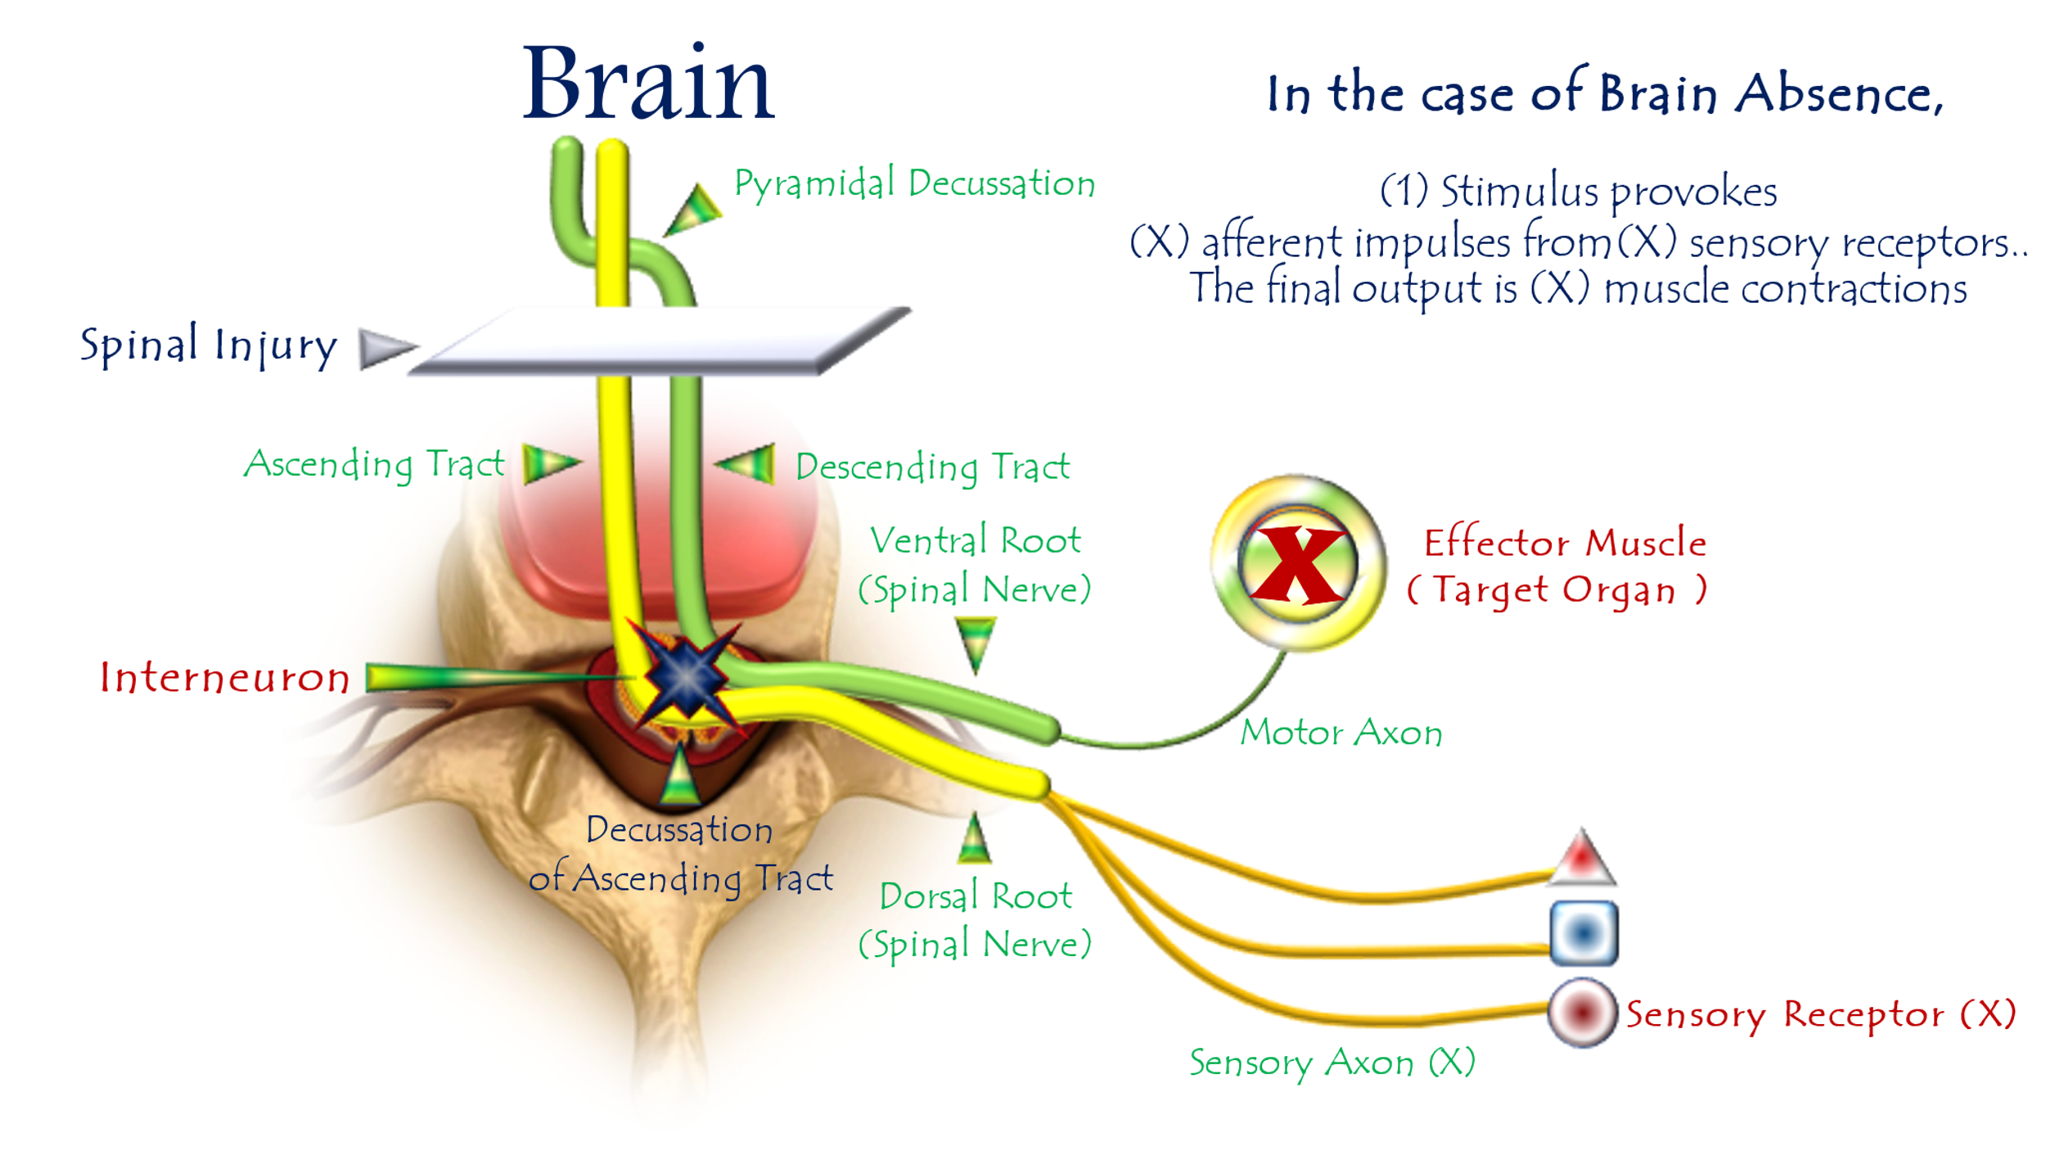
First Hypothesis of Clonus Pathophysiology
(Temporal Dispersion → Clonic Oscillation)
For video explanation, click here:

Core Mechanism: Temporal Dispersion → Rhythmic Oscillations
Normal vs. Pathological Processing
Stage | Healthy State | UMN Lesion State
Afferent Signal | Hybrid impulse (X elements) | Identical hybrid impulse
Integration | Cortical processing → Unified command | Direct spinal relay
Motor Output | Single calibrated response | X sequential responses
Feedback Loop | Purposeful termination | Self-sustaining oscillations
Key Pathophysiological Steps
- Stimulus Application
  - Activates heterogeneous receptor cohort (muscle spindles, Golgi, nociceptors)
- Temporal Dispersion
  - Variable conduction velocities → Staggered afferent arrival at spinal cord
- Spinal Relay Hijacking
  - Interneurons deliver raw volleys directly to LMNs
- Serial Motor Firing
  - Fastest volley → Initial contraction (e.g., dorsiflexion)
  - Intermediate volley → Secondary contraction
  - Slowest volley → Tertiary contraction
"One stretch becomes a symphony of desynchronized commands - each afferent volley demanding its own motor encore"
Clinical Validation
Observation | Explained by Hypothesis
>5 beats pathological | Minimum volleys needed for sustained rhythm
Ankle predominance | Longest nerve → Maximal temporal dispersion
Velocity-dependence | Faster stretch → More receptors recruited
33 Hz frequency | Matches 30ms delay (1/0.03s = 33 Hz)
Conclusion: The Neurology of Desynchronization
This model reveals clonus as:
"A temporal breakdown in neural orchestration - where lost cortical conduction exposes the inherent asynchrony of sensory pathways, converting singular stimuli into rhythmic motor cascades."
Diagnostic Imperatives:
- Test for >5 beats even without hyperreflexia
- Prioritize ankle assessment (highest diagnostic yield)
- Early intervention prevents circuit entrenchment

……………………………………………………………………………………………………………………………………..
In other contexts, you can also read the following articles:
The Spinal Reflex, New Hypothesis of Physiology
The Hyperreflexia, Innovated Pathophysiology
The Spinal Shock
The Spinal Injury, the Pathophysiology of the Spinal Shock, the Pathophysiology of the Hyperreflexia
Upper Motor Neuron Lesions, the Pathophysiology of the Symptomatology
The Hyperreflexia (1), the Pathophysiology of Hyperactivity
The Hyperreflexia (2), the Pathophysiology of Bilateral Responses
The Hyperreflexia (3), the Pathophysiology of Extended Hyperreflex
The Hyperreflexia (4), the Pathophysiology of Multi-Response Hyperreflex
The Clonus, 1st Hypothesis of Pathophysiology
The Clonus, 2nd Hypothesis of Pathophysiology
The Clonus, Two Hypotheses of Pathophysiology
The Nerve Transmission through Neural Fiber, Personal View vs. International View
The Nerve Transmission through Neural Fiber (1), The Action Pressure Waves
The Nerve Transmission through Neural Fiber (2), The Action Potentials
The Nerve Transmission through Neural Fiber (3), The Action Electrical Currents
The Function of Standard Action Potentials & Currents
The Three Phases of Nerve transmission
Neural Conduction in the Synapse (Innovated)
Nodes of Ranvier, the Equalizers
Nodes of Ranvier, the Functions
Nodes of Ranvier, First Function
Nodes of Ranvier, Second Function
Nodes of Ranvier, Third Function
Node of Ranvier, The Anatomy
The Wallerian Degeneration
The Neural Regeneration
The Wallerian Degeneration Attacks Motor Axons, While Avoids Sensory Axons
The Sensory Receptors
Nerve Conduction Study, Wrong Hypothesis is the Origin of the Misinterpretation (Innovated)
Piriformis Muscle Injection_ Personal Approach
The Philosophy of Pain, Pain Comes First! (Innovated)
The Philosophy of the Form (Innovated)
Pronator Teres Syndrome, Struthers-Like Ligament (Innovated)
Ulnar Nerve, Congenital Bilateral Dislocation
Posterior Interosseous Nerve Syndrome
The Multiple Sclerosis: The Causative Relationship Between
The Galvanic Current & Multiple Sclerosis?
Cauda Equina Injury, New Surgical Approach
Carpal Tunnel Syndrome Complicated by Complete Rupture of Median Nerve
Biceps Femoris' Long Head Syndrome (BFLHS)
Barr Body, The Whole Story (Innovated)
Adam's Rib and Adam's Apple, Two Faces of one Sin
Adam's Rib, could be the Original Sin?
Barr Body, the Second Look
Who Decides the Sex of Coming Baby?
Boy or Girl, Mother Decides!
Oocytogenesis
Spermatogenesis
This Woman Can Only Give Birth to Female Children
This Woman Can Only Give Birth to Male Children
This Woman Can Give Birth to Female Children More Than to Male Children
This Woman Can Give Birth to Male Children More Than to Female Children
This Woman Can Equally Give Birth to Male Children & to Female Children
Eve Saved Human Identity; Adam Ensured Human Adaptation
Coronavirus (Covid-19): After Humiliation, Is Targeting Our Genes
Coronavirus (Covid-19): After Humiliation, Is Targeting Our Genes
The Black Hole is a (the) Falling Star?
Mitosis in Animal Cell
Meiosis
Universe Creation, Hypothesis of Continuous Cosmic Nebula
Circulating Sweepers
Pneumatic Petrous, Bilateral Temporal Hyperpneumatization
Congenital Bilateral Thenar Hypoplasia
Ulnar Dimelia, Mirror hand Deformity
Surgical Restoration of a Smile by Grafting a Segment of the Gracilis Muscle to the Face
Mandible Reconstruction Using Free Fibula Flap
Presacral Schwannoma
Liver Hemangioma: Urgent Surgery of Giant Liver Hemangioma
Due to Intra-Tumor Bleeding
Free Para Scapular Flap (FPSF) for Skin Reconstruction
Claw Hand Deformity (Brand Operation)
Algodystrophy Syndrome Complicated by Constricting Ring at the Proximal Border of the Edema
Non- Traumatic Non- Embolic Acute Thrombosis of Radial Artery
(Buerger’s Disease)
Isolated Axillary Tuberculosis Lymphadenitis
The Iliopsoas Tendonitis... The Snapping Hip
To read the article in Arabic, click on
The New Frankenstein Monster
The Lone Wolf
The Delirium of Night and Day
The Delirium of the Economy
Ovaries in a Secure Corner… Testicles in a Humble Sac:
An Inquiry into the Function of Form
Eve Preserves Humanity’s Blueprint; Adam Drives Its Evolution

2/6/2020

