AMMAR YASEEN MANSOUR

The Pathophysiology of Extended Spinal Hyperreflex
"The LMN becomes a desperate monarch—welcoming sensory envoys from any spinal province."


To watch a brief video explaining the pathophysiology of the Extended Spinal Hyperreflexia, click this link:
Core Mechanism: Segmental Recruitment
Trigger: UMN lesion → Loss of cortical containment
Response:
- Interneuron-Mediated Expansion
  - Interneurons recruit sensory/motor neurons from adjacent spinal segments (X±1)
- Pathological Circuit Widening
  - Original reflex circuit (Segment X) merges with neighboring segments → Expanded hyperreflex loop
- Sensory Receptor Proliferation
  - New sensory receptors co-opted into circuit (muscle, skin, tendons)
"Interneurons become imperialists—conquering neural territories beyond their domain."

Pathological vs. Normal Reflex Physiology

Feature | Normal Reflex | Extended Hyperreflexia
Trigger Specificity | Strictly tendon stimulation | Any stimulus in expanded sector
Somatotopic Focus | Confined to target segment (e.g., L4) | Spills to adjacent segments
Sensory Gatekeeping | Cortical filtering of inputs | Raw sensory bombardment
Clinical Example:

- Normal: Patellar tendon tap → Quadriceps contraction (L2-L4)
- Pathological:
  - Skin scratch over quadriceps → Knee jerk
  - Muscle belly percussion → Knee jerk
  - Thigh pressure → Knee jerk
Key Players:

- Sensory Neurons: Recruited from adjacent segments
- Propriospinal Tracts: Facilitate intersegmental crosstalk
- Lost Inhibition: Absent cortical γ-aminobutyric acid (GABA) control
Why “Extended Sector” Emerges

- Compensatory Signal Hunting
  - Denervated circuits seek alternative input sources
- Glutamatergic Overdrive
  - Interneurons amplify excitatory signals 200-300%
- Maladaptive Neuroplasticity
  - "Silent synapses" in adjacent segments activated
Therapeutic Implications

Clinical Challenges:
- Focal interventions fail (e.g., nerve blocks) due to circuit redundancy
- Pharmacological resistance (GABA agonists lose efficacy)
Management Strategies:
Approach | Mechanism
Segmental Vibration | Desensitizes co-opted receptors
Transcranial Magnetic Stimulation (rTMS) | Restores cortical inhibition
Dorsal Rhizotomy | Severs pathological sensory inputs
Prognostic Sign:
Extended hyperreflexia indicates advanced maladaptive plasticity → Predicts chronic spasticity.
Conclusion: Neurology of Imperialism

This model defines extended hyperreflexia as: “A neural land grab—where interneurons colonize adjacent segments, enslaving sensory receptors and motor outputs into a pathological empire."
This explains three clinical truths:
- Why non-tactile stimuli trigger reflexes (sensory sector expansion)
- Why reflexes lack somatotopic precision (segmental spillover)
- Why localized treatments fail (circuit redundancy)

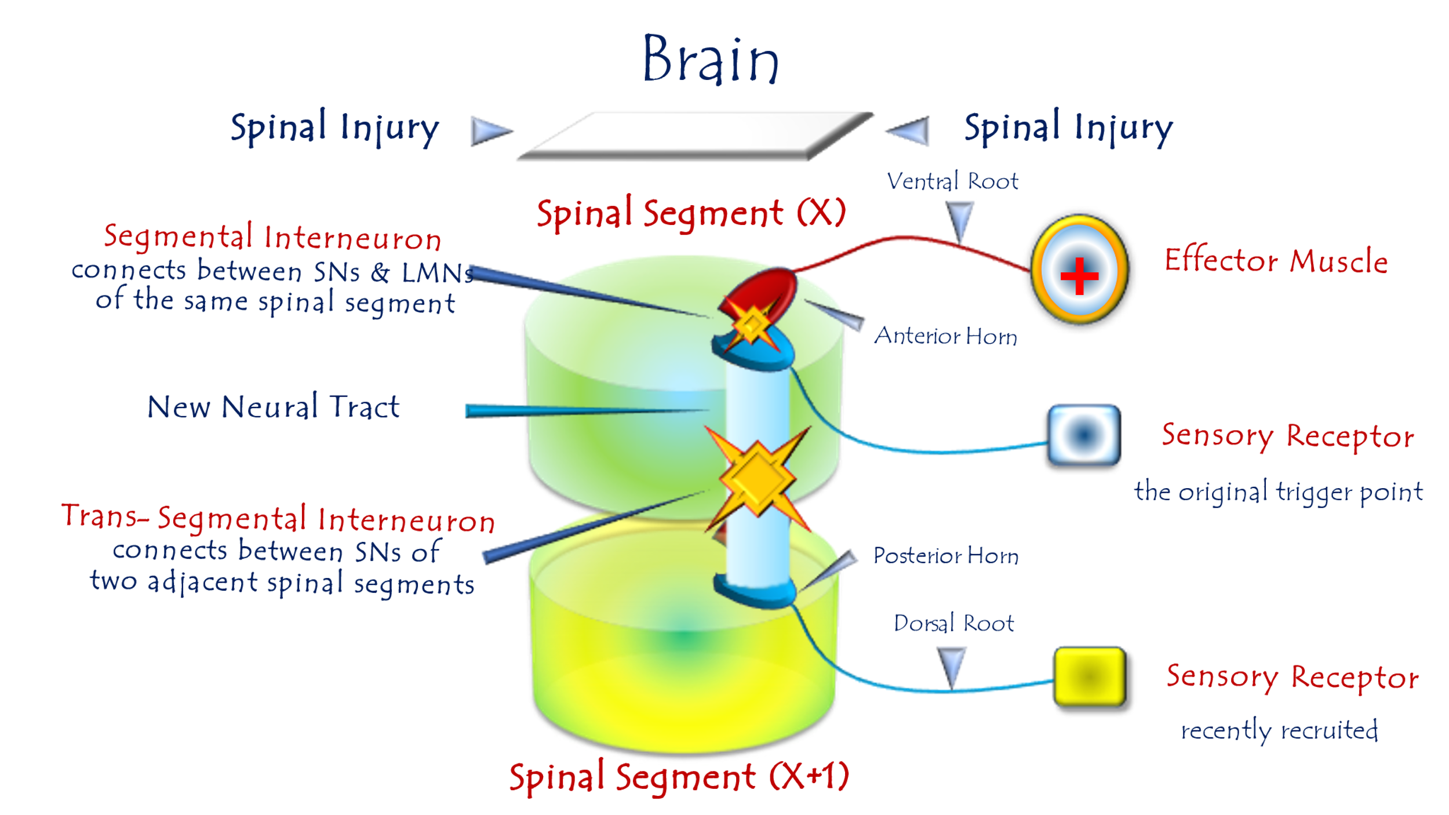
Pathophysiology of Extended Spinal Hyperreflexia
For video explanation, click here
Core Mechanism: Multi-Segmental Hijacking
Pathogenesis: Post-UMN lesion → LMNs forge aberrant alliances with sensory neurons across multiple spinal segments:
Key Pathological Features
Normal Reflex | Extended Hyperreflexia
Stimulus confined to specific receptor field | Stimuli anywhere in expanded sector trigger response
Segmental precision (e.g., L4-only) | Multi-segmental spillover (L3-L5)
Requires high-specificity triggers | Low-threshold/non-specific activation
Clinical Example:
- Normal: Knee jerk requires patellar tendon strike (L2-L4)
- Pathological:
  - Skin scratch over thigh → Quadriceps contraction
  - Calf muscle percussion → Quadriceps contraction
  - Foot pressure → Quadriceps contraction
Neurophysiological Basis
- Denervation Hypersensitivity
  - LMNs develop "synaptic hunger," accepting inputs from ANY sensory neuron
- Interneuron Complicity
  - Mediate connections between LMNs and distant sensory pools
- Signal Amplification
  - Stimuli gain 200-400% potency via glutamatergic overdrive
"The LMN becomes a desperate monarch—welcoming sensory envoys from any spinal province."
Why Extension Worsens Prognosis
- Treatment Resistance
  - Blocking one sensory input fails (redundant pathways)
- Self-Reinforcing Loop
- Functional Disability
  - Simple touch triggers disabling spasms
Therapeutic Strategies
Goal | Approach | Efficacy
Contain Expansion | Segmental dorsal root ganglion (DRG) blocks | Moderate (temporary)
Dampen Hyperexcitability | Intrathecal ziconotide (Ca²⁺ channel blocker) | High (risk heavy)
Restore Inhibition | Repetitive transcranial magnetic stimulation (rTMS) | Limited in chronic cases
Critical Insight:
Extended sectors indicate irreversible maladaptive plasticity → Focus shifts from cure to symptom management.
Conclusion: Neurology of Territorial Invasion
This model defines extended hyperreflexia as:
"A sensory insurgency without borders—where LMNs surrender to any stimulus, turning the spinal cord into an anarchic reflex free-for-all."
This explains three clinical imperatives:
- Avoid sensory provocation in UMN lesion patients
- Prioritize early intervention before segmental spread
- Accept functional trade-offs in chronic cases (e.g., partial denervation)

………………………………………………………………………………………….
In other contexts, you can also read the following articles:

The Spinal Reflex, New Hypothesis of Physiology
The Hyperreflexia, Innovated Pathophysiology
The Spinal Shock
The Spinal Injury, the Pathophysiology of the Spinal Shock, the Pathophysiology of the Hyperreflexia
Upper Motor Neuron Lesions, the Pathophysiology of the Symptomatology
The Hyperreflexia (1), the Pathophysiology of Hyperactivity
The Hyperreflexia (2), the Pathophysiology of Bilateral Responses
The Hyperreflexia (3), the Pathophysiology of Extended Hyperreflex
The Hyperreflexia (4), the Pathophysiology of Multi-Response Hyperreflex
The Clonus, 1st Hypothesis of Pathophysiology
The Clonus, 2nd Hypothesis of Pathophysiology
The Clonus, Two Hypotheses of Pathophysiology
The Nerve Transmission through Neural Fiber, Personal View vs. International View
The Nerve Transmission through Neural Fiber (1), The Action Pressure Waves
The Nerve Transmission through Neural Fiber (2), The Action Potentials
The Nerve Transmission through Neural Fiber (3), The Action Electrical Currents
The Function of Standard Action Potentials & Currents
The Three Phases of Nerve transmission
Neural Conduction in the Synapse (Innovated)
Nodes of Ranvier, the Equalizers
Nodes of Ranvier, the Functions
Nodes of Ranvier, First Function
Nodes of Ranvier, Second Function
Nodes of Ranvier, Third Function
Node of Ranvier, The Anatomy
The Wallerian Degeneration
The Neural Regeneration
The Wallerian Degeneration Attacks Motor Axons, While Avoids Sensory Axons
The Sensory Receptors
Nerve Conduction Study, Wrong Hypothesis is the Origin of the Misinterpretation (Innovated)
Piriformis Muscle Injection_ Personal Approach
The Philosophy of Pain, Pain Comes First! (Innovated)
The Philosophy of the Form (Innovated)
Pronator Teres Syndrome, Struthers-Like Ligament (Innovated)
Ulnar Nerve, Congenital Bilateral Dislocation
Posterior Interosseous Nerve Syndrome
The Multiple Sclerosis: The Causative Relationship Between
The Galvanic Current & Multiple Sclerosis?
Cauda Equina Injury, New Surgical Approach
Carpal Tunnel Syndrome Complicated by Complete Rupture of Median Nerve
Biceps Femoris' Long Head Syndrome (BFLHS)
Barr Body, The Whole Story (Innovated)
Adam's Rib and Adam's Apple, Two Faces of one Sin
Adam's Rib, could be the Original Sin?
Barr Body, the Second Look
Who Decides the Sex of Coming Baby?
Boy or Girl, Mother Decides!
Oocytogenesis
Spermatogenesis
This Woman Can Only Give Birth to Female Children
This Woman Can Only Give Birth to Male Children
This Woman Can Give Birth to Female Children More Than to Male Children
This Woman Can Give Birth to Male Children More Than to Female Children
This Woman Can Equally Give Birth to Male Children & to Female Children
Eve Saved Human Identity; Adam Ensured Human Adaptation
Coronavirus (Covid-19): After Humiliation, Is Targeting Our Genes
Coronavirus (Covid-19): After Humiliation, Is Targeting Our Genes
The Black Hole is a (the) Falling Star?
Mitosis in Animal Cell
Meiosis
Universe Creation, Hypothesis of Continuous Cosmic Nebula
Circulating Sweepers
Pneumatic Petrous, Bilateral Temporal Hyperpneumatization
Congenital Bilateral Thenar Hypoplasia
Ulnar Dimelia, Mirror hand Deformity
Surgical Restoration of a Smile by Grafting a Segment of the Gracilis Muscle to the Face
Mandible Reconstruction Using Free Fibula Flap
Presacral Schwannoma
Liver Hemangioma: Urgent Surgery of Giant Liver Hemangioma
Due to Intra-Tumor Bleeding
Free Para Scapular Flap (FPSF) for Skin Reconstruction
Claw Hand Deformity (Brand Operation)
Algodystrophy Syndrome Complicated by Constricting Ring at the Proximal Border of the Edema
Non- Traumatic Non- Embolic Acute Thrombosis of Radial Artery
(Buerger’s Disease)
Isolated Axillary Tuberculosis Lymphadenitis
The Iliopsoas Tendonitis... The Snapping Hip
To read the article in Arabic, click on
The New Frankenstein Monster
The Lone Wolf
The Delirium of Night and Day
The Delirium of the Economy
Ovaries in a Secure Corner… Testicles in a Humble Sac:
An Inquiry into the Function of Form
Eve Preserves Humanity’s Blueprint; Adam Drives Its Evolution

13/6/2020

