Dr. AMMAR YASEEN MANSOUR
The Pathophysiology of Multi- Motor- Response
Spinal Hyperreflex
A neural coup d'état – where interneurons dissolve segmental borders, conscripting motor circuits into a chaotic hive-mind."

To watch a brief video explaining the pathophysiology of the Multi-Motor-Response Spinal Hyperreflexia, click this link:

Core Mechanism: Pathological Circuit Convergence
Trigger: UMN lesion → Interneuron hyperactivity creates aberrant alliances between:
- Agonistic neural circuits (evolutionarily paired)
- Antagonistic neural circuits (normally mutually inhibitory)
Key Pathological Features
Normal Response | Multi-Motor Hyperreflexia
Stimulus → Single motor output | Stimulus → Multiple motor outputs
Reciprocal inhibition (agonist/antagonist) | Loss of inhibition → Co-contraction
Functionally purposeful | Discordant, purposeless movements

Clinical Examples:
Stimulus | Normal Reflex | Pathological Response
Patellar tap | Knee extension | Knee extension + Hip flexion
Finger flick | None | Finger flexion (Hoffman) + Wrist flexion
Plantar scratch | Toe flexion | Toe extension (Babinski) + Ankle dorsiflexion

Neurophysiological Basis
- Agonist Circuit Recruitment
  - Revival of primitive synergies (e.g., Babinski’s Sign)
- Antagonist Circuit Hijacking
  - Most pathologically significant: Forced partnership between naturally opposing circuits → Rigidity & Weakness
- Glutamatergic Storm
  - Interneurons override GABAergic inhibition → Simultaneous agonist/antagonist firing
"Interneurons become anarchist matchmakers—forcing enemies into doomed marriages."

Why Antagonistic Partnerships Are "Condemned"
Pathological Consequences:
Partnership Type | Mechanism | Clinical Manifestations
Agonistic Circuits | Co-activation of evolutionarily linked muscles | Pathological reflexes (Hoffman, Babinski)
Antagonistic Circuits | Loss of reciprocal inhibition | Muscle rigidity + Functional weakness

Critical Insight:
Antagonistic co-activation causes:
- Rigidity: Constant muscle battle → Increased tone at rest
- Weakness: Energy wasted on internal conflict → Reduced net force output
- Early Fatigue: Metabolic exhaustion from futile contractions

Clinical Correlation: Spastic Paralysis Triad
- Pathological Reflexes (Agonist circuits)
  - Babinski, Hoffman
- Rigidity (Antagonist circuits)
  - Clasp-knife phenomenon: Initial resistance → Sudden release
- Weakness
  - Not paralysis but inefficient force generation

"Rigidity and weakness are two faces of the same coin—antagonists trapped in a metabolic wrestling match."

Therapeutic Implications
Treatment Challenges:
- Agonist hyperactivity → Manageable with GABA agonists
- Antagonist co-activation → Treatment-resistant (requires circuit disruption)
Intervention Strategies:
Target | Approach | Rationale
Agonist Overactivity | Botulinum toxin to overactive muscles | Reduces pathological reflexes
Antagonist Co-Activation | Dorsal root entry zone (DREZ) lesioning | Severs sensory input to antagonistic circuits
Global Circuit Chaos | Intrathecal baclofen + rTMS | Combats glutamatergic storm & restores inhibition

Prognostic Reality:
Antagonistic involvement → Poor functional recovery due to irreversible rigidity/weakness.
Conclusion: Neurology of Forced Alliances
This model defines multi-motor hyperreflexia as:
"A neural civil war—where interneurons draft rival circuits into battle, turning precise reflexes into discordant motor chaos."
This explains three clinical imperatives:
- Distinguish spasticity from rigidity (antagonistic involvement = worse prognosis)
- Prioritize early GABAergic intervention to prevent circuit entrenchment
- Accept functional trade-offs in chronic cases (e.g., selective denervation)

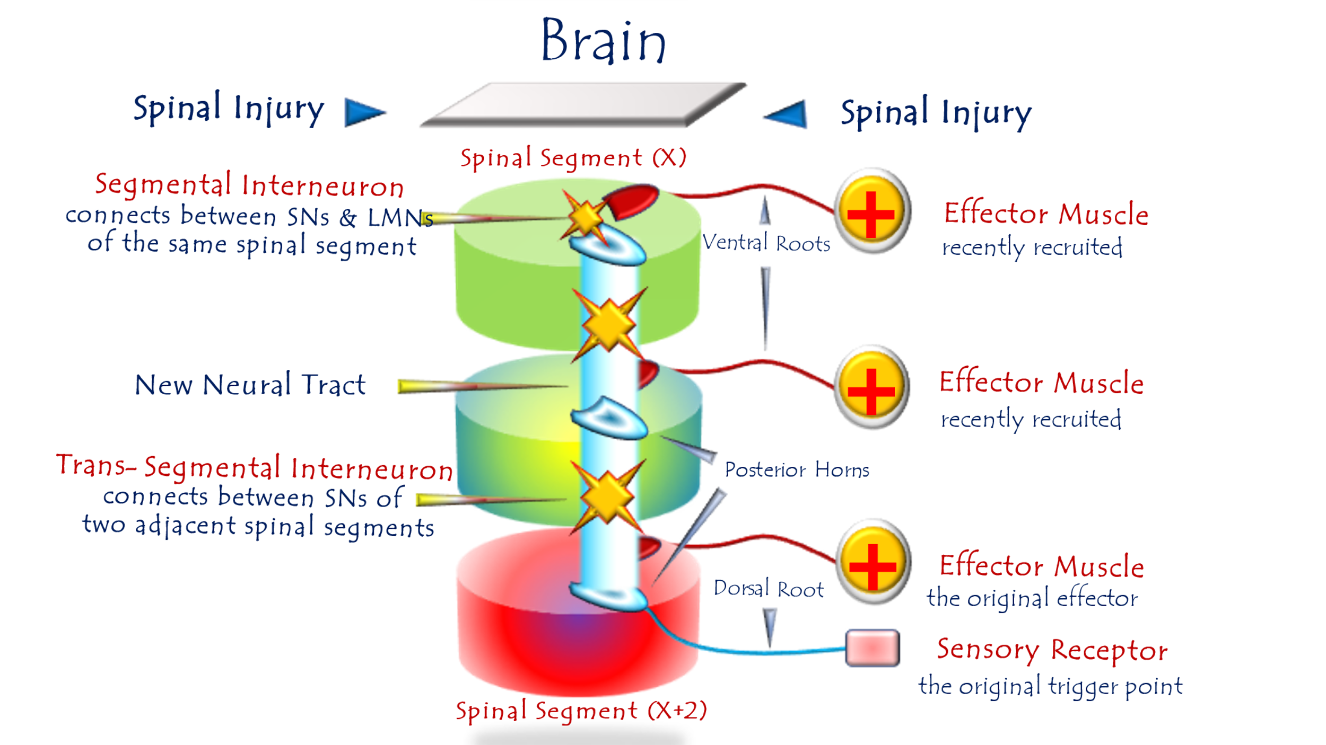
Pathophysiology of Multimotor-Response Spinal Hyperreflexia
For video explanation, click here:
Core Mechanism: Pathological Circuit Fusion
Process: Post-UMN lesion → Interneurons bridge hyperreflex circuits across adjacent spinal segments (X, X+I, X+II), creating a unified aberrant network.
Key Pathological Features
Normal Physiology | Multimotor Hyperreflexia
1 stimulus → 1 motor response | 1 stimulus → Multiple motor responses
Segmental isolation | Cross-segmental circuit fusion
Functionally specific | Discordant, non-purposeful outputs
Clinical Examples:
- Patellar tap (L4) → Knee extension + Hip flexion
- Plantar stimulus → Babinski sign + Toe fanning
Neurophysiological Basis
- Interneuron Hyperactivity
  - Overexpression of glutamate → Fuels cross-circuit signaling
- Loss of Inhibitory Control
  - Absent cortical GABAergic suppression → Unchecked signal spread
- Maladaptive Synaptic Potentiation
  - "Silent synapses" in adjacent segments activated → Circuit integration
"Interneurons become anarchist unifiers—melting spinal segments into a single pathological entity."
Why Multimotor Responses Worsen Disability
- Energy Waste
  - Co-contracting muscles cancel useful movement → Net weakness
- Functional Chaos
  - Walking attempt → Leg extension + hip flexion + foot inversion (→ fall risk)
- Metabolic Exhaustion
  - Futile contractions deplete ATP → Early fatigue
Therapeutic Challenges & Strategies
Challenge | Intervention | Limitations
Circuit Redundancy | Dorsal root ganglion (DRG) radiofrequency ablation | Temporary relief
Glutamatergic Storm | Intrathecal riluzole (glutamate inhibitor) | CNS side effects
Irreversible Fusion | Functional electrical stimulation (FES) | Retrains circuits, not curative
Prognostic Reality:
Multimotor responses signal end-stage maladaptive plasticity → Focus shifts to palliative symptom control.
Clinical Correlation:
Pathological Reflex | Mechanism
Babinski Sign | Fusion of plantar + toe extension circuits
Hoffman Sign | Fusion of finger flexion + wrist flexion circuits
Muscle Spasm | Agonist-antagonist co-activation (e.g., biceps/triceps)
Rigidity | "Condemned partnership" of antagonistic circuits
"Rigidity is the price of forced neural alliances – enemies shackled together, waging constant war."
Conclusion: Neurology of Forced Unity
This model defines multimotor hyperreflexia as:
"A neural coup d'état – where interneurons dissolve segmental borders, conscripting motor circuits into a chaotic hive-mind."
This explains three clinical imperatives:
- Early intervention prevents circuit fusion
- Rigidity ≠ spasticity – requires targeted therapy
- Antagonistic co-activation is the chief driver of disability

......................................................................................................................
In other contexts, you can also read the following articles:

The Spinal Reflex, New Hypothesis of Physiology
The Hyperreflexia, Innovated Pathophysiology
The Spinal Shock
The Spinal Injury, the Pathophysiology of the Spinal Shock, the Pathophysiology of the Hyperreflexia
Upper Motor Neuron Lesions, the Pathophysiology of the Symptomatology
The Hyperreflexia (1), the Pathophysiology of Hyperactivity
The Hyperreflexia (2), the Pathophysiology of Bilateral Responses
The Hyperreflexia (3), the Pathophysiology of Extended Hyperreflex
The Hyperreflexia (4), the Pathophysiology of Multi-Response Hyperreflex
The Clonus, 1st Hypothesis of Pathophysiology
The Clonus, 2nd Hypothesis of Pathophysiology
The Clonus, Two Hypotheses of Pathophysiology
The Nerve Transmission through Neural Fiber, Personal View vs. International View
The Nerve Transmission through Neural Fiber (1), The Action Pressure Waves
The Nerve Transmission through Neural Fiber (2), The Action Potentials
The Nerve Transmission through Neural Fiber (3), The Action Electrical Currents
The Function of Standard Action Potentials & Currents
The Three Phases of Nerve transmission
Neural Conduction in the Synapse (Innovated)
Nodes of Ranvier, the Equalizers
Nodes of Ranvier, the Functions
Nodes of Ranvier, First Function
Nodes of Ranvier, Second Function
Nodes of Ranvier, Third Function
Node of Ranvier, The Anatomy
The Wallerian Degeneration
The Neural Regeneration
The Wallerian Degeneration Attacks Motor Axons, While Avoids Sensory Axons
The Sensory Receptors
Nerve Conduction Study, Wrong Hypothesis is the Origin of the Misinterpretation (Innovated)
Piriformis Muscle Injection_ Personal Approach
The Philosophy of Pain, Pain Comes First! (Innovated)
The Philosophy of the Form (Innovated)
Pronator Teres Syndrome, Struthers-Like Ligament (Innovated)
Ulnar Nerve, Congenital Bilateral Dislocation
Posterior Interosseous Nerve Syndrome
The Multiple Sclerosis: The Causative Relationship Between
The Galvanic Current & Multiple Sclerosis?
Cauda Equina Injury, New Surgical Approach
Carpal Tunnel Syndrome Complicated by Complete Rupture of Median Nerve
Biceps Femoris' Long Head Syndrome (BFLHS)
Barr Body, The Whole Story (Innovated)
Adam's Rib and Adam's Apple, Two Faces of one Sin
Adam's Rib, could be the Original Sin?
Barr Body, the Second Look
Who Decides the Sex of Coming Baby?
Boy or Girl, Mother Decides!
Oocytogenesis
Spermatogenesis
This Woman Can Only Give Birth to Female Children
This Woman Can Only Give Birth to Male Children
This Woman Can Give Birth to Female Children More Than to Male Children
This Woman Can Give Birth to Male Children More Than to Female Children
This Woman Can Equally Give Birth to Male Children & to Female Children
Eve Saved Human Identity; Adam Ensured Human Adaptation
Coronavirus (Covid-19): After Humiliation, Is Targeting Our Genes
Coronavirus (Covid-19): After Humiliation, Is Targeting Our Genes
The Black Hole is a (the) Falling Star?
Mitosis in Animal Cell
Meiosis
Universe Creation, Hypothesis of Continuous Cosmic Nebula
Circulating Sweepers
Pneumatic Petrous, Bilateral Temporal Hyperpneumatization
Congenital Bilateral Thenar Hypoplasia
Ulnar Dimelia, Mirror hand Deformity
Surgical Restoration of a Smile by Grafting a Segment of the Gracilis Muscle to the Face
Mandible Reconstruction Using Free Fibula Flap
Presacral Schwannoma
Liver Hemangioma: Urgent Surgery of Giant Liver Hemangioma
Due to Intra-Tumor Bleeding
Free Para Scapular Flap (FPSF) for Skin Reconstruction
Claw Hand Deformity (Brand Operation)
Algodystrophy Syndrome Complicated by Constricting Ring at the Proximal Border of the Edema
Non- Traumatic Non- Embolic Acute Thrombosis of Radial Artery
(Buerger’s Disease)
Isolated Axillary Tuberculosis Lymphadenitis
The Iliopsoas Tendonitis... The Snapping Hip
To read the article in Arabic, click on
The New Frankenstein Monster
The Lone Wolf
The Delirium of Night and Day
The Delirium of the Economy
Ovaries in a Secure Corner… Testicles in a Humble Sac:
An Inquiry into the Function of Form
Eve Preserves Humanity’s Blueprint; Adam Drives Its Evolution

27/6/2020

