Dr. Ammar Yaseen Mansour

Pathophysiology of Overactive Spinal Hyperreflexia
"The LMN becomes a puppet to sensory tyranny—every whisper becomes a shout"
(Feather touch → Hammer-like reflex)

To watch a brief video explaining the pathophysiology of the Overactive spinal hyperreflexia, click this link:

Normal vs. Pathological Reflex Physiology
Feature | Normal State | UMN Lesion State
Brain Control | Full dominance over sensory/motor pathways | Functional absence of brain oversight
Reflex Specificity | Stimulus-locked, graded, localized response | Non-specific, explosive output
Neural Pathways | Dedicated, evolutionarily refined circuits | Aberrant rewiring of dormant/novel pathways
Output Modulation | Precision-controlled motor execution | Unmodulated "sensory dumping" onto LMNs

Mechanism of Pathological Circuit Formation
After UMN injury, interneurons trigger a cascade:
- Activation of Dormant Pathways
  - Revival of primitive neural circuits abandoned since early childhood
- De Novo Circuit Synthesis
  - Creation of entirely new sensory-motor connections within spinal segments
- Aberrant Wiring
  - Direct coupling of sensory neurons → LMNs in anterior horn (bypassing brain)
"Interneurons become anarchist engineers—rebuilding broken networks without blueprints."

The Hyperreflex Circuit: Structural & Functional Flaws
Circuit Pathway:
Sensory Receptor → Sensory Neuron →Interneuron→ LMN → Target Muscle
Pathological Characteristics:
Abnormality | Consequence
Unprocessed Signal | Raw sensory data floods LMNs
No Cortical Filter | Loss of intensity/purpose calibration
Energy Dumping | Full neural charge delivered to LMNs
Runaway Execution | Explosive, non-adaptive muscle contraction
Clinical Signature:
- Disproportionate Response: e.g., Light tap triggers violent jerk
- Loss of Spatial Specificity: Reflex spreads beyond stimulated area
- Clonic Phenomena: Self-sustaining oscillations (e.g., ankle clonus)
Why "Overactive Hyperreflexia" Emerges
- Functional absence of brain oversight
- Unmodulated "sensory dumping" onto LMNs
- Signal Amplification
  - Interneurons boost sensory input gain by 300-500% (compensatory hyperactivity)
- Loss of Inhibitory Controls
  - Absent cortical γ-aminobutyric acid (GABA) modulation
- Positive Feedback Loop
  - Muscle spindles → Sensory neurons → LMNs → Muscle contraction → Re-excitation of spindles
"The LMN becomes a puppet to sensory tyranny—every whisper becomes a shout"

Therapeutic Implications
Intervention Targets:
- Circuit Disruption
  - Intrathecal baclofen: GABA-B receptor agonism → Inhibits interneuron hyperactivity
- Sensory Gatekeeping
  - Vibration therapy: Desensitizes muscle spindles
- Neural Reprogramming
  - Constraint-induced movement therapy: Rewires cortical-spinal connections
Prognostic Challenge:
Once established, these circuits resist reversal due to:
- Synaptic potentiation (LTP-like mechanisms)
- Gliotic scarring at lesion sites
- Maladaptive neuroplasticity

Conclusion: The Neurology of Chaos
This model reveals overactive hyperreflexia as:
"A perfect storm of neural anarchy—where primitive pathways awaken, interneurons amplify chaos, and LMNs execute sensory orders with blind fury."
This explains why UMN lesion hyperreflexia is:
- Disproportionate (input-output mismatch)
- Irreversible (entrenched circuit autonomy)
- Pathognomonic (definitive biomarker of UMN pathology)

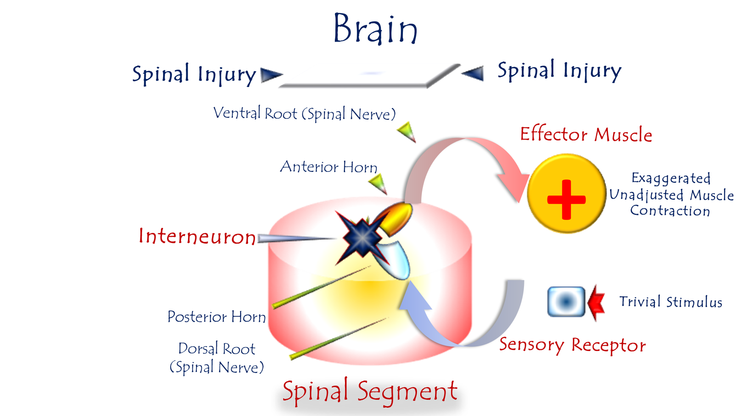

Figure 4: Pathophysiology of Overactive Spinal Hyperreflexia
For video explanation, click here

Core Mechanism: Pathological LMN-SN Coupling
Trigger: Loss of UMN control → LMN develops "energy hunger"
Response:
- Aberrant Synapse Formation
  - LMN directly connects with sensory neurons (SN) in the same or adjacent spinal segment.
- Sensory Signal Hijacking
  - SN dumps raw, unprocessed sensory data onto LMN (throwing its full load into LMN's lap).
- Emergency Motor Interpretation
  - LMN misinterprets all sensory input as high-priority motor commands.
"The LMN becomes a puppet of sensory chaos—every whisper becomes a scream for action."
Functional Consequences
Normal UMN Function | Pathological LMN Response
Sensory Refinement | Raw sensory bombardment (no filtering)
Motor Dose Calibration | Explosive, non-graded output
Contextual Adaptation | Stereotyped violence to mild stimuli
Clinical Hallmarks:
- Disproportionate Reflexes: e.g., Light touch triggers limb jerk
- Clonus: Self-sustaining oscillations (foot tapping → sustained ankle beating)
- Loss of Spatial Specificity: Reflex spreads beyond stimulus site

Why "Overactivity" Emerges
- Functional absence of brain oversight
- Unmodulated "sensory dumping" onto LMNs
- Lost Inhibitory Gates
  - Absent UMN suppression (e.g., corticospinal GABAergic control)
- Signal Amplification
  - Interneurons boost sensory gain by 200-400% (compensatory hyperactivity)
Therapeutic Implications
Intervention Targets:
Goal | Approach
Block Aberrant Synapses | Botulinum toxin (SN-LMN junction)
Dampen Sensory Noise | GABA agonists (baclofen), vibration therapy
Restore Inhibition | rTMS to stimulate residual UMN pathways
Prognostic Reality:
- Once entrenched, the circuit becomes autonomous (self-nourishing energy loop).
- Explains why chronic hyperreflexia resists treatment.

Conclusion: Neurology of Dysregulation
This model reveals overactive hyperreflexia as:
"A perfect storm of neural desperation—starved of brain governance, the LMN forges reckless alliances, turning sensory whispers into motor thunder."
This explains three clinical paradoxes:
- Why mild stimuli trigger violence (lost sensory refinement)
- Why reflexes lack gradation (absent motor dosing)
- Why recovery plateaus (entrenched pathological autonomy)

……………………………………………………………………………………………………………………………….
In other contexts, you can also read the following articles:
The Spinal Reflex, New Hypothesis of Physiology
The Hyperreflexia, Innovated Pathophysiology
The Spinal Shock
The Spinal Injury, the Pathophysiology of the Spinal Shock, the Pathophysiology of the Hyperreflexia
Upper Motor Neuron Lesions, the Pathophysiology of the Symptomatology
The Hyperreflexia (1), the Pathophysiology of Hyperactivity
The Hyperreflexia (2), the Pathophysiology of Bilateral Responses
The Hyperreflexia (3), the Pathophysiology of Extended Hyperreflex
The Hyperreflexia (4), the Pathophysiology of Multi-Response Hyperreflex
The Clonus, 1st Hypothesis of Pathophysiology
The Clonus, 2nd Hypothesis of Pathophysiology
The Clonus, Two Hypotheses of Pathophysiology
The Nerve Transmission through Neural Fiber, Personal View vs. International View
The Nerve Transmission through Neural Fiber (1), The Action Pressure Waves
The Nerve Transmission through Neural Fiber (2), The Action Potentials
The Nerve Transmission through Neural Fiber (3), The Action Electrical Currents
The Function of Standard Action Potentials & Currents
The Three Phases of Nerve transmission
Neural Conduction in the Synapse (Innovated)
Nodes of Ranvier, the Equalizers
Nodes of Ranvier, the Functions
Nodes of Ranvier, First Function
Nodes of Ranvier, Second Function
Nodes of Ranvier, Third Function
Node of Ranvier, The Anatomy
The Wallerian Degeneration
The Neural Regeneration
The Wallerian Degeneration Attacks Motor Axons, While Avoids Sensory Axons
The Sensory Receptors
Nerve Conduction Study, Wrong Hypothesis is the Origin of the Misinterpretation (Innovated)
Piriformis Muscle Injection_ Personal Approach
The Philosophy of Pain, Pain Comes First! (Innovated)
The Philosophy of the Form (Innovated)
Pronator Teres Syndrome, Struthers-Like Ligament (Innovated)
Ulnar Nerve, Congenital Bilateral Dislocation
Posterior Interosseous Nerve Syndrome
The Multiple Sclerosis: The Causative Relationship Between
The Galvanic Current & Multiple Sclerosis?
Cauda Equina Injury, New Surgical Approach
Carpal Tunnel Syndrome Complicated by Complete Rupture of Median Nerve
Biceps Femoris' Long Head Syndrome (BFLHS)
Barr Body, The Whole Story (Innovated)
Adam's Rib and Adam's Apple, Two Faces of one Sin
Adam's Rib, could be the Original Sin?
Barr Body, the Second Look
Who Decides the Sex of Coming Baby?
Boy or Girl, Mother Decides!
Oocytogenesis
Spermatogenesis
This Woman Can Only Give Birth to Female Children
This Woman Can Only Give Birth to Male Children
This Woman Can Give Birth to Female Children More Than to Male Children
This Woman Can Give Birth to Male Children More Than to Female Children
This Woman Can Equally Give Birth to Male Children & to Female Children
Eve Saved Human Identity; Adam Ensured Human Adaptation
Coronavirus (Covid-19): After Humiliation, Is Targeting Our Genes
Coronavirus (Covid-19): After Humiliation, Is Targeting Our Genes
The Black Hole is a (the) Falling Star?
Mitosis in Animal Cell
Meiosis
Universe Creation, Hypothesis of Continuous Cosmic Nebula
Circulating Sweepers
Pneumatic Petrous, Bilateral Temporal Hyperpneumatization
Congenital Bilateral Thenar Hypoplasia
Ulnar Dimelia, Mirror hand Deformity
Surgical Restoration of a Smile by Grafting a Segment of the Gracilis Muscle to the Face
Mandible Reconstruction Using Free Fibula Flap
Presacral Schwannoma
Liver Hemangioma: Urgent Surgery of Giant Liver Hemangioma
Due to Intra-Tumor Bleeding
Free Para Scapular Flap (FPSF) for Skin Reconstruction
Claw Hand Deformity (Brand Operation)
Algodystrophy Syndrome Complicated by Constricting Ring at the Proximal Border of the Edema
Non- Traumatic Non- Embolic Acute Thrombosis of Radial Artery
(Buerger’s Disease)
Isolated Axillary Tuberculosis Lymphadenitis
The Iliopsoas Tendonitis... The Snapping Hip
To read the article in Arabic, click on
The New Frankenstein Monster
The Lone Wolf
The Delirium of Night and Day
The Delirium of the Economy
Ovaries in a Secure Corner… Testicles in a Humble Sac:
An Inquiry into the Function of Form
Eve Preserves Humanity’s Blueprint; Adam Drives Its Evolution

1/6/2020

