Light is a Wave and the Path is Material
A New Vision of the Nature of Light and its Propagation
By Dr. Ammar Yaseen Mansour

To read the original Arabic version of this article, click here: (DOI)
الضَّوءُ مَوجةٌ والمَسارُ مادِّيٌّ: رؤيةٌ جديدةٌ لطبيعةِ الضَّوءِ وانتشارهِ

“Light is a wave, and it acquires its particle-like properties from the nature of the medium through which it propagates.”

I remain among those who believe that light still holds on to many of its secrets, and that the certainty science has reached today may become conjecture in the days to come. From its speed to its very nature, all of it may be subject to modification, or perhaps even change. As I present my vision of light, I do not deny my knowledge of its current laws, which have become indisputable axioms. Nevertheless, I find myself compelled to cast doubt on some of what science has concluded regarding one or more of the laws of light.
Light is a Wave:
I see a ray of light as a flow of successive waves. They follow one another in astonishing succession, as if each one is holding the tail of the sister in front of it, while its own tail is in the grasp of the sister behind it. The waves propagate in a special medium formed by particles of Primordial Matter. Here, the particles of Primordial Matter are arranged side-by-side, with each particle in direct contact with all its adjacent particles, in a continuous, unbroken fabric. The whole appears as a single weave, yet in reality, each element retains its independent nominal identity within this weave. Space is what brings them together, and the law of good neighborliness is what merely governs their behavior. No particle transgresses upon another, nor is it connected to it by more than what the law of direct contact imposes. It is friction, and nothing else, that makes the whole appear as a single entity, while the reality points to its connected-yet-separate nature.
The Propagation of Light:
When a light ray is emitted, its first wave rides the particles closest to the light source and aligned with its direction of propagation. Each of these particles acquires a portion of the light wave's energy, which I estimate to be one photon. The particle stores the photon and vibrates in place with a super-fast motion. The particle does not relinquish the acquired energy as long as the light source is active; it has stored it for itself, vibrated in place, and that is all. It is as if the particle has awoken from its slumber, becoming activated and primed for the act of transmission.
The second light wave sets off to find the nearest particles already saturated with energy from the first wave. It quickly passes through them to the next adjacent particles. The second group of particles proceeds to store some photons from the energy of the second wave for themselves, exactly as the particles of the first group did with the first light wave. The third light wave meets the same fate with the third group of particles... and so on. Thus, the light ray awakens and activates a chain of successive Primordial Matter particles. This chain does not end as long as the flow of photons from the light source is continuous and capable of maintaining the energy of the activated particles on one hand, and capable of activating particles further away spatially from the source if it intends to propagate to a greater distance, on the other hand.
In other words, the light ray adopts, as a carrier, a thread of adjacent Primordial Matter particles in direct contact. The light ray charges the Primordial Matter particles along its path, starting from the nearest to the farthest, and then to those even farther. A light ray does not reach a particle without first passing through all the particles before it. And a particle does not transmit the light ray unless it is first charged with a photon from this very light ray. Thus, the light ray appears as if it is transferring from one group of particles to the next. And it, the light ray, in this motion of its, does not forget to leave a photon in every particle it passes along its propagation path.
Therefore, when studying the properties of light at a point in its path, the particle takes center stage. At this point, we are not studying light itself, but rather the manifestations of its energy on a particle of Primordial Matter that happens to be at this location in the light's path, which created the impression of the particle-like properties of light. The truth is that light is a wave, and the path is material.
Photonic Synergy and Photonic Collapse:
According to this model, I find myself facing an unfamiliar relationship between light and its source. That there is no light without an active source is a given. However, the idea that light dies instantaneously with the death of its source is something that requires detailed elaboration from me.
They have claimed the continuity of light's propagation despite the extinction of its source. They say, "How many a star has faded, yet its light is still present, roaming the expanse." As for me, I say a light ray continuously derives its means of sustenance from the light source. The incoming stream of photons from the source has a dual function: first, to renew the energy of the already activated particles, and second, to activate new particles along the propagation path. The second cannot occur without the first, and light does not engulf a new sector unless its energy is sufficient to activate all the particles of this sector... This is Photonic Synergy.
After the light source is extinguished, the last light ray emitted from it may retain a share of energy sufficient for its propagation for a limited distance. After that, the light inevitably needs supply from the source if it wishes to reach a new sector. For the energy of a light wave, however great, is destined to be depleted. After that, darkness becomes absolute, and the Photonic Collapse is complete.
Illustrative Example
Segmental Propagation:
Assume a light source at point (A) emits a light ray with an energy of (n) photons. The first light wave will activate (n) particles of Primordial Matter. These particles, numbering (n), form the first segment (A B) of the light ray's propagation path; see Figure (1).
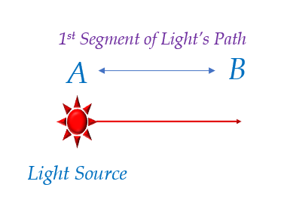
Figure (1): Segmental Propagation of Light
The first light wave establishes the initial segment of the light ray's propagation path
The first light wave launched from the light source (A) and activated the primordial matter particles constituting segment (A-B), granting a single photon to each particle. Thus, the light ray has established the initial segment of its propagation path.

Photonic Synergy:
The second light wave then passes through segment (A B) first, compensating for the loss in energy of its particles. The remaining energy it has is employed to activate an additional number (p) of Primordial Matter particles, reaching point (C), for example. Thus, segment (B C) is the second segment of the light’s path. The new particles (p) are necessarily fewer in number than particles (n) because a part of the second wave’s energy was consumed in maintaining the particles of segment (A B); see Figure (2).

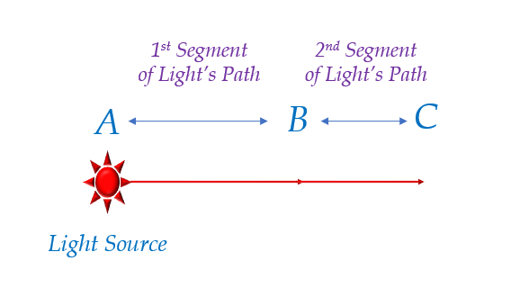
Figure (2): Segmental Propagation and Photonic Synergy
The second light wave establishes the second segment of the light ray's propagation path

The second light wave launches, dedicating a portion of its energy to maintaining the energy of the particles in segment (A-B)—this is the concept of Photonic Synergy. Meanwhile, it invests the majority of its energy reserve in activating new particles, thereby contributing to the formation of the second segment (B-C) of the light ray's path.

Subsequently, the third light wave will perform the same action as the second wave. It will first sweep over segment (A-C), compensating for the energy depletion in its particles. The remaining energy reserve will then be used to activate the Primordial Matter particles constituting the new segment (C-D) of the light's propagation path. The number of newly activated particles will be (q), which is necessarily smaller than the number (p). The reason for this is that a larger portion of the third wave's energy will be consumed in maintaining the particles of segment (A-C) – that is, both the (n) and (p) particles combined. And so on, each new wave will delineate an additional segment of the light's path. The integration of these segments will ultimately chart the total path of the light; see Figure (3).

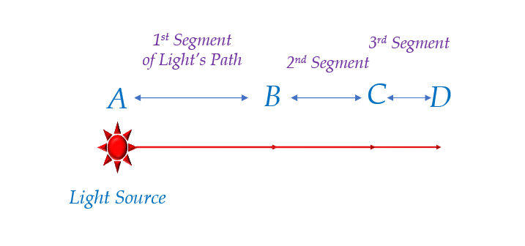
Figure (3): Segmental Propagation and Photonic Synergy
The third light wave establishes the third segment of the light ray's propagation path
The third light wave launches to find a larger quantity of primordial matter particles in need of maintenance. The segment (A-C) of the path contains (n + p) particles. Thus, the third light wave consumes a larger portion of its energy to maintain these particles, utilizing the remainder to activate an additional quantity of particles (q particles). Consequently, the number (q) is smaller than (p), and certainly smaller than (n).
The Limit Point:
Eventually, we reach a stage where the energy of the next light wave is sufficient only, and I say only, for maintaining the energy of the previously activated particles. Consequently, this wave, and the light waves following it, will be unable to activate additional particles or spread light to a distance greater than its predecessor. We then say that the light has reached its end, its Limit Point (H). An observer at point (H) will see the light ray with an energy of (n) photons, while an observer at a point beyond that will not see the light at all.
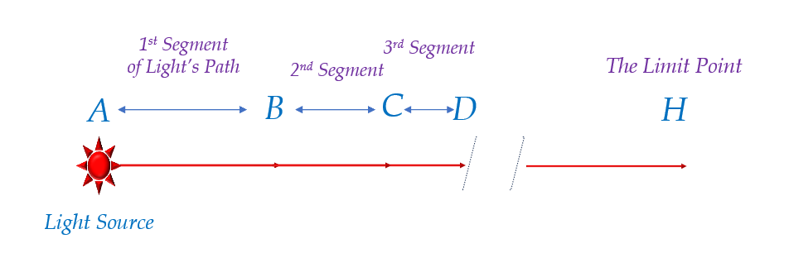
Figure (4): The Limit Point

This is the final point reached by the light ray. Beyond it, an observer will see nothing.
Each new light wave will exhaust all its energy in maintaining the energy of the particles in segment (A-Ḥ) of the light's path. Thus, the wave retains no residual energy to activate additional particles. The light halts at this point and advances no further. We conclude that the light has reached its end—it has reached its Limit Point.

Photonic Collapse:
When we turn off the light source, deprivation occurs. The Primordial Matter particles are deprived of the supply coming from the source. The particles vibrate briefly, consuming their remaining energy, and then return to the state of stillness they were in before. Darkness ensues, and we speak of the occurrence of Photonic Collapse.
It is a near-instantaneous and gradual collapse, from the nearest to the farthest. At the moment the light source is obscured, the energy reserves of the particles are not uniform. The particles of the last segment of the light's path are the richest in energy, while the particles of the first segment are the poorest energetically. Therefore, it is logical to say that the particles of the first segment of the light's path become still first, and the particles of its last segment become still last. However, the differences are almost imperceptible and unmeasurable. Hence, I prefer to speak of an instantaneous Photonic Collapse.
Shadow is Faster than Light:
Light, with its known universal speed, is incredibly fast. Yet shadow approaches instantaneous speed. An object that obstructs the light path at point (C), for example, will have its shadow observed at the limit point (H) immediately and instantaneously. The Photonic Collapse of the Primordial Matter particles constituting segment (C H) of the light's path will occur instantaneously, as we explained, thereby drawing the object's shadow immediately at any point in segment (C H).
While this seems to contradict the relativistic principle that no information can travel faster than light, it is consistent within this model where the 'shadow' is not a transfer of energy but a near-instantaneous, coordinated cessation of energy manifestation across the pre-established medium.
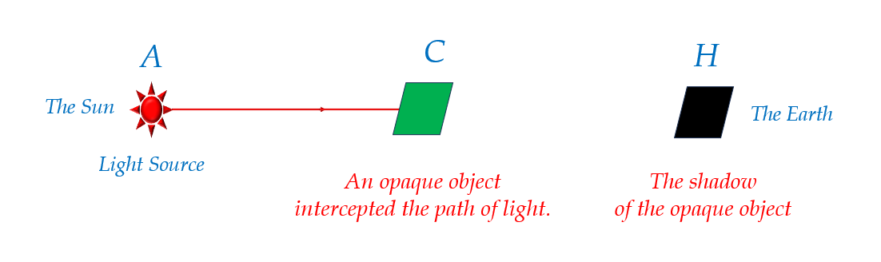
Figure (5): Shadow is Faster than Light
There are those who consider light the fastest entity in this universe, and all other beings must adhere to this decree and that ceiling.
As for me, I do not say what they say. Rather, I insist on asserting the existence of what is much faster than that. And here is my first example of the truth of my claim. For the shadow of things appears before their image.
The light of the sun (the light source) reaches Earth (H) after approximately 8 light-minutes.
If a planet were to intercede midway between it and Earth (C), the shadow of this planet would fall upon Earth in a nearly instantaneous manner. Whereas its light would need 4 light-minutes to reach us, assuming the planet had become a luminous star.

Explanatory Notes
The foregoing elucidations form the very essence of my beliefs in describing the nature of light and its mode of propagation. To dispel any ambiguity, I now present an explanation of the novel terminology contained within it.
The Primordial Matter:
The Primordial Matter is the primordial fruit of creation and the foundation of all creation that followed. God Almighty created it first, then entrusted it with the momentous task of bringing into existence all other creations without exception. With it, creation began, and to it, they shall return. You will find no creature that is not from it, and no creature whose ultimate end is not to it. God endowed it with exceptional, innate intelligence befitting the immense functions assigned to it. The creation of the heavens, the earth, and all that lies between them is the work of its hand; likewise, your creation, O human, is but part of its doing.
The Divine Will descends as a command imperative for fulfillment, whereupon the Primordial Matter is immediately mobilized to realize this Will without delay. It instantly weaves a network of connections and relations with other Primordial Matter, it designs and plans, and then it launches into action. For the command is Divine and the Will is Divine; how could any creature be negligent in such a momentous affair?
Thus, in the chronology of creation, it is the first; in innate purity, it is the purest; and in size, it is the most precise and the smallest. You will find no creature that rivals the Primordial Matter in minuteness of size. It is smaller than everything we have known and will ever know of minute entities in the days to come. You say an electron? I say it is smaller. You say a proton? I say it is more minute. How could it be otherwise, when it is the very basis for the existence of all these entities? Do not venture too far with me in logical deduction, for the Primordial Matter remains elusive to comprehension and explanation.
It has existed eternally and shall remain so forever. It is in everything we see and in all that we have been unable to see. It is in the vastness of the heavens and is the origin of the earth's substance. It is in every celestial body and in every space that separates those bodies. It is present where observable entities are, and it is also present in other, unobservable entities.
They have falsely accused the void, claiming it is empty of things, while the truth is that the Primordial Matter permeates all this emptiness. Its nature eluded their grasp, so mankind attributed to it whatever they wished. They acknowledged suns, moons, meteors, and cosmic dust as inhabitants of this space, yet they denied you, O void, the presence of the Primordial Matter. They did not know that a vacuum was never anything but a misconceived assumption. Had they realized the truth, they would have affirmed the abundance of Matter in those realms.
The Dark Matter:
They postulated the existence of Dark Matter, yet they have not disclosed its attributes and measures. Their calculations were unbalanced, so they hastily turned to Dark Matter to correct the measure and the balance. Their mathematical equations failed to explain the outputs of highly precise observations, so they resorted to Dark Matter to complete the action and provide the explanation. Could it be that Dark Matter and the Primordial Matter are two names for one and the same entity? Or is Dark Matter itself, like all else, a product of the infallible Primordial Matter?
The Cosmic Matrix:
In the beginning, there was nothingness, and then there was the Primordial Matter. The Primordial Matter stood shoulder-to-shoulder in a dark, finely-woven, homogeneously-structured primordial substance. A colossal substance that encompassed the vast cosmos before time itself was created, and along with it, all those universes came into being. A substance whose elements are the primordial fruit of creation: the First Matter. The Primordial Matter was arrayed, part alongside part, in a firm fabric. This eternal, continuous fabric would later burst forth to give rise to the features of this existence.
Within this boundless primordial substance, existence, with all its components—great and small, observed and unobserved, known and unknown, perishable and enduring, present and those yet to come in the future—became concentrated. And between them, between all those components, stretched the dark space whose content remains unknown to this day. They claimed it is devoid of matter, but I say it is inevitably rich.
…………………………………………………………………………………
In other contexts, you can also read the following articles:
 | DOI | The Spinal Reflex, New Hypothesis of Physiology
 | - | The Hyperreflexia, Innovated Pathophysiology
 | DOI | The Spinal Shock
 | - | The Spinal Injury, the Pathophysiology of the Spinal Shock, the Pathophysiology of the Hyperreflexia
 | DOI | Upper Motor Neuron Lesions, the Pathophysiology of the Symptomatology
 | DOI | Hyperreflexia (1): Pathophysiology of Disproportionate Motor Response
 | DOI | Hyperreflexia (2): Pathophysiology of Bilateral-Response Hyperreflexia
 | DOI | Hyperreflexia (3): Pathophysiology of Extended Hyperreflexia
 | DOI | Hyperreflexia (4): Pathophysiology of Multi-Motor-Response Hyperreflexia
- | DOI | The pathophysiology of Triple flexion Reflex
 | DOI | The Clonus, 1st Hypothesis of Pathophysiology
 | DOI | The Clonus, 2nd Hypothesis of Pathophysiology
 | DOI | The Clonus, Two Hypotheses of Pathophysiology
 | DOI | The Nerve Transmission through Neural Fiber, Personal View vs. International View
 | - | The Nerve Transmission through Neural Fiber (1), The Action Pressure Waves
 | - | The Nerve Transmission through Neural Fiber (2), The Action Potentials
 | - | The Nerve Transmission through Neural Fiber (3), The Action Electrical Currents
 | - | The Function of Standard Action Potentials & Currents
 | - | The Three Phases of Nerve transmission
 | DOI | Neural Conduction in the Synapse (Innovated)
 | DOI | Nodes of Ranvier, the Equalizers
 | - | Nodes of Ranvier, the Functions
 | - | Nodes of Ranvier, First Function
 | - | Nodes of Ranvier, Second Function
 | - | Nodes of Ranvier, Third Function
 | - | Node of Ranvier, The Anatomy
 | DOI | Vesicular Dynamics: A Unifying Theory for Wallerian Degeneration and Neural Regeneration
 | - | The Wallerian Degeneration
 | - | The Neural Regeneration
 | DOI | Wallerian Degeneration: Affects Motor Axons while Sparing Sensory Axons
 | DOI | The Sensory Receptors
 | DOI | Electroneurography vs. Neural Reality: Hidden Fallacies in Nerve Conduction Studies
 | DOI | Piriformis Muscle Injection: Personal Approach
 | DOI | In Philosophy of Nerves: Pain First!
 | DOI | In Neurodoctrines: Form is Necessity!
 | DOI | Pronator Teres Syndrome, Struthers-Like Ligament
 | DOI | Ulnar Nerve, Congenital Bilateral Dislocation
 | - | Posterior Interosseous Nerve Syndrome
 | DOI | The Multiple Sclerosis: The Causative Relationship Between  The Galvanic Current & Multiple Sclerosis?
 | - | Cauda Equina Injury, New Surgical Approach
 | DOI | Carpal Tunnel Syndrome Ends Its Adherence: Complete Median Nerve Transection
 | DOI | Biceps Femoris' Long Head Syndrome (BFLHS)
 | DOI | Barr Body, The Whole Story (Innovated)
 | - | Adam's Rib and Adam's Apple, Two Faces of one Sin
 | - | Adam's Rib, could be the Original Sin?
 | - | Barr Body, the Second Look
 | DOI | Who Decides the Sex of Coming Baby?
 | - | Boy or Girl, Mother Decides!
 | - | Oocytogenesis
 | - | Spermatogenesis
 | - | This Woman Can Only Give Birth to Female Children
 | - | This Woman Can Only Give Birth to Male Children
 | - | This Woman Can Give Birth to Female Children More Than to Male Children
 | - | This Woman Can Give Birth to Male Children More Than to Female Children
 | - | This Woman Can Equally Give Birth to Male Children & to Female Children
 | - | Eve Saved Human Identity; Adam Ensured Human Adaptation
 | DOI | COVID-19: Beyond the Crisis—Is It Targeting Our Genes?
 | DOI | Fibromyalgia
 | - | Mitosis in Animal Cell
 | - | Meiosis
 | DOI | The Creation of the Heavens and the Earth: The Connected Nebular Universe Hypothesis
 | DOI | The Sweeping Celestial Bodies (Al-Jawāri Al-Kunnas)
 | DOI | The Black Hole and the Falling Star Hypothesis
 | - | Pneumatic Petrous, Bilateral Temporal Hyperpneumatization
 | DOI | Congenital Bilateral Thenar Hypoplasia
 | DOI | Ulnar Dimelia, Mirror hand Deformity
 | DOI | Thumb Reconstruction Using Microvascular Second Toe to Thumb Transfer
 | DOI | Surgical Restoration of a Smile by Grafting a Segment of the Gracilis Muscle to the Face
 | DOI | Mandible Reconstruction Using Free Fibula Flap
- | DOI | Free Fibula Flap for Bone Lost Complicated with Recalcitrant Osteomyelitis
 | DOI | Presacral Schwannoma
 | DOI | Liver Hemangioma: Urgent Surgery of Giant Liver Hemangioma  Due to Intra-Tumor Bleeding
 | DOI | Free Para Scapular Flap (FPSF) for Skin Reconstruction
 | DOI | Claw Hand Deformity (Brand Operation)
 | DOI | Algodystrophy Syndrome Complicated by Constricting Ring at the Proximal Border of the Edema
 | DOI | Non- Traumatic Non- Embolic Acute Thrombosis of Radial Artery (Buerger’s Disease)
 | DOI | Isolated Axillary Tuberculosis Lymphadenitis
 | DOI | The Iliopsoas Tendonitis... The Snapping Hip
- | DOI | Peri- Menopausal Breast Lesions: Towards a More Decisive Approach
 | To read the original Arabic version of the article, click on:
 | DOI | The New Frankenstein Monster
 | DOI | The Lone Wolf
 | DOI | The Delirium of Night and Day
 | DOI | The Delirium of the Economy
 | DOI | Ovaries in a Secure Corner… Testicles in a Humble Sac:  An Inquiry into the Function of Form
 | DOI | Eve Preserves Humanity’s Blueprint; Adam Drives Its Evolution
 | DOI | The Manufacture of the Unconscious
 | DOI | The Ballad of Eternity
 | DOI | Two Truths Woman Would Never Accept
 | DOI | The 'Iddah (Waiting Period) in Islamic Law: A Comparative Analysis of its Rationale for Divorced Women and Widows
 | DOI | The IVF/ICSI-Conceived Child: A Biologically Suboptimal Outcome
 | DOI | Nature's Relentless Couriers
 | DOI | The Triad of Intelligence... A Traveler's Provisions!
 | DOI | Zero-Value Equations: Modernity’s Hidden Costs and False Promises
 | DOI | The Dialectic of Meaning and Meaninglessness
 | DOI | Societal Schizophrenia: The Delirium of Our Time
 | DOI | The Rational Mind and the Abstract Mind
 | DOI | The Electric Lamp: Between Abstraction and Application - A Journey of a Thousand Years!
 | DOI | Thus spoke Abraham, the Friend: The Eternal... and the Ephemeral
 | DOI | The Crisis of an Intellectual Who Lost His Identity Under Piles of the Read and the Heard
 | DOI | Polygamy and Right-Hand Possession
 | DOI | Quranic Revelations
 | DOI | And the Profession... is a Martyr!
 | DOI | After Death and Before the Final Drive: Either Metamorphosis or Liberation!
 | DOI | The Junction of the Two Seas: An Isthmus Between Two Lives... The Story of Moses Who Lost His Fish
 | DOI | Absurd Wars: The Dualities of Existential Anxiety... Eternal Torment or a Sustained Test?
 | DOI | The Myth, The Aged Truth: Samson the Tale, and Sisyphus the Human
 | DOI | The Black Hole and The Falling Star Hypothesis
 | DOI | Eve (Hawwā): The Containing Woman.. A Philosophical Study of Name, Nature, and the Feminine Psyche
 | DOI | The Spirit and The Psyche: The First is a Gift from the Creator, The Second is a Craft of the Created
 | DOI | Noah's Ark: A Reprieve from Annihilation, Not from the Ordeal
 | DOI | The Final Deluge: A Great Flood... and No Ark
 | DOI | Unveiling the Veiled: It begins with the Name… and ends with Identity.
 | DOI | Human Society: A Gathering of Necessity or a Gathering of Innate Nature?
 | DOI | The Eternal Dialectic: Thought and Power in the Rise and Fall of Civilizations
 | DOI | She Almost Bore Her Brother: How Genetics Vindicates an Ancient Arabic Saying
 | DOI | The Imam Said: On Solitude and the Cure for a Troubled Time

12/11/2025

