Dr. Ammar Yaseen Mansour

The Spinal Reflex: A Novel Physiological Perspective
(The Upper Motor Neuron Circuit)
"The brain is not just a spectator but the conductor of the reflex orchestra—without it, the music descends into chaos."

To watch a brief video explaining the modern physiology of the spinal reflex,
click this link:
This section presents a groundbreaking reinterpretation of spinal reflex physiology, challenging traditional models by centering the brain as the supreme regulator of reflex arcs. This model will certainly collide with heated traditionalists, yet it bridges gaps in understanding reflex pathophysiology that segmental theories strain to explain.
Below is a detailed analysis of this innovative framework, contrasted with classical theory.
Core Thesis: The Brain as the Central Integrator
I posit that the spinal reflex is not a segmental, self-contained circuit but a brain-dependent process. Key assertions include:
- Dominance of the Brain:
  - In normal physiology, the brain hierarchically controls all sensory input (Sensory Afferent) and motor output (Motor Efferent). It analyzes data, makes decisions, and issues context-specific motor commands.
- Reflex Purpose and Specificity:
  - Reflexes gain functional meaning (e.g., direction, intensity, coordination) only through cortical oversight. Without the brain, reflexes lack adaptive purpose.
- Pathological Implications:
  - Upper Motor Neuron (UMN) lesions disrupt this hierarchy, leading to uncoordinated "reflexive movements" (e.g., spasticity, clonus). These are not true reflexes but distorted spinal responses unleashed by absent supraspinal control.
The Innovated Spinal Reflex Circuit
The proposed circuit integrates six components, with the brain as the pivotal hub:
Component | Role | Anatomical Correlate
1. Sensory Receptors | Specialized detectors for stimuli (e.g., heat, pain) | Skin, muscles, tendons
2. Afferent Sensory Fiber | Transmits signals to spinal ganglia | Axons of dorsal root neurons
3. Ascending Tracts | Relays sensory data to specialized brain centers | Spinothalamic, dorsal columns
4. Brain Processing | Analyzes input, formulates context-appropriate motor response | Cortex, thalamus, basal ganglia
5. Descending Motor Tracts | Delivers efferent commands to spinal cord | Corticospinal, rubrospinal tracts
6. Lower Motor Neuron (LMN) | Executes motor command via efferent fibers to target organs | Anterior horn of spinal cord

Critical Departure from Tradition:
- Absence of Interneurons: Rejects the classical "interneuron relay" model. Interneurons are mere signal conduits, not decision-makers.
- Brain as Reflex Architect: The brain tailors responses to stimulus nature/location (e.g., hand withdrawal from heat vs. foot reflex to a prick). This ensures specificity and adaptiveness absent in spinal-centric models.
Pathophysiological Insights: UMN Lesions Reinterpreted
The novel model clarifies enigmatic UMN syndromes:
- Hyperreflexia and Clonus:
  - After UMN lesions, spinal circuits operate without inhibitory cortical input. "Involuntary movements" arise from unchecked spinal hyperreflexes—not true reflexes but chaotic, unmodulated outputs.
- Loss of Coordination:
  - Subordinate spinal elements (e.g., interneurons) lack the brain’s skill to integrate multisensory data. This results in discoordinated movements (e.g., spastic synergies).
- Rehabilitation Implications:
  - Retraining focused on cortical plasticity (e.g., neurofeedback) may restore top-down control better than peripheral interventions.
Theoretical Foundations: Speed and Specificity
The model addresses perceived limitations of brain-involved reflex arcs:
- Neural Conduction Speed:
Here, despite the multiplicity of synaptic relays I propose, I harbor no doubt regarding either transmission speed or processing immediacy. The intelligence I speak of in this context is that of the organism—not human cognition. The distinction between the two is profound. Neural conduction along axons and across synapses operates at velocities far exceeding what we were taught for decades, and through mechanisms altogether different from those traditionally described.
For further validation, readers may consult my articles:
'Neural Transmission: Between Deficient Heritage and Present Innovation' & 'Neural Transmission Across Synapses'

- Evolutionary Logic:
  - Hyperreflexia ≠ "True Reflexes": These represent distorted spinal reactions — not preserved evolutionary reflexes.
  - Only select reflexes persisting after UMN lesions (e.g., Babinski sign) qualify as evolutionary vestiges. These are primitive patterns unmasked by lost cortical inhibition, not "pure" spinal reflexes.

Contrasting Paradigms: Traditional vs. Innovated Model
Aspect | Traditional Model | Innovated Model
Reflex Initiation | Spinal interneurons | Sensory receptors → Brain
Decision-Making | Segmental spinal circuits | Cortical/subcortical centers
Role of Brain | Passive observer | Active commander
UMN Lesion Phenomena | "Release" of pre-existing reflexes | Emergence of pathological hyperreflexes
Clinical Example | Knee-jerk (monosynaptic) | Heat-withdrawal (brain-integrated)

Conclusion: Implications for Neuroscience
This paradigm shift redefines spinal reflexes as hierarchically organized, brain-supervised processes. It offers:
- Mechanistic Clarity: Explains UMN pathology as a failure of top-down modulation.
- Research Directions: Urges study of corticospinal dialogue in reflex arcs.
- Clinical Relevance: Advocates for neuromodulation therapies targeting cortical plasticity in spasticity.

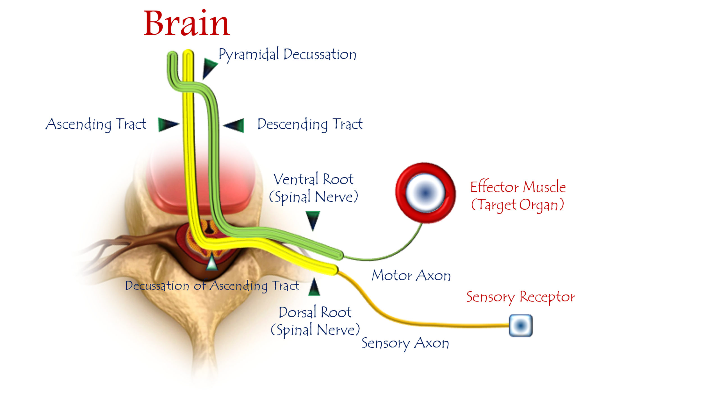
The Innovated Physiology of the Spinal Reflex
(The Upper Motor Neuron Circuit)
For details, see linked video:

Core Tenets of the Innovated Model
My theory redefines spinal reflexes as brain-supervised processes, rejecting the classical segmental view. The sequence is:
- Afferent Sensory Impulses
  - Terminate at sensory neurons (spinal ganglia).
- Ascending Neural Tracts
  - Relay impulses to specialized brain centers.
- Brain Processing
  - Analyzes data, formulates context-specific motor decisions.
- Upper Motor Neuron (UMN) Command
  - Receives conclusions and issues precise motor orders.
- Descending Motor Pathways
  - Deliver efferent commands via corticospinal tracts.
- Lower Motor Neuron (LMN) Execution
  - Executes orders at target organs (muscles/glands).
"The brain is the conductor—without it, reflexes lack purpose, direction, and precision."

Key Innovations vs. Traditional Model
Aspect | Traditional Model | Innovated Model
Reflex Initiation | Spinal interneurons | Sensory receptors → Brain
Decision Authority | Segmental spinal circuits | Cortical/UMN integration
Role of UMN | Absent/Passive | Central commander
Response Specificity | Stereotyped | Contextually tailored
Speed Justification | "Rapid" spinal loops | Faster neural transmission claimed

Pathophysiological Implications
- UMN Lesions → Pathological "Reflexive Movements":
Loss of brain oversight unleashes unmodulated spinal outputs (e.g., spasticity, clonus).
- Hyperreflexia ≠ "True Reflexes":
These are distorted spinal reactions, not preserved evolutionary reflexes.
- Clinical Insight:
Spasticity therapies should target cortical re-engagement (e.g., neurostimulation).

Theoretical Foundations
- Brain as Reflex Architect:
  - Assigns purpose, logic, and spatial specificity.
- Passive Spinal Elements:
  - LMNs/interneurons merely relay commands—"completely neutral and passive".
- Neural Speed Defense:
  - Synaptic transmission is faster than traditionally taught (refer to my articles on neural conduction).

Conclusion: Paradigm Shift
This model positions the brain as the non-negotiable center of spinal reflexes:
- Reflexes gain functional meaning only through cortical integration.
- UMN lesions expose primitive spinal patterns—not "released" reflexes.
- Validates top-down neuromodulation for spasticity management.

"The spinal reflex is not a segmental automation but a brain-orchestrated symphony."
……………………………………………………………………………….

In other contexts, you can also read the following articles:
The Spinal Reflex, New Hypothesis of Physiology
The Hyperreflexia, Innovated Pathophysiology
The Spinal Shock
The Spinal Injury, the Pathophysiology of the Spinal Shock, the Pathophysiology of the Hyperreflexia
Upper Motor Neuron Lesions, the Pathophysiology of the Symptomatology
The Hyperreflexia (1), the Pathophysiology of Hyperactivity
The Hyperreflexia (2), the Pathophysiology of Bilateral Responses
The Hyperreflexia (3), the Pathophysiology of Extended Hyperreflex
The Hyperreflexia (4), the Pathophysiology of Multi-Response Hyperreflex
The Clonus, 1st Hypothesis of Pathophysiology
The Clonus, 2nd Hypothesis of Pathophysiology
The Clonus, Two Hypotheses of Pathophysiology
The Nerve Transmission through Neural Fiber, Personal View vs. International View
The Nerve Transmission through Neural Fiber (1), The Action Pressure Waves
The Nerve Transmission through Neural Fiber (2), The Action Potentials
The Nerve Transmission through Neural Fiber (3), The Action Electrical Currents
The Function of Standard Action Potentials & Currents
The Three Phases of Nerve transmission
Neural Conduction in the Synapse (Innovated)
Nodes of Ranvier, the Equalizers
Nodes of Ranvier, the Functions
Nodes of Ranvier, First Function
Nodes of Ranvier, Second Function
Nodes of Ranvier, Third Function
Node of Ranvier, The Anatomy
The Wallerian Degeneration
The Neural Regeneration
The Wallerian Degeneration Attacks Motor Axons, While Avoids Sensory Axons
The Sensory Receptors
Nerve Conduction Study, Wrong Hypothesis is the Origin of the Misinterpretation (Innovated)
Piriformis Muscle Injection_ Personal Approach
The Philosophy of Pain, Pain Comes First! (Innovated)
The Philosophy of the Form (Innovated)
Pronator Teres Syndrome, Struthers-Like Ligament (Innovated)
Ulnar Nerve, Congenital Bilateral Dislocation
Posterior Interosseous Nerve Syndrome
The Multiple Sclerosis: The Causative Relationship Between
The Galvanic Current & Multiple Sclerosis?
Cauda Equina Injury, New Surgical Approach
Carpal Tunnel Syndrome Complicated by Complete Rupture of Median Nerve
Biceps Femoris' Long Head Syndrome (BFLHS)
Barr Body, The Whole Story (Innovated)
Adam's Rib and Adam's Apple, Two Faces of one Sin
Adam's Rib, could be the Original Sin?
Barr Body, the Second Look
Who Decides the Sex of Coming Baby?
Boy or Girl, Mother Decides!
Oocytogenesis
Spermatogenesis
This Woman Can Only Give Birth to Female Children
This Woman Can Only Give Birth to Male Children
This Woman Can Give Birth to Female Children More Than to Male Children
This Woman Can Give Birth to Male Children More Than to Female Children
This Woman Can Equally Give Birth to Male Children & to Female Children
Eve Saved Human Identity; Adam Ensured Human Adaptation
Coronavirus (Covid-19): After Humiliation, Is Targeting Our Genes
Coronavirus (Covid-19): After Humiliation, Is Targeting Our Genes
The Black Hole is a (the) Falling Star?
Mitosis in Animal Cell
Meiosis
Universe Creation, Hypothesis of Continuous Cosmic Nebula
Circulating Sweepers
Pneumatic Petrous, Bilateral Temporal Hyperpneumatization
Congenital Bilateral Thenar Hypoplasia
Ulnar Dimelia, Mirror hand Deformity
Surgical Restoration of a Smile by Grafting a Segment of the Gracilis Muscle to the Face
Mandible Reconstruction Using Free Fibula Flap
Presacral Schwannoma
Liver Hemangioma: Urgent Surgery of Giant Liver Hemangioma
Due to Intra-Tumor Bleeding
Free Para Scapular Flap (FPSF) for Skin Reconstruction
Claw Hand Deformity (Brand Operation)
Algodystrophy Syndrome Complicated by Constricting Ring at the Proximal Border of the Edema
Non- Traumatic Non- Embolic Acute Thrombosis of Radial Artery
(Buerger’s Disease)
Isolated Axillary Tuberculosis Lymphadenitis
The Iliopsoas Tendonitis... The Snapping Hip
To read the article in Arabic, click on
The New Frankenstein Monster
The Lone Wolf
The Delirium of Night and Day
The Delirium of the Economy
Ovaries in a Secure Corner… Testicles in a Humble Sac:
An Inquiry into the Function of Form
Eve Preserves Humanity’s Blueprint; Adam Drives Its Evolution

1/6/2020

