Dr. Ammar Yaseen Mansour
The Creation of the Heavens and the Earth
The Connected Nebular Universe Hypothesis – The Counterpart to the Big Bang Theory

To watch a video explaining in detail the origin of the universe according to the Connected Cosmic Nebula hypothesis, click here:
"Do the disbelievers not see that the heavens and the earth were a joined entity, and We separated them..." (Quran 21:30)
To read the original Arabic version of this article, click here: (DOI)
خَلْقُ السَّماواتِ وَالأرضِ: فرضيَّةُ الكونِ السَّديميِّ المُتَّصلِ
In the beginning, there was the Primordial Matter. It was the foundation of creation, the smallest of God's creations that we know of and that we do not know of. This Primordial Matter filled the entire vast universe, making it appear as a dense, homogeneous, and seamless fabric—similar to a plasma or a primal substance. With and within it, the universe was a connected, continuous nebula (a Ratq), with no gaps or separations in its substance.
Within this immense, infinite nebula, existence would condense, and stars and planets would be born. From its substance, all of God's creations would emerge, without exception—great or small. From its substance, the Sun and its light, the Moon and its orbit, and even humans and their actions would come to be. This cosmic nebula is the origin and foundation for the existence of universes and all components alike. See figure (1).
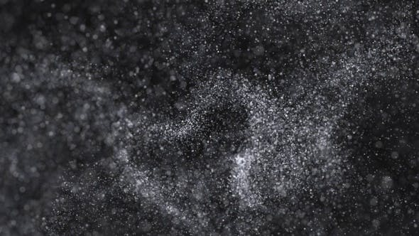
Figure (1): The Connected Cosmic Nebula
In the beginning was the Primordial Matter. It is the smallest of God's creations,
from what we know and from what we do not know.
The Primordial Matter filled the universe in all its vastness. Through it, the universe became a dense, homogeneous fog with boundless expanse. Through it, the universe became a connected nebula—with no gaps nor separations.
This cosmic nebula is what would later give rise to all celestial bodies, regardless of their classifications. It would also form the foundation for the existence of all God's creations—without exception. Some of these creations are ones whose existence and details we have already come to know. Others are those whose existence will be revealed to us later.
However, the overwhelming majority of them will remain hidden from us as long as we humans live.

The Spherical Shape of Celestial Bodies and Their Rotation
The Primordial Matter was in perpetual motion within this cosmic plasma. Then, an event occurred: two or more of its particles coalesced into a single mass. From the kinetic energy of the merging matter, two opposing forces emerged—equal in magnitude and diagonally opposed. This pair of Coupled Forces set the nascent mass into rotation counterclockwise.
Alternatively, it is possible that the Primordial Matter was inherently in rotational motion around its own axis, counterclockwise from the start. Thus, it was natural for the merged mass to continue rotating in the same direction—a view I personally favor. Regardless of the cause, this rotational motion is what grants celestial bodies their distinctive spherical form. See figure (2).

Coupled Forces

Coupled Forces
Anticlockwise Rotation
Primordial Matter (1)

Primordial Matter (2)

The mass resulting from the merger
of two particles of the Primordial Matter
Figure (2)
The Sphericity of Celestial Bodies and Their Rotation Around Themselves

To explain the rotation and sphericity of celestial bodies, I propose one of the following two hypotheses:
The First Hypothesis: The collision and subsequent merging of two particles of the Primordial Matter generated a pair of Coupled Forces. This pair of forces acted to rotate the mass around its axis. It so happened that the direction of rotation was counterclockwise (Anticlockwise Rotation).
The Second Hypothesis (Which I Favor): The Primordial Matter was inherently rotating around its own axis in a direction counterclockwise to the movement of a clock's hands. Therefore, it was not coincidental, but rather inevitable, for the resulting mass from the merging of these particles to rotate in the same direction.
.
The nascent mass, formed from the gathering of Primordial Matter, possessed a gravitational force greater than the inertia of the matter in its immediate vicinity. The surrounding matter was drawn into the larger mass, causing it to grow further. A larger mass equates to a greater gravitational force, leading to the accumulation of even more matter. Over time, the mass grew into the core of a celestial body. See figure (3).

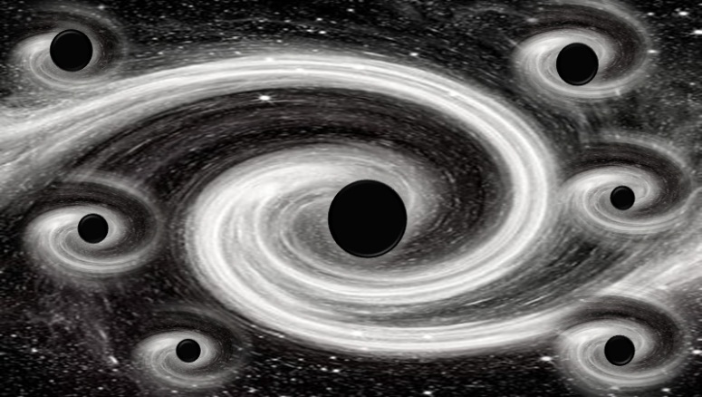
Figure (3)
The Birth of Celestial Bodies

The Primordial Matter coalesces into masses that form the fundamental cores
of all celestial bodies. Due to the emerging gravitational force, these nascent masses absorb more Primordial Matter from their immediate vicinity. Consequently, their size increases, and along with it, the reach of their gravitational pull expands.
The result is the incorporation of more Primordial Matter into these masses, this time from regions farther away than before.
Gradually, the size grows, and the celestial bodies complete their formation.
The final sizes vary depending on the amount of Primordial Matter available within the effective range of each body's gravity.
This appears to be related to the age of the celestial body itself, on one hand, and its proximity to other, older and larger celestial bodies, on the other. The older bodies sweep up the Primordial Matter before the newer ones can access it.
Thus, the latter remain small, potentially becoming dependent on or even orbiting their older, and necessarily larger, neighbors.

The Sweeping Orbs
This process repeated across time and space, leading to the formation of all celestial bodies of various names and sizes. These bodies, in their relentless pursuit of mass and size, swept up the Primordial Matter from their surrounding space. They collected matter wherever their gravitational reach extended along their orbit.
A celestial body's gravitational radius defines its own domain. Its orbital motion carves out its unique Functional Space—the region it cleanses of Primordial Matter as it travels. See figure (4).

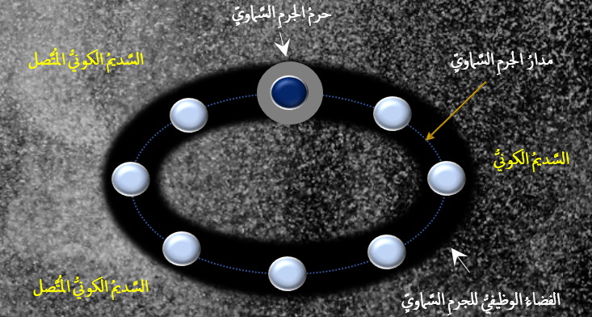

Figure (4)
Sweeping Orbs & Functional Space
Important Note:
The Cosmic Nebula = السَّديمُ الكونيُّ - The celestial body = الجرمُ السَّماويُّ
The Functional Space = الفضُاء الوظيفيُّ - The celestial body's domain = حرمُ الجرمِ السَّماويِّ
The celestial body's Orbit = مدارُ الجرمِ السَّماويِّ

During the formation phase, the celestial body captures all the Primordial Matter within the effective range of its mass's gravity. The space surrounding the body is thus emptied of its matter, becoming void or nearly so. The gravitational radius defines the celestial body's own domain. Due to its orbital motion, the celestial body and its domain move from one point to another along its orbit. As it moves along this path, it sweeps up all available Primordial Matter within the reach of its gravity.

The region delineated by the celestial body's domain throughout its orbit is what I term its Functional Space.

The Separated Seamless Whole (Al-Ratq Al-Maftooq)
Thus, at the beginning of creation, the universe was a single, connected entity—a Ratq. The particles of Primordial Matter were closely packed, shoulder to shoulder. It was a seamless fabric, where distances were lost in the abyss of its darkness and time was overwhelmed by its awe.
Then, it happened that some of the Primordial Matter coalesced into a distinct mass. The gravity of this nascent mass overcame the inertia of the nearby particles, drawing them in. As new arrivals accumulated, the mass grew in size and power, its gravitational reach extending further into the cosmic nebula. Over time, the mass grew into a full-fledged celestial body.
Imagine this event repeating billions of times, with each event taking a bite out of the substance of the cosmic nebula. Undoubtedly, you would find the seamless fabric of the universe now full of separated holes (Fataq). Each separation corresponded to a star or a wandering planet that consumed its share from the substance of the universal mother and moved on. See figure (5).

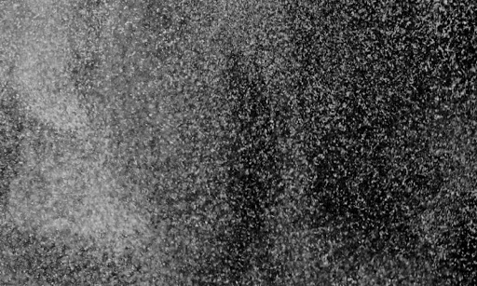 | 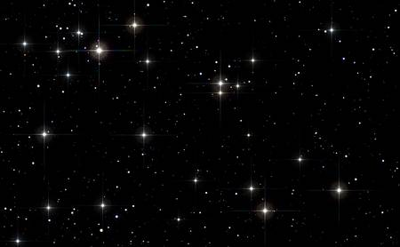
Figure (5): The Separated Seamless Whole

The Universe at the Beginning of Creation | The Universe Currently
It was the Connected Cosmic Nebula,  where Primordial Matter was closely packed, shoulder to shoulder, in a seamless fabric resembling a plasma or a primal substance. Here, interstitial distances are absent,  and dimensions disappear. | Celestial bodies are separated by vast,  empty space. The interstitial spaces are devoid  of any trace of matter, or nearly so.  Here, the components have absorbed almost  all of the Primordial Matter.

……………………………………………………………………………………
In other contexts, you can also read the following articles:
 | DOI | The Spinal Reflex, New Hypothesis of Physiology
 | - | The Hyperreflexia, Innovated Pathophysiology
 | DOI | The Spinal Shock
 | - | The Spinal Injury, the Pathophysiology of the Spinal Shock, the Pathophysiology of the Hyperreflexia
 | DOI | Upper Motor Neuron Lesions, the Pathophysiology of the Symptomatology
 | DOI | Hyperreflexia (1): Pathophysiology of Disproportionate Motor Response
 | DOI | Hyperreflexia (2): Pathophysiology of Bilateral-Response Hyperreflexia
 | DOI | Hyperreflexia (3): Pathophysiology of Extended Hyperreflexia
 | DOI | Hyperreflexia (4): Pathophysiology of Multi-Motor-Response Hyperreflexia
- | DOI | The pathophysiology of Triple flexion Reflex
 | DOI | The Clonus, 1st Hypothesis of Pathophysiology
 | DOI | The Clonus, 2nd Hypothesis of Pathophysiology
 | DOI | The Clonus, Two Hypotheses of Pathophysiology
 | DOI | The Nerve Transmission through Neural Fiber, Personal View vs. International View
 | - | The Nerve Transmission through Neural Fiber (1), The Action Pressure Waves
 | - | The Nerve Transmission through Neural Fiber (2), The Action Potentials
 | - | The Nerve Transmission through Neural Fiber (3), The Action Electrical Currents
 | - | The Function of Standard Action Potentials & Currents
 | - | The Three Phases of Nerve transmission
 | DOI | Neural Conduction in the Synapse (Innovated)
 | DOI | Nodes of Ranvier, the Equalizers
 | - | Nodes of Ranvier, the Functions
 | - | Nodes of Ranvier, First Function
 | - | Nodes of Ranvier, Second Function
 | - | Nodes of Ranvier, Third Function
 | - | Node of Ranvier, The Anatomy
 | DOI | Vesicular Dynamics: A Unifying Theory for Wallerian Degeneration and Neural Regeneration
 | - | The Wallerian Degeneration
 | - | The Neural Regeneration
 | DOI | Wallerian Degeneration: Affects Motor Axons while Sparing Sensory Axons
 | DOI | The Sensory Receptors
 | DOI | Electroneurography vs. Neural Reality: Hidden Fallacies in Nerve Conduction Studies
 | DOI | Piriformis Muscle Injection: Personal Approach
 | DOI | In Philosophy of Nerves: Pain First!
 | DOI | In Neurodoctrines: Form is Necessity!
 | DOI | Pronator Teres Syndrome, Struthers-Like Ligament
 | DOI | Ulnar Nerve, Congenital Bilateral Dislocation
 | - | Posterior Interosseous Nerve Syndrome
 | DOI | The Multiple Sclerosis: The Causative Relationship Between  The Galvanic Current & Multiple Sclerosis?
 | - | Cauda Equina Injury, New Surgical Approach
 | DOI | Carpal Tunnel Syndrome Ends Its Adherence: Complete Median Nerve Transection
 | DOI | Biceps Femoris' Long Head Syndrome (BFLHS)
 | DOI | Barr Body, The Whole Story (Innovated)
 | - | Adam's Rib and Adam's Apple, Two Faces of one Sin
 | - | Adam's Rib, could be the Original Sin?
 | - | Barr Body, the Second Look
 | DOI | Who Decides the Sex of Coming Baby?
 | - | Boy or Girl, Mother Decides!
 | - | Oocytogenesis
 | - | Spermatogenesis
 | - | This Woman Can Only Give Birth to Female Children
 | - | This Woman Can Only Give Birth to Male Children
 | - | This Woman Can Give Birth to Female Children More Than to Male Children
 | - | This Woman Can Give Birth to Male Children More Than to Female Children
 | - | This Woman Can Equally Give Birth to Male Children & to Female Children
 | - | Eve Saved Human Identity; Adam Ensured Human Adaptation
 | DOI | COVID-19: Beyond the Crisis—Is It Targeting Our Genes?
 | DOI | Fibromyalgia
 | - | Mitosis in Animal Cell
 | - | Meiosis
 | DOI | The Creation of the Heavens and the Earth: The Connected Nebular Universe Hypothesis
 | DOI | The Sweeping Celestial Bodies (Al-Jawāri Al-Kunnas)
 | DOI | The Black Hole and the Falling Star Hypothesis
 | - | Pneumatic Petrous, Bilateral Temporal Hyperpneumatization
 | DOI | Congenital Bilateral Thenar Hypoplasia
 | DOI | Ulnar Dimelia, Mirror hand Deformity
 | DOI | Thumb Reconstruction Using Microvascular Second Toe to Thumb Transfer
 | DOI | Surgical Restoration of a Smile by Grafting a Segment of the Gracilis Muscle to the Face
 | DOI | Mandible Reconstruction Using Free Fibula Flap
- | DOI | Free Fibula Flap for Bone Lost Complicated with Recalcitrant Osteomyelitis
 | DOI | Presacral Schwannoma
 | DOI | Liver Hemangioma: Urgent Surgery of Giant Liver Hemangioma  Due to Intra-Tumor Bleeding
 | DOI | Free Para Scapular Flap (FPSF) for Skin Reconstruction
 | DOI | Claw Hand Deformity (Brand Operation)
 | DOI | Algodystrophy Syndrome Complicated by Constricting Ring at the Proximal Border of the Edema
 | DOI | Non- Traumatic Non- Embolic Acute Thrombosis of Radial Artery (Buerger’s Disease)
 | DOI | Isolated Axillary Tuberculosis Lymphadenitis
 | DOI | The Iliopsoas Tendonitis... The Snapping Hip
- | DOI | Peri- Menopausal Breast Lesions: Towards a More Decisive Approach
 | To read the original Arabic version of the article, click on:
 | DOI | The New Frankenstein Monster
 | DOI | The Lone Wolf
 | DOI | The Delirium of Night and Day
 | DOI | The Delirium of the Economy
 | DOI | Ovaries in a Secure Corner… Testicles in a Humble Sac:  An Inquiry into the Function of Form
 | DOI | Eve Preserves Humanity’s Blueprint; Adam Drives Its Evolution
 | DOI | The Manufacture of the Unconscious
 | DOI | The Ballad of Eternity
 | DOI | Two Truths Woman Would Never Accept
 | DOI | The 'Iddah (Waiting Period) in Islamic Law: A Comparative Analysis of its Rationale for Divorced Women and Widows
 | DOI | The IVF/ICSI-Conceived Child: A Biologically Suboptimal Outcome
 | DOI | Nature's Relentless Couriers
 | DOI | The Triad of Intelligence... A Traveler's Provisions!
 | DOI | Zero-Value Equations: Modernity’s Hidden Costs and False Promises
 | DOI | The Dialectic of Meaning and Meaninglessness
 | DOI | Societal Schizophrenia: The Delirium of Our Time
 | DOI | The Rational Mind and the Abstract Mind
 | DOI | The Electric Lamp: Between Abstraction and Application - A Journey of a Thousand Years!
 | DOI | Thus spoke Abraham, the Friend: The Eternal... and the Ephemeral
 | DOI | The Crisis of an Intellectual Who Lost His Identity Under Piles of the Read and the Heard
 | DOI | Polygamy and Right-Hand Possession
 | DOI | Quranic Revelations
 | DOI | And the Profession... is a Martyr!
 | DOI | After Death and Before the Final Drive: Either Metamorphosis or Liberation!
 | DOI | The Junction of the Two Seas: An Isthmus Between Two Lives... The Story of Moses Who Lost His Fish
 | DOI | Absurd Wars: The Dualities of Existential Anxiety... Eternal Torment or a Sustained Test?
 | DOI | The Myth, The Aged Truth: Samson the Tale, and Sisyphus the Human
 | DOI | The Black Hole and The Falling Star Hypothesis
 | DOI | Eve (Hawwā): The Containing Woman.. A Philosophical Study of Name, Nature, and the Feminine Psyche
 | DOI | The Spirit and The Psyche: The First is a Gift from the Creator, The Second is a Craft of the Created
 | DOI | Noah's Ark: A Reprieve from Annihilation, Not from the Ordeal
 | DOI | The Final Deluge: A Great Flood... and No Ark
 | DOI | Unveiling the Veiled: It begins with the Name… and ends with Identity.
 | DOI | Human Society: A Gathering of Necessity or a Gathering of Innate Nature?
 | DOI | The Eternal Dialectic: Thought and Power in the Rise and Fall of Civilizations
 | DOI | She Almost Bore Her Brother: How Genetics Vindicates an Ancient Arabic Saying
 | DOI | The Imam Said: On Solitude and the Cure for a Troubled Time

04/11/2025

