Dr. Ammar Yaseen Mansour

The Sweeping Celestial Bodies
(Al-Jawāri Al-Kunnas)
(So I swear by the planets that recede, The sweeping celestial bodies)
"(Qur'an, 81:15-16)"
To read the original Arabic version of this article, click here: (DOI)
الجواري الكُنَّسُ

The Sweeping Celestial Bodies
These are the celestial bodies that, in their relentless pursuit to acquire mass and volume, swept up the primordial matter from the surrounding space. They captured matter, wherever their gravitational reach extended within their immediate space and all along their orbital path. It is known to us that celestial bodies rotate around their mass axis, and also revolve along their pre-ordained orbits since the beginning of creation. Their gravitational radius carved out their own exclusive domain from space. Their motion along the orbit delineated the specific functional space for each celestial body; see Figure (1).


For more detail, watch the attached video:
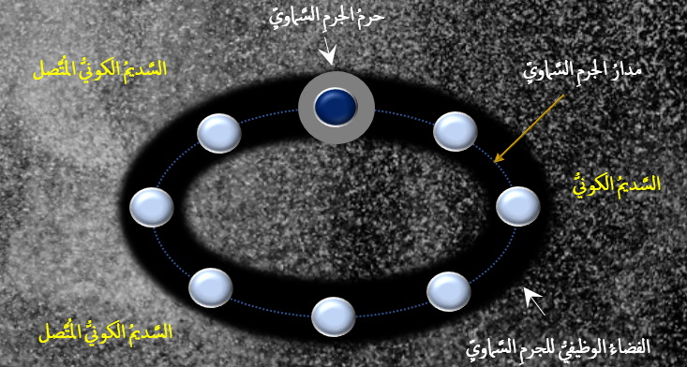
Figure (1):
The Sweeping Celestial Bodies & The Functional Space

During the formation stage,
the celestial body captures all the primordial matter within the operational range of its mass's gravity. Thus, the space surrounding the body is emptied of its matter, becoming void or nearly void of matter. The gravitational radius defines the exclusive domain of the celestial body. Due to its orbital motion, the celestial body and its domain move from one point to another along the orbit. Through this movement, it sweeps up all available primordial matter reached by its gravitational pull. What the domain of the celestial body traces in its orbit is what I term the Functional Space of the celestial body.

The Hypothesis of the Continuous Cosmic Nebula
In the beginning... there was the Primordial Matter. It is the inception of creation, the smallest of God's creatures that we know of and that we do not know of. The Primordial Matter filled the vast cosmos entirely, making the latter appear as a very dense, homogeneous, fabric-like nebula. It resembled a plasma or a primeval chaos due to its density. With it and through it, the cosmos appeared as a seamless nebula, with no break in its matter and no fissure. Within this formidable nebula, existence would condense, and stars and planets would be born. From its matter, all of God's creatures would come into being, without exception, be they great or small. From its matter, the Sun and its light would form, and the Moon and its orbit would form. From its matter, humans are formed, and so are their actions. It is the Cosmic Nebula, the origin and foundation for the existence of universes and components alike. To watch detailed elaboration, see the presentation attached as Figure (2).

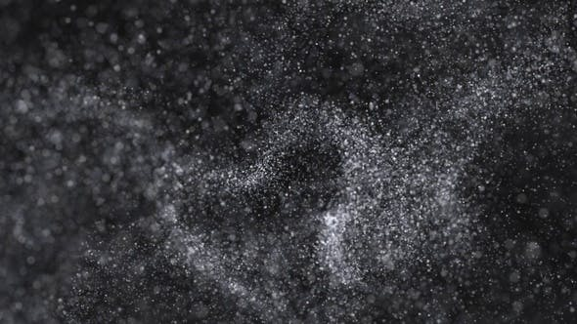
Figure (2)
The Continuous Cosmic Nebula

In the beginning, there was the Primordial Matter.
It is the smallest of God's creatures that we know of and that we do not know of.
The Primordial Matter filled the cosmos in its vastness. Through it, the cosmos became a homogeneous, dense fog with boundless extent.
Through it, the cosmos became a continuous nebula, with no fissures or breaks.
This Cosmic Nebula is what would later give rise to all celestial bodies, regardless of their classifications. It will also be the basis for the existence of God's creatures; I exclude none from this. Some creatures are those whose existence and details we have previously come to know. Others are those whose existence will be revealed to us later. However, the vast majority of them will remain hidden from us throughout our lives as humans.

The Birth of Celestial Bodies
The Primordial Matter was in constant motion within this chaotic cosmos. Then it happened that two or more of them came together into a single mass. The nascent mass, resulting from the gathering of a small amount of Primordial Matter, possessed a gravitational force greater than the inertia of the matter in its immediate vicinity. Thus, the matter from the surroundings joined the larger neighboring mass, causing the latter to grow larger. A larger mass equates to a greater gravitational force, which consequently means the incorporation of a greater quantity of matter into the mass.
And so, over time, the volume of the mass increased, forming the core foundation of the celestial body. This action repeated over the course of time, and in many places throughout this expansive cosmos. The result was the formation of celestial bodies with different names and sizes; see Figure (3).

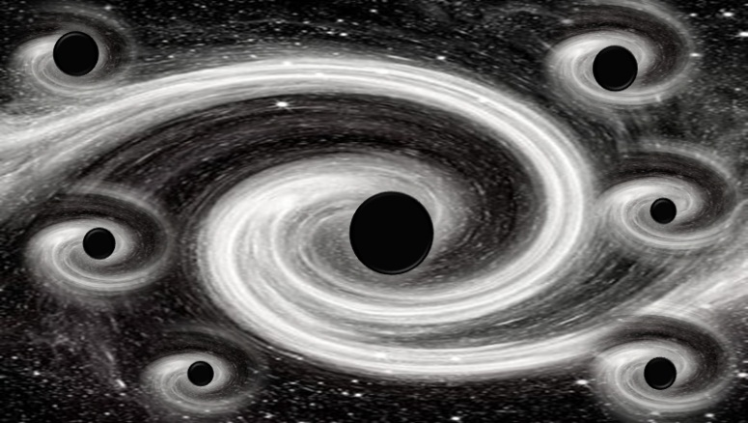
Figure (3)
The Birth of Celestial Bodies

The Primordial Matter gathers into masses which are the fundamental nuclei for all celestial bodies. Due to the emerging gravitational force, the nascent masses absorb the Primordial Matter from the immediate surroundings.
Thus, they increase in volume, and along with it, the reach of the gravitational force for each of them lengthens. The result is the joining of more Primordial Matter to these masses, this time from sectors farther than the previous ones.
Gradually, the size increases and the growth of the celestial bodies is completed.
The sizes differ according to the available Primordial Matter within the operational range of each body's specific gravitational radius. This appears to be linked to the age of the body itself, on one hand. And to its proximity to other, older celestial bodies, on the other hand. The older ones sweep the Primordial Matter from the path of the newer ones. Thus, the latter remains small, and perhaps dependent, and perhaps a satellite to its older neighbor, which is necessarily historically older and larger in size.

……………………………………………………………………………………….
In other contexts, you can also read the following articles:
 | DOI | The Spinal Reflex, New Hypothesis of Physiology
 | - | The Hyperreflexia, Innovated Pathophysiology
 | DOI | The Spinal Shock
 | - | The Spinal Injury, the Pathophysiology of the Spinal Shock, the Pathophysiology of the Hyperreflexia
 | DOI | Upper Motor Neuron Lesions, the Pathophysiology of the Symptomatology
 | DOI | Hyperreflexia (1): Pathophysiology of Disproportionate Motor Response
 | DOI | Hyperreflexia (2): Pathophysiology of Bilateral-Response Hyperreflexia
 | DOI | Hyperreflexia (3): Pathophysiology of Extended Hyperreflexia
 | DOI | Hyperreflexia (4): Pathophysiology of Multi-Motor-Response Hyperreflexia
- | DOI | The pathophysiology of Triple flexion Reflex
 | DOI | The Clonus, 1st Hypothesis of Pathophysiology
 | DOI | The Clonus, 2nd Hypothesis of Pathophysiology
 | DOI | The Clonus, Two Hypotheses of Pathophysiology
 | DOI | The Nerve Transmission through Neural Fiber, Personal View vs. International View
 | - | The Nerve Transmission through Neural Fiber (1), The Action Pressure Waves
 | - | The Nerve Transmission through Neural Fiber (2), The Action Potentials
 | - | The Nerve Transmission through Neural Fiber (3), The Action Electrical Currents
 | - | The Function of Standard Action Potentials & Currents
 | - | The Three Phases of Nerve transmission
 | DOI | Neural Conduction in the Synapse (Innovated)
 | DOI | Nodes of Ranvier, the Equalizers
 | - | Nodes of Ranvier, the Functions
 | - | Nodes of Ranvier, First Function
 | - | Nodes of Ranvier, Second Function
 | - | Nodes of Ranvier, Third Function
 | - | Node of Ranvier, The Anatomy
 | DOI | Vesicular Dynamics: A Unifying Theory for Wallerian Degeneration and Neural Regeneration
 | - | The Wallerian Degeneration
 | - | The Neural Regeneration
 | DOI | Wallerian Degeneration: Affects Motor Axons while Sparing Sensory Axons
 | DOI | The Sensory Receptors
 | DOI | Electroneurography vs. Neural Reality: Hidden Fallacies in Nerve Conduction Studies
 | DOI | Piriformis Muscle Injection: Personal Approach
 | DOI | In Philosophy of Nerves: Pain First!
 | DOI | In Neurodoctrines: Form is Necessity!
 | DOI | Pronator Teres Syndrome, Struthers-Like Ligament
 | DOI | Ulnar Nerve, Congenital Bilateral Dislocation
 | - | Posterior Interosseous Nerve Syndrome
 | DOI | The Multiple Sclerosis: The Causative Relationship Between  The Galvanic Current & Multiple Sclerosis?
 | - | Cauda Equina Injury, New Surgical Approach
 | DOI | Carpal Tunnel Syndrome Ends Its Adherence: Complete Median Nerve Transection
 | DOI | Biceps Femoris' Long Head Syndrome (BFLHS)
 | DOI | Barr Body, The Whole Story (Innovated)
 | - | Adam's Rib and Adam's Apple, Two Faces of one Sin
 | - | Adam's Rib, could be the Original Sin?
 | - | Barr Body, the Second Look
 | DOI | Who Decides the Sex of Coming Baby?
 | - | Boy or Girl, Mother Decides!
 | - | Oocytogenesis
 | - | Spermatogenesis
 | - | This Woman Can Only Give Birth to Female Children
 | - | This Woman Can Only Give Birth to Male Children
 | - | This Woman Can Give Birth to Female Children More Than to Male Children
 | - | This Woman Can Give Birth to Male Children More Than to Female Children
 | - | This Woman Can Equally Give Birth to Male Children & to Female Children
 | - | Eve Saved Human Identity; Adam Ensured Human Adaptation
 | DOI | COVID-19: Beyond the Crisis—Is It Targeting Our Genes?
 | DOI | Fibromyalgia
 | - | Mitosis in Animal Cell
 | - | Meiosis
 | - | Universe Creation, Hypothesis of Continuous Cosmic Nebula
 | - | Circulating Sweepers
 | DOI | The Black Hole and the Falling Star Hypothesis
 | - | Pneumatic Petrous, Bilateral Temporal Hyperpneumatization
 | DOI | Congenital Bilateral Thenar Hypoplasia
 | DOI | Ulnar Dimelia, Mirror hand Deformity
 | DOI | Thumb Reconstruction Using Microvascular Second Toe to Thumb Transfer
 | DOI | Surgical Restoration of a Smile by Grafting a Segment of the Gracilis Muscle to the Face
 | DOI | Mandible Reconstruction Using Free Fibula Flap
- | DOI | Free Fibula Flap for Bone Lost Complicated with Recalcitrant Osteomyelitis
 | DOI | Presacral Schwannoma
 | DOI | Liver Hemangioma: Urgent Surgery of Giant Liver Hemangioma  Due to Intra-Tumor Bleeding
 | DOI | Free Para Scapular Flap (FPSF) for Skin Reconstruction
 | DOI | Claw Hand Deformity (Brand Operation)
 | DOI | Algodystrophy Syndrome Complicated by Constricting Ring at the Proximal Border of the Edema
 | DOI | Non- Traumatic Non- Embolic Acute Thrombosis of Radial Artery (Buerger’s Disease)
 | DOI | Isolated Axillary Tuberculosis Lymphadenitis
 | DOI | The Iliopsoas Tendonitis... The Snapping Hip
- | DOI | Peri- Menopausal Breast Lesions: Towards a More Decisive Approach
 | To read the original Arabic version of the article, click on:
 | DOI | The New Frankenstein Monster
 | DOI | The Lone Wolf
 | DOI | The Delirium of Night and Day
 | DOI | The Delirium of the Economy
 | DOI | Ovaries in a Secure Corner… Testicles in a Humble Sac:  An Inquiry into the Function of Form
 | DOI | Eve Preserves Humanity’s Blueprint; Adam Drives Its Evolution
 | DOI | The Manufacture of the Unconscious
 | DOI | The Ballad of Eternity
 | DOI | Two Truths Woman Would Never Accept
 | DOI | The 'Iddah (Waiting Period) in Islamic Law: A Comparative Analysis of its Rationale for Divorced Women and Widows
 | DOI | The IVF/ICSI-Conceived Child: A Biologically Suboptimal Outcome
 | DOI | Nature's Relentless Couriers
 | DOI | The Triad of Intelligence... A Traveler's Provisions!
 | DOI | Zero-Value Equations: Modernity’s Hidden Costs and False Promises
 | DOI | The Dialectic of Meaning and Meaninglessness
 | DOI | Societal Schizophrenia: The Delirium of Our Time
 | DOI | The Rational Mind and the Abstract Mind
 | DOI | The Electric Lamp: Between Abstraction and Application - A Journey of a Thousand Years!
 | DOI | Thus spoke Abraham, the Friend: The Eternal... and the Ephemeral
 | DOI | The Crisis of an Intellectual Who Lost His Identity Under Piles of the Read and the Heard
 | DOI | Polygamy and Right-Hand Possession
 | DOI | Quranic Revelations
 | DOI | And the Profession... is a Martyr!
 | DOI | After Death and Before the Final Drive: Either Metamorphosis or Liberation!
 | DOI | The Junction of the Two Seas: An Isthmus Between Two Lives... The Story of Moses Who Lost His Fish
 | DOI | Absurd Wars: The Dualities of Existential Anxiety... Eternal Torment or a Sustained Test?
 | DOI | The Myth, The Aged Truth: Samson the Tale, and Sisyphus the Human
 | DOI | The Black Hole and The Falling Star Hypothesis
 | DOI | Eve (Hawwā): The Containing Woman.. A Philosophical Study of Name, Nature, and the Feminine Psyche
 | DOI | The Spirit and The Psyche: The First is a Gift from the Creator, The Second is a Craft of the Created
 | DOI | Noah's Ark: A Reprieve from Annihilation, Not from the Ordeal
 | DOI | The Final Deluge: A Great Flood... and No Ark
 | DOI | Unveiling the Veiled: It begins with the Name… and ends with Identity.
 | DOI | Human Society: A Gathering of Necessity or a Gathering of Innate Nature?
 | DOI | The Eternal Dialectic: Thought and Power in the Rise and Fall of Civilizations
 | DOI | She Almost Bore Her Brother: How Genetics Vindicates an Ancient Arabic Saying
 | DOI | The Imam Said: On Solitude and the Cure for a Troubled Time

03/11/2025

