AMMAR YASEEN MANSOUR

Adam's Apple & Adam's Rib,
Two Sides of the Original Sin?
Adam's apple and Adam's rib are two faces of one sin.
Adam's rib is a scientific metaphor. While the other,
Adam's apple, is an instigator of the imagination.
They are two sides of the original sin. The sin that is the basis of our presence as humans.

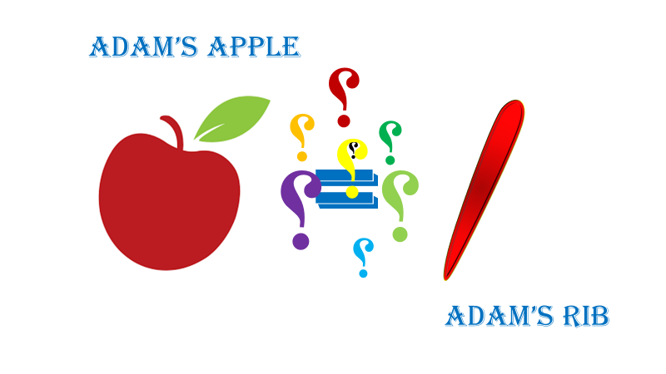

In another context, one could read:
- | Neural Conduction, Personal View vs. International View (Innovated)
 | Neural Conduction, Action Pressure Waves (Innovated)
 | Neural Conduction, Action Potentials (Innovated)
 | Neural Conduction, Action Electrical Currents (Innovated)
 | The Function of Action Potentials (Innovated)
 | The Three Phases of Neural Conduction
 | Neural Conduction in the Synapse (Innovated)
 | Sensory Receptors
- | Nodes of Ranvier, the Equalizers (Innovated)
 | Nodes of Ranvier, the Functions (Innovated)
 | Nodes of Ranvier, Function N1 (Innovated)
 | Nodes of Ranvier, Function N2 (Innovated)
 | Nodes of Ranvier, Function N3 (Innovated)
- | The Philosophy of Pain, Pain Comes First! (Innovated)
- | The Philosophy of Form (Innovated)
- | Spinal Injury, pathology of Spinal Shock, Pathology of Hyperreflexia
 | Spinal Shock (Innovated)
 | The Clonus (Innovated)
 | Hyperactivity Hyperreflexia (Innovated)
 | Hyperreflexia, Extended Sector of Reflex
 | Hyperreflexia, Bilateral Responses
 | Hyperreflexia, Multiple Responses
- | Nerve Conduction Study, Wrong Hypothesis is the Origin of Misinterpretation (Innovated)
 | Wallerian Degeneration (Innovated)
 | Neural Regeneration (Innovated)
- | Wallerian Degeneration Attacks Motor Axons, While Avoids Sensory Axons
 | Barr Body, the Whole Story (Innovated)
 | Boy or Girl, Mother Decides!
 | Adam's Rib and Adam's Apple, Two Faces of one Sin
 | The Black Hole is a (the) Falling Star?

09/01/2020

