Ammar Yaseen Mansour
Boy or Girl?
Mother Decides!
N.B.
The Arabic version of this article is the reference,
read it on one of the following links:
ولدٌ أم بنتٌ، الأمُّ تُقرِّرُ!
Boy or Girl? Mother Decides!
They said, the man produces two types of sperms. Half of his sperms are masculine, and the other half are feminine. I do say the same thing. They also said, the woman stores one type of oocytes. Since all her stock of oocytes are female oocytes. Personally, I do not have the same concept. I insist that half of the woman's stock of oocytes are female, while the second half of her oocytes are male oocytes.
The Oogonium:
Such as every female somatic cell, the oogonium cell contains in its nucleus the sexual chromosomes XX. Conventionally, the tow chromosomes X are unlike, functionally and in shape as well. One of them is not active, and forms the famous Barr Body in every female somatic cell. This concept is widely accepted nowadays in form of Lyon hypothesis.
However, I do not have the same concept. Since, I do believe Barr Body to be the female sexual chromosome itself, whereas the other chromosome X is just a chromosome porter, and non-sexual chromosome per se. Furthermore, I do consider Barr Body to be the sum of Adam's Rib and the host chromosome X; figure (1).

For more details
concerning my personal view of Barr body and Adam's rib,
one can read my articles:
Barr Body, the Whole Story (Innovated)
Adam and Eve, Adam's Rib could be the Original Sin

Barr Body
(Female Sexual Chromosome)
Adam's Rib
Chromosome X
Chromosome Porter
Figure (1)
I do believe Barr Body is the female sexual chromosome itself,
whereas the other chromosome X is just a chromosome porter, and non-sexual chromosome per se. Furthermore, I do consider Barr Body to be the sum of Adam's Rib and the host chromosome X.

Since, the oogonium begins its meiosis very early in the ovaries of the female fetus, the woman is born and she has already had all her stock of oocytes.
In meiosis, each oogonium equally distributes its chromatin between the two daughter cells that are the oocytes; figure (2).

Oogonium
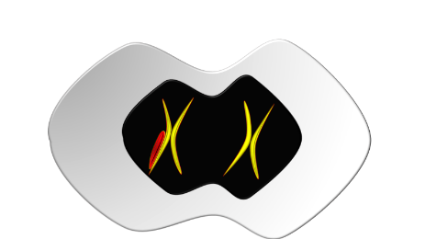
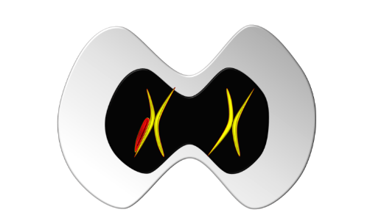
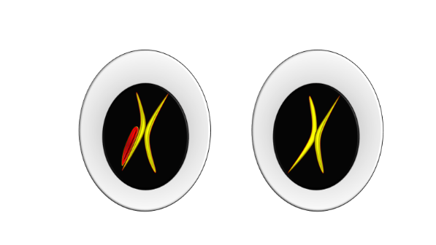
Oocyte
Oocyte
Figure (2)
The Oogonium in Meiosis
Each oogonium equally distributes its chromatin between
the two daughter cells that are the oocytes.
The oogonium begins its meiosis very early in the ovaries of the female fetus.
Therefore, the woman is born and she has already had all her stock of the primary oocytes.
Conventionally, they think of the similarity of the two oocytes. However, I do believe in their difference. One oocyte is heavier than the other. The heavier should be the female oocyte, while the lighter should be the male oocyte. I attribute the difference of molecular weight between the two oocytes to Adam's rib; figure (3).

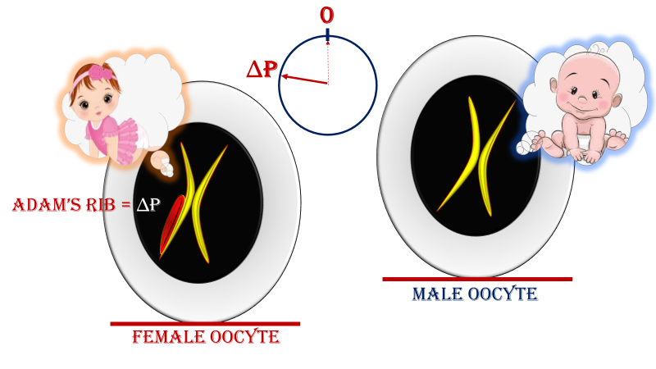
الخليَّةُ المُولِّدةُ للبويضات
الـ Oogonium
Figure (3)
The Female Oocyte is Heavier than Male Oocyte
Conventionally, it is said that the two oocytes are female.
However, I do believe a deep difference between them does exist.
One oocyte actually is heavier than the other.
The heavier oocyte should be the female oocyte, while the lighter oocyte should be the male oocyte. I attribute the difference of molecular weight between the two types of oocyte
to Adam's rib.

The Female Oocyte:
The female Oocyte, it cannot give but a female embryo. Its chromosome X* is of a higher molecular weight than the chromosome X found in the male Oocyte. This dissimilarity is due to the famous Adam's Rib (* = Adam's Rib), which might be integrated in (shown here), or is attached to, or just lies beside the host chromosome X; figure (4).

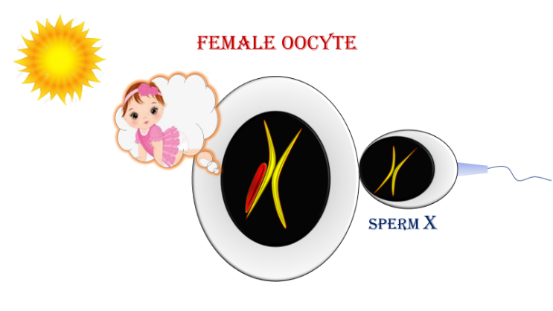
Figure (4-a)
The female Oocyte cannot give but a female embryo
Fecundated by a compatible spermatozoid (i.e., FO is fecundated by spermatozoid X),
the process of creation continues as it should be to give a female baby.
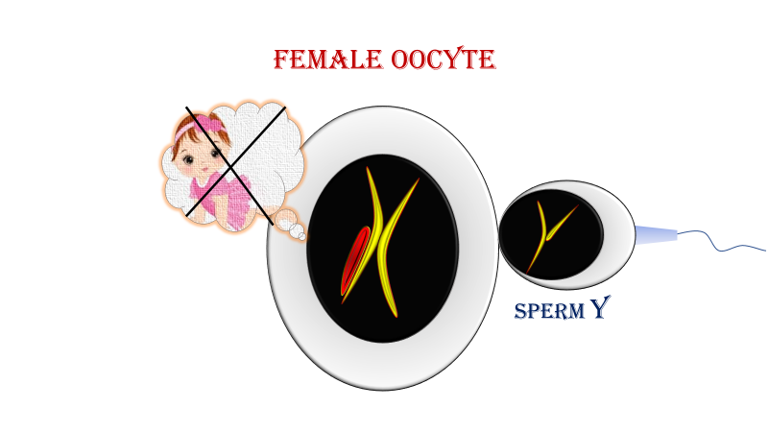

Figure (4-b)
The female Oocyte cannot give but a female embryo
Fecundated by an incompatible spermatozoid (i.e., FO is fecundated by spermatozoid Y),
the process of creation is eventually aborted.

The Male Oocyte:
The male Oocyte, it cannot give but a male embryo. If it is fecundated by a compatible spermatozoid (i.e., spermatozoid Y), the process of creation goes on. Provided, it is fertilized by an incompatible spermatozoid (i.e., the spermatozoid X), the process of creation is eventually aborted; figure (5).

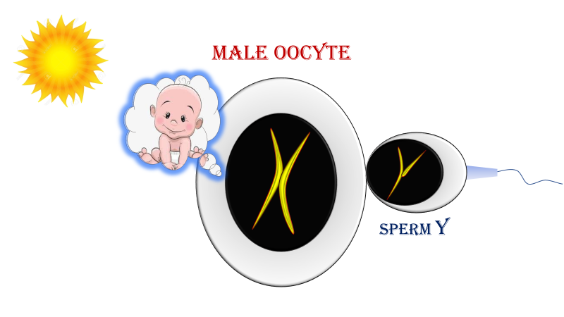
Figure (5-a)
The male Oocyte cannot give but a male embryo
If it is fecundated by a compatible spermatozoid (i.e., spermatozoid Y),
the process of creation goes on to give a male baby.

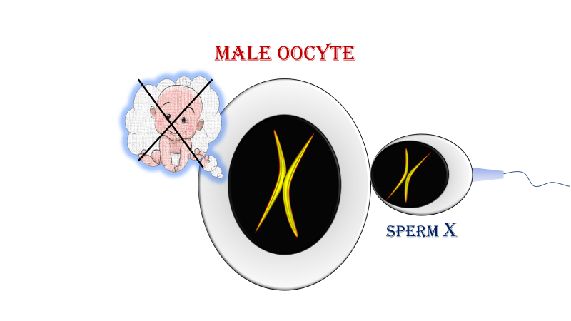
Figure (5-b)
The male Oocyte cannot give but a male embryo
Provided, it is fertilized by an incompatible spermatozoid (i.e., the spermatozoid X),
the process of creation is eventually aborted.

The Conclusion:
Regardless of the diversity of the autosomal genes, I do believe in the presence of two types of oocytes. One type is the Female Oocyte (FO); the progenitor of female embryo. While, the other type is the Male Oocyte (MO); the progenitor of male embryo.
The female oocytes (FOs) do not give but the female babies. While, the male oocytes (MOs) give only male babies. Moreover, the FO could not be fecundated but by the spermatozoid X. moreover, the MO can only receive the spermatozoid Y.
Fecundated by an incompatible spermatozoid
(i.e., FO is fecundated by a spermatozoid (Y) or MO is fecundated by a spermatozoid (X), the process of creation is eventually aborted.
………………………………………………………………………………………
In another context, one could read:
Neural Conduction, Personal View vs. International View (Innovated)
Upper Motor Neuron Lesions, Pathophysiology of Symptomatology
Neural Conduction, Action Pressure Waves (Innovated)
Neural Conduction, Action Potentials (Innovated)
Neural Conduction, Action Electrical Currents (Innovated)
The Function of Action Potentials (Innovated)
The Three Phases of Neural Conduction (Innovated)
Neural Conduction in the Synapse (Innovated)
Sensory Receptors
Nodes of Ranvier, the Equalizers (Innovated)
Nodes of Ranvier, the Functions (Innovated)
Nodes of Ranvier, First Function (Innovated)
Nodes of Ranvier, Second Function (Innovated)
Nodes of Ranvier, Third Function (Innovated)
Node of Ranvier The Anatomy
The Philosophy of Pain, Pain Comes First! (Innovated)
The Philosophy of the Form (Innovated)
Spinal Injury, Pathophysiology of Spinal Shock, Pathophysiology of Hyperreflexia
Who Decides the Sex of Coming Baby?
Spinal Shock (Innovated)
The Clonus (Innovated)
Hyperactivity Hyperreflexia (Innovated)
Hyperreflexia, Extended Sector of Reflex
Hyperreflexia, Bilateral Responses
Hyperreflexia, Multiple Responses
Nerve Conduction Study, Wrong Hypothesis is the Origin of the Misinterpretation (Innovated)
Wallerian Degeneration (Innovated)
Neural Regeneration (Innovated)
Wallerian Degeneration Attacks Motor Axons, While Avoids Sensory Axons
Barr Body, the Whole Story (Innovated)
Boy or Girl, Mother Decides!
Adam's Rib and Adam's Apple, Two Faces of one Sin
The Black Hole is a (the) Falling Star?
Adam's Rib, could be the Original Sin?
Pronator Teres Syndrome, Struthers Like Ligament (Innovated)
Function of Standard Action Potentials & Currents
Posterior Interosseous Nerve Syndrome
Spinal Reflex, New Hypothesis of Physiology
Hyperreflexia, Innovated Pathophysiology
Clonus, 1st Hypothesis of Pathophysiology
Clonus, 2nd Hypothesis of Pathophysiology
Clonus, Two Hypotheses of Pathophysiology
Hyperreflexia (1), Pathophysiology of Hyperactivity
Hyperreflexia (2), Pathophysiology of bilateral Responses
Hyperreflexia (3), Pathophysiology of Extended Hyperreflex
Hyperreflexia (4), Pathophysiology of Multi-Response Hyperreflex
Barr Body, the Second Look
Mitosis in Animal Cell
Meiosis
Universe Creation, Hypothesis of Continuous Cosmic Nebula
Circulating Sweepers
Pneumatic Petrous, Bilateral Temporal Hyperpneumatization
Ulnar Nerve, Congenital Bilateral Dislocation
Oocytogenesis
Spermatogenesis
This Woman Can Only Give Birth to Female Children
This Woman Can Only Give Birth to Male Children
This Woman Can Give Birth to Female Children More Than to Male Children
This Woman Can Give Birth to Male Children More Than to Female Children
This Woman Can Equally Give Birth to Male Children & to Female Children
Piriformis Muscle Injection_ Personal Approach
Eve Saved Human's Identity, Adam Ensured Human's Adaptation
Corona Virus (Covid-19): After Humiliation, Is Targeting Our Genes
Claw Hand Deformity (Brand Operation)
Corona Virus (Covid-19): After Humiliation, Is Targeting Our Genes
Barr Body; Mystery of Origin & Ignorance of Function
The Multiple Sclerosis: The Causative Relationship Between
The Galvanic Current & Multiple Sclerosis?
Liver Hemangioma: Urgent Surgery of Giant Liver Hemangioma
Because of Intra-Tumor Bleeding
Cauda Equina Injury, New Surgical Approach

Ulnar Dimelia, Mirror hand Deformity
Carpal Tunnel Syndrome Complicated by Complete Rupture of Median Nerve
Presacral Schwannoma
Congenital Bilateral Thenar Hypoplasia
Biceps Femoris' Long Head Syndrome (BFLHS)
Algodystrophy Syndrome Complicated by Constricting Ring at the Proximal Border of the Edema
Mandible Reconstruction Using Free Fibula Flap
Non- Traumatic Non- Embolic Acute Thrombosis of Radial Artery
(Buerger’s Disease)
Isolated Axillary Tuberculosis Lymphadenitis
Free Para Scapular Flap (FPSF) for Skin Reconstruction
Three Steps of Neural Conduction

28/12/2019

