AMMAR YASEEN MANSOUR
Neural Conduction in Neural Fibers,
Action Pressure Waves
(Innovated)
I do believe the mechanism of the neural conduction to be simpler than its worldwide conception. Moreover, I do believe the main stone of the neural conduction is
a pressure wave generated at the distal limit of the Axon Hillock.
See the details in the following video link:

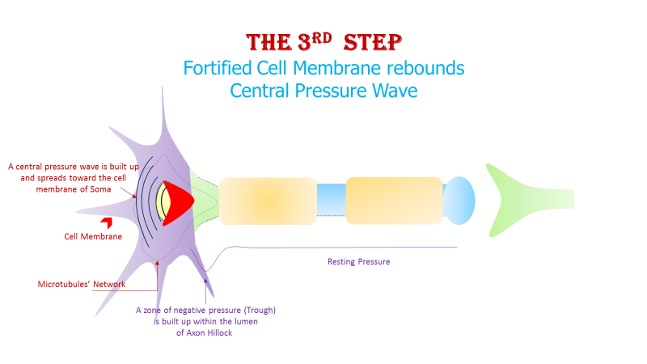
1-1 The Action Pressure Wave in the Motor Neuron
At rest, a resting pressure dominates inside the soma (the cell body of the neuron) and inside the axon as well. This resting pressure is considered the base line pressure.
In the axon hillock, after reaching the threshold, the massively present microtubules contract and withdraw toward the soma. Thus, they create the central pressure wave. Moreover, an area of negative pressure is created inside the axon hillock. The induced negative pressure opens the gates of the sodium channels and invites the sodium ions to enter into the lumen of the axon hillock. These incoming positive sodium ions positively charge the cytoplasm in this specific area (axon hillock), while the rest of the axon's cytoplasm is negatively charged due mainly to the negative charge of intra cellular proteins.
After contracting, the microtubules of the axon hillock relax and return to its essential position influenced by the rebound of the central pressure. Their return to the starting position compresses the incoming sodium ions and creates a pressure impulse, which is the action pressure wave.
Consequently, the incoming positive sodium ions create the anode of the action neural conduction current, whereas the negative charge of the distal axon makes its cathode.
1-2 The Action Pressure Wave in the Sensory Neurons
In response to a stimulant, a mini pressure wave (Wave Unit) is built up in every sensory receptor. At its passage through the first node of Ranvier, every wave unit builds up its mini neural conduction current (Current Unit).
At the root of the dendrites, all the units of the same neuron merge together to form one single action pressure wave, and one neural conduction current as well; figure (2).
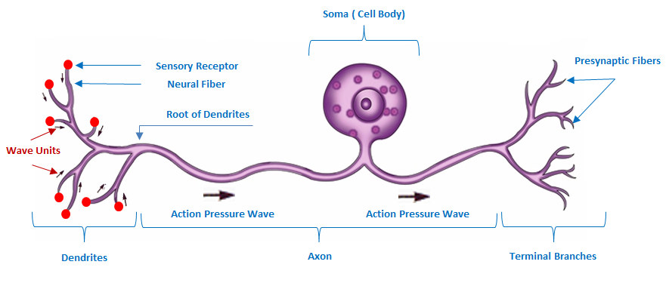
Figure (2)
The Sensory Neuron, The Action Pressure Wave
In every sensory receptor, a wave unit is built up in response to the stimulation. During its passage through the first node of Ranvier, the negative pressure of the wave unit's tail invites the positively charged sodium ions into the lumen of the neural fiber. Consequently, the current unit is built up. At the root of the dendrites, all the wave units and the current units emerge together in one single action pressure wave and one single action current respectively. Then, the two, the action wave and the action current, run on throughout the axon at the center sector of the lumen.
Note: I used the term UNIT_{(s)}, such as the Wave Units and the Current Units, to identify the ingredients of the final entity, such as the Action Pressure Wave and the Neural Conduction Current.

In another context, one can read:
- | Neural Conduction, Personal View vs. International View (Innovated)
 | Neural Conduction, Action Pressure Waves (Innovated)
 | Neural Conduction, Action Potentials (Innovated)
 | Neural Conduction, Action Electrical Currents (Innovated)
 | The Function of Action Potentials (Innovated)
 | The Three Phases of Neural Conduction
 | Neural Conduction in the Synapse (Innovated)
 | Sensory Receptors
- | Nodes of Ranvier, the Equalizers (Innovated)
 | Nodes of Ranvier, the Functions (Innovated)
 | Nodes of Ranvier, Function N1 (Innovated)
 | Nodes of Ranvier, Function N2 (Innovated)
 | Nodes of Ranvier, Function N3 (Innovated)
- | The Philosophy of Pain, Pain Comes First! (Innovated)
- | The Philosophy of Form (Innovated)
- | Spinal Injury, pathology of Spinal Shock, Pathology of Hyperreflexia
 | Spinal Shock (Innovated)
 | The Clonus (Innovated)
 | Hyperactivity Hyperreflexia (Innovated)
 | Hyperreflexia, Extended Sector of Reflex
 | Hyperreflexia, Bilateral Responses
 | Hyperreflexia, Multiple Responses
- | Nerve Conduction Study, Wrong Hypothesis is the Origin of Misinterpretation (Innovated)
 | Wallerian Degeneration (Innovated)
 | Neural Regeneration (Innovated)
- | Wallerian Degeneration Attacks Motor Axons, While Avoids Sensory Axons
 | Barr Body, the Whole Story (Innovated)
 | Boy or Girl, Mother Decides!
 | Adam's Rib and Adam's Apple, Two Faces of one Sin
 | The Black Hole is a (the) Falling Star?
 | Adam's Rib, could be the Original Sin?

26/02/2020

